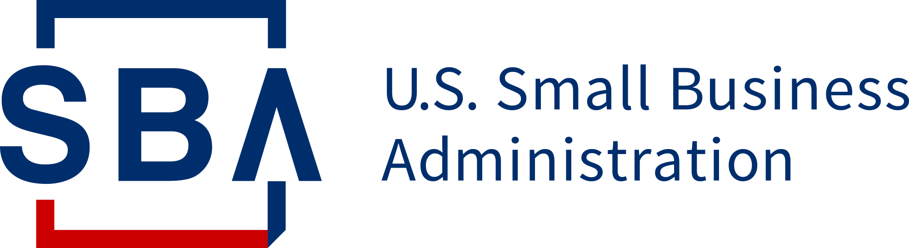

State Trade Expansion Program
Export Voucher Application and Program Guidelines
October 1, 2022 – September 29, 2023
Administered by the Washington State Department of Commerce
Funded through a federal grant from the U.S. Small Business Administration

Table of Contents
Section I – General Information 1
A. Program Overview 1
B. Participant Eligibility 1
C. Export Voucher Application Process 2
D. Eligible Events and Expenses 3
E. Voucher Reimbursement Process 4
Section II – Program Specifics 4
A. Important Program Points 4
B. Regarding Airfare 5
Section III – Confidentiality 5

Section I – General Information

Program Overview
The Washington State Department of Commerce (Commerce) administers the Export Voucher program through its Small Business Export Assistance Team, which seeks to increase the number of eligible small business concerns (ESBCs) that export. The program is funded by the U.S. Small Business Administration’s (SBA) State Trade Expansion Program (STEP) and is used to reimburse eligible ESBCs up to $10,000 for eligible export-related expenses.
Our review committee considers a number of factors when reviewing applications including: availability of funds, the number of applications submitted, the merits of a given application, and the projected sales resulting from the activity.
The committee will not approve late, weak, or incomplete applications.

Participant Eligibility
To be eligible, Washington State companies must:
- Be organized or incorporated and operating in the U.S.
- Be a registered business in Washington State
- Meet a) the applicable industry-based small business size standard established under section 3 of the Small Business Act; or b) the alternate size standard applicable to the program, under section 7(a) of the Small Business Act and the loan program, under Title V of the Small Business Investment Act of 1958 (15 U.S.C. 695 et seq.) The U.S. Small Business Administration (SBA) size standards are found at 13 C.F.R Part 121.

Use the SBA's Size Standards Tool for information on size standards for your business based on your NAICS code.

- Be in good standing with the Washington State Department of Revenue.

You can confirm your businesses’ good standing by using the Washington State Department of Revenue’s Business Lookup Tool.

- Have a Federal Identification Number tied to a Washington address.
- Adhere to the following additional program criteria:
(a) have been in business for one year at the time of application;
(b) demonstrate understanding of the costs associated with exporting and doing business with foreign purchasers;
(c) export goods or services of US origin or have at least 51% US content (ex-factory price of a good minus the aggregate value of foreign sources equals more than 51%);
(d) have a strategic export plan;
(e) demonstrate export readiness.
- Agree to provide information on export sales data resulting from the Export Voucher-supported activity, and respond to all subsequent Commerce sales surveys on a timely basis. Commerce will send surveys every six months, for up to 4 years. By applying for an export voucher, you are agreeing to respond to these confidential surveys with information on export sales data.

Export Voucher Application Process
- Company reads program guidelines.
- Company applies for a Unique Entity Identifier (UEI) or submits an existing DUNS number (these verify the existence of your company).

Please be aware that the Federal Government, including the SBA, is phasing out use of DUNS and will begin mandating the use of UEI. We encourage all business to sign up for a UEI immediately.

- Company applies for a Statewide Vendor Number. This number is how state agencies send payments to companies. Without this number, we cannot process reimbursements.
- Company submits application at least 6 weeks in advance of the start of the export activity.
- The Export Voucher Committee (composed of representatives from Commerce, the Export Finance Assistance Center of Washington and the US Export Assistance Center) meets to review applications and ensure applicants meet program qualifications.
- Applicant is notified of their application status and next steps, if any.
- Awarded company executes proposed activity and incurs expenses. (Expenses incurred prior to the receipt of an award are not eligible for reimbursement)
- Washington State Department of Commerce decisions on Export Voucher awards and reimbursements are final.

Eligible Events and Expenses
The following specific events and expenses are eligible for reimbursement:
- Design of international marketing, digital advertising (such as ads in a foreign industry magazine or Facebook/Google ads)
- Translation of marketing media, including audio/video
- International web design, maintenance and international payment handling
- Online market listing fees
- E-commerce platform fees
- Expenses to set up a website to accept international payments
- Services of the U.S. Commercial Service
- International shipment of product samples
- Compliance testing of an existing product for entry into an export market
- Export research tool subscription
- Cost associated with international IP protection (limited to the following--USPTO PCT transmittal fee, filing fee, search fee; Hague Intl Design App transmittal fee, Trademark Madrid Protocol fee)
- International business travel up to two company representatives (economy airfare only) (See Section II.B for further details)
- International trade show or trade mission fees (virtual or in-person)
- Foreign market sales trips
- EXIM Credit Insurance fees
The following expenses are not eligible for export voucher reimbursement, but may contribute towards an awardee’s obligatory 25% cash match (See Section I.E):
- Lodging
- Ground Transportation
The following expenses are neither eligible for reimbursement or for cash match:
- Food and beverages
- Gas
- General business expenses (shipping materials, printing expenses, purchase of equipment)

Voucher Reimbursement Process
Within 30 days of completing your export activity, you should fill out the reimbursement sheet issued with your award and include the following documentation:
- Invoices and matching receipts for your reimbursable and cash match expenses.
Your response to Commerce’s confidential sales survey, which you will receive by email.
- Receipts and invoices to cover the 25% of the voucher award as a “cash match”, or non-reimbursable, out of pocket expense. If you cannot meet the 25% cash match requirement, your voucher award will be adjusted to meet the cash match requirement.
- The company receives an electronic deposit or check in about 3-4 weeks once all documents have been submitted and approved.

Section II – Program Specifics

Important Program Points
- Limit three Export Vouchers per program year (10/1 to 9/29), with a combined total not to exceed $10,000. The $10,000 award cap may be covered by 1, 2, or 3 voucher applications.
- Export activities supported by an export voucher must end and be paid for by Sep 29, 2023.
- Company must be either “new to export” or engaging in “market expansion” – that is, the event/activity must help them to enter a new market or expand where they do not already have significant export sales.
- The 25% company cash match may not come from any other federal government source.
- An Export Voucher may be used to cover travel costs for only one individual, unless the activity is targeted by Commerce, in which case it may be used to cover costs for up to two individuals with prior approval.
- Vouchers can only be used for the approved activity and approved expenses stated in the award notification. Applicants must notify the STEP Program Manager if unable to complete the activity.
- If you do not submit all the necessary documents within 30 days of the event end date, or by Sep 29, 2023 (whichever comes first), the STEP Program Manager retains the right to revoke your award.
- These terms and conditions are subject to change without notice based on funding availability and changes in federal and state procedures and laws.

Regarding Airfare
Companies must meet the following requirements to receive reimbursement for airfare:
- Travelers must comply with the Fly America Act.
- The traveler must use a US carrier or a carrier from a country with a current Open Skies Agreement with the US.
- Companies must retain and submit boarding passes STEP Program Manager.
- Companies must submit an email confirmation from the airline stating the itinerary and confirmation of payment to the STEP Program Manager.
- Airfare will only be reimbursed for one traveler unless the event is Commerce-supported, in which case prior approval must be received.
- Airfare will be reimbursed for basic economy class (premium economy is not economy).
- Airfare purchased with frequent flyer miles is ineligible for reimbursement.

Section III – Confidentiality
The financial and commercial information pertaining to or on your application for an Export Voucher will be kept strictly confidential pursuant to RCW 42.56.270. Any information given on an application or subsequent completion report and surveys will only be reported as part of aggregated data from multiple Commerce clients that does not identify any individual responses or companies.

Please note that the Federal Government is currently phasing out the use of DUNS numbers in favor of UEI numbers. While ESBC’s are still eligible to apply for funds using an already assigned DUNS number, we highly encourage all applicants to obtain a UEI number.

