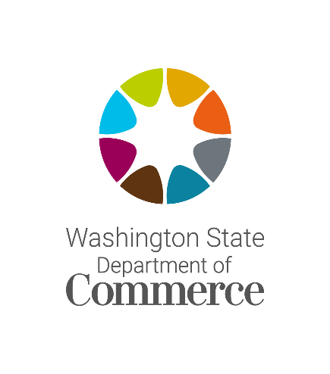
CLEAN ENERGY TRANSFORMATION ACT
DISCUSSION SERIES
Public Participation, Vulnerable Populations, and Equity Indicators (WAC 194-40-200)
No. 18, 2022, starting at 9 a.m.
Hosted via online webinar, details below

The Washington State Department of Commerce is hosting a three part discussion series on clean implementation plans (CEIPs) submitted by consumer-owned utilities to the Commerce on Jan. 1, 2022.

The first workshop focused on clean energy targets and actions set under subsections 1-3 under WAC 194-40-200. The second workshop focuses on public participation, identification of vulnerable populations and highly impacted communities, and selection of equity indicators under subsection 4. The third workshop will focus on the forecasted benefits and specific actions to mitigate risks to highly impacted communities and vulnerable populations.

The CEIP is the first planning document submitted to the agency under the Clean Energy Transformation (CETA). It documents how a utility intends to comply with CETA’s clean energy and equity requirements over the next four years and make progress towards the state’s 2030 greenhouse gas neutral and 2045 greenhouse gas free standards.

(Meeting details are available on the next page)

Login information
- Meeting link (link)
- Meeting ID: 880 7520 0713

- Passcode: CEIP
Dial-in information
- Phone #: +1 253 215 8782
- Meeting ID: 880 7520 0713

- Passcode: 918401
AGENDA
- Welcome and introductions 5 minutes

- Public Participation 30 minutes

- Vulnerable Populations and Highly Impacted Communities 30 minutes

- Avista Corp Presentation 30 minutes
  - Q & A 15 minutes

- Break 10 minutes

- Indicators 40 minutes

- Closing comments and next steps 20 minutes

