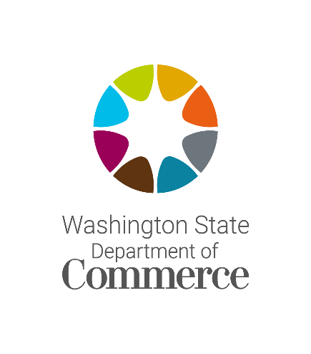
CLEAN ENERGY TRANSFORMATION ACT
DISCUSSION SERIES
Targets and Actions (WAC 194-40-200)
Oct. 28, 2022, starting at 9 a.m.
Hosted via online webinar, details below

The Washington State Department of Commerce is hosting a three part discussion series on clean implementation plans (CEIPs) submitted by consumer-owned utilities to the Commerce on Jan. 1, 2022.

The first workshop will focus on the clean energy targets and actions set under subsections one through three under WAC 194-40-200. The agency will provide time to discuss the upcoming two webinars on the equity elements of the CEIPs and hear from utilities and the public on what they would like to learn most at those meetings.

The CEIP is the first planning document submitted to the agency under the Clean Energy Transformation (CETA). It documents how a utility intends to comply with CETA’s clean energy and equity requirements over the next four years and make progress towards the state’s 2030 greenhouse gas neutral and 2045 greenhouse gas free standards.

Login information
- Meeting link (link)
- Meeting ID: 830 6962 6392
- Passcode: CEIP
Dial-in information
- Phone #: +1 253 215 8782
- Meeting ID: 830 6962 6392
- Passcode: 079469
AGENDA
- Welcome and introductions 15 minutes

- Starting the CEIP Process 30 minutes

- Interim and specific targets 45 minutes

- Actions 45 minutes

- Discussion of upcoming workshops on equity 15 minutes

  - Second webinar (11/18): Public participation, vulnerable populations, and equity indicators

- Third webinar (11/30): Forecasted distribution of energy and nonenergy costs and benefits, and risks to highly impacted communities and vulnerable populations

- Public comment 20 minutes

- Closing comments and next steps 10 minutes

