Utility Resource Plan
Cover Sheet Instructions
Due September 2, 2022
Dated June 30, 2022

Washington State Utility Resource Plans, 19.280 RCW (2006 House Bill 1010)

Utility Resource Plans including, at a minimum, the attached cover sheet must be submitted to the Washington State Department of Commerce (Commerce) by September 1, 2022. An excel spreadsheet template of this cover sheet is provided and is recommended for use in reporting as it ensures more accurate data compilation. For detailed requirements of plan development, see 19.280 RCW, at http://app.leg.wa.gov/RCW/default.aspx?cite=19.280

Selecting a Plan: Resource Plan or Integrated Resource Plan?

Before you continue, select the correct set of instructions for your utility. There are two plan types:
1) a Resource Plan and 2) an Integrated Resource Plan.

These instructions address a Resource Plan which should be completed by full requirements customers (also referred to as 100% BPA customer utility) and utilities with fewer than 25,000 meters. See Cover Sheet screenshot below.

Integrated Resource Plans should be completed by:
- all utilities with more than 25,000 meters that are not full requirements/100% customers of BPA, and/or
- utilities with less than 25,000 meters that follow their own electric loads.

Do not convert this to a PDF. We need it kept in Excel for incorporation into the database.

Resource Plan Cover Sheet screenshot
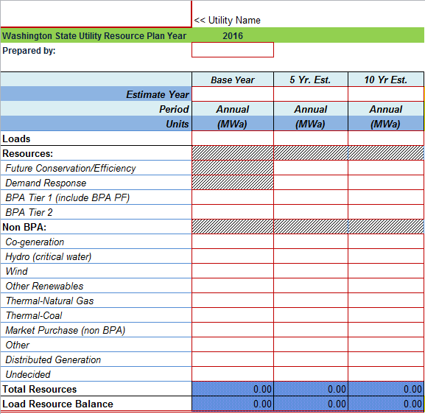

Reporting Details

Resource Plan (RP) Year
This is the 2022 reporting cycle and the cover sheet has this date embedded in it.

Base Year
Twelve month period of actual, not projected electricity service. A Base Year of 2020 or 2021 is recommended.

Five and Ten Year Load and Resource Reporting:
On the cover sheet, five and ten year reporting is for calendar year or is based on the Federal Fiscal Year (October – September). Federal fiscal year has been added as an option to simplify reporting for BPA customers who have contracts based on the fiscal year. If your Base Year is 2020, the five and ten year estimates should be 2025 and 2030. If your Base Year is 2021, they should be 2026 and 2031.

Reporting Units
Reporting units are Annual Energy, Average Megawatt (MWa).

Loads
Electric loads include retail sales + line losses + utility needs.

If the utility develops a range of forecasts they should report the data from their “preferred alternative” or equivalent scenario or their “mid-range” forecast or equivalent scenario. Otherwise, they should simply report their current and estimated loads and resources.

COMMERCE recommends that utilities report a weather adjusted load for the base year. This will provide more consistent reporting between the base year, five-year and ten-year estimates. This will also provide more consistent reporting across the state. Other options for reporting load are actual base year load or an alternative method. Note the type reported. The method used to calculate the base year load should be well documented in the RP.

Five and Ten Year Loads: On the cover sheet, record the weather adjusted loads for the projected five and ten year increments.

All projected loads (non-base year) are before estimated reductions from conservation programs or demand reduction program estimates. Conservation and demand response are treated as a resource to meet load. The Base year does not include conservation or demand reduction as a load or resource.

Resources (General)
On the cover sheet, record the quantity of each resource. Where you are not certain of which resource category to use, make your best selection and describe any issues in the area provided.

Use the most specific resource description. There may be times when a resource will fit into more than one definition. Select the most specific resource description. Ensure resources are accounted in only one category.

For small and full-requirements utilities, most of the resource will be BPA supplied energy. Other resource acquisitions, if any, will be a minor part of the overall resource mix. Power purchases that are linked to a specific resource or type of resource should be included in the row for that specific resource type. Unspecified, non-market, resources should be included in the “Other” row. It is expected that utilities will leave many of the rows blank.

Future Conservation and Efficiency
Conservation and efficiency in the base year should be left at zero. Only power resources that have served load should be reported in the base year.

For the five and ten year estimates, summarize expected annual energy savings from planned added conservation and efficiency measures.

RCW 19.280.020 defines conservation and efficiency resources as “any reduction in electric power consumption that results from increases in the efficiency of energy use, production, transmission or distribution.”

Demand Response
Demand response is temporary reductions or shifts in the timing of some uses of electricity. Demand response is used for peak load control, and does not result in significant annual energy savings. This row is expected to be blank on most if not all Resource Plan cover sheets. A discussion of demand response in the RP may be applicable to some utilities. Base Year demand response should be blank.

BPA Tier 1
Purchases made via contract with Bonneville Power Administration acquired under the Tier 1 agreement.

BPA Tier 2
Purchases made via contract with Bonneville Power Administration acquired under the Tier 2 agreement. Exclude market purchases acquired from non-BPA sources. These purchases should be included in the category: Market Purchase (non BPA).

Co-generation
RCW 19.280.020 defines Co-generation as ’the sequential production of electricity and useful thermal energy from a common fuel source.” From the 5th Northwest Power plan Co-generation is defined as “Cogeneration is the joint production of electricity and useful thermal or mechanical energy for industrial process, space conditioning or hot water loads.” For the purposes of this report co-generation may either result in a reduction in load at a specific customer’s site—e.g. a pulp mill—in which as it should be counted as conservation, or the utility may purchase the output from the industrial customer and use it meet other loads, in which case it should be reported as a resource.

Hydro (critical water)
It is assumed that “critical water conditions” will be used. Utilities should specify if something else is used in the RP. The critical water year should also be specified in the RP.

Wind
Base year wind data for energy may reflect actual experience, if available. Five and ten year wind can be estimated on anticipated wind sites and/or best available generic studies such as the Northwest Wind Integration Plan or the Northwest Resource Adequacy Forum. As with all other resources, whatever is included in the RP should be reported here.

Other Renewables
“ …(c) solar energy, (d) geothermal energy, (e) landfill gas, (f) biomass energy utilizing animal waste, solid organic fuels from wood, forest or field residues or dedicated energy crops that do not include wood pieces that have been treated with chemical preservatives such as creosote, pentachlorophenol, or copper-chrome-arsenic; (g) by-products of pulping or wood manufacturing processes, including but not limited to bark, wood chips, sawdust, and lignin in spent pulping liquors; (h) ocean thermal, wave or tidal power; and (i) gas from sewage treatment facilities.”

Note: This definition, from 19.280.020 RCW (HB1010), varies in specific details from the definition of renewables in the Energy Independence Act (I-937 / 19.285 RCW). If a utility must comply with the Energy Independence Act, they should use that definition.

Thermal: Natural Gas
Includes all gas generated resource including utility owned and long term contract purchases.

Thermal: Coal
Includes all coal generated resource including utility owned and long term contract purchases.

Market Purchase (non BPA)
Net energy or capacity obtained from entities other than BPA under agreements one year in length or longer and are not tied to specific resources. Include any Tier 2 market purchases provided by BPA, but, by a third party.

Other
Net short-term contracts under one year in length.

Distributed Generation
This includes Distributed Generation sources as described in the Energy Independence Act: “an eligible renewable resource where the facility or any integrated cluster of generating units has a generating capacity of not more than five megawatts. Enter the total amount from such facilities or unit clusters. Identify the type of fuel sources in the Notes section.

Undecided
Identify power that will be acquired from an undetermined source.

Additional considerations
Utilities may include monthly load and resource with their RP.
Seasonal exchanges need not be reported on the cover sheet but should be included in the RP narrative.

Total Resources and Load Resource Balance
Load Resource Balance is loads minus resources. These rows calculate automatically on the Cover Sheet Excel workbook template. The Balance row will be zeros if loads equal resources.

For more information, contact:
Austin Scharff
State Energy Office
360-764-9632
Austin.Scharff@commerce.wa.gov

