Submitting Online A19s to the Washington State Department of Commerce
Introduction 2
Step 1 – Create your Secure Access Washington (SAW) account (one-time only) 3
Step 2 – Add the Commerce Contract Management System service 7
Step 3 – Submit a CMS Access Request form 10
Step 4 – Log into CMS Portal site using the registration code 12
CMS Portal 13
Screens 14
How to Create a New A19 24
How to Add an Attachment 26
How to Add Reportable Expenses 27
How to Submit an A19 32
How to Print an A19 33
How to Correct an A19 35
How to Find Your Commerce contract manager 35
How to view Contract Summary Information 36
How to print Loan Amortization Schedules 36
How to Logout of the System 37
How to Access CMS Portal Help 37
Track your A19s 37
System Access Request Form 39

Introduction
This manual will guide you through the registration and use of the Commerce Contract Management System (CMS) Portal.
If you have any questions, contact your Commerce contract manager.
You can also use the Table of Contents to navigate through this document.

Getting Started
In order to gain access to system you must first complete a few initial steps:
- Create a Secure Access Washington (SAW) account
- Add the Commerce Contract Management System service
- Submit a CMS Access Request form
- Log into CMS Portal site using the registration code via SAW.

Step 1 – Create your Secure Access Washington (SAW) account (one-time only)

In order to access Commerce applications, you will need to create a Secure Access Washington (SAW) account. If you already have a SAW account, go to Step 2.
Go to the Secure Access Washington site at https://secureaccess.wa.gov/
Click the “Sign Up!” button to begin. 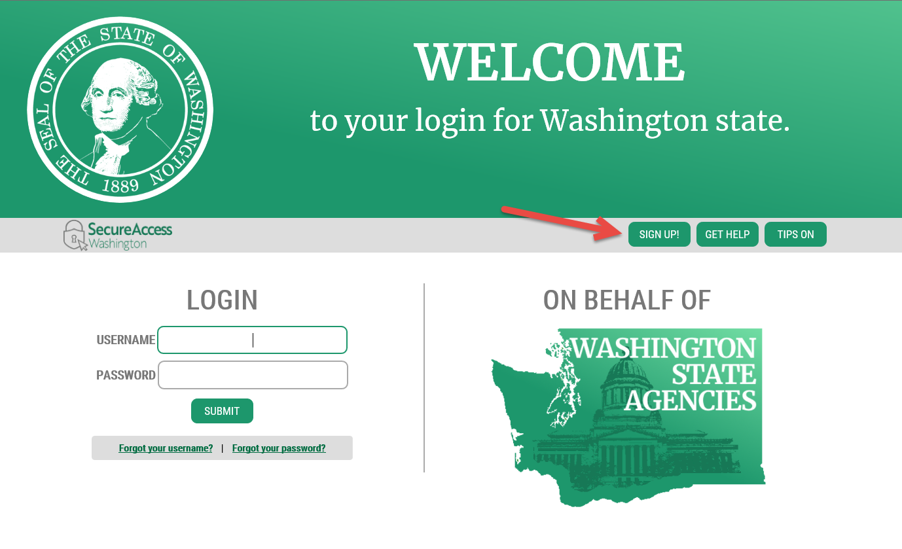

Enter your name, email and create a Username. Note the requirements for a secure password. You will also need to verify that you are not a “Not a robot”.
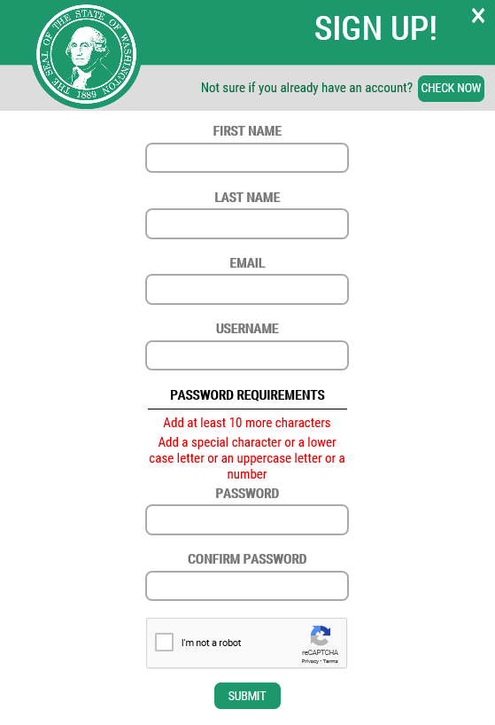
You will be sent an email to activate your account.
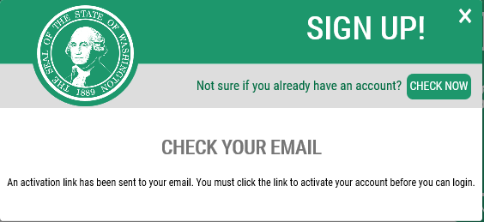
Go to your email account and click the link provided on your email. The email will be titled SecureAccess Washington: Welcome to SecureAccess Washington. Click the link to activate your account.

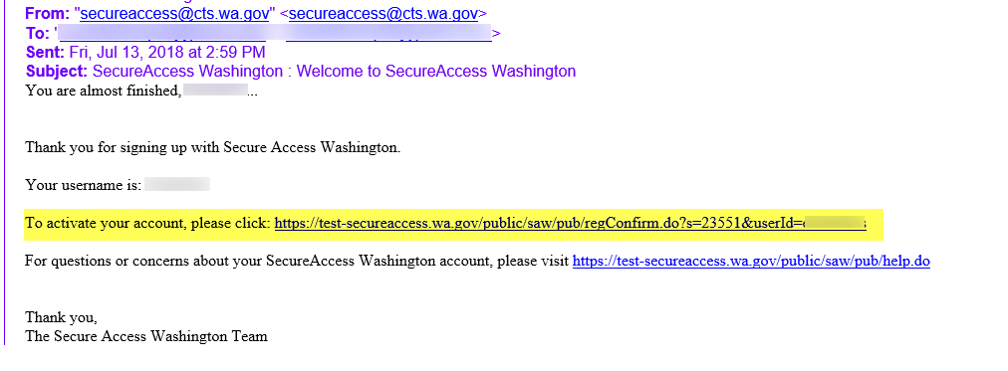

You will get an Account Activated message when you have successfully activated your SAW account.

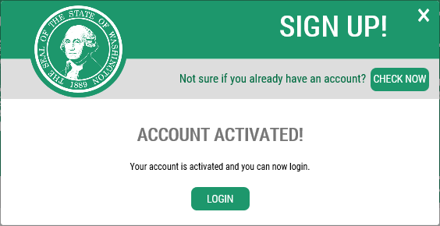
Next log into SAW using your new username and password.
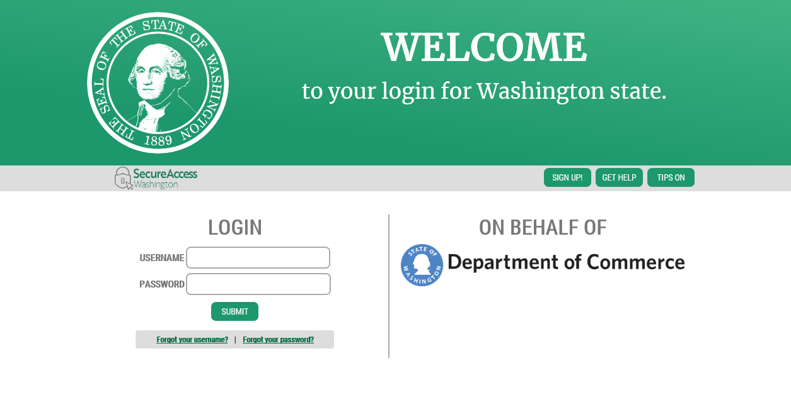

Step 2 – Add the Commerce Contract Management System service

Once you’ve logged into SAW, you can add your selected services by clicking on the “Add a New Service” button.
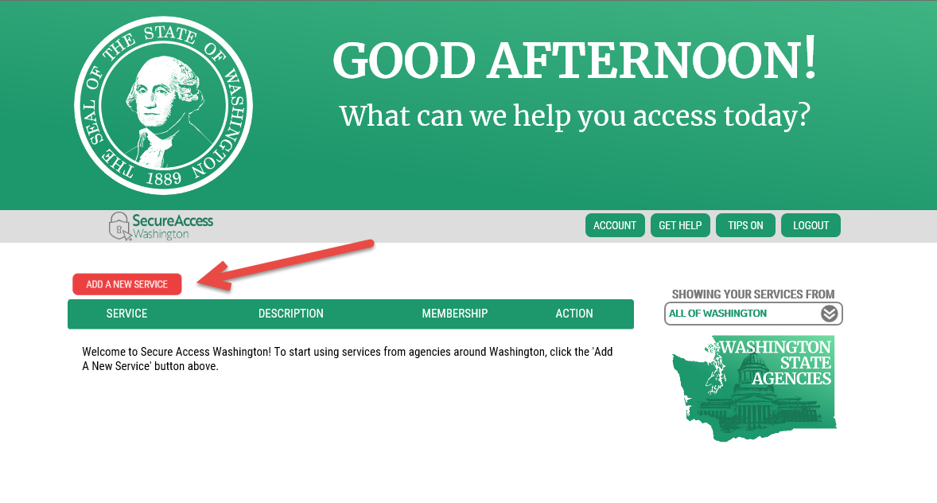

Next, select the “I would like to browse a list of services” option.
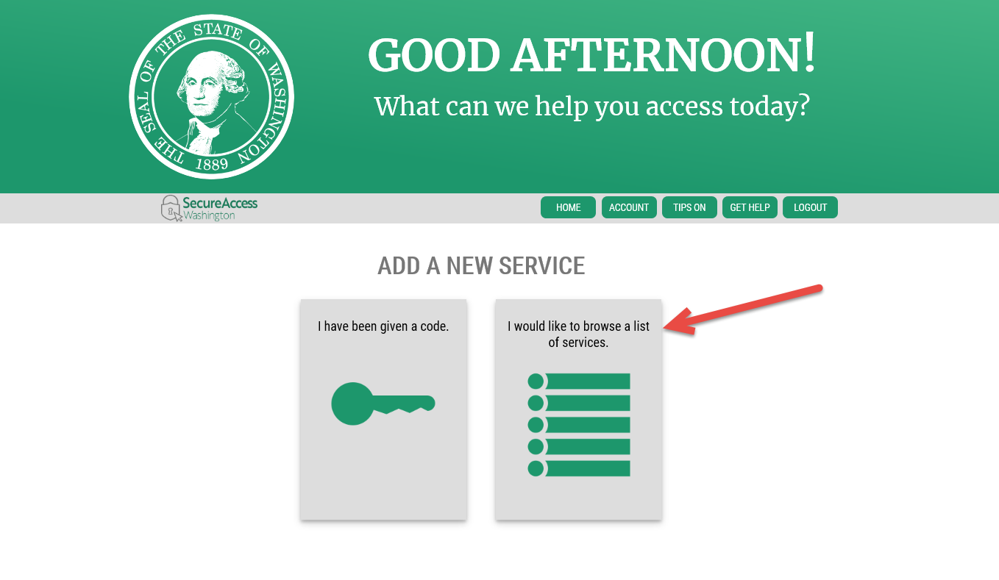
This will take you to a list of state agencies. Click on Department of Commerce to see the list of available Commerce services.
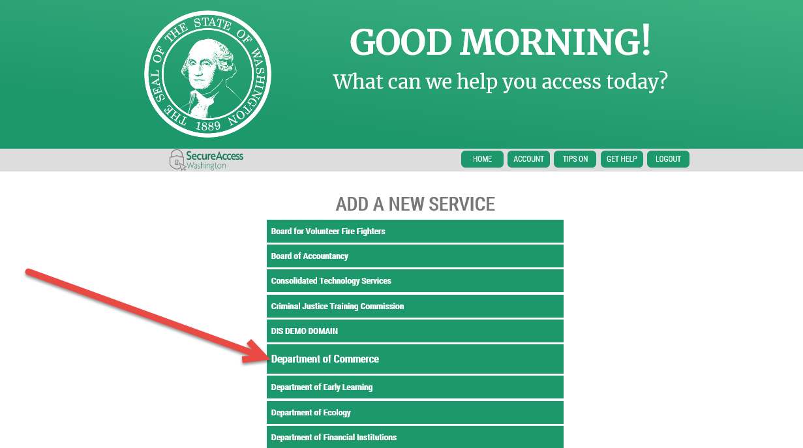

Click Apply for the Commerce Contract Management System. 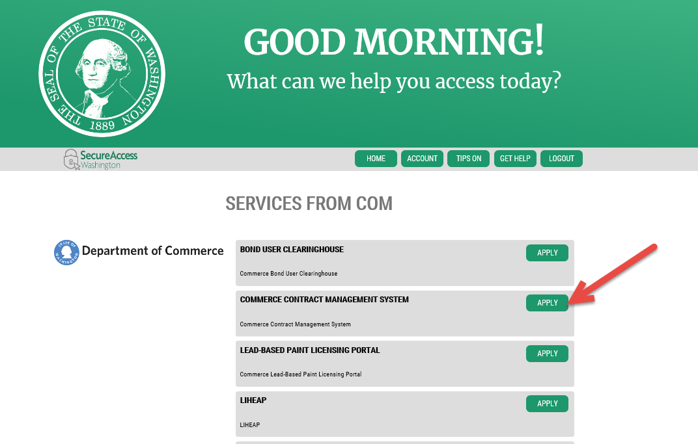
You will get a Registration Complete message. You will also get two emails, a User Registered for Service email and an Access Approved email. They are informational only and you do not need them to continue.
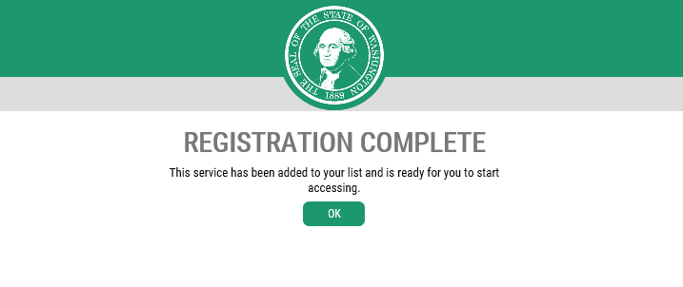

You will be redirected to the Home screen. Click on the Commerce Contract Management System link to access the system.
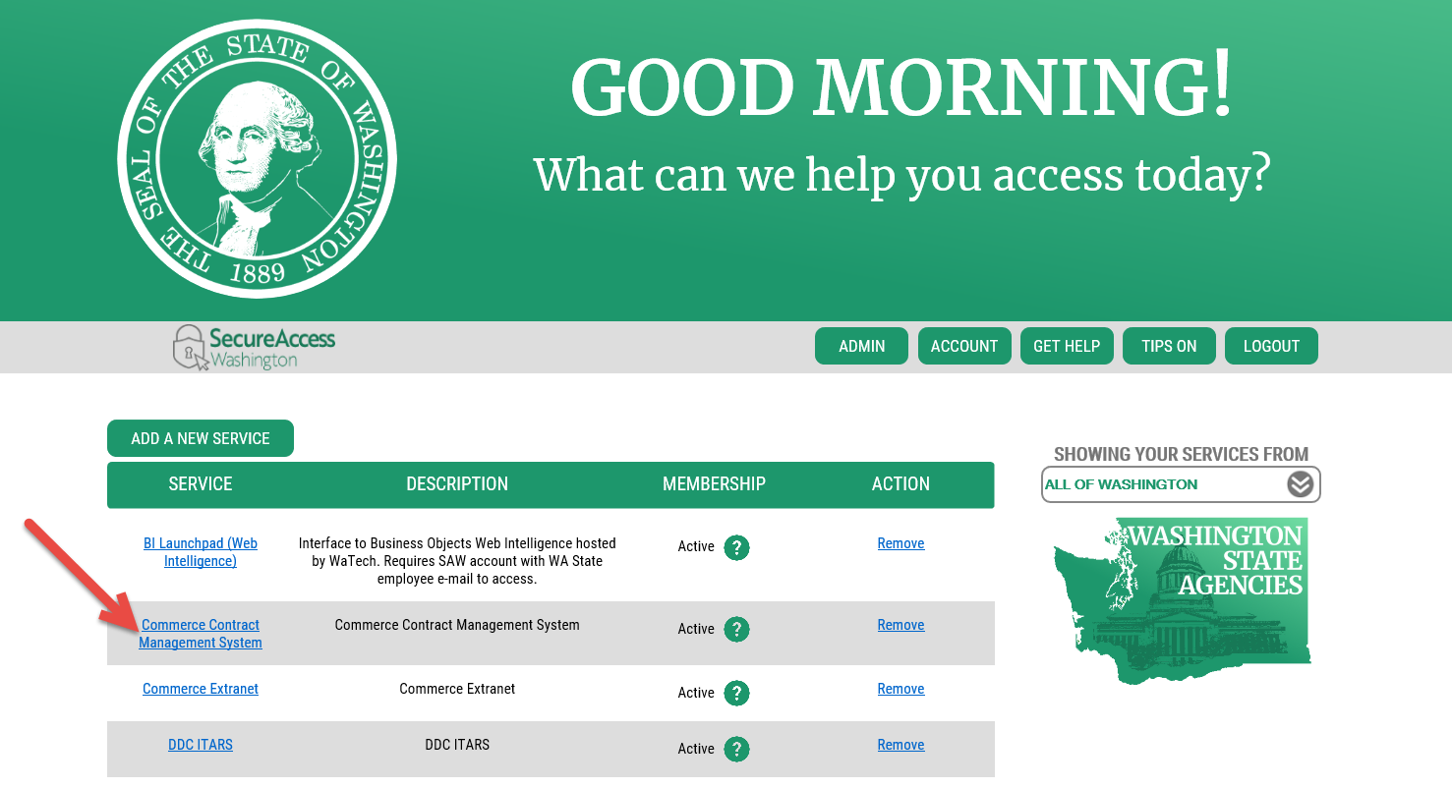

Step 3 – Submit a CMS Access Request form

You will also need to send a message to your Commerce contract/program manager letting them know that you would like to access the system. Send them a CMS Access Request form to make sure that they have all of the information necessary to get you added into the system.
The CMS portal has three roles available. Submit, Data Entry and Read Only. Below is a list of activities available by role.
 | Submit | Data Entry | Read Only
View Contract Details | X | X | X
View A19s | X | X | X
Print A19s | X | X | X
Create A19s | X | X
Submit A19s | X
Correct and Resubmit A19s | X

Access to contracts is granted by SWV number, please complete as many forms as needed to be granted access to all the SWV numbers used for contracts by you organization.
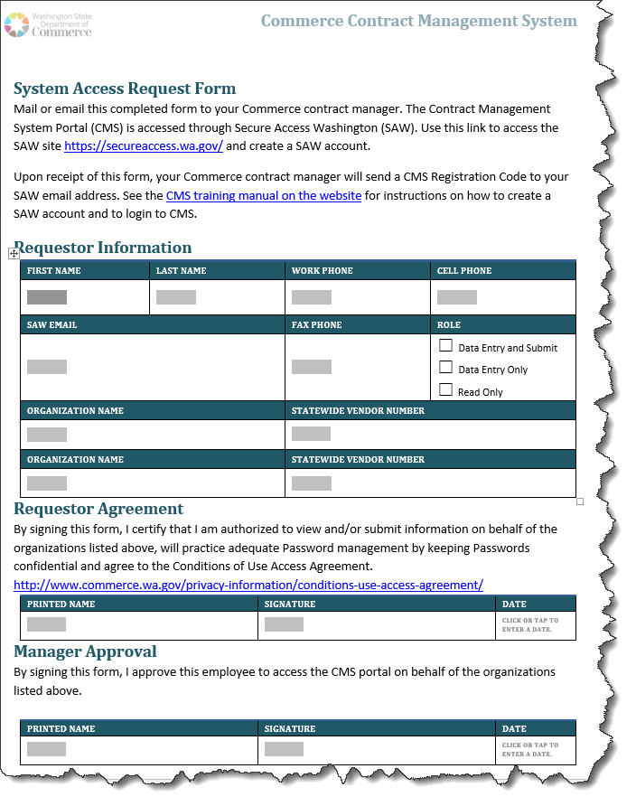

Step 4 – Log into CMS Portal site using the registration code

Once your Commerce contract manager registers you as a CMS portal user, you will receive an email like the one pictured below.
If you received an email first, but have not created a SAW account, complete Steps 1 - 3 above.
When you receive this email and have an active SAW account, you can either click on the link in the email to launch the CMS Portal or you can enter the Commerce Contract Management System through you “My Services” in SAW.
If your organization contracts with multiple programs within Commerce, you may have already received an email like the one below. If you have been granted access to all of your Statewide Vendors, you will be automatically granted access to those contracts, provided the program allow online invoices. This means you have already been set up as a person in the Contract Management System. If you need to be granted access to another SWV, submit a completed CMS Access Request form to the applicable Program Manager.
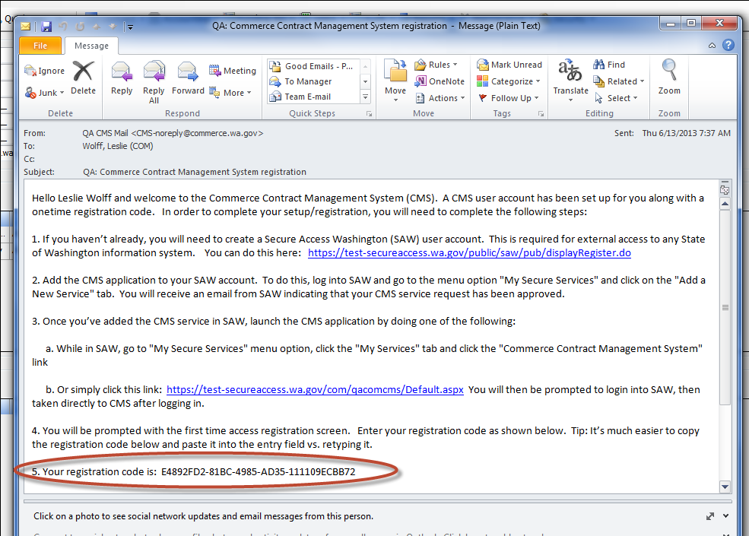
When you receive this email, copy your registration code. You can do this by highlighting the text and holding down the control key while pressing ‘c’.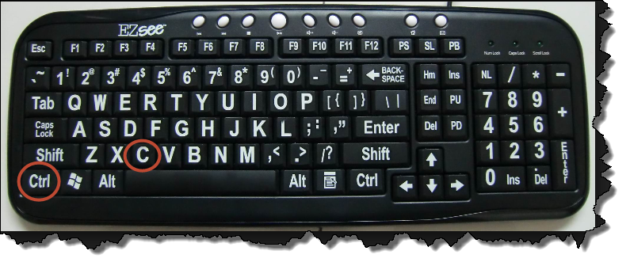
Then follow the link found in the email to the CMS Portal.
You will be prompted to enter your registration code.
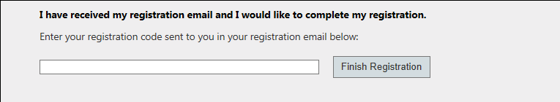
Click in the text box and paste the code. This can be done holding down the control key while pressing ‘v’. Then click on “Finish Registration”.
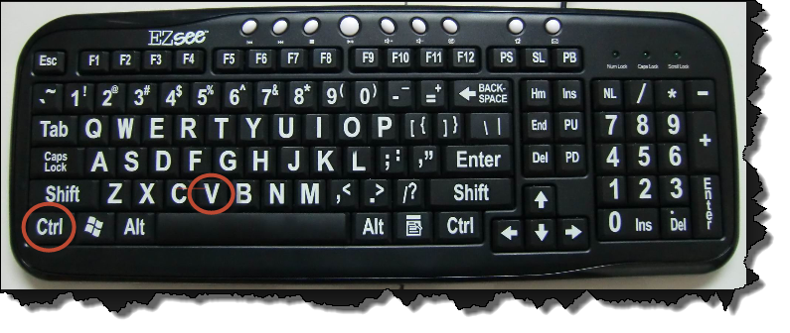
Log into CMS Portal site using the registration code via SAW.

CMS Portal

You will be granted access and redirected to the Commerce Contract Management System Home page.
The CMS portal provides more than just the ability to submit your A19s electronically. You can track the progress of your A19, print your A19s at any time, view A19 attachments. You will be able to review contract information, print a copy of the contract and any executed amendments. You will be able to view the ststus of funds available and spent. If your contract is a loan you will be able to see status of the loan as well as print loan amortizations schedules. You will even be able to email your contract manager from the contract details or A19 screen. Use the links below to find out more.
- Screen Overviews
- Create and Submit a New A19
- Print an A19
- Correct an A19
- View Contract Summary Information
- View and Print Loan Amortization Schedules
- Track your A19 Status
- System Access Request Form

Screens
There are three menu options on the top of the Portal. Use these to navigate to each page.
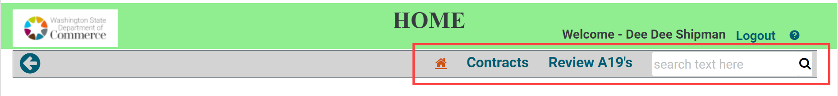

Home Screen
The home page will contain two sections, pending A19’s and contracts. This screen contains links to the Department of Commerce website and the Commerce CMS Portal site. All tables throughout the site can be sorted by clicking on the column headers; once for an ascending list, twice for a descending list, and the third click will remove the sort.
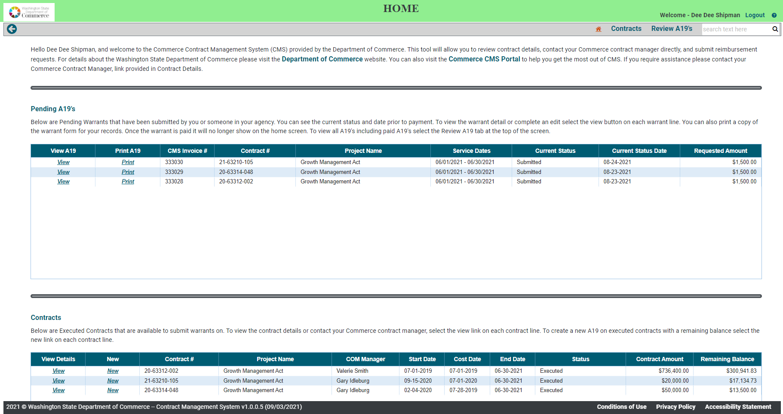
The first section of the home page will show a table of pending A19’s (invoices) associated with your contracts. Your Commerce contract manager will be able to see the same information within Commerce with the exception of drafts, which are A19s that you have created but not submitted to Commerce. You will be able to quickly navigate to the A19 details by selecting View directly from the table, this will allow you to review notes from your contract manager or make any requested edits. You can also print the A19 directly from the table by selecting Print.
This section shows you the A19s you currently have in process. “In process” statuses are:
- Draft
- Submitted
- Program Approved
- Processing Payment

Learn more about statuses here.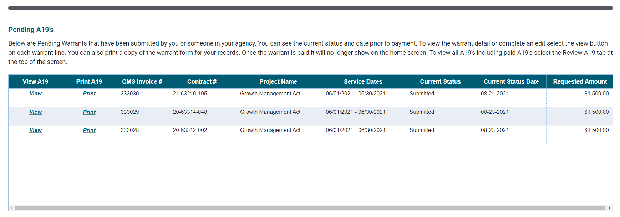
The second section of the home page will show a table of executed contracts associated with the organization’s SWV numbers included on your system access form. Once a contract has been executed, fully signed and approved by our accounting office, it will show on your list of available contracts to submit a reimbursement request. You will be able to view contract details by selecting View or directly from the table. You will also be able to create a new A19 by selecting New, this will only be an option on contracts with a remaining balance.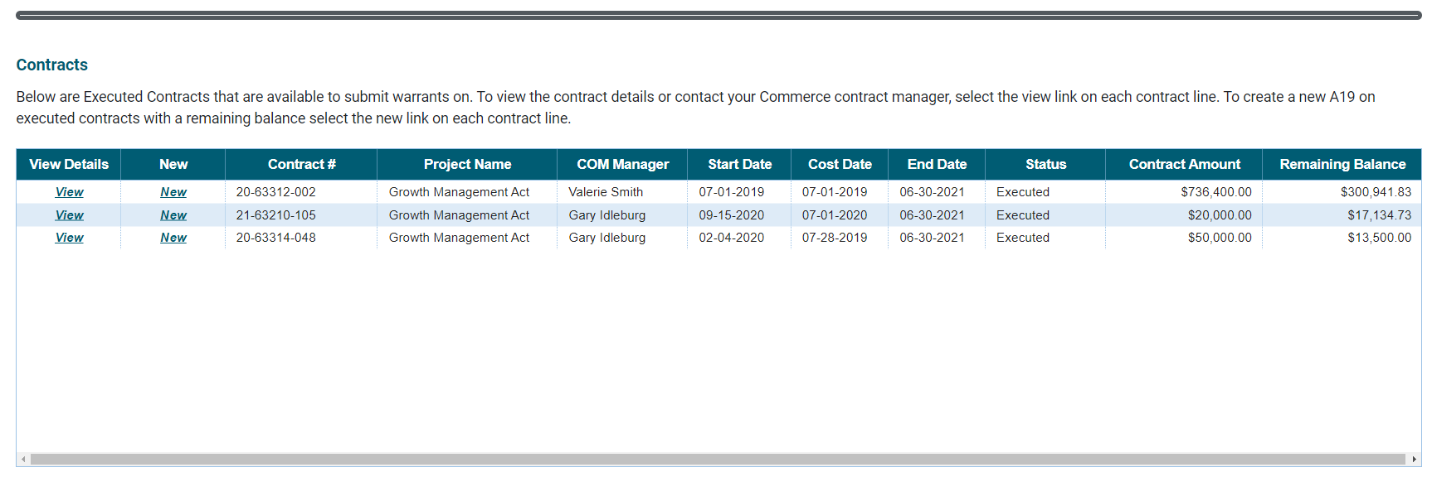

Contracts Screen
This screen will show you all of the contracts that you have been given access to by the Commerce contract manager(s), based on the SWV numbers provided on your system access request form. The table will open showing Active (executed) contracts. Above the table you will be able to select All Contracts, this will allow you to see executed and closed contracts. This option allows you to see the history of work your organization has completed with Commerce. All tables throughout the site can be sorted by clicking on the column headers; once for an ascending list, twice for a descending list, and the third click will remove the sort.
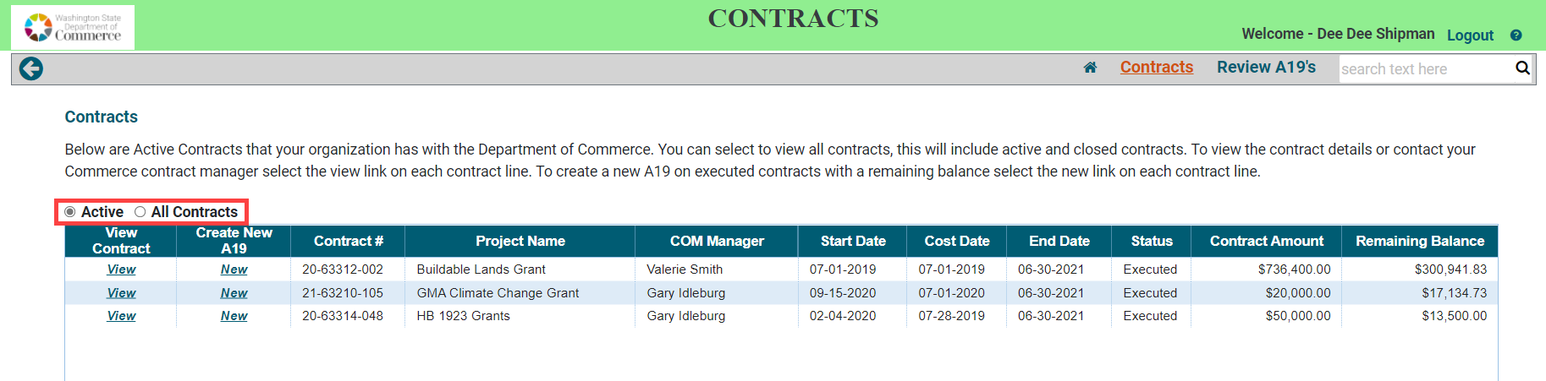You can view your Contract Summary Information on all contracts by clicking on View in the first column, View Contract. You will also be able to create a new A19 by selecting New in the second column, Create New A19. The New option will only appear on contracts that are executed and have a remaining balance. The New option will be removed on closed contracts and those that have spent all contracted funds.
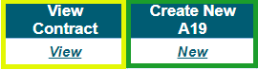

Review A19s Screen
This screen will open showing all of the A19’s in process for your agency, based on the SWV numbers provided to your contract manager. Above the table you will be able to select All A19’s, this will show all A19’s from draft status to paid, you will also see any rejected A19’s. All tables throughout the site can be sorted by clicking on the column headers; once for an ascending list, twice for a descending list, and the third click will remove the sort.
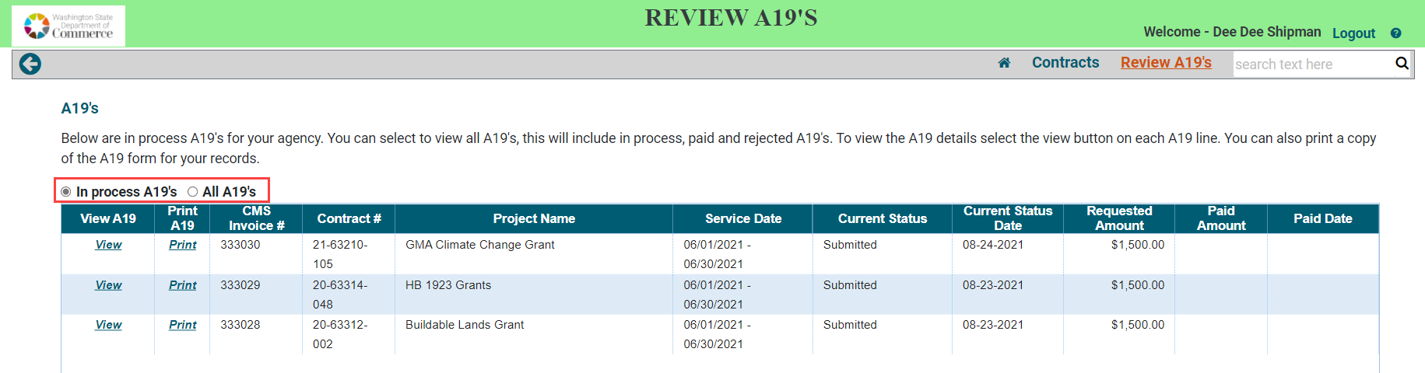
You can view A19 Information for created A19’s by clicking on View in the first column, View A19. You will be able to view A19’s in all statuses listed in the table. You will also be able to print a copy of the A19 form by selecting Print in the second column, Print A19.
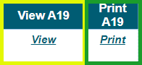

A19 Details Screen
By selecting View in an A19 table the system will open the A19 record. You will be able to view A19’s that have been previously created. At the top of the screen the CMS Invoice ID will be displayed, this is the unique number for your Invoice. It will be added to your EFT notification. The A19 details screen is divided into six sections. They are described below with key entry fields defined for clarity.

Contract Details
This section will contain basic contract information such as contract number, project name and UBI number that was provided to your contract manager. It also includes an “Email contract manager” button, this will open an email window with your commerce contract managers email address as will as your project name and contract number populated in the email subject line. Your Commerce contract manager information is also displayed if you have any questions or need assistance. 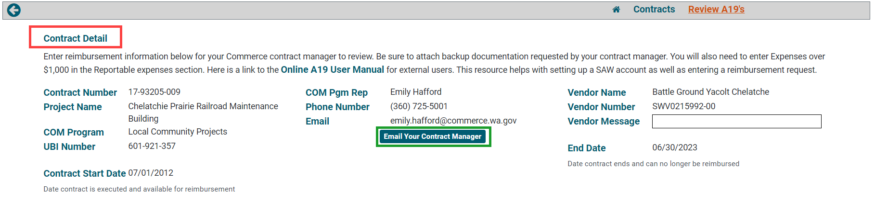

A19 Status Dates
This section will show the submitted, program approved, paid or rejected dates. These dates will be populated as the A19 goes through the processing steps. 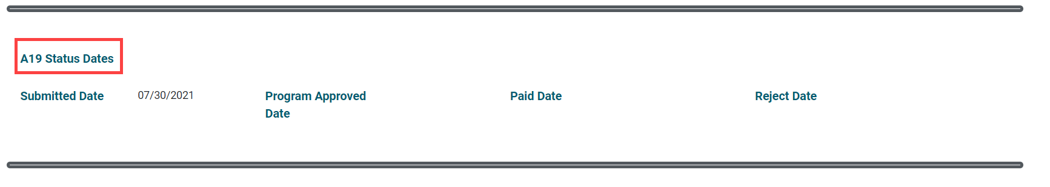

A19 Reimbursement Request
This section contains reimbursement information such as the service dates and amount of funds requested for the A19. It also contains a budget table providing up-to-date budget balances and percentages. The items below are editable on new and submitted A19’s. Once the dates are entered the CMS invoice ID is created and the system begins auto saving information as it is entered.
- Account # --This is where you can track your account number, if applicable.
- *From Date -- This is the start date for the service period. *Required
- *Thru Date -- This is the end date for the service period. *Required
- Vendor Notes to Commerce -- Enter notes here that will be visible to Commerce.
- Request Amount -- This is where you enter the amount they are requesting on your A19. If your program manager has set up budgets categories and/or activities then you have the ability to request amounts by line item.
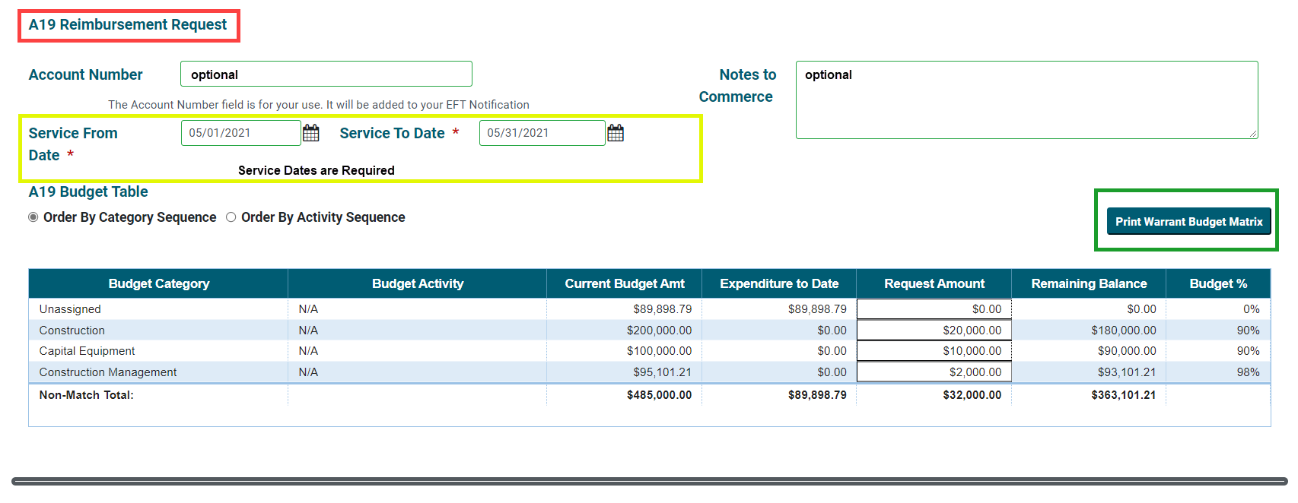

Attachments
In this section you can browse and upload documents to the A19 as backup documentation. The attachments will be reviewed by your Commerce contract manager. You will be able to View, Edit and Print an attachment. You will only be able to Delete an attachment prior to submitting the A19 to Commerce. 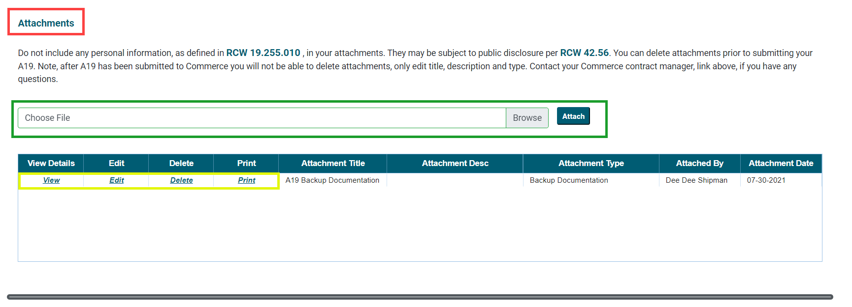

Reportable Expenses
This section is where you report Subcontractor and Sub Subcontractor expenses over $1,000. You may manually enter expenses by adding information in the top row and select the on the top left of the expenses table, or by uploading the Expense Template Excel spreadsheet. For detailed instructions on what expenses to report, visit the Contract Management Portal Webpage.
- Download Template button – allows you to download the Excel template that you can complete.
- All Expenses Under $1,000 checkbox – Check this box if you do not have any eligible expenses to report.
- Browse/Upload – this allow you to select and upload the Excel template. This works similarly to the Browse/Attach buttons for attachments.
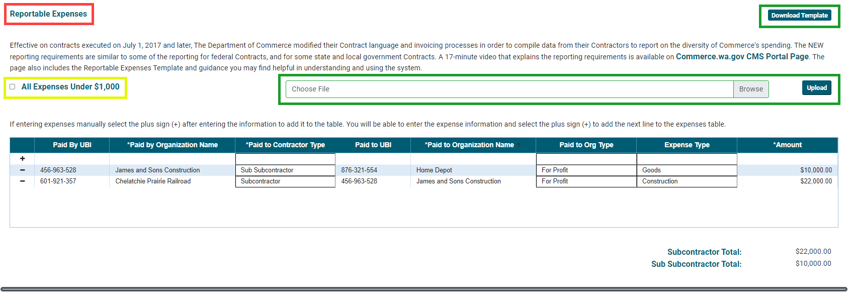

Submit
This section is where you certify, print and submit the A19.
- Certification Checkbox -- In order to submit an A19 to Commerce you will be required to check the certification box to verify that they have the authority to submit the invoice. This removes the need for a signature. You will need to re-certify by clicking the checkbox each time you re-submit your A19.
- Submit and Print – Once you have certified the A19 you can Submit your A19. Once submitted your Commerce contract manager is able to view and process it for payment. This will populate the submitted by and date throughout the screen and prints a copy of the A19 for your records.
- Print A19 – This allows you to print a copy of the A19 for your records.
- Cancel – Will allow you to exit the screen without saving any changes, this is helpful if you are making requested edits to the A19.
- Delete – You can delete a draft A19 using the “Delete” button. If there is a need to delete a submitted A19, contact your Program Manager and they will reject the A19 for you.
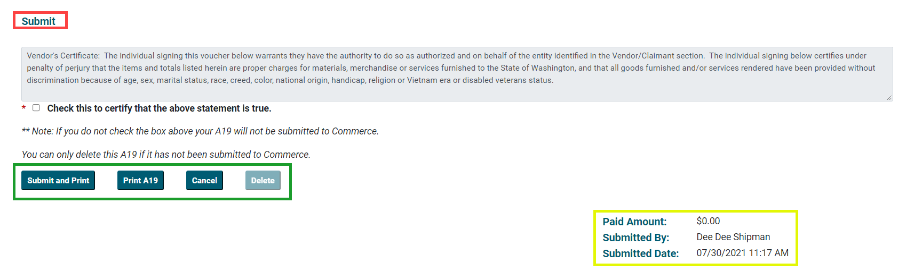

Contract Details Screen
By selecting View from a contract table the system will open your contract record, providing a summary view of your contract information in multiple sections. You will be able to pring a copy of the contract and any amendments comlpeted. You will also be able to print a simple contract budget or a combined loan amortization schedules for loan contracts. You can access all of its A19s, or create a new one if the contract is in executed status and has an available balance. If you see any incorrect information, please contact your Commerce contract manager. At the top of the screen the Contract number and project name will be displayed.
The contract details screen is divided into four for grant contracts and five sections for loan contracts. They are described below with key entry fields defined for clarity.

Contract Details
This section will contain basic contract information such as contract number, project name and vendor contract that was provided to your contract manager. It also includes an “Email contract manager” button, this will open an email window with your commerce contract managers email address as will as your project name and contract number populated in the email subject line.
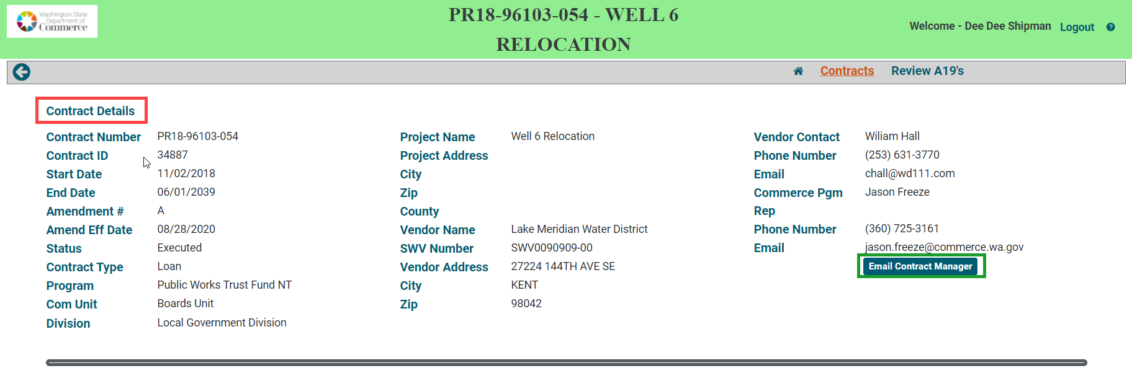

Contract Description
This section will show the contract description entered into the system by your contract manager. Below the description is an attachment table, you will be able to print a copy of the signed contract and any amendments that have been attached to the system by your contract manager. 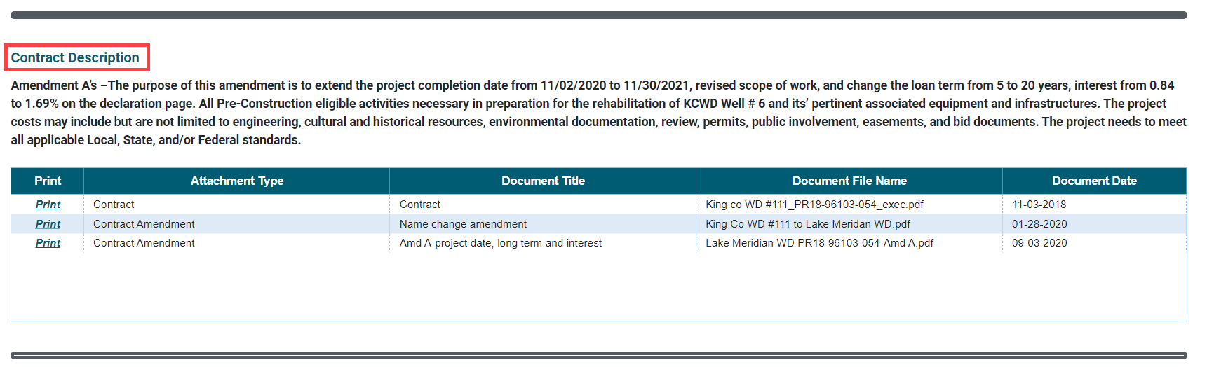

Fiscal Summary
This section will show the Contract totals, original and amendment amounts. It will also show a budget table created by your contract manager. This will show budget categories, current budget amount, spent to date amount and remaining balance. There is also a button that will print a simple budget matrix for the contract. 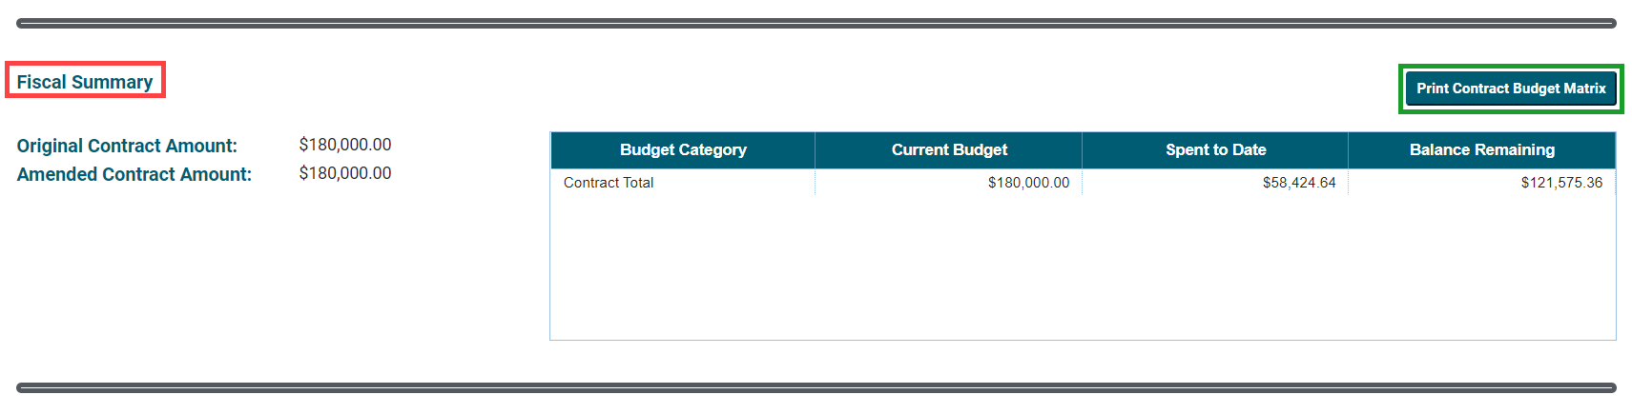

Loan Summary
If the contract is a loan this section will show a table containing loan title and information about each loan created for the contract, there can be multiple loans. There is also a button that will print the combined amort schedules, if you have more than one funding source for your contract, you can print a combined amortization schedule that will roll them up for you.
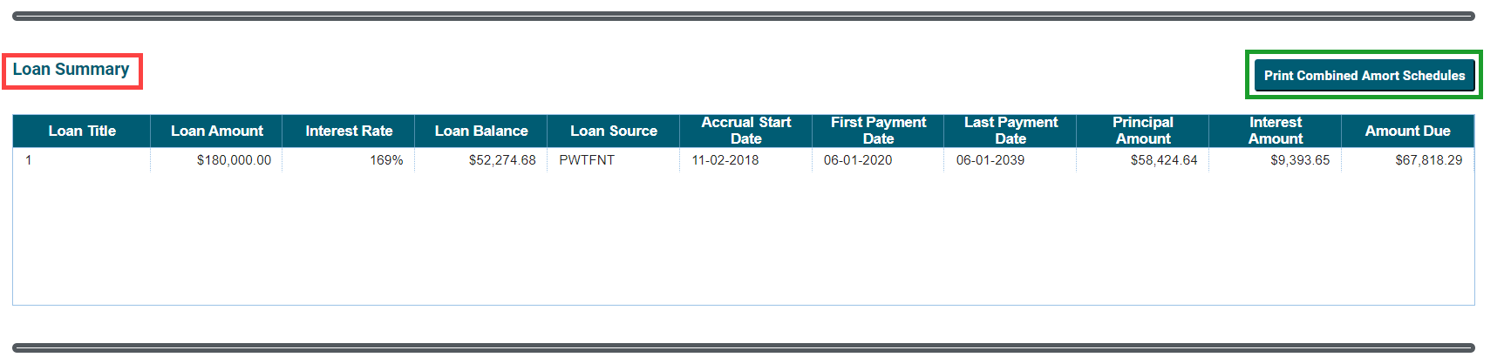

A19 History
The final section will show all pending, paid, and rejected invoices. You will be able to select View and Print for each A19 in the table. If the contract is executed and has a remaining balance the New A19 button will be available to select. 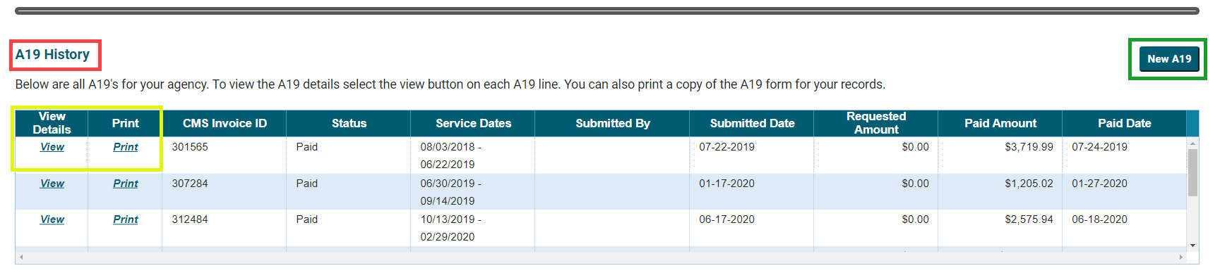

If you feel you are missing any contracts or if any information is incorrect, please email your Commerce contract manager.

How to Create a New A19
You can create a new A19 from any contracts table and the contract detail screen if the contract is executed and there are available funds. Go to the contract and select the New from the Create New A19 column.
This will take you to a new invoice screen. You will see contract details in the first section including the contract number, project name, the Commerce program and UBI number based on the contract you selected to create an invoice/A19 for. There is also an email your contract manager button so you can quickly contact them if you have questions or need help completing the A19.
In the reimbursement request section you will need to enter the required service dates, you can use the calendar icon to quickly select dates. 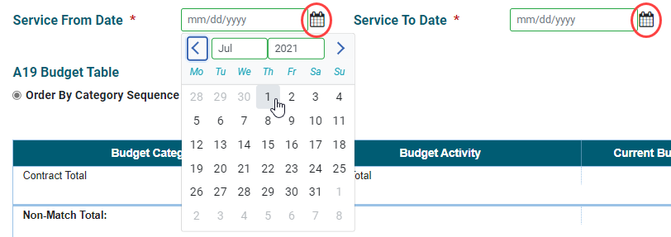
Once the dates have been entered the system will begin auto saving the A19 and create a CMS invoice ID. At this point the A19 status will be Draft and not yet visible to your Commerce contract manager. It will be included in your tables of pending/in process A19’s. If you need to exit the system, you will be able to return to your A19 to complete and submit it. Re-open the draft A19 you just created by clicking on View in the View A19 column of any A19 table.
The reimbursement request section also contains the A19 budget table. This is where you enter the amount you are requesting on your A19. If your program manager has set up budgets categories and/or activities then you have the ability to request amounts by line item. The table will show budget categories and activities, current budget amount, expenditures to date, and remaining balance and % which updates as you enter the Request amount. There is also a button that will print a warrant budget matrix for the information entered. 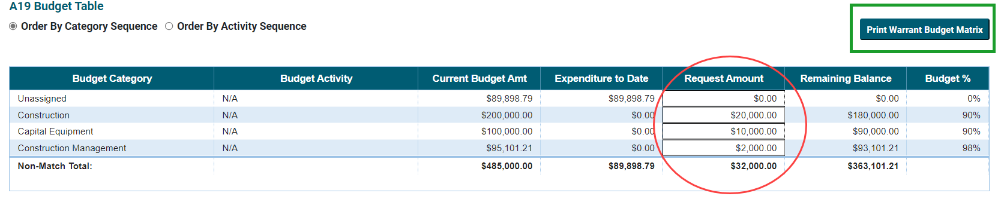

How to Add an Attachment
After you complete the A19 reimbursement request section, you will need to add backup documentation as an attachment. Attachments can be 10mb or smaller, if your document is larger you will need to separate it into multiple documents prior to attaching. Any attachments you add will be visible to your Commerce contract manager once the A19 is submitted.
Click Browse. The Browse button will give you access to the documents on your computer or within your network depending on where you are working from. It’s the same as adding an attachment to an email.
Navigate to the document you’d like to upload, click on the file and click Open. 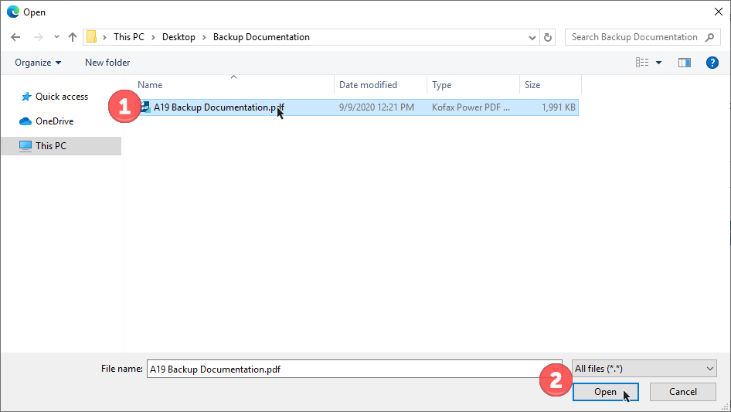
You will see the name of your attachment on the screen, but in order to finish attaching, you will need to click “Attach”.
You will now see the attached file in the Attachment table. Click the View to open the attachment.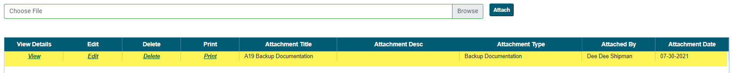
You will not be able make changes to your attachment from within the CMS Portal. If you need to update or change an attachment, you will need to delete the old attachment and upload the corrected version prior to submitting the A19. Once an attachment has been submitted to Commerce, you will not be able to delete it. Use Edit to open an edit window, you will be able to change the attachment title, type and description. You can enter information that lets your Commerce contract manager know to disregard the document or that it has been replaced. Once your edits are completed select the save button to save the edits or the cancel button to disregard the edits and close the edit window.
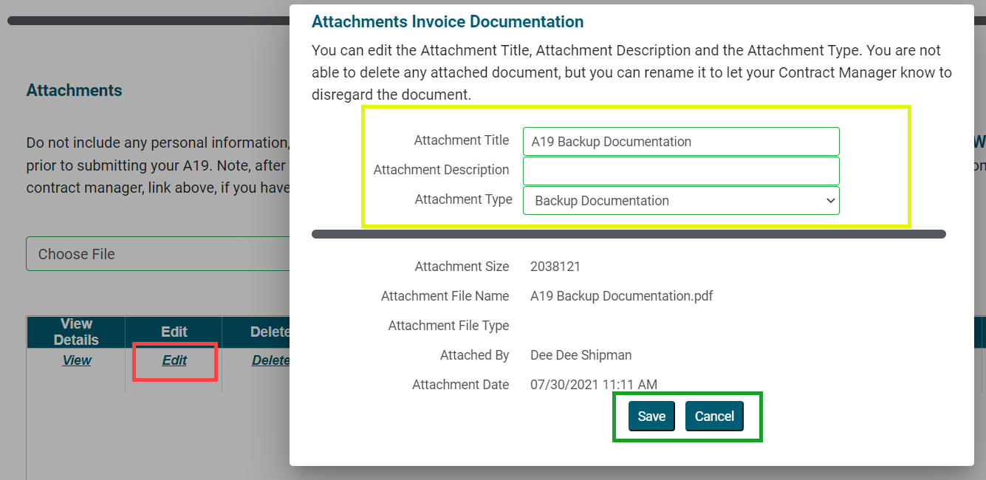

How to Add Reportable Expenses
There are two ways to enter Reportable Expenses in the CMS portal. Manually entering the expenses or by uploading a template. Review the Reportable expenses guide on the CMS Portal Page for more information about reportable expenses and if they are eligible.
If the expenses are not eligible or they are under $1,000 you can select the checkbox All Expenses under $1,000.
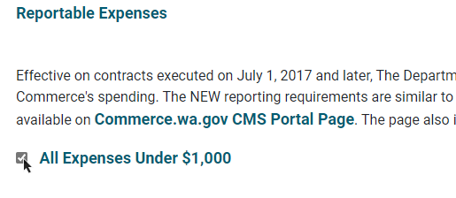
Manually Entered Expenses
This is a good option when there are only a few expenses to enter for an A19.
Enter Expense Information
Begin entering the expense information on the top line of the expense table. Once all the information is entered select the plus icon at the beginning of the line, this will add a row into the table. Repeat this step to enter another line of expenses. 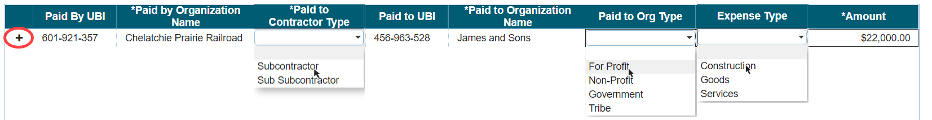
The added rows of information will have a minus icon in place of the plus, to delete the row of information click on the minus icon. 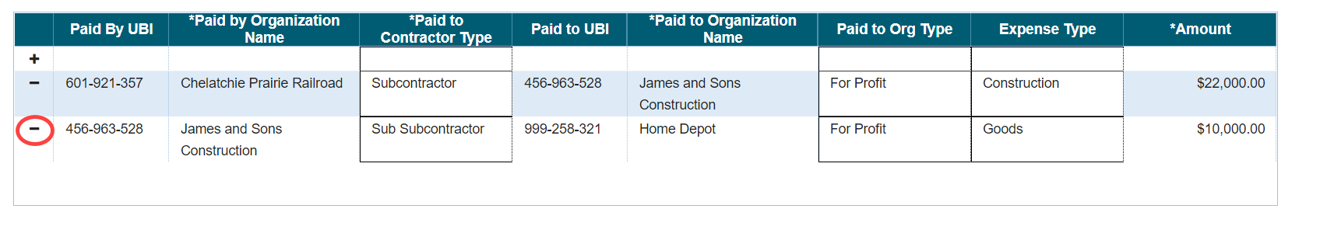
Required Fields
There are only four fields are required for a valid expense row, they are marked by an Asterisk *. The UBI for your organization must match the UBI on record for your organization. You can check the UBI in the contract details section of the screen.
Upload a Template
When the Reportable Expense list if extensive, using a Template allows users to gather and organize the information into an excel form before entering it into the system.
Use the Download Template button to the right of the Reportable Expenses section title. 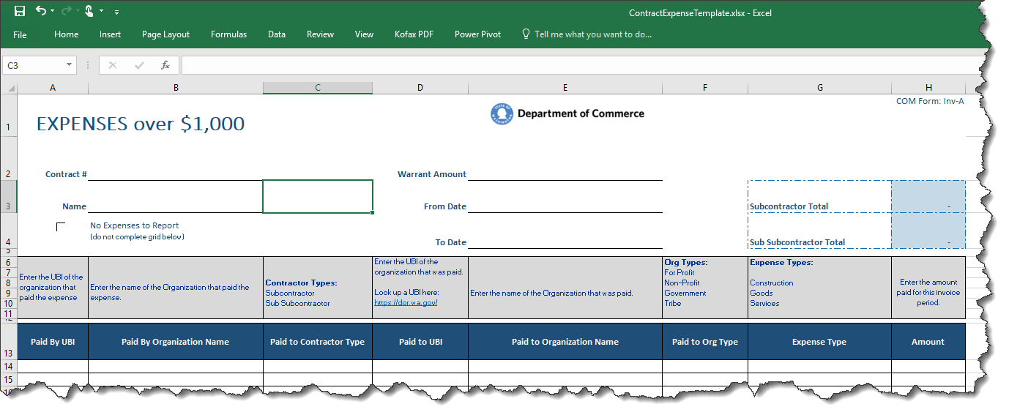
Once the information is entered into the form and saved to your computer. 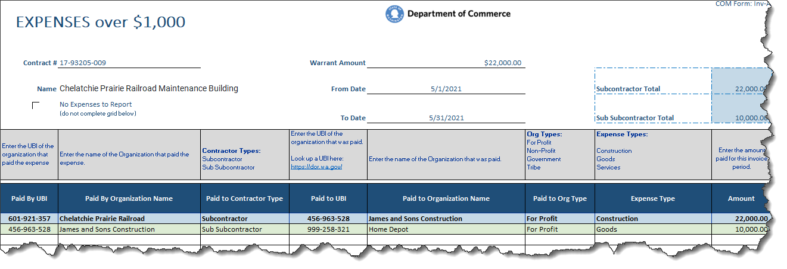
Click the Browse button, this will give you access to the documents on your computer or within your network depending on where you are working from. It’s the same as adding an attachment to an email.
Navigate to the saved Template you’d like to upload, click on the file and click Open. 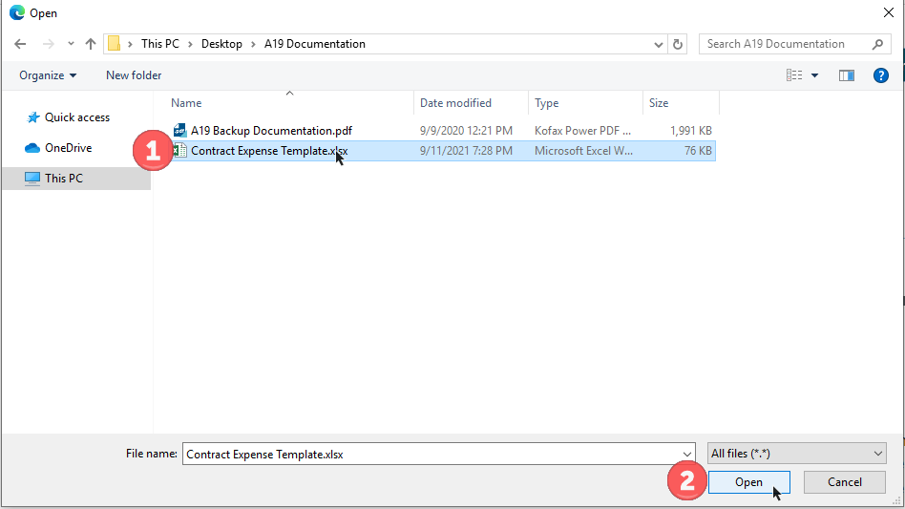
You will see the name of your template on the screen, but in order to finish attaching, you will need to click “Upload”.
Successful Template Upload Message
The system will show a pop up message when you successfully upload a template. 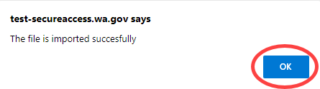
Select the “OK” button to view the reportable expenses in the expenses table.
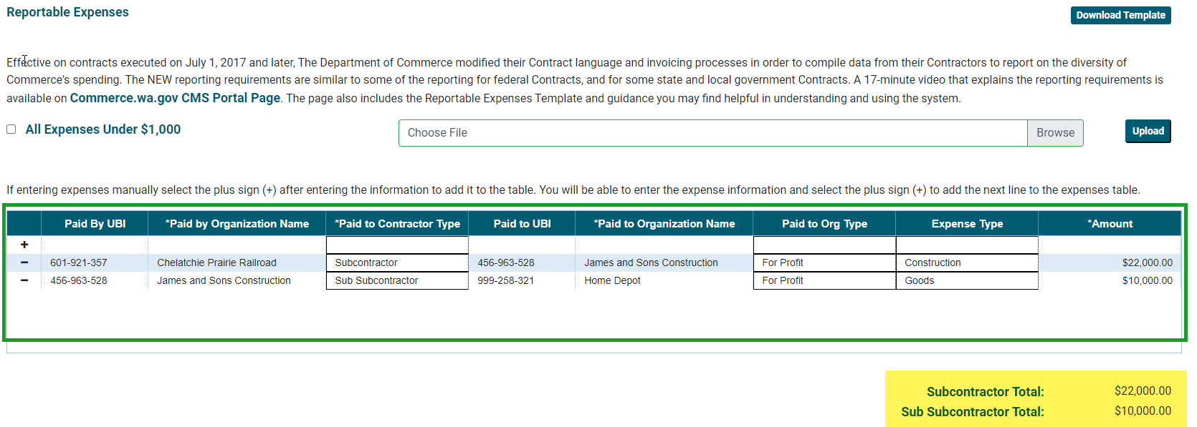
Subtotals
Subtotals are provided for each Contractor Type, Subcontractor and Sub Subcontractor, when you add a row into the expense table or upload a successful Template. Highlighted in the picture above.
Reload a Template
If you need to update the expenses, simply upload the template again. The system will delete all existing expense records before reloading the updated ones. You must click the Continue button before reloading expenses.
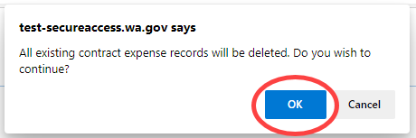
Upload Errors and Warnings
We have made every attempt to help you load good expense data. If there are errors on the template, you will get an error message at the top of the A19 detailing how many records had errors and a Validation and Errors list with the errors for each record by row number. Some messages are warnings. A warning will not prevent the file from uploading, but the data may need further review.
Error Warning
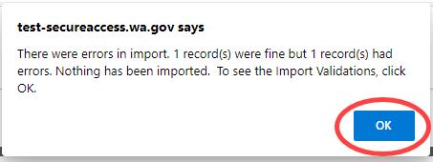
Validation (Warnings) and Errors
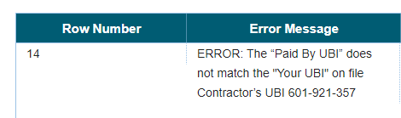

Add Template as an Attachment
The template should be added as backup for the A19.
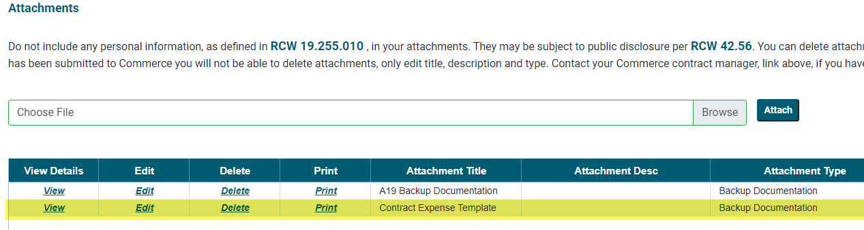

How to Submit an A19
Once you are ready to submit your A19 to Commerce, check the certification box, stating that you are authorized to submit the A19 and click on “Submit and Print”. This will send your A19 to Commerce’s Contract Management System, where your contract manager will review and process it.
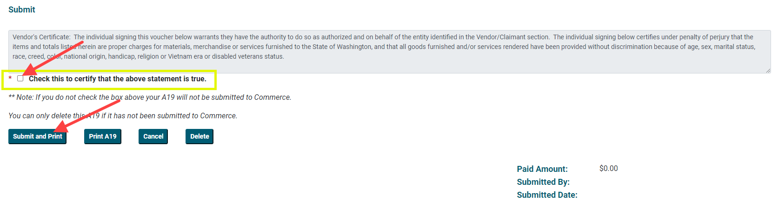
If you are missing any required fields, you will see a pop up message letting you know what you need to fill in. Select ok and populate the missing required field, and select “Submit and Print” button again.
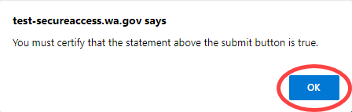
If all required fields are populated you will see a pop up message letting you know your A19 has been submitted.
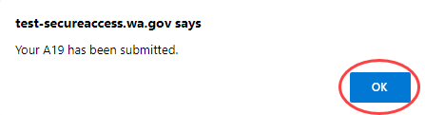
From within the A19, you also have the ability to delete the A19 using the “Delete” button. This option is only available for Draft A19s. If there is a need to delete a submitted A19, contact your Commerce contract manager and they will reject the A19 for you.
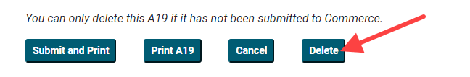
The “Cancel” button takes you out of the A19 and sends you back to your home screen.

How to Print an A19
To print a copy of your A19, select the “Print A19” button.
This will give you a PDF version of the A19 you created. There is no requirement to send this to Commerce. This copy is for your own records.
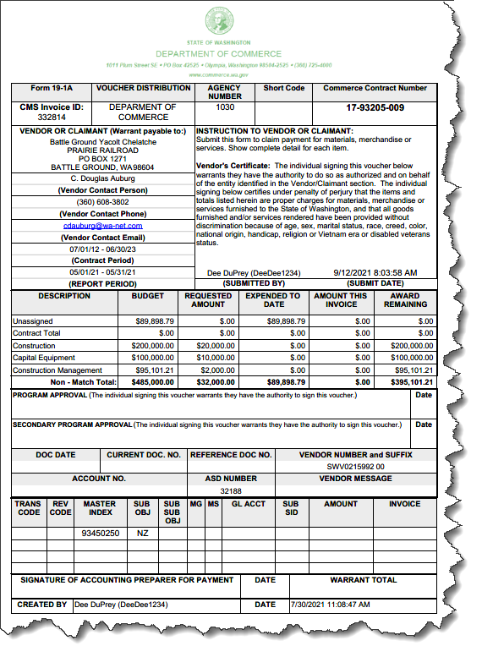

How to Correct an A19
After you’ve submitted or closed an A19, you can get back to it from any A19 table, either on the home screen or Review A19’s screen. You will be able to view A19 details for all A19’s listed in the table (draft to paid). You will be able to correct the information and add new attachments only if the A19 is in draft or submitted status. Once your A19 has been approved by Commerce, it will be locked down to you. If your A19 has moved to approved status, you will need to contact your Commerce contract manager if you’d like to make any changes, they should be able to unlock the A19 for you to correct.
To correct an A19 in draft or submitted status, select the View in the first column of your chosen A19.
This will open to the A19 details and you will be able to correct or update the information entered. This includes the A19 date range, notes to Commerce, requested amount, and reportable expenses. You will also be able to add new attachments. Note: if the A19 is in submitted status you will not be able to delete documents that have been attached. You will be able to edit the document title, this is a great way to let your Commerce contract manager know to disregard that document or that it has been replaced by a new document.
Once all of the corrections or updates have been made to the A19, check the certify box, and click “Submit and Print”.
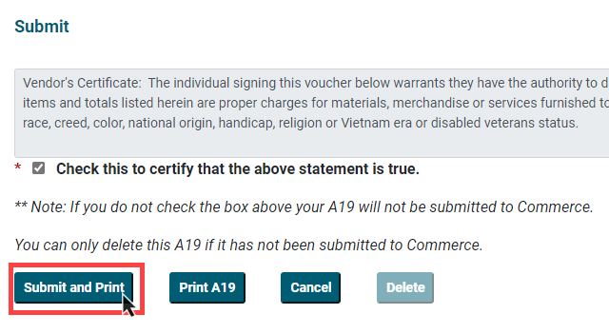

This submits your updated A19 to Commerce.
Note: since the A19 has been previously submitted you will not be able to “Delete,” the button will be unavailable.

How to Find Your Commerce contract manager
Your Commerce contract manager is listed in the contract details section of contract records and on your A19, along with their phone number and email address.
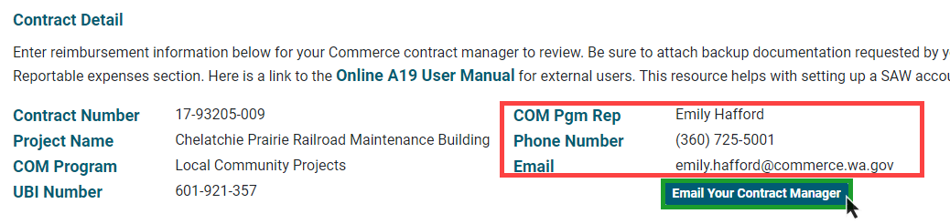
There is also an “Email your Contract Manager” button available, this will open a email window with the email address populated as well as the subject line containing the contract number and project name. 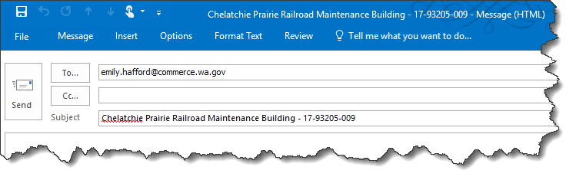

You can also find your Commerce contract manager’s name in the COM Manager column in any contract table, either on the home screen or the contracts screen.
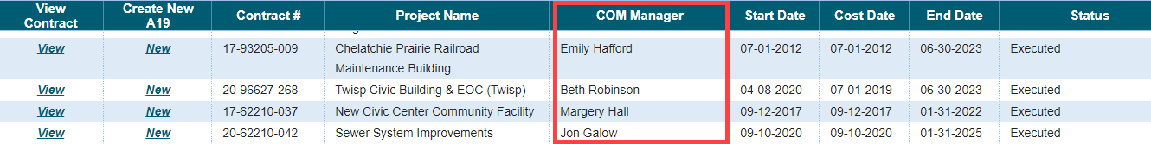

How to view Contract Summary Information
You will be able to view contract details by selecting View in the first column of any contract table, on either the home screen or the contracts screen.

How to print Loan Amortization Schedules
You can print your Loan Amortization schedules from the Contracts Detail screen. In the loan summary section you can select the “Print Combined Amort Schedule” button, if the contract has more than one funding source the button will print a combined amortization schedule that will them roll-up for you.
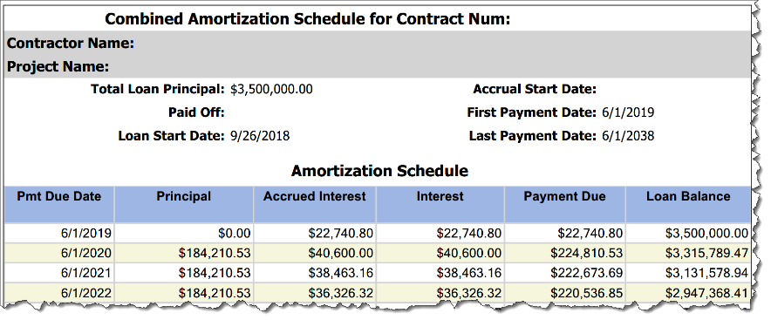

How to Logout of the System
When you are done using the CMS Portal, you can logout of the portal by clicking on Logout. This will allow other to login if you are using a share machine.
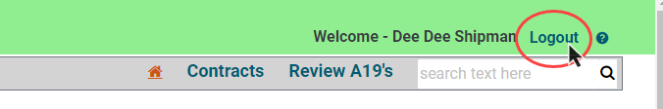

How to Access CMS Portal Help
The teal question mark in the upper right corner of the CMS Portal is a link to user manuals, help documents and other useful information on the Commerce CMS Portal website. If you don’t find what you need here, then contact your Commerce contract manager.
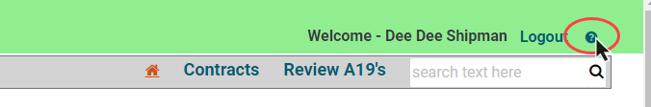

Track your A19s
Your A19 will move through several different statuses. You’ll see the status on your list of A19s on the Home page.
Here are the statuses you will see and the actions that lead to them.
User Action | A19 - Status
You enter basic A19 information online and click save. The A19 has not been seen by Commerce. | Draft
You click the submit button. Your A19 can now be seen by Commerce. | Submitted
Commerce approves your A19. | Program Approved
Commerce fiscal services has received your approved A19. | Processing Payment
Your A19 has left Commerce. You have either already been paid or will be paid shortly. | Paid
Commerce rejects your A19. You will need to talk to your program manager to determine next steps. | Rejected

System Access Request Form
Return the completed form to your Commerce contract manager by the method requested; email or Smartsheet upload. The Contract Management System Portal (CMS) is accessed through Secure Access Washington (SAW). Use this link to access the SAW site https://secureaccess.wa.gov/ and create a SAW account.
Upon receipt of this form, your Commerce contract manager will send a CMS Registration Code to your SAW email address. See the CMS training manual on the website for instructions on how to create a SAW account and to login to CMS.
Requestor Information
First Name | Last Name | Work Phone | Cell Phone
SAW Email |  | FAX Phone | Role
☐ Data Entry and Submit
☐ Data Entry Only
☐ Read Only
Organization Name |  | Statewide Vendor Number
Organization Name |  | Statewide Vendor Number
Requestor Agreement
By signing this form, I certify that I am authorized to view and/or submit information on behalf of the organizations listed above, will practice adequate Password management by keeping Passwords confidential and agree to the Conditions of Use Access Agreement. http://www.commerce.wa.gov/privacy-information/conditions-use-access-agreement/
Printed Name | Signature | Date
 |  | Click or tap to enter a date.
Manager Approval
By signing this form, I approve this employee to access the CMS portal on behalf of the organizations listed above.

Printed Name | Signature | Date
 |  | Click or tap to enter a date.

