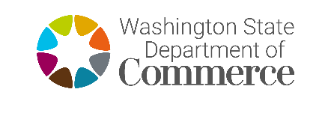 | Energy Division  42.52 RCW Compliance Certification

Applicant Name:

Project Name:
42.52 RCW Compliance Certification

Pursuant to Chapter 42.52 RCW, the Ethics in Public Service Act, any current (or within the past 24 months) employees or governing board members who are, who have been employed by the State of Washington, must be indicated below. Include the name, job title, and separation date, if any.

☐ Currently, or within the past 24 months, there are/have been no employees or governing board members who were employed by the State of Washington.

☐ Currently, or within the past 24 months, there are/have been the following employees or governing board members who were employed by the State of Washington.

☐ Currently, or within the past 24 months, there are/have been no conflict or bias with an existing program employee.

Name: ____________________________ Title:__________________ Separation Date:_______

Name: ____________________________ Title:__________________ Separation Date:_______

If a determination is made that a conflict of interest exists, or that requested information was withheld, I understand my organization may be disqualified for further consideration for award of funding.

On behalf of <<Organization Name>>, I certify that this organization complies with 42.52 RCW, the Ethics in Public Service Act.

Signature Date
Print Name Title

