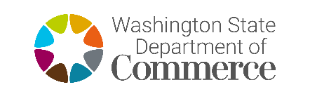 | Clean Energy Fund 4  CEF RD&D Program  Certification of Organization Official

Project Title

Project Budget
$
CERTIFICATION OF ORGANIZATION OFFICIAL

I certify, on behalf of (Organization name) that (Organization name) will adhere to all Federal,
State, and local laws and regulations that are applicable to the Clean Energy Fund 4
RD&D Program. I will also ensure adherence to the operations of (Organization name) and the scope of the proposed project.

(Organization Name) has all necessary, current business licenses and regulatory approvals required in the state of Washington, including but not limited to current registration status with the Secretary of State and Department of Revenue.

I have read the OFM Finance Guidelines and will adhere to state prevailing wage laws, as applicable.

The project proposed in this application could not go forward at the scale or on the schedule proposed without the requested funding. (Organization name) will use any funds received under this request, to supplement, not to supplant, other funds.

(Organization Name) certifies it is not using any other state funds as part of this project.

Signature Date
Print Name Title

