CDBG INCOME SURVEY GUIDE

A Step-By-Step Survey Process for Determining Income Levels and
Assessing Needs of Low- And Moderate-Income Persons

Introduction
This guide outlines a step-by-step survey process for determining income levels and assessing the needs of low- and moderate-income (LMI) persons. It is to be used by local officials, staff, and volunteers working for jurisdictions eligible to apply for funding through the Community Development Block Grant (CDBG) Program. It contains instructions necessary for a jurisdiction to develop, administer, and document a statistically-valid income survey and to determine if a service area or target population will meet CDBG Program requirements related to LMI benefits. It also contains instructions for conducting a community needs survey as a separate process, or in tandem with an income survey. Use the Documentation of Income Survey Methodology Followed (Attachment 3) to assist in completion of the Twelve Steps for Conducting a Survey included in this guide. The most current version of the Income Limits must be used and can be found, along with this guide, under “Guidance Materials” at www.commerce.wa.gov/cdbg.

Area Benefit projects
An income survey is required of any applicant submitting a project proposal that provides area benefit, unless US Department of Housing and Urban Development (HUD)’s latest LMI data already show at least 51 percent of the service area population meets the LMI criteria. The survey determines the percentage of LMI persons in the community. The minimum percentage of LMI benefit required of an area benefit project is 51 percent.

An income survey conducted since January 2016 may be used to meet this requirement if the applicant can demonstrate the survey results are still current and representative of the community. This may be accomplished by documenting that population size, demographics, unemployment rate, and employment has remained nearly the same since the survey. Sources of documentation include: hospitals, realtors, local employers, the Office of Financial Management, and/or the Department of Employment Security.

Direct Benefit projects
A community proposing a project that provides direct benefits to persons or households who are individually qualified on the basis of income prior to receiving the benefit is not required to conduct an income survey. Instead, the LMI benefit requirement is met by the type of activities and services proposed and the commitment on the part of the applicant to screen beneficiaries for income eligibility prior to delivering the service.

NOTE: Jurisdictions seeking funds from multiple funders can use the IACC Income Survey Guide that will satisfy CDBG, PWTF, Ecology, DOH, and USDA RD income survey requirements. Go to the IACC website: www.infrafunding.wa.gov, or the CDBG website: www.commerce.wa.gov/cdbg to download the IACC Income Survey Guide.

CDBG Income Survey Guide -- Recent updates
This guide was updated to improve compliance with HUD guidance and also align with changes in the IACC Income Survey Guide. This page offers highlights of important changes.
- The new HUD 2019 LMI Data was recently published. A number of communities were impacted by the change in LMI status.
- Both the Confidence Level and Margin of Error have changed for the CDBG Survey Guide (only).
- New Confidence Level = 90% (formerly 95%)
- New Margin of Error = variable with 10% maximum (formerly 5%)
- These changes will significantly reduce the required sample size and total survey effort for determining LMI percentage under the new CDBG guidelines. A response rate of 80 percent or better is still required for a valid survey.
- These values remain unchanged for the IACC Survey Guide.
Definitions

A. Low- and Moderate-Income (LMI) Persons
For the purposes of evaluating and rating CDBG applications, a “LMI person” is defined as persons whose household income is no more than 80 percent of the median household income for the county. These income levels are updated annually, and available on the WA State CDBG website.

B. Area Benefit Project
Benefits provided to LMI persons by a CDBG project may be either area or direct. Area benefit activities meet the identified needs of all households within a clearly defined service area or jurisdiction, and at least 51 percent of the persons meet the LMI criteria. Development of a park or construction of a municipal sewage treatment plant to benefit a community or neighborhood with a high percentage of LMI persons are examples of projects that provide area benefits. Any applicant submitting a project proposal that provides area benefit may either use HUD’s LMI data or conduct an income survey following this guide.

C. Direct Benefit Project
Direct benefit activities clearly focus on benefiting LMI persons or members of eligible special groups rather than all residents of a particular area. A housing rehabilitation project providing loans to LMI homeowners, or a daycare facility that serves exclusively LMI families are examples of direct benefit activities.
D. Area or Universe
The universe is the total number of people/households within the entire benefit area to be served by the project or activity. A portion of the entire benefit area with a heavy concentration of LMI households cannot be singled out as a target area.

- Random Sampling Survey
This guidance assumes a random sampling survey will be done. A random sampling survey uses a subset of the population chosen on a random basis to make assumptions about the whole population. A random sample-type survey is when less than 100 percent of the households in the service area or universe are asked to participate in the survey, based on an appropriate sample size and random sampling process. A sample size is a number of households that have been randomly selected from an area and the sample is selected before the survey is conducted. Random selection of an adequate-sized sample ensures that it is representative of the area from which it has been drawn.

The following procedure is NOT a method for ensuring randomness: Surveying all residents and taking the first number of respondents that meet the minimum sample size needs. The random sample list (plus the oversampling list) must be drawn-up BEFORE the surveys are sent out. The minimum response rate to be considered a valid survey remains at 80%.

F. Total Household Income
Total Household Income is all taxable and nontaxable income earned by all members of the household (whether related or not) for the latest tax year (example: a survey in 2020 would be for tax year 2019). Income includes (but is not limited to) wages, business, retirement, supplemental security, public assistance, disability, unemployment and investment income, VA payments, alimony and so forth. Income received by children under the age of 15 for work such as baby sitting, paper routes, or lawn mowing does not need to be included.

- Household
Household means all persons who occupy a housing unit. A household may consist of persons living together or any other group of related or unrelated persons who share living arrangements, regardless of actual or perceived sexual orientation, gender, identity, or marital status.

TWELVE STEPS FOR CONDUCTING A SURVEY

STEP ONE - APPOINT A SURVEY COORDINATOR
The first step of a survey process is to appoint a Survey Coordinator to lead the process and provide oversight through all steps from beginning to end. Surveys typically take planning, coordination, and effort over a period ranging from several days to several months depending on the size of the population or target area to be surveyed. The Coordinator must contact the funding agency before conducting the survey to ensure the survey method is acceptable and then after the survey to confirm the effort yields statistically valid results.

An applicant community has several options to select and appoint a Survey Coordinator. It may be possible to use an existing member of the jurisdiction’s administrative, planning, community development, or public works department staff. It may also be possible to recruit a volunteer to serve as the coordinator. In some cases, a community may choose to hire a consultant to oversee and conduct the survey process, although the steps outlined in this guidebook are designed for people who have no prior survey expertise. Many communities have used resources available to them through local community colleges and universities. Some instructors and professors will take on a community survey as part of their planning or social services curriculum. What is important at this stage is: to obtain a commitment from the person selected to see the process through; to be clear about expectations of the job; and to establish effective communication channels with local elected officials.

STEP TWO - DEFINE SURVEY AREA OR UNIVERSE
This step of the survey process is designed to yield a definition of the survey area or universe. Completion of this step is dependent on identifying: the goal or goals of the survey; the physical boundaries of the geographic area to be surveyed or the characteristics of the total population to be surveyed; and the households that exist within the defined geographic area or meet the demographic characteristics of the target population.

A. Identify goals of the survey process.
Each applicant must choose from among at least three possible survey goals:
1) Determine incomes of a community, service area, or target population,
2) Determine community development and housing needs of a community, or
3) Determine incomes and needs of a community.

If the goal is to determine incomes of a community, service area, or target population, the process will unfold as an income survey. This is an appropriate choice if the community is attempting to demonstrate the benefiting area is primarily low- and moderate-income, in order to apply for CDBG funding.

If the goal is to determine community development and housing needs, the process will unfold as a need survey. This is an appropriate choice if the priority needs and service areas have not yet been identified.

If the goal of the survey is to assess the housing and community development needs of the community while at the same time determining incomes of residents community-wide, a combined income and needs survey process will be necessary. This is an appropriate choice if priority needs and incomes are not known and the community intends to conduct only one survey. To accomplish a combined survey, care must be taken to build in indicators that allow breaking results into subgroups to allow analysis under each type of need. Color-coding surveys from different subgroups is one method to distinguish survey results.

B. Identify geographic boundaries or population characteristics of the survey area or universe.
The geographic boundaries or populations that define the survey universe will vary depending on the goals of the survey process. When priority needs and activities have been identified and an income survey is planned to determine area benefit, the proposed activities determine the geographic area or characteristics of the population that should be included in the survey universe. For example, if the priority activity is a senior center, it follows that the survey universe should include all residents of the community who are senior citizens (age 62 or older.) If the priority need is water system improvements that will exclusively benefit a specific neighborhood, then the survey universe should include the entire geographic area of the neighborhood. If the priority need is a sewer system that will benefit the entire jurisdiction, then the geographic boundaries of the survey universe should include the entire jurisdiction. In this case, the survey universe must conform to geographic boundaries of the service area, or the unique characteristics of the population that will receive services.

C. Identify households within the survey area or universe.
To complete the process of defining the survey universe, all households in the community, service area or target population must be identified. A method for identifying the households (and the site addresses) within a universe must be developed in order to draw a sample group. Ideally a list of each household address in the survey area or universe is already available. Devise a procedure to randomly select households to be interviewed, and document the procedure. If a list is not already available, the following resources may be useful for identifying all households in the survey universe:

1. City indexes, if available and up-to-date, usually provide the best source of household information suitable for selecting samples.
2. Reverse directories are potential sources for obtaining sampling information. They help to eliminate households that are located outside a service area.
3. Online telephone directories are also a potential source for obtaining sampling information. However, people without telephones or those who have unlisted numbers would be excluded from a sample, unless additional tools are used.
Note on use of cell phone numbers for survey sampling: The geographic information derived from cell phone numbers is subject to a great deal of error, with the size of the error increasing as the geographic unit for analysis gets smaller. At the county level of analysis the sample zip code-derived values do not match for nearly 4 in 10 cell respondents. Because of this, surveyors wishing to conduct household analysis should explore other alternatives.
- Tax rolls are another potential source of addresses. The limitation of tax rolls is that they identify only property owners, not the residents. Since property owners and residents may not be the same, additional research will be necessary. Also, tax rolls identify only building addresses, not specific household addresses. For instance, apartment buildings will be listed by address while individual apartments within the building need to be identified for sampling purposes. Tax rolls identify locations for interviews, but cannot be used as the basis of a mail or telephone survey unless a reverse directory is used.
- Consideration must be given to multiple unit residences, such as apartment buildings, which may have only one billing address but represent several households to be surveyed.
- Exclude commercial (retail/industrial) businesses, abandoned homes, vacant lots, and part-time residences (occupied less than half the year). Do not count these addresses as households/individuals in the survey universe. See page 11 for more information about resident status.

If the survey universe is smaller than the entire jurisdiction, then the service area households or target population households will need to be extracted from the above sources based on addresses. If the survey universe is a target population, it is also often possible to involve other service providers in identifying the number and location of households. In some cases, if the survey universe is a target neighborhood, it is possible to actually walk through the neighborhood and inventory all households.

When planning a combined income and needs survey, it is useful to identify households by neighborhood.

STEP THREE - DEVELOP LIST OF HOUSEHOLDS TO SURVEY

Follow the process below to select a survey sample of households within the survey universe. To complete this step, it is necessary to: determine the appropriate sample size; establish a process to replace unreachable and other non-response households; and draw the survey sample.

A. Determine sample size needed to generate the minimum number of required responses.
The next step is to determine the sample size needed to generate the minimum number of responses required for the income survey. If the minimum number of responses is not obtained, the survey will not be considered valid.

Use the free Survey Monkey sample size calculator (SSC) tool available online at Surveymonkey to determine the minimum randomized sample size needed for reasonably reliable and valid results.

To use the calculator tool you must:
- Enter the population size (number of households in the service area)
- Select a Confidence Level of 90%
- Set the Margin of Error (up to 10%, see below)
- Then click “Calculate” and the tool will give you the Sample Size

Figure 1
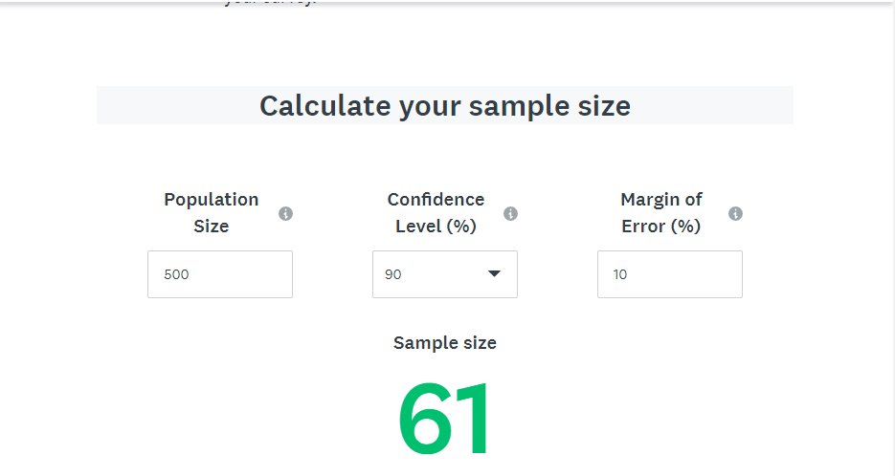

The margin of error (MOE) is also called the confidence interval. It tells you how sure you can be. It is expressed as a percentage and represents how often the true percentage of the population who would pick an answer falls within the confidence interval.

HUD has established an MOE for each community in Washington, based on the current ACS survey data. Some communities have an MOE of close to 50%, some as low as 2/10 of a percent. It is important to check the MOE for the community in question since this will determine the MOE you use for your sample size. HUD has instructed that in establishing the sample size MOE, you must use the lesser of:
(a) The HUD-established MOE for the community, or
(b) 10%

Information regarding how the MOE is used can be found here: CPD Notice 19-02. The actual table for finding a community’s MOE is located here: ACS 2011-2015 Low-Mod Margin of Error for Places or on the CDBG website. This is an Excel spreadsheet with a complete set of national data so you will need to filter by state 51 (Washington) to locate all Washington communities and their respective MOE’s. The exact column in the table that references the MOE is called: moe_lowmod_pct.

In the example shown above (Figure-1), the fictitious community’s HUD-established MOE happens to be 12%. That means they are allowed to use the maximum 10% as an MOE. The resulting required minimum sample size for this community is 60 responses. You can over-sample by a maximum of 20%, or 12 residences in this case (60 x 20% = 12). Always round down to stay within the 20% maximum. The maximum number of surveys to include in this sample is 72 (60 required minimum + 12 replacements). See the following page for more about oversampling.
Note: Under the current IACC guide the Figure-1 survey would result as follows:
Population Size = 500
Confidence Level = 95%
Margin of Error = 5%
Sample Size = 218 (vs. 60 for CDBG)

A note of caution in using higher MOEs. The smaller the total sample size the greater the likelihood that you may not reach the required 20% response rate even with proper oversampling, thus invalidating the survey.

B. Establish a process to replace unreachable and other non-response households within the sample.

You need to have a plan to deal with non-responsive households. Some households will not be home during the periods set aside for interviewing, some will refuse to be interviewed, some will terminate the interview before it is completed, and some will complete the interview but fail to provide an answer to the key question on income level. To be considered a completed interview for CDBG purposes, the interview must include complete and accurate information on the respondent’s household size and income level.

The minimum sample size found by using the Sample Size Calculator represents the number of interviews to be completed, not necessarily the number of households to be contacted. You may need to over-sample to reach the required minimum response rate.

Over-sampling is one way to deal with unreachable households, unoccupied homes and other non-response situations. There is a limit to how many households can be in your over-sampling (replacements) list, in order to avoid it becoming a 100 percent Census-type of survey. The limit is 20 percent of the sample size needed. You cannot go over this 20 percent limit. Using the same example of 60 interviews as the target (Figure 1), you can over-sample by as much as 12 more households (20% of 60).

If you choose to get responses from replacements (the over-sample group), they must be selected through a random sampling process. The replacements can be surveyed at the same time as the original survey group, but only counted if/when needed, or you can wait to survey them later if/when needed.

In Figure 1, the oversample would be households numbered 61 through 72. The first non-respondent household would be replaced by the 61st household on the replacements list; the second non-respondent household would be replaced by the 62nd household on the replacements list, and so on.

Even with over-sampling, and surveying up to 72 households, experience indicates you can expect to get a response from only about 50 percent doing an all-mail survey, so you might have to reconsider your strategy and plan to do a door-to-door survey as a follow-up to the all-mail survey.

You must keep specific documentation of the strategies used, surveys distributed, the responses, the follow-up attempts, the replacement households used, and where they fell on the random selection list.

C. Draw Samples.
Every household in the survey area needs to have an equal chance of being included in the sample. To ensure an equal chance, a random sample may be drawn using a random numbers table or Microsoft Excel Random Number Generator or Sampling Analysis tool.

It is advisable to over-sample when unreachable households and other non-response situations are encountered. They may be replaced with households in the over-sample list in the order replacements were randomly selected. For example, if a list of 500 households is drawn in an effort to obtain a sample size of 60 interviews, the first household written off as “unreachable” should be replaced by the 61st household on the sample list.

Better survey results will be obtained if households are not too quickly written off as unreachable. Randomness is most certain if interviews are conducted from the households first selected. Thus, if a door-to-door survey is being conducted, two or more passes through the area (at different times) should be attempted. With a telephone survey, attempt three calls before replacing a household. Track these attempts to document your efforts to reach everyone in the sample.

STEP FOUR - SELECT SURVEY METHOD
Those conducting the survey should decide which survey method or combination of survey methods is best for the community, considering the number of people available to assist, the size of the sample needed, and the means available for identifying households to interview. Any survey method selected should provide a means for households with limited English proficiency (LEP) to respond to the survey. Please refer to the Department of Justice website http://www.justice.gov/crt/lep/resources/resources.html or from 65 CFR 50123 for the specifics of this requirement.

A. A telephone survey is relatively easy to conduct. The interviewer places a telephone call to a previously determined household, introduces himself/herself, identifies the head of the household or a knowledgeable person, proceeds with the interview, and accurately records the answers. However, the steps that must be taken before making telephone calls may prove difficult. In a telephone survey, the telephone numbers of all the households in the service area must be obtained, and a method for contacting households without telephones or those with unlisted numbers must be devised. A reverse directory, listing telephone numbers by addresses, is helpful especially if a sample of the total population is used or survey boundaries are defined.

B. A door-to-door survey takes more time to conduct because of the “leg work” needed to obtain interviews. First, the interviewer should introduce himself, then make contact with someone who is qualified to speak for the household (i.e., head of household, spouse of the head of household, or someone in the household who is mature and knowledgeable about household income.) Next, the interviewer identifies the purpose of the survey, solicits participation from the respondent, and accurately records the answers.

Small communities often use a door-to-door survey because the service area is easily defined. By developing procedures for sampling within the service area, a list of all households within the service area is not needed beforehand.

C. A mail survey may be the easiest to conduct, but often yields a low rate of response, which means a low degree of accuracy. To conduct a mail survey, the community needs a list of all the addresses in the service area; a questionnaire; stamped, self-addressed return envelope; and postage. Also, provisions must be made to provide non-English-speaking residents with a questionnaire in their own language. Consideration must be given to multiple unit residences, such as apartment buildings, which may have only one billing address but represent several households to be surveyed. With mail surveys, at least one follow-up letter or telephone call may be needed to produce the required number of responses.

D. A combination survey may be advisable in some situations. For example, when no one is home to answer a door-to-door survey, a note may be left requesting that the occupants telephone the interviewer. Similarly, the interviewer may telephone a household to schedule an interview time. A letter may be mailed to residents of the target area informing them of the date a survey will occur and a time an interviewer(s) will be in the area.

STEP FIVE - DEVELOP SURVEY QUESTIONNAIRE
Consistent and accurate responses are more likely to be obtained when questionnaires include a standard introduction explaining the purpose of the survey and ensuring that the respondents’ answers will be kept confidential. A procedure to maintain this confidentiality needs to be established. If the respondent’s name, address, and telephone number appear only on a cover sheet, it can be thrown away or separated from the questionnaire after the survey is completed. What is important is that people will not be able to pick up a questionnaire and identify a specific household.

The same set of questions must be asked in each interview. Questionnaires that contain clearly written questions are more likely to elicit consistent and accurate responses. An additional factor to consider when designing a questionnaire is they cannot be biased or structured to favor one response over another. For example, the questions must not imply that the neighborhood will benefit or receive federal funding if respondents say they have low incomes. However, it is permissible to disclose that the survey is being conducted to gather essential information to support an application for funding under the CDBG Program.

Ideally, questions to determine household income levels and questions related to community development plan priorities are combined into the same survey instrument. Of course, a questionnaire may be designed to ask only the critical questions about income, or only questions about needs. The questionnaire should be long enough to gather needed information, yet brief enough to hold the respondent’s attention. It is advised to test a draft questionnaire to identify questions that are unclear.

A. Income Questions - The purpose of income questions is to determine whether the household being surveyed has an income above or below the LMI limit. Therefore, income questions must provide accurate information for both household size and household income.

Since questions about income are personal, people are often reluctant to answer them. This is especially true if the reason for the question is not understood. One way to handle this problem is to structure the interview process to first explain why income information is needed, and then to ask the two essential income questions: 1) How many people live in your home? and 2) What is the total income of all members of your household? . . .or . . . Are you above or below X? (where X is the appropriate 80 percent MHI level for that county, for that household size). If the service area covers more than one county, you may need to create more than one questionnaire using the appropriate income limits for each county. Use the sample questionnaire (Attachment 1) as a guide when developing the questionnaire, and use the Income Limit tables in the application handbook to develop your questions. The latest County Income Limits can also be found on the CDBG website: www.commerce.wa.gov/cdbg, under Guidance Materials.

When conducting a telephone survey, the interviewer should refer to the Income Limits, ask the size of the household, then ask, “During the past 12 months, was the total income of your household less than or more than (the income amount listed for a family of that size)?”

When conducting a door-to-door survey, the interviewer should carry a set of income cards. Each card should have the income limit for each size of household. (See Figure 2 for an illustration of how to design income cards.) The interviewer finds the appropriate card for the household, hands it to the respondent, and asks “Would you tell me whether, during the past twelve months, the total income of all members of your household was above or below the figure noted on this card?”

Figure 2
This is only an example. Be sure to customize your cards with the appropriate income levels for the county being surveyed.
Illustration of Income Cards

Persons in Household | County’s Income Level
1 | $31,750
2 | $36,250
3 | $40,800
4 | $45,300
5 | $48,950
6 | $52,550
7 | $56,200
8 | $59,800

When conducting a mail survey, a clearly written, unbiased questionnaire that includes the two questions about income and household size should be developed. (See Attachment 1, Sample CDBG Income and Community Needs Questionnaire).

B. Questions on Residence Status
Seasonal residents (such as vacation homes or rentals) should be included in the income survey if the CDBG-funded activity is for water or sewer services that are provided to the residence year-round. Other part-time residences (homes occupied less than 6 months of a year) may be excluded from the survey, unless the cumulative part-time residences account for more than 25 percent of the project’s service area. An exception would be someone who is home less than 6-months of the year, but considers it his/her primary residence. You would include them in the survey, if you can reach them.
In order to assess the impact of seasonal residents, you may want to include a question on your survey questionnaire about their residence status. (See Attachment 1, Sample CDBG Income and Community Needs Questionnaire).
- Questions On Community Need and Other Data
The community needs survey is a tool which communities may use when designing a citizen participation process to identify perceived priority needs of the general community and needs of LMI persons.

Additionally, questions concerning needs allow representatives of a local unit of government to compare their own priorities with those of the community’s residents. Differences in priorities may signify a need for educating the community or for redefining community priorities. For example, a community may have a severe problem with the sewage system, but the survey response indicates the community development priority of the general population, including LMI persons, is a park. In this case local government officials and staff may need to educate the community about the sewage system need, so a project agreement can be reached.

Needs questions may be developed in many different ways. Two common formats are described below:

- Develop a list of potential community development needs and ask the respondent to rank them in priority order.
- Ask the respondent to prioritize three or four community projects that should be addressed if funds were to become available.

While there is no “right” or “wrong” format, it should fit the type of survey that will be conducted. Do not, for example, ask a respondent to prioritize a long list of possible community development needs during a door-to-door survey. This may be too time-consuming and confusing. A shorter and less confusing approach when conducting a door-to-door survey might be to ask open-ended questions concerning community development needs.

No matter how questions concerning need are formatted, special care should be taken to ensure that the questions are not “loaded” or biased so that respondents will answer in a particular way. If a list will be used, it should include the same number of possible responses in all categories. While examples are valuable for clarification, they might encourage the respondent to target a particular need they might not previously have considered.

STEP SIX - PUBLICIZE SURVEY PROCESS
To promote citizen participation, it may be worthwhile to provide advance notice of the upcoming income survey. A notice in a local newspaper or announcements at churches or civic organizations can let people know that a survey will be conducted to determine the income levels of the area. People will be more likely to cooperate if they know in advance how, why and when the survey will be conducted.

As with all aspects of the survey and questionnaire, any publicity must be worded so that it does not bias the results. For example, it is better to say that the community is applying for funding assistance and that, as part of the application, the community has to provide current estimates of the incomes of the residents of the service area. It is not appropriate to say that, in order for the community to receive the desired funding, a survey must be conducted to show that most of the residents of the service area have low incomes.

STEP SEVEN - RECRUIT AND TRAIN SURVEY STAFF

A. Recruit staff
It is not necessary to go to great expense to hire professional interviewers. Persons from local community groups may volunteer, or colleges that offer courses on civics, public policy, or survey research may be willing to assist as a means of providing their students with practical experience and credit.

It is best to choose interviewers who can make respondents feel comfortable, who will hold the attention of the respondent, ask the questions as they are written, follow respondent selection procedures, and accurately record the responses.

B. Train staff
Interviewers should read the questions exactly as they are written. If the respondent does not understand the question or gives an unresponsive answer, the interviewer should repeat the question exactly as written. Questions should be read in the order in which they are written. The respondent’s answers should be recorded neatly and accurately as they are provided. Before proceeding to the next interview, the interviewer should review the questionnaire to be sure that every answer is clear and accurately recorded. This simple check helps to avoid the need to re-contact the respondent for clarification.

For questions concerning income, note that there may be an important exception to reading the questions in the exact order every time. If questions pertaining to issues other than income are included, and questions on income are placed at the end of the survey, a respondent could end the interview before the critical income question is asked. If it appears to the interviewer that the respondent is about to terminate the interview, it is recommended that he or she immediately try to get an answer to the critical income question.

STEP EIGHT - CONDUCT INTERVIEWS
Interviewers should attempt to contact respondents at a time when they are most likely to get a high rate of response. Telephone interviews are conducted early in the evening when most people are home. Door-to-door interviews also may be conducted early in the evening or on weekends. Attempts should be made at different times to reach anyone in the original sample missed by the initial round of interviews.

The interviewer should avoid selecting a time or method that will yield biased results. For example, interviewing only during the day from Monday to Friday probably will miss families where both spouses work. Since these families could have higher incomes than families with only one employed member, such a methodology may lead to biased results.

Remember, interviewers also should follow the set procedures for replacing non-respondents or unreachable households as discussed in Step 3. Once the interview is done, the interviewer must write the sampling number equivalent or a unique identifier on the completed questionnaire. This will serve as the tracking number for the Survey Coordinator.

STEP NINE - EVALUATE QUESTIONNAIRES
Interviewers must return completed surveys to the Survey Coordinator. The coordinator is to ensure that each survey is complete, with household sizes and income information clearly identified. Questions or errors found should be referred to the interviewer for clarification. Incomplete or ambiguous responses can be clarified by re-contacting the respondent. If an error or question cannot be resolved, consider that survey response as invalid and do not include it in the next step. Do not make assumptions about what a survey-taker meant.

As a matter of policy (with the intent to preserve the credibility of the results of the survey), non-respondents are classified as non-LMI persons, when counting them is necessary to reach the required sample size. The decision to get responses from replacements may become inevitable if the proportion of the non-responses is high enough to affect the validity of the survey results. Non-response rates greater than 20 percent make the survey less than credible, as it is not statistically valid to make assumptions about the non-responders when there are too many. If the required minimum response rates (see step 3) are not reached, and the non-response rates are greater than 20 percent (of the sample size), the survey is not valid.

If you have a response rate of 80 percent or better, you can count some of the non-responders as above LMI, if needed to meet the required minimum response rate. If that is the case, you would enter them into your tabulation spreadsheets as “above” for whatever household size represents the average household size for the responses you got.

STEP TEN - TABULATE SURVEY RESULTS
The Survey Coordinator should organize and record survey data on a spreadsheet such as the example below. The tables on this page help translate the data collected by households into data based on individuals.

The image below shows an Excel file you can download from the CDBG website (look under Guidance Materials). The file includes the Tally Sheet (Figure 3), Households to Persons Above and Below Income Limits (Figure 4) and the Income Survey Worksheet (Attachment 2). See tabs at bottom of the file worksheets. There are directions for using this tool on the “Data Input Form – Tally Sheet” as shown.

The Tally Sheet (Figure 3) will feed the Households to Persons table (Figure 4), to calculate LMI results for individuals. Then complete the Income Survey Worksheet (Attachment 2). If you use the Excel file provided, most of this will calculate and populate the data for you.

Figure 3
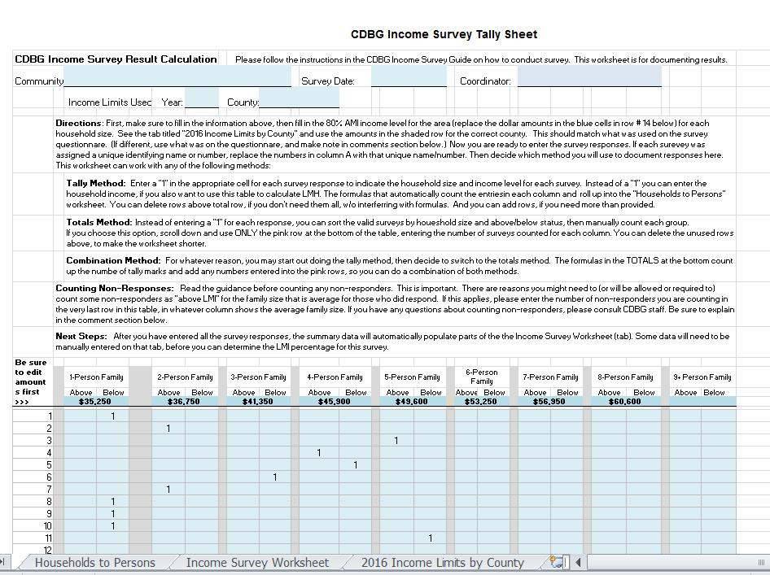

You may use another tabulation system, as long as you can translate your survey results into responses for individuals and complete the Income Survey Worksheet accurately.

.
Figure 4
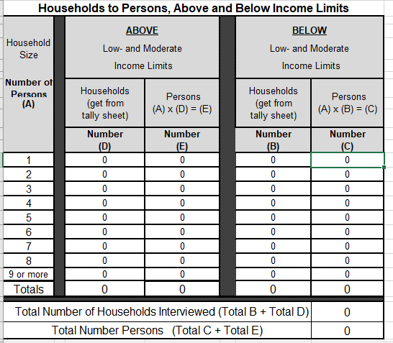

STEP ELEVEN - ANALYZE SURVEY RESULTS & SUBMIT TO CDBG
Surveyors should carefully analyze the survey results and tabulations. An application to fund an activity benefiting everyone in a service area WILL NOT meet the CDBG LMI requirement if less than 51 percent of the service area population has low- and moderate-incomes.

If the survey results and tabulation indicate that between 51 and 60 percent of the service area residents have low- and moderate-incomes, applicants must send Commerce CDBG staff the surveys (originals will be returned) along with the survey method documentation described below. Commerce will review the documents to ensure every survey counted is valid and the tabulations are correct. If the LMI percentage is validated to be under 51 percent, the application will not be considered for CDBG funding.

STEP TWELVE - RETAIN DOCUMENTATION OF SURVEY PROCESS AND RESULTS
Maintain survey documentation consisting of completed questionnaires, a list of respondents, a description of the sampling procedures, and survey tabulations.

A. Retain completed surveys. These serve to document the survey was conducted, the proper questions asked, and that the sample was adequate. If you sent them to Commerce CDBG for review, they will be returned for you to retain with your grant application files.

To maintain confidentiality, save the cover sheets separately from the survey questions. If necessary, they can be matched later for verification.

B. Retain a list of households of the original sample and a list of households actually interviewed. Compile a list of households in the original sample and those households actually interviewed. Note the process used to replace unreachable or other non-respondent households.

C. Retain sampling procedures. Written documentation should describe the method used to select sample households.

D. Retain data. Data may be retained by paper or electronic file.

E. Submit the following to the CDBG program for validation.
- Map of survey area;
- Income Survey Worksheet (Attachment 2);
- Sample of the survey tool, tallying the number of responses by household size;
- Income survey forms (copies are acceptable). If the income survey resulted in a LMI percentage between 51% - 60%, submit survey forms with the application (or before). If the income survey resulted in a LMI percentage above 60 percent, you may submit survey forms before contract execution (if awarded); and
- Written narrative of the survey process, describing how the survey universe was defined and efforts to ensure randomness. Attachment 3 provides an outline of the required survey narrative elements and essential supporting documentation.

Note: To reuse the results of a survey for a future application with the same service area/universe, the applicant jurisdiction must submit all items in E above with their new application and must retain copies of other documents (items A through D above) for their new application file.
Attachment 1

SAMPLE CDBG INCOME AND COMMUNITY NEEDS QUESTIONNAIRE

Instructions to help communities create a survey are in italics. The non-italicized text is sample language to use.

Use the current Income Limits for your county, as provided on the CDBG website at www.commerce.wa.gov/cdbg under Guidance Materials, to find income data to insert into the last column, titled “80% of MHI,” in the table below.

In the “Household Size” column below, circle the number of persons in your household. Then, in that same row, place a check in the box corresponding to whether your household income is above or below the dollar amount listed for your household size.

Household Size | Income Above |  |  | or | Income Below |  | 80% of MHI
1 person: | income is |  | at/above | or |  | below annual income | $
2 persons: | income is |  | at/above | or |  | below annual income | $
3 persons: | income is |  | at/above | or |  | below annual income | $
4 persons: | income is |  | at/above | or |  | below annual income | $
5 persons: | income is |  | at/above | or |  | below annual income | $
6 persons: | income is |  | at/above | or |  | below annual income | $
7 persons: | income is |  | at/above | or |  | below annual income | $
8 persons: | income is |  | at/above | or |  | below annual income | $

Is this residence occupied for at least six months each year? Yes / No
If not, is this your primary residence? Yes / No

The community may want to ask additional questions when the income survey is conducted, to gather additional information. Below are samples of optional questions:

What do you think are the priority needs in your community? Please rank each item (#1 being the highest, and #10 being the lowest) in the following list:

 | Sewer System |  | Water System Improvements
 | Housing Rehab. Projects |  | Increased Fire Protection
 | Park and Rec., School |  | Community Center
 | Senior Center |  | Day Care
 | Streets and Sidewalks |  | Other (please list):

 | I am 62+ years of age |  |  | I am less than 62 years of age
 | I am female and head of household
PRESENT EMPLOYMENT STATUS:
 | Employed |  |  | Part-time Employment
 | Unemployed |  |  | Retired

Comments:

 |  |  |  | Attachment 2
 | Income Survey Worksheet |  |  | Submit with Application
 | For CDBG Projects
The Excel version of this worksheet is available on the CDBG webpage: www.commerce.wa.gov/cdbg under Guidance Materials. The Excel version has formulas that allows user to fill in the blue cells only and the other cells will self-populate using data entered on the Data Input Form. The end result should reflect the correct basis for LMI determination.
 | Applicant Jurisdiction:
 | Survey Coordinator’s Name:
 | Service Area
 | Potential CDBG Project:
 | Fill in data in the blue cells here, and data in the yellow cells will come from the other worksheets, as noted.
 | Submit completed form with CDBG application.
 | Enter population data on the service area on lines 1 & 2 as reported on CDBG application and as affirmed after doing survey.
 | 1 |  | Enter the current estimated total number of households in the service area. Do not count known vacant residences or mainly commercial businesses. This number should match what is reported in your CDBG application.
 | 2 |  | Enter the current estimated total number of persons in the service area. This number should match what is reported in your CDBG application.
 | Data on lines 3 through 7 will self-populate if completing this using the Excel file provided.
 | 3 |  | Enter the total number of valid surveys received. Refer to last line in “Households to Persons” table, “Total Number of Households Interviewed.”
 | 4 |  | Enter the total number of persons in the responding households. Refer to last line in “Households to Persons” table, “Total Number of Persons Interviewed.”
 | 5 |  | Average household size from valid surveys. [Divide line 4 by line 3).
 | 6 |  | Enter the total number of persons living in the low- and moderate-income households interviewed. Refer to total of Column C in the “Households to Persons” table.
 | 7 |  | Resulting LMI percentage: Divide line 6 by line 4. This is the estimated percentage of low- and moderate-income persons living in the service area.

Attachment 3
Documentation of Income Survey Methodology Followed
Applicant Jurisdiction:
Survey Coordinator’s Name/Ph #:
Date of Survey:
Service Area:
Potential CDBG Project:

With your CDBG application, submit a written description of your survey methodology that addresses the following questions. This will help ensure you conduct a survey meeting CDBG requirements.

- Explain goals for survey (incomes, housing needs, prioritize community development, other?).
- Which guide (CDBG or IACC) was used and why?
- What are the geographic boundaries of your service area, and how many households are in it? (maps and brief narrative needed)
- Who performed the survey? How did you train survey takers? Who was the Survey Coordinator?
- How did you publicize the survey? Provide copies of announcements or cover letter used.
- Provide a copy of the survey questionnaire and script used. Make sure you used the most recent Income Limits for your county available.
- What was your survey methodology? (telephone, door-to-door, mail, or a combination of these?) Explain what and why you used that method.
- Document the minimum number of responses required, and explain how you arrived at that number. (Hint: use the Monkey Survey Sample Size Calculator). How many responses did you get.
- Explain how you ensured randomness in selecting households to survey.
- Explain how you handled non-responses, or those who refused to participate. How many did you have? What controls did you use to identify those who didn’t respond?
- Provide a list of addresses of all the households in your service area, as well as the list of those you surveyed. This can be one list, marked or sorted to show randomness, or two separate lists. Label what each list is.
- If you needed to count any of the non-responders as non-LMI to meet your sample size, how many non-responders were counted this way and what percentage of your survey population was that (must be 20% or less).
What’s next? If the income survey resulted in a LMI percentage between 51% - 60% submit the collected survey forms (clear copies), tally sheets and calculations with the application (or before). If you submit the original surveys, we will return them when we’re done with our review. If the income survey resulted in a LMI percentage above 60 percent, you may wait and submit the survey forms before contract execution (if awarded). If results were previously verified by CDBG, please also provide copies of the correspondence from Commerce that documents CDBG validation of your survey results.
Word versions of this guide and the attachments can be found at www.commerce,wa,gov/cdbg under the “Guidance Materials” link.

