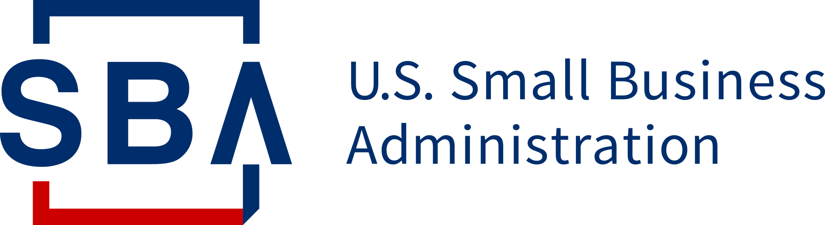

State Trade Expansion Program
Export Voucher Application and Program Guidelines
October 1, 2020 – September 30, 2021
Administered by the Washington State Department of Commerce
Funded through a federal grant from the U.S. Small Business Administration

Table of Contents
Section I – General Information 1
A. Program Overview 1
B. Participant Eligibility 1
C. Export Voucher Application Process 2
D. Eligible Events and Expenses 2
E. Voucher Reimbursement Process 3
Section II – Program Specifics 3
A. Important Program Points 3
B. Regarding Airfare 4
Section III – Confidentiality 4

Section I – General Information

Program Overview
The State of Washington Department of Commerce (Commerce) Small Business Export Assistance Program seeks to increase the number of eligible small business concerns (ESBCs) that export. Commerce administers the Export Voucher program. The program is funded by the U.S. Small Business Administration’s State Trade Expansion Program (STEP) and is used to reimburse eligible ESBCs up to $6,000 for eligible export-related expenses.

Participant Eligibility
Voucher awards are based on funds available, number of applications submitted and the merits of the application, especially regarding projected sales anticipated from the activity. Late, weak or incomplete applications will not be approved. The export voucher application is available here. Qualifying Washington State companies must:
- Be organized or incorporated and operating in the U.S.
- Meet a) the applicable industry-based small business size standard established under section 3 of the Small Business Act; or b) the alternate size standard applicable to the program, under section 7(a) of the Small Business Act and the loan program, under Title V of the Small Business Investment Act of 1958 (15 U.S.C. 695 et seq.) The U.S. Small Business Administration (SBA) size standards are found at 13 C.F.R Part 121. Use this link for information on size standards for your business based on your NAICS code.
- Be in good standing with the Washington State Department of Revenue.
- Have a Federal Identification Number tied to a Washington address.
- Adhere to the following additional program criteria:
(a) have been in business for not less than the 1-year period ending on the date on which the Export Voucher is provided;
(b) demonstrate understanding of the costs associated with exporting and doing business with foreign purchasers;
(c) export goods or services of US origin or have at least 51% US content (ex-factory price of a good minus the aggregate value of foreign sources equals more than 51%);
(d) have in effect a strategic plan for exporting;
(e) demonstrate export readiness; and
(f) be registered with the WA Secretary of State
- Agree to provide information on export sales data resulting from the Export Voucher-supported activity, and respond to all subsequent Commerce surveys on a timely basis. Commerce will send surveys every six months, for up to 4 years. By applying for an export voucher, you are agreeing to respond to these confidential surveys with information on export sales data.

Export Voucher Application Process
- Company reads program guidelines.
- Company applies for a DUNS number (this verifies the existence of your company) and Statewide Vendor Number (this is how state agencies send payments to companies).
- Company submits application at least 1 month in advance of the start of the export activity.
- The Export Voucher Committee (composed of representatives from WA Commerce’s Export Program Managers, EFACW and US Export Assistance Center) meets to review applications and ensure applicants meet program qualifications.
- Applicant is notified of their application status and next steps, if any.
- Awarded company executes proposed activity and incurs expenses. (Past activities are not eligible for an export voucher.)
- Washington State Department of Commerce decisions on Export Voucher awards and reimbursements are final.

Eligible Events and Expenses
Only specific events and expenses are eligible for reimbursement:
Eligible Expenses
- Design of international marketing, digital advertising (voucher reimbursement up to $6000)
- Translation of marketing media, including audio/video (voucher reimbursement up to $6000)
- Website design, maintenance, marketing and international payment handling (voucher reimbursement up to $6,000)
- Online market listing fees (voucher reimbursement up to $6,000)
- E-commerce platform fees (voucher reimbursement up to $6,000)
- Services of the U.S. Commercial Service
- International shipment of product samples (voucher reimbursement up to $4,000)
- Compliance testing of an existing product for entry into an export market (voucher reimbursement up to $6,000)
- Export research tool subscription (voucher reimbursement up to $2,000)
- Cost associated with international IP protection (limited to the following--USPTO PCT transmittal fee [up to $120], filing fee [up to $200], search fee [up to $1040]; Hague Intl Design App transmittal fee [up to $60], Trademark Madrid Protocol fee [up to $250])
- International business travel (airfare only)
- International trade show or trade mission fees (virtual or in-person)
- International conference or symposium fees
- Foreign Market Sales Trips
- Export conferences, meetings, symposiums or training programs: prior approval needed from the U.S. Small Business Administration
Eligible Expenses
- Hotel, meals, in-country transportation, any other export expenses that do not include entertainment or alcohol
- Eligible expenses that exceed the voucher award amount

Voucher Reimbursement Process
After you complete your voucher-supported activity, you will receive an email from the STEP Program Manager requesting:
- Invoices and matching receipts for your reimbursable and cash match expenses.
- Your response to Commerce’s confidential sales survey, which you will receive by email.

Section II – Program Specifics

Important Program Points
- Limit one Export Voucher per program year (10/1/2020 to 9/30/2021); very limited exceptions apply.
- Activity must end by Sep 18, 2021.
- Company must be either “new to export” or “market expansion” – that is, the event/activity must help them to enter a new market or expand where they do not already have significant export sales.
- Applications must be submitted for future shows or eligible export activity.
- Export Voucher reimbursement is limited to 75% of paid eligible expenses, up to $6,000, depending on the export activity.
- STEP Program Manager follows up with the applicant requesting documents within 30 days of the activity (or by September 18, 2021, whichever comes first).
- The company receives an electronic deposit or check in about 3-4 weeks.
- The 25% company cash match may not come from any other federal government source.
- Preference will be given to ESBCs that:
  - Are minority-owned, Native American-owned, veteran-owned, disabled veteran-owned, woman-owned, or rural, socially and economically disadvantaged businesses.
  - Focus on or operate in the aerospace, information communication & technology, life sciences, clean technology or advanced manufacturing industries.
- An Export Voucher may be used to cover travel costs for only one individual, unless the activity is targeted by Commerce, in which case it may be used to cover costs for up to two individuals with prior approval. See this link for a list of events targeted by Commerce.
- Companies awarded a voucher may receive less than the award amount if they do not submit enough eligible or cash match expenses and documentation.
- Vouchers can only be used for the approved activity and approved expenses stated in the award notification. Applicants must notify the STEP Program Manager if unable to complete the activity.
- If you do not submit all the necessary documents within 30 days of the last event date, or by Sep 18, 2021 (whichever comes first), the STEP Program Manager retains the right to revoke your voucher award.
- These terms and conditions are subject to change without notice based on funding availability and changes in federal and state procedures and laws.

Regarding Airfare
The following requirements must be met in order to receive reimbursement for airfare:
- Travelers must comply with the Fly America Act.
- The traveler must use a US carrier when available, or a carrier from a country with a current Open Skies Agreement with the US.
- Boarding passes must be retained and submitted to the STEP Program Manager.
- An email confirmation from the airline stating the itinerary and confirmation of payment must be submitted to the STEP Program Manager.
- Airfare will only be reimbursed for one traveler unless the event is Commerce-supported, in which case prior approval must be received.
- Airfare will be reimbursed for basic economy class. Premium economy is not economy.
- Airfare purchased with frequent flyer miles is ineligible for reimbursement.

Section III – Confidentiality
The financial and commercial information pertaining to or on your application for an Export Voucher will be kept strictly confidential pursuant to RCW 42.56.270. Any information given on an application or subsequent completion report and surveys will only be reported as part of aggregated data from multiple Commerce clients that does not identify any individual responses or companies.

