Contents

Washington State Electricity: Clean, Affordable, Reliable and Equitable 2

Summary of Rulemaking Work 2

Developing a Framework for Equity 3

Equity and the Utility Planning Process 4

Long Term Planning and Equity 4

Context for Equity in CETA 6

Highly Impacted Communities and Vulnerable Populations 6

Indicators 8

Equitable Distribution of Energy and Nonenergy Benefits 9

Public Participation 10

Compliance and Enforcement 11

Appendix A: Materials from February 5, 2020 Joint UTC-COM Workshop 12

Appendix B: Illustrative List of Planning Documents 13

# Washington State Electricity: Clean, Affordable, Reliable and Equitable

The foundational mission of public power is to ensure that the public good of electricity is available to all customers. In the past, this mission has prioritized affordability, universal access, and reliability as the central tenets of fair and just service and in doing so provided service across Washington, especially to rural communities. Consumer-owned utilities have promoted conservation since the 1980s as a least-cost, environmentally friendly resource. In 2006, the Energy Independence Act added a clean mandate to electricity by establishing a renewable portfolio standard for the state. With the passage of the Clean Energy Transformation Act (CETA), electricity in our state now has a new mandate centered on equity. Therefore, all electric power in Washington must now be: **C**lean, **A**ffordable, **R**eliable and **E**quitable. This new mandate is based on the idea that all customers must benefit as we transition our electric power to 100% clean energy. These guidelines will provide some framework and context for how to understand equity as part of CETA.

# Summary of Rulemaking Work

The Department of Commerce convened the first workshop on implementation of the Clean Energy Transformation Act (CETA) in July 2019. Since then, Commerce has held two dozen workshops regarding the implementation of CETA. We are thankful to the stakeholders who have contributed time and comments to this process.

The Utilities and Transportation Commission (UTC) and Commerce are currently in a parallel rulemaking processes covering investor-owned utilities and consumer-owned utilities, respectively. Given the differences in authority between the UTC and Commerce, it makes sense that our rules look different. However, the agencies continue to closely coordinate as we develop our rules, especially as agencies develop best practices and frameworks for this new work on equity.

The development of rules to implement the provisions in RCW 19.405.040(8) has included several workshops and an initial round of draft rules. Commerce and the UTC held a joint workshop on February 5, 2020 to explore the idea of equity in the utility planning process. Materials from this workshop can be found in Appendix A as well as on the Commerce CETA website. UTC also held a workshop on May 22, 2020 to further discuss the broader equity framework in CETA. Most of the figures in this guidance are adopted from those workshop materials. All materials from the UTC workshop can found under docket UE-191023.

Commerce must finalize initial rules by December 31, 2020. For the latest information on comment opportunities and workshop please refer to the Commerce CETA website: www.commerce.wa.gov/ceta.

# Developing a Framework for Equity

While the agencies work to finish rules, there is still much opportunity to develop best practices around equity in the utility planning process for Washington. The work of developing an effective and robust framework for equity in CETA will be an ongoing process that requires many stakeholders at the table.

We provide here for consideration a framework proposed by Front and Centered through public comment, which demonstrates the cyclical and iterative nature of the work in the clean energy implementation plans (CEIP) and translates well to the broader equity work in CETA.



Figure 1 CEIP Equity Framework. Developed for Front and Centered by the Initiative for Energy Justice.

# Equity and the Utility Planning Process

Starting with the intent section (RCW 19.405.010), CETA establishes policy that the public interest includes the “equitable distribution of energy benefits and reduction of burdens to vulnerable populations and highly impacted communities.”

This language is repeated as a requirement under the 2030 Greenhouse Gas Neutral Standard:

In complying with this section, an electric utility must, consistent with the requirements of RCW [**19.280.030**](http://app.leg.wa.gov/RCW/default.aspx?cite=19.280.030) and [**19.405.140**](http://app.leg.wa.gov/RCW/default.aspx?cite=19.405.140), ensure that all customers are benefiting from the transition to clean energy: Through the equitable distribution of energy and nonenergy benefits and reduction of burdens to vulnerable populations and highly impacted communities; long-term and short-term public health and environmental benefits and reduction of costs and risks; and energy security and resiliency. (RCW 19.405.040(8))

RCW 19.405.040(8) (“4(8)”) can be thought of as the core equity provision in CETA. All other equity provisions relate back to 4(8).

## Long Term Planning and Equity

Given the novelty of this work, developing best practices for incorporating equity into utility work will be an iterative process both within and across planning cycles. The specific actions from the previous cycle will inform the direction of work for subsequent cycles. Given these new requirements we expect there to be refinement occurring as conditions change and best practices evolve. However, it will also be important to maintain consistency during a compliance period to track progress using common metrics. Here is a brief summary of how equity touches different parts of the utility planning process. An illustrative list of planning documents for utilities can be found in Appendix B.

|  |  |  |  |
| --- | --- | --- | --- |
| **Document** | **Statute** | **Requirements** | **Notes** |
| Integrated Resource Plan | 19.280.030(1)(j) | Must implement RCW 19.405.030 through RCW 19.405.050, including 4(8) | Utilities that prepare a Resource Plan must also comply with 19.405.030,-040 &-050 |
| Integrated Resource Plan | 19.280.030(1)(k) | An assessment, informed by the cumulative impact analysis ( RCW 19.405.140) of energy and nonenergy benefits and reductions of burdens to vulnerable populations and highly impacted communities; long-term and short-term public health and environmental benefits, costs, and risks; and energy security and risk | Not required for a Resource Plan |
| Clean Energy Action Plan | 19.280.030(1)(l) | A ten-year clean energy action plan for implementing RCW 19.405.030 through 19.405.050, including 4(8) at the lowest reasonable cost, and at an acceptable resource adequacy standard  identify specific actions to be taken by the utility consistent with the long-range integrated resource plan | This is a requirement of an IRP  There is a separate requirement for Resource Plans |
| Ten Year Action Plan | 19.280.939(5)(d) | Starting December 31, 2020 every resource plan must identify how the utility to implement RCW 19.405.040 and 19.405.050, including 4(8), over a ten year period (19.280.030(5)(d)) | This is a requirement of a Resource Plan. |
| Clean Energy Implementation Plan | 19.405.060 | Primary purpose of the CEIP is to meet the standards in RCW 19.405.030 through 19.405.050, including 4(8). | The clean energy implementation plan (CEIP) is the central requirement related to the 4(8) provisions. |

*Note on Low-Income Energy Assistance Programs (RCW 19.405.120): While energy assistance is an important element of equity, it is separate and distinct both in statute and in the implementation process, so it is not within the scope of the 4(8) provisions.*

# Context for Equity in CETA

## Highly Impacted Communities and Vulnerable Populations

The heart of equity work in CETA is about identifying and communicating with communities, specifically “highly impacted communities” and “vulnerable populations”. These two communities are both defined in statute to different degrees.

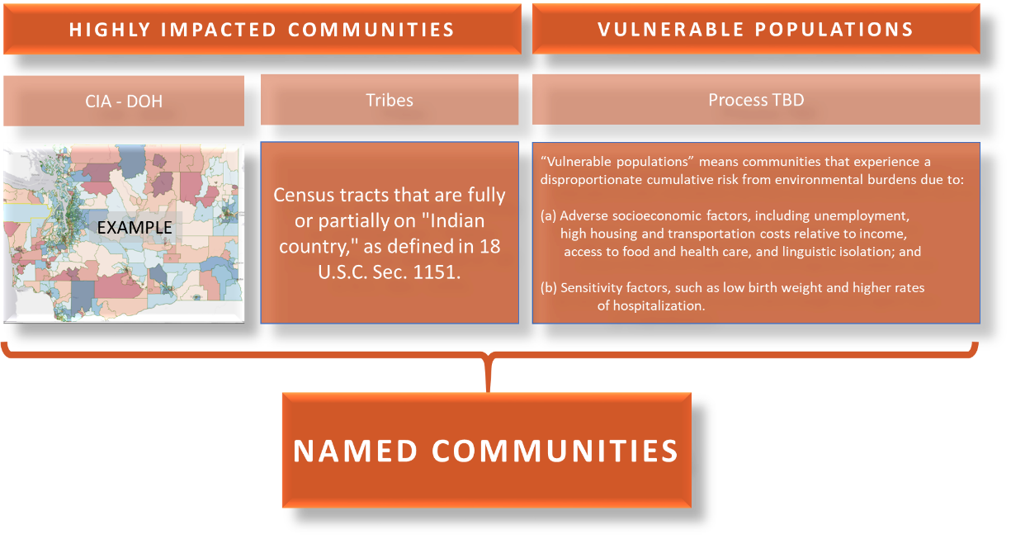

Figure 3 Adopted from UTC May 22, 2020 workshop on equity.

Under the definitions section, the statute provides clear guidance on the determination of highly impacted communities (19.405.020(23)), which are geographic communities. Utilities must use a combination of the cumulative impacts assessment (CIA) developed by the Department of Health (DOH) directed under RCW 19.405.140, which will “designate the communities highly impacted by fossil fuel pollution and climate change in Washington.” Highly impacted communities also includes tribes, which will be identified using census tracts at least partially in Indian Country as defined in 18 U.S.C. Sec. 1151.

The DOH map is still in development with a statutory requirement to be completed by the end of 2020. However, utilities can get a sense for the locational information provided by a CIA by looking at the existing Environmental Health Disparities (EHD) map on the DOH Washington Tracking Network (WTN).[1] The CIA developed under RCW 19.405.140 will be built around the WTN platform:

* The CIA will be at the census tract level where the census tracts are broken into 10 groups or deciles. Each tract will get a score of 1-10 based on the conditions of that census tract and show relative rankings across the state.
* UTC and Commerce will work with DOH to develop a process for utilities to use the map. For example, by establishing a number – like 8 – where all census tracts with an 8 or higher will be designated “highly impacted.”
* DOH may not include a layer for Indian Country census tracts, so that may need to be added separately to designate all highly impacted communities. Commerce will continue to work with utilities and state agencies to develop a workable approach.

An important note about the EHD map, is that the rankings help to compare health and social factors that may contribute to disparities in a community. However, the rankings should not be interpreted as absolute values and should not be used to diagnose a community health issue or assign a negative label a community. Further information on the methodology, definitions and indicators used in the EHD map can be found in DOH publications as well as the website for the map.[2],[3],[4]

The definition for vulnerable populations is a bit different than highly impacted communities (19.405.020(40)) and focuses on demographic communities. CETA does not provide a specific process for identifying vulnerable populations. Instead, it provides two sets of factors for determining vulnerable populations: adverse socioeconomic factors and sensitivities factors.

The statute provides examples of these factors but does not provide an exhaustive list. While highly impacted communities are by definition geographic communities, vulnerable populations are demographic communities. However, there may be a geographic aspect to these communities. For example, if a utility chooses to use “high asthma rates” as a factor, there may be a geographic component to communities with higher asthma rates related to pollution. However, there may be populations that suffer from asthma at higher rates due to other factors not tied to geography. The utility would want to ensure that all members of that population were identified and may turn to a local health agency to help with outreach. In this case, there is not a mapping component involved to identify the community, though there is some element of place-based identity for this group.

To develop these factors for vulnerable populations a utility must both analyze data from their service territory and consult with community members to identify priority factors. The WTN EHD map as a whole, or individual layers, can be a useful tool to start this process by identifying which factors are most important in a service territory. For example, a utility can look at the EHD overall cumulative ranking to identify communities with overall higher environmental health disparities and target communities in the top 20 percent. However, it is important that this be understood as a first step for identifying communities. The development of specific factors should include community expertise.

A utility can also use the individual rankings for a particular layer under the EHD, or within all of the WTN, to understand a specific health, environmental or socioeconomic factors within their territory. A few examples of individual layers are lead risk from housing, transportation expense, and death from cardiovascular disease. These layers are not directly tied to utility service. Rather, the EHD and WTN tools are meant to identify populations that are more vulnerable to inequities and to provide an equity lens in utility decisions. All data on WTN are from publicly available resources and updated on a rolling basis. Further workshops and development around best practices will be an important part of incorporating these tools into the equity work of CETA.

## Indicators

Developing indicators will be a necessary component in CEIP reporting to ensure that all customers are benefitting from the transition to clean energy as directed under the 4(8) provisions.

Utilities should develop indicators related to the provisions in 4(8): Equitable distribution of energy- and non-energy benefits and reductions of burdens to highly impacted communities and vulnerable populations, public health, environment, economics, energy security, and resiliency. For indictors related to equitable distribution, the utilities will need to engage highly impacted communities and vulnerable populations as those benefits are associated specifically with those communities. All customers should be engaged for indicators associated with the other provisions in 4(8).

Indictors may be developed at any point in the utility planning process but will ultimately be adopted as part of the utility’s CEIP. Indicators are the data that utilities will report to Commerce, though Commerce has no authority to modify these indicators. Like the factors to identify vulnerable populations, indicators should remain relatively stable cycle-over-cycle, with changes to the indicators only when conditions warrant. The WTN EHD, utility outage data, and other data tools will be useful for indicator development.

The table in Appendix A provides an illustrative table of utility equity indicators from the joint UTC-Commerce equity workshop on February 5, 2020. This work can provide a jumping off point for indicator development. State agencies will continue to work with all stakeholders on best practices for developing these indictors.

## Equitable Distribution of Energy and Nonenergy Benefits

4(8) directs utilities to ensure “*that all customers are benefiting from the transition to clean energy: Through the equitable distribution of energy and nonenergy benefits.”* While this framework may seem brand new, utilities are already well-equipped to consider multiple factors in utility decision when selecting resources and designing programs. The equitable distribution requirement adds a new lens to those analyses.

The idea of energy and nonenergy benefits and environmental burdens is expansive, and in CETA it relates to utility decisions that impact both highly impacted communities and vulnerable populations. Utility decisions include procuring physical resources, specific actions to achieve CEIP targets, distribution planning, and programs. Utilities will need to forecast the impacts of those planning decisions on both highly impacted communities and vulnerable populations. That analysis will help paint a picture as to how both benefits and burdens are distributed among communities. The policy goal in 4(8) is to ensure that all customers benefit, which may require an unequal allocation of resources to create an equitable distribution.

The UTC includes a definition for equitable distribution in their draft CEIP rules released on May 5, 2020 (and updated in an erratum order on May 6. See docket UE-191023 for most updated draft rules):

“Equitable distribution” means a fair and just, but not necessarily equal, allocation intended to mitigate disparities in benefits and burdens, and based on current conditions, including existing legacy and cumulative impacts, which are informed by the assessment described in RCW 19.280.030(1)(k) from the most recent integrated resource plan.

The analysis of utility resources and the identification of communities also makes up the assessment described in RCW 19.280.030(1)(k). The ten year action plan as part of the RPs also has utilities identify how they will implement the requirements of 4(8). All of these long term planning documents should inform the analysis required in the CEIP.

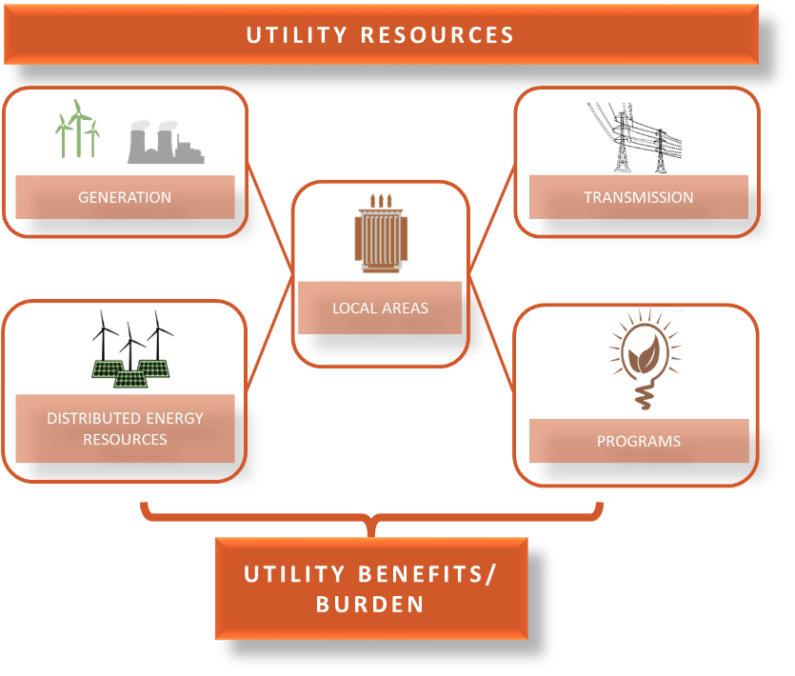

Figure 4 Adopted from UTC May 22, 2020 workshop on equity.

## Public Participation

An important aspect of implementing the 4(8) provisions is robust public engagement. Public participation during the evaluation and development process is necessary to ensuring equitable distribution as required by 4(8). Utilities are already well familiar with public engagement such as considerations of customer input to inform a utility’s choices between reliability and affordability. The 4(8) requirements add a new lens to those public engagement strategies.

The process of developing the reporting requirements in this guidance must begin with robust, equitable, inclusive, and accessible public participation, including the identification of barriers that prevent certain communities and populations from being able to engage in this process. It will be incumbent upon utilities to develop effective and accessible outreach strategies. There are many good resources available that provide frameworks for robust public participation, including the International Association of Public Participation.[5] This group gave a presentation at a UTC workshop on public participation on May 5, 2020. Materials for this workshop, including a recording of the event, can be found under docket UE-191023.

Some questions that utilities can ask of their public participation strategies are:

* Are we reaching highly impacted communities and vulnerable populations?
* Are timelines reasonable for input?
* Is information accessible?
* Are we doing proper consultation with Tribes?

In addition to developing strategies for robust public participation, it will be important to assess the effectiveness of those strategies. For example, outreach is not just holding a public meeting it is also ensuring that everyone has access to that meeting. Effective outreach could include figuring out why no one attends by asking communities, providing language access and advertising through well-used and well-trusted community partners. The utility may also involve stakeholders in developing the timing and extent of meaningful and inclusive public participation throughout the development and duration of planning, including outreach and education to vulnerable populations and highly impacted communities.

As part of reporting for the CEIP, utilities will report a summary of the public input process, including a summary of public comments, used in developing the requirements of specific actions related to equitable transition. The minimum for public participation must include reasonable opportunities for customers and interested stakeholders to provide input to the utility during the development of plans. A reasonable opportunity is one that considers barriers to public participation due to language, cultural, economic or other factors consistent with community needs.

Some content that utilities can include to support a public participation process:

* A proposed schedule of formal and informal public meetings or engagement, including any advisory group meetings;
* A list of significant topics that will be discussed at public meetings;
* Plans to provide information and data in broadly understood terms through meaningful participant education;
* A link to a website accessible to the public and managed by the utility, to which the utility posts and makes publicly available the following information:
  + meeting summaries and materials for all relevant meetings, including materials for future meetings;
  + information on how the public may participate in CEIP development; and
  + final plans, compliance, and progress reports

Public utilities already have several law governing public process, including the Open Public Meetings Act (Chapter 42.30 RCW) and other local ordinances which may serve as the baseline for this work.

# Compliance and Enforcement

For rules established by Commerce to implement CETA, the State Auditor’s Office is responsible for compliance and the Attorney General is responsible for enforcement.

# Appendix A: Materials from February 5, 2020 Joint UTC-COM Workshop

This table is for illustrative purposes only and shows possible indicators that could be used to track equity in different areas of utility work. This table does not show who should benefit and developing these indicators should be supported by robust public participation.

|  |  |  |
| --- | --- | --- |
| **Equity Area** | **Indicator** | **Example/Program** |
| **Access to Clean Energy** | Energy and cost savings for customers in aggregate  Locations and expenditures of existing and planned community energy projects  Participation and attrition rate of programs, locations and monetary benefits received | Energy efficiency and renewable energy programs  Net metering participation  EV charger rebate programs  Low income community solar |
| **Cost Discrimination** | Burden (cost) to program participation  Accessibility to non-single-family homeowners  Amount of investment financed | Expensive or burdensome EE program participation costs  Type of financing (tax credit, on-bill programs)  Inclusive financing |
| **Community Engagement and Participation** | Awareness of programs  Linguistic isolation of participants  Public participation in planning  Geographic or demographic distribution of customer service complaints | Multi-lingual outreach materials  Community based participatory program design  Non-discriminatory customer service |
| **Community Improvement** | Economic development activity  Jobs  Resilient infrastructure  Improved housing stock | Assistance and job training for retiring fossil fuel workers (just transition)  Distribution of microgrids  Reasonable access to essential utility functions during disasters |
| **Health and Safety** | Outdoor air quality  Indoor air quality  Household factors  Reduced fires and accidents caused by energy infrastructure or appliances | Percent of days that PM2.5 did not meet EPA standard  Low income weatherization (target deferrals)  Household health and safety due to issues like tobacco smoke; pet dander; water damage; mold; VOCs and radon; improved airflow |

DRAFT – 02.03.2020

# Appendix B: Illustrative List of Planning Documents

**Illustrative Schedule of Plans and Reports for Small Utilities**

June 2020 Fuel mix report [RCW 19.29A.140]

July 2020 Data submission on energy assistance programs [RCW 19.405.120(3)]

Sept 2020 Resource plan for next 10 years [RCW 19.280.030]

Dec 2020 CETA 10-year action plan [RCW 19.280.030(5)(d)]

June 2021 Fuel mix report, with GHG emissions [RCW 19.29A.140, 19.405.070]

July 2021 Energy assistance compliance and assessment reports

* + - Availability of energy assistance programs for low-income households [RCW 19.405.120(2)]
    - Assessment of programs, outreach, cumulative funding [RCW 19.405.120(4)]

Jan 2022 CETA clean energy implementation plan, 2022-2025 [RCW 19.405.060(2)]

* + - Interim targets toward GHG neutral standard
    - Specific targets for energy efficiency, demand response, renewable energy
    - Identifies specific actions to demonstrate progress, including equitable distribution
    - Public involvement results

June 2022 Fuel mix report, with GHG emissions [RCW 19.29A.140, 19.405.070]

July 2022 Data submission on energy assistance programs [RCW 19.405.120(3)]

Sept 2022 Resource plan for next 10 years, with CETA 10-year action plan [RCW 19.280.030]

June 2023 Fuel mix report, with GHG emissions [RCW 19.29A.140, 19.405.070]

July 2023 Assessment report on energy assistance programs [RCW 19.405.120(4)]

June 2024 Fuel mix report, with GHG emissions [RCW 19.29A.140, 19.405.070]

July 2024 Data submission on energy assistance programs [RCW 19.405.120(3)]

Sept 2024 Resource plan for next 10 years, with CETA 10-year action plan [RCW 19.280.030]

June 2025 Fuel mix report, with GHG emissions [RCW 19.29A.140, 19.405.070]

July 2025 Assessment report on energy assistance programs [RCW 19.405.120(4)]

Jan 2026 CETA clean energy implementation plan, 2026-2029 [RCW 19.405.060(2)]

* + - Interim targets toward GHG neutral standard
    - Specific targets for energy efficiency, demand response, renewable energy
    - Identifies specific actions to demonstrate progress, including equitable distribution
    - Public involvement results

June 2026 Fuel mix report, with GHG emissions [RCW 19.29A.140, 19.405.070]

July 2026 CETA interim compliance report for 2022-2025 period [RCW 19.405.100(4)]

* + - Use of renewable and non-emitting resources
    - Achievement on targets for energy efficiency, demand response, renewable energy
    - Progress toward 2030 GHG standard, including equitable distribution
    - Use of alternative compliance options or 2% incremental cost mechanism

July 2026 Data submission on energy assistance programs [RCW 19.405.120(3)]

Sept 2026 Resource plan for next 10 years, with CETA 10-year action plan [RCW 19.280.030]

1. <https://www.doh.wa.gov/DataandStatisticalReports/WashingtonTrackingNetworkWTN/InformationbyLocation/WashingtonEnvironmentalHealthDisparitiesMap>
2. <https://deohs.washington.edu/sites/default/files/images/Washington_Environmental_Health_Disparities_Map.pdf>
3. Min, E., Gruen, D., Banerjee, D., Echeverria, T., Freelander, L., Schmeltz, M., & Seto, E. Y. (2019). The Washington state environmental health disparities map: development of a community-responsive cumulative impacts assessment tool. *International journal of environmental research and public health*, *16*(22), 4470.
4. <https://www.doh.wa.gov/DataandStatisticalReports/WashingtonTrackingNetworkWTN/InformationbyLocation/WashingtonEnvironmentalHealthDisparitiesMap>
5. <https://www.iap2.org/mpage/Home>