June 11, 2020
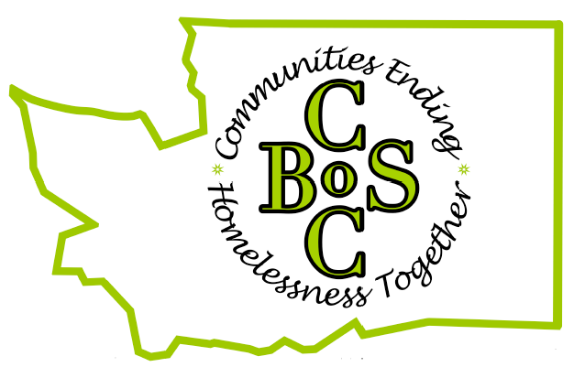

To All Interested Parties:
The Washington Balance of State (BoS) Continuum of Care (CoC) is inviting interested persons to join our CoC and attend our monthly online meetings.
The BoS is comprised of the 34 smallest counties in the state (excluding King, Pierce, Snohomish, Clark and Spokane). The BoS works with 48 Housing and Urban Development-funded projects to coordinate planning, data collection and funding applications. The BoS also discusses strategies to better prevent and end homelessness in our 34 county region.
We want a broad network of individuals to attend our monthly online meetings to help our efforts to prevent and end homelessness. If you are interested in joining or have any questions, please contact Mark Porter mark.porter@commerce.wa.gov

