Background on Rules Development for HB 1257

The Department of Commerce is authorized by HB 1257 to develop rules for the adoption of the Washington State Energy Performance Standard for Commercial Buildings. HB 1257 requires Commerce to use ANSI/ASHRAE/IES standard 100-2018, Energy Efficiency in Existing Buildings (standard) as the basis for these rules. Rules will be implemented that adopt the standard by reference, with amendments.

Amendments to the standard will be made to make the standard consistent with the features prescribed in HB 1257. The standard will also be modified to clarify administrative procedures. Additional rules may be required outside of this standard as well.

The following draft rule has been developed by Commerce staff. Then modifications to the various sections of the standard are made to provide consistency between the rule and HB 1257.

Interested parties are encouraged to review standard 100 and modifications made by Commerce staff. Input can be provided on any element that will align the standard with the legislation or existing state laws, clarify application, or improve administrative procedures.

Stakeholders are invited to participate in workshops scheduled to review specific sections of this work. Commerce request that written post workshop comments relating to sections covered at each workshop be received within by the scheduled time period posted on the Commerce Clean Buildings Web site. All comments will be posted on the buildings web site.

Submit comments via email; buildings@commerce.wa.gov.
Review comments and schedules on the Commerce Clean Buildings web site: http://commerce.wa.gov/buildings
When editing the standard, please use a standard markup format that includes the following:
- Copy the entire sub-section to be edited
- Underline text to be added
- Use cross out text to indicate deletions
- Provide a reason statement for the change
For any new sections, provide suggested location in the document by referencing the previous section.

3. DEFINITIONS

weather normalized: a method for modifying the measured building energy use in a specific weather year to energy use under normal weather conditions

weather normalized energy utilization index (WNEUI): means a measurement that normalizes a building's site energy use relative to its size based on the buildings weather normalized site energy use. A building's energy use intensity is calculated by dividing the total net weather normalized energy consumed in one year by the gross floor area of the building, excluding the parking garage. "weather normalized energy use intensity" is reported as a value of a thousand British thermal units per square foot per year.

4. COMPLIANCE REQUIREMENTS

4.2 Energy Management Plan and Operations and

Maintenance Program
4.2.1 Operations and Maintenance. The building manager shall comply with the operations and maintenance (O&M) requirements of Section 6. The qualified person determining compliance shall state in writing on Form A that the operating and maintenance requirements of Section 6 have been met according to the following subsections.
4.2.1.1 For first-time applicants, for the previous year.
4.2.1.2 For previously compliant buildings, since the previous validation of compliance.
4.2.2 Energy Management Plan. The building manager shall comply with the energy management requirements of Section 5. The qualified person determining compliance shall state in writing on Form A that the energy management program described in Section 5 has been developed and is being maintained as of the date on Form A.

4.4 General
4.4.1 Administrative Requirements. Administrative requirements relating to permits, enforcement by the AHJ, locally adopted energy standards including energy performance targets, interpretations, claims of exemption, and rights of appeal are specified by the AHJ.

4.4.1.* Reporting Schedule: A building owner of a covered commercial building must meet the following reporting schedule for complying with the standard established under this section:
(a) For a building with more than two hundred twenty thousand gross square feet, June 1, 2026;
(b) For a building with more than ninety thousand gross square feet but less than two hundred twenty thousand and one gross square feet, June 1, 2027; and
(c) For a building with more than fifty thousand gross square feet but less than ninety thousand and one square feet, June 1, 2028.

4.4.1.? Reporting Requirements, The building owner of a covered commercial building must report the building owner's compliance with the standard to the department in accordance with the schedule established under section 4.4.1.* of this section and every five years thereafter.
Exceptions: For buildings that meet one of the following exemptions, the building owner shall submit documentation that they qualify for the exception by the reporting date specified in section 4.4.1.*
(i) The building did not have a certificate of occupancy or temporary certificate of occupancy for all twelve months of the calendar year prior to the building owner compliance schedule established under section 4.4.1.*
(ii) The building did not have an average physical occupancy of at least fifty percent throughout the calendar year prior to the building owner compliance schedule established under section 4.4.1.*
(iii) The sum of the buildings gross floor area minus unconditioned and semiconditioned spaces, as defined in the Washington state energy code, is less than fifty thousand square feet;
(iv) The primary use of the building is manufacturing or other industrial purposes, as defined under the following use designations of the international building code:
(A) Factory group F; or
(B) high hazard group H;
(v) The building is an agricultural structure; or
(vi) The building meets at least one of the following conditions of financial hardship:
(A) The building had arrears of property taxes or water or wastewater charges that resulted in the building's inclusion, within the prior two years, on a city's or county's annual tax lien sale list;
(B) the building has a court appointed receiver in control of the asset due to financial distress;
(C) the building is owned by a financial institution through default by a borrower; (D) the building has been acquired by a deed in lieu of foreclosure within the previous twenty-four months;
(E) the building has a senior mortgage subject to a notice of default; or
(F) other conditions of financial hardship identified by the department by rule.

4.4.1.?.1 Energy Management Plan Reporting Requirements: The building owner shall provide a copy of the Energy Management Plan as specified in section 5.1.2 to the AHJ.

5. ENERGY MANAGEMENT PLAN

5.1 Establish the Energy Management Plan
5.1.1 The building owner shall designate an energy manager (EM) to develop and maintain an energy management plan for the building.
Exception to 5.1.1: Buildings smaller than 5000 ft² (465 m²) are not required to have an EM or an energy management plan.
5.1.2 The energy management plan shall incorporate the following.
5.1.2.1 An energy accounting system to record the energy use in accordance with Section 5.2.
5.1.2.2 In the initial year of compliance, the building’s weather normalized energy use intensity (WNEUI) and energy-use intensity (EUI).
5.1.2.3 Annual updates of the net energy use, WNEUI and EUI.
5.1.2.4 Annual comparison of the net WNEUI and EUI to the energy target.
5.1.2.5 Documentation of original, current, and changes in number of occupants, weekly operating hours, or time of day scheduled for occupancy, production rates, and energy using equipment that would have caused change in the measured WNEUI and EUI.

NEW Section: Operations and Maintenance Plan and Implementation Documentation. The energy management plan documentation shall include:
(a) An operations and maintenance (O&M) program as defined in Section 6
(b) An O&M implementation plan as specified in Normative Annex L.
(c) Implementation documentation as specified in L2.2.5 Documentation.

5.1.2.6 Energy audit reports and recommended energy efficiency measures (EEMs). (Refer to Section 8.)
5.1.2.7 A list of EEMs that have been implemented and dates of implementation, including the following:
- An operations and maintenance (O&M) program as defined in Section 6 for the EEMs
- An implementation plan for EEMs, including EEM commissioning
- Staff training plan for EEMs
- Ongoing commissioning plans for the EEMs
5.1.2.8 A method to inform occupants about the benefits of efficient energy use, and to instruct them in the use and adjustment of operable windows, HVAC system controls, and lighting system components and controls. This shall include materials (electronic or printed) as appropriate.
5.1.2.9 A training plan for the O&M personnel to operate the building systems to achieve established indoor environmental targets with optimum energy efficiency.
5.1.2.10 A capital management plan identifying equipment for replacement with energy efficient and ENERGY STAR® rated equipment in case of failure.
5.1.2.11 A contact list of suppliers and manufacturers’ local representatives of energy efficient equipment, qualified energy auditors, the EM, and the building owner.
5.1.2.12 The current lighting schedule and the calculated lighting power density along with the potential savings from any potential EEMs.
5.1.2.13 The current lighting satisfaction survey and lighting checklist as described in Appendix D of Performance Measurement Protocols for Commercial Buildings ¹.
5.1.3 The EM shall provide a copy of the energy management plan to the building occupants and other stakeholders annually.
5.1.4 The building owner shall review and sign the energy management plan annually.

5.2 Building Energy Monitoring. Building net energy use shall be monitored and recorded in accordance with following sections.
5.2.1 Provide measured net energy consumption data for each building, including all forms of imported and exported energy from at least 12 consecutive months of data monitored in a period not to exceed two years prior to the efficiency audit reporting deadline specified in section 4.4.1.*. The net energy concept is illustrated in Figure 5-1 and Table 5-1 and is calculated in accordance with Section 5.2.4 as follows:
Net energy use = (1a + 1b + 1c + 1d) – (3a + 3b + 3c + 3d + 3e)
where 1a, 1b, 1c, and 1d are metered energy supplies that are used in the building (this includes bulk energy sources), and 3a, 3b, 3c, 3d, and 3e are metered energy excesses that are supplied to another building or grid as useful energy.

5.2.2 Procedures for reporting net energy consumption using Energy Star Portfolio Manager. For buildings with building renewable energy generation….. tbd

5.2.2 Energy-use data for each type of energy imported into and exported from the building shall be collected from utility or energy delivery bills (that must include the quantity of energy or fuel delivered) or by monitoring local energy meters (either utility or owner-provided meters). If the exported energy cannot be measured, it shall be estimated using a methodology that is acceptable to the authority having jurisdiction (AHJ).

5.2.2.1 When an energy type such as oil, solid fuels, or biomass is delivered in bulk to the building for storage prior to actual use, the annual energy use for that energy type shall be calculated as follows:
Annual energy use = A + B – C where
- = measured inventory of the energy type at the beginning of the 12 month period, converted to energy equivalent (Refer to Section 5.2.3.)
- = the amount of the energy type delivered to the building during the 12month period, converted to energy equivalent (Refer to Section 5.2.3.)
- = measured inventory of the energy type at the end of the 12 month period, converted to energy equivalent (Refer to Section 5.2.3.)

5.2.2.2 If the annual energy consumption of an inventoried energy type is less than twice its on-site storage capacity, the inventory measurement accuracy and methodology shall be reported as part of the energy accounting system documentation.

5.2.3 Energy Conversion Factors. The site energy content of different forms of purchased energy shall be converted from the purchased unit to the standard site energy unit using the conversation factors incorporated in Energy Star Portfolio Manager. If site energy conversion factors are not provided by Energy Star Portfolio Manager the utility or fuel supplier, the conversion factors in Table 5-2a shall be used. (See also Informative Annex K.)

5.2.4 The energy accounting system shall be Energy Star Portfolio Manager or an alternate as designated by the AHJ. Reporting shall include building description and energy consumption data as specified by the AHJ.
. perform the following.
5.2.4.1 Record annual net energy consumption data for each building, including all forms of purchased energy from at least 12 consecutive months of data.
5.2.4.2 Record total net energy use expressed as Btu/year (MJ/year).
5.2.4.3 Record each nonresidential building’s EUI as follows, as applicable:
- Annual net energy use, MJ/gross floor area for nonresidential buildings, m²
- Annual net energy use, kBtu/gross floor area for nonresidential buildings, ft²
5.2.4.4 Record each residential building’s EUI as follows, as applicable:
- annual net energy use, MJ/gross floor area for residential buildings, m²
- annual net energy use, kBtu/gross floor area for residential buildings, ft²

5.3 Energy Manager. The EM shall be responsible for the following.
5.3.1 Conducting technical, policy-related planning related to energy efficiency.
5.3.2 Purchasing energy for spaces under his or her control.
5.3.3 Public relations matters related to energy.
5.3.4 Implementing the results of energy audits and EEMs outlined in the energy management plan.

5.3.5 Evaluating energy efficiency of proposed new construction, facility expansion, remodeling, or new equipment purchases.
5.3.6 Reviewing building O&M procedures for optimal energy management.
5.3.7 Adhering to energy codes and standards.
5.3.8 Reporting regularly to management and other stakeholders.
5.3.9 Developing and implementing an energy efficiency plan according to Section 9.1.

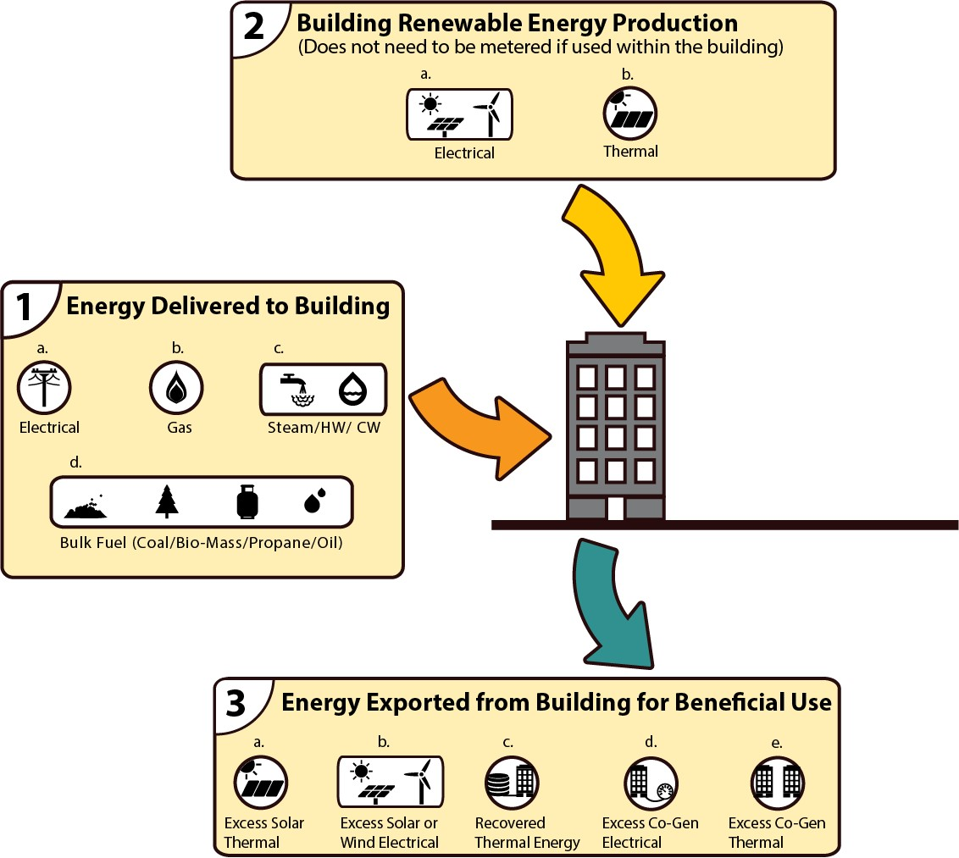
Figure 5-1 Net energy concept. Table 5-1 Energy Flow Definitions
Energy Delivered to Building | Building Renewable  Energy Production | Energy Exported from Building for Beneficial Use
1a. Electrical | 2a. Electrical | 3a. Excess solar thermal
1b. Gas | 2b. Thermal | 3b. Excess solar or wind electrical
1c. Steam/hot-water (HW)/chilled and hot water (CHW) |  | 3c. Recovered thermal energy
1d. Bulk fuel (coal/biomass/propane/oil) |  | 3d. Excess co-gen electrical
 |  | 3e. Excess co-gen thermal

Table 5-2a Site Energy Conversion Factors
Fuel Oils | kJ/L | Btu/U.S. gal
#1 | 37,600 | 135,000
#2 | 38,700 | 139,000
#4 | 40,700 | 146,000
#5L | 41,300 | 148,000
#5H | 41,800 | 150,000
#6 | 42,900 | 154,000
Gas | kJ/m³ | Btu/ft³
Natural Gas | 38,400 | 1030
 | kJ/L | Btu/U.S. gal
Propane | 25,500 | 91,600
Electricity | kJ/kWh | Btu/kWh
 | 3600 | 3412
Informative Note: Energy accounting and conversion factors shown in Table 5-2 are based on site energy.

Table 5-2b Primary Energy Conversion Factors
Energy Form
Conversion Factor
Electricity |  | 3.15
Natural gas |  | 1.09
Fuel oil |  | 1.19
Liquefied petroleum gas (LPG) or propane |  | 1.15
Other |  | 1.10
Purchased district energy | Hot water | 1.35  1.45  1.04
 | Steam
 | Chilled water
Informative Note: Energy accounting and conversion factors shown in Table 5-2b are based on site energy using conversion factors in Table 5-2a converted to primary or source energy. Section 4.4.2 of the standard allows alternative energy targets established by the adopting AHJ. The AHJ may choose to use site energy to source energy conversion factors shown in Table 5-2b or may use other conversion factors following the processes and procedures incorporated within ANSI/ASHRAE Standard 105, Standard Methods of Determining, Expressing, and Comparing Building Energy Performance and Greenhouse Gas Emissions. The AHJ may also choose to use locally appropriate factors for source (primary) energy.

