Background on Rules Development for HB 1257

The Department of Commerce is authorized by HB 1257 to develop rules for the adoption of the Washington State Energy Performance Standard for Commercial Buildings. HB 1257 requires Commerce to use ANSI/ASHRAE/IES standard 100-2018, Energy Efficiency in Existing Buildings (standard) as the basis for these rules. Rules will be implemented that adopt the standard by reference, with amendments.
Amendments to the standard will be made to make the standard consistent with the features prescribed in HB 1257. The standard will also be modified to clarify administrative procedures. Additional rules may be required outside of this standard as well.
The following draft rule has been developed by Commerce staff. Commerce first establishes by rule the adoption of the standard by rule. Then modifications to the purpose, scope and definitions are made to provide consistency between the rule and HB 1257.
Interested parties are encouraged to review standard sections 1, 2 and 3. Provide input on any element that will align the standard with the legislation or existing state laws, clarify application, or improve administrative procedures.
This work will be reviewed during the January 30, 2020 workshop. Commerce request that written comments be received by February 9, 2020. All comments will be posted on the buildings web site. Submit comments via email; buildings@commerce.wa.gov
When editing the standard, please use a standard markup format. Make sure you copy the entire subsection (in the case of section 3, the definition) to be edited. Underline text to be added. Use cross out text to indicate deletions. Provide a reason statement for the change. For any new sections, provide suggested location in the document by referencing the previous section.
Draft Revisions to ANSI/ASHRAE/IES standard 100-2018, Energy Efficiency in Existing Buildings, sections 1, 2 and 3.
Washington State Energy Performance Standard for Commercial Buildings
CHAPTER XX WAC
Authority: ANSI/ASHRAE/IES standard 100-2018, Energy Efficiency in Existing Buildings, is adopted by the Washington State Department of Commerce pursuant to chapters RCW 19.27a.200 and RCW 19.27a.210. Legislature delegated the responsibility of adoption and amendment of these standards to the Washington State Department of Commerce.
WAC XX ANSI/ASHRAE/IES standard 100-2018, Energy Efficiency in Existing Buildings.

ANSI/ASHRAE/IES standard 100-2018, Energy Efficiency in Existing Buildings published by American Society of Heating, Refrigerating and Air-Conditioning Engineers, Inc. is hereby adopted by reference with the amendments noted in this chapter of the Washington Administrative Code.

- PURPOSE
1.1 This standard provides criteria that will result in reduced energy consumption through improved energy efficiency and performance in existing buildings. In adopting this standard by rule, Washington State Department of Commerce shall seek to maximize reductions of greenhouse gas emissions from the building sector.
- SCOPE
This standard is mandatory for all covered commercial buildings located in the state of Washington. This standard is also applicable to a multifamily residential building seeking early adopter incentives consistent with RCW 19.27A.220.
This standard applies to existing buildings, portions of buildings, and building complexes, including the envelope and all systems in the building. This standard excludes industrial and agricultural processes in buildings for which the energy targets do not include those processes.
- DEFINITIONS
agricultural structure: a structure designed and constructed to house farm implements, hay, grain, poultry, livestock, or other horticultural products, and is not a place used by the public or a place of human habitation or employment where agricultural products are processed, treated, or packaged.
applicable building codes: the Washington State Building Codes as adopted by the Washington State Building Code Council, and as modified by local government amendments.
authority having jurisdiction (AHJ): the agency or agent responsible for enforcing this standard. Washington State Department of Commerce.
baseline energy use intensity means a building's weather normalized energy use intensity measured in the previous year to making an application for an incentive under RCW 19.27A.220
building owner: the holder of the property title for the building and/or the land upon which the building sits. an individual or entity possessing title to a building.

conditional compliance: a compliance level between the completion of implementation in Section 9.1 and verification of compliance in Section 9.2. Conditional compliance expires 15 months following the completion of implementation. a temporary compliance method used by building owners that demonstrate the owner has implemented energy use reduction strategies required by the standard, but has not demonstrated full compliance with the energy use intensity target.
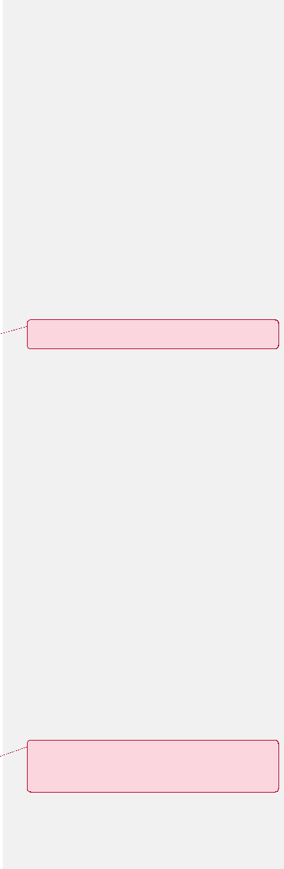
Commented [CM1]: From the WSEC, as referenced in RCW 19.27a.200.
Commented [CM2]: From the WSEC, referenced in rcw 19.27a.200
covered commercial building: a building where the sum of nonresidential, hotel, motel, and dormitory floor areas exceeds fifty thousand gross square feet, excluding the parking garage area.
conditioned space: a space that is provided with heating and/ or cooling capable of maintaining the temperature of the space between 50*F (10*C) and 86*F (30*C) crawl spaces: a shallow, unfinished space beneath the first floor or under the roof of a building.
conditioned space: An area, room or space that is enclosed within the building’s thermal envelope and is directly heated or cooled or is indirectly heated or cooled. Spaces are indirectly heated or cooled where they communicate through openings with conditioned spaces, where they are separated from conditioned spaces by uninsulated walls, floors or ceilings, or where they contain uninsulated ducts, piping or other sources of heating or cooling. (also see, semi-heated space).
energy use intensity (EUI): an expression of building energy use per year in terms of net energy divided by gross floor area.
energy use intensity (EUI) means a measurement that normalizes a building's site energy use relative to its size. A building's energy use intensity is calculated by dividing the total net energy consumed in one year by the gross floor area of the building, excluding the parking garage. "Energy use intensity" is reported as a value of a thousand British thermal units per square foot per year.
energy target (EUIt): the net EUI (of a building) that has been established for compliance with this standard.
energy use intensity target (EUIt) the net energy use intensity of a covered commercial building that has been established for the purposes of complying with the standard.
gross floor area for nonresidential buildings: the sum of the floor areas of all the spaces within the building with no deductions for floor penetrations other than atria. It is measured from the exterior faces of exterior walls or from the centerline of walls separating buildings, but it excludes covered walkways, open roofed over areas, porches and similar spaces, pipe trenches, exterior terraces or steps, roof overhangs, parking garages, surface parking, and similar features.
gross floor area the total number of square feet measured between the exterior surfaces of the
enclosing fixed walls of a building, including all supporting functions such as offices, lobbies, restrooms,

equipment storage areas, mechanical rooms, break rooms, and elevator shafts. Gross floor area does not include outside bays or docks.
Commented [CM3]: This will be detailed in section 8,9 of the standard. Suggest deletion rather than editing.
Commented [CM4]: From 19.27a.200
optimized bundle: a collection of EEMs that maximizes the energy savings at a facility within the cost
effectiveness criteria of the standard. It excludes any measure with a simple payback that exceeds the life of the measure. A bundle of measures is optimized by including the maximum number of EEMs within the bundle while still meeting the cost effectiveness criteria. The process for determining the optimized bundle may be an iterative one due to interactive effects of individual EEMs.
savings-to-investment ratio: the ratio of the total present value savings to the total present value costs of a bundle of an energy or water conservation measure estimated over the projected useful life of each measure. The numerator of the ratio is the present value of net savings in energy or water and nonfuel or nonwater operation and maintenance costs attributable to the proposed energy or water
conservation measure. The denominator of the ratio is the present value of the net increase in investment and replacement costs less salvage value attributable to the proposed energy or water conservation measure.
semi-heated space: an enclosed space within a building, including adjacent connected spaces separated by an uninsulated component (e.g., basements, utility rooms, garages, corridors), which:
- Is heated but not cooled, and has a maximum installed heating system output capacity of 3.4 Btu/(h-ft2) but not greater than 8 Btu/(h-ft2);
- Is not a walk-in or warehouse cooler or freezer space.
state equipment standards: appliance and equipment standards listed in Washington State Chapter 19.260 RCW: ENERGY EFFICIENCY
weather normalized: a method for modifying the measured building energy use in a specific weather year to energy use under normal weather conditions.

