U.S. DEPARTMENT OF ENERGY

WASHINGTON STATE LOW-INCOME
WEATHERIZATION ASSISTANCE PLAN

2018

Prepared by
Washington State Department of Commerce

Brian Bonlender, Director

Michael Furze, Energy Division Assistant Director

Washington State
Department of Commerce
1011 Plum Street SE
PO Box 42525
Olympia, Washington 98504-2525

- INTRODUCTION AND PROGRAM UPDATES 1
- ANNUAL FILE
A. Grant Application – Standard Form 424 3
B. Program Budget 6
C. Subgrantees 7
1. Weatherization Service Providers, Service Area, and congressional Districts
2. Allocation and Production Schedule
D. Energy Savings 9
III. MASTER FILE
A. Technical Assistance and Training 10
1. Allocation of Funding
2. Overview of Activities
3. Description of Activities
B. Monitoring Activities 12
1. Monitoring Scheduling, Visits, and Reporting
2. Multifamily Monitoring
3. Weatherization Monitoring Manual
4. Fiscal Monitoring
5. Performance and Risk Assessment
6. Washington State’s Weatherization Information Data System

C. DOE Funded Leveraging Activities 14
D. Policy Advisory Council 16
E. Hearings and Transcripts 17
F. Adjustments to On-File Information 17
G. Miscellaneous 17
1. Weatherization Advisory Council
2 Service to Native Americans and the Tribal Weatherization Project
3. Weatherization Plus Health
4. Washington State Disaster Relief Plan
5. Assurances and Certification

- INTRODUCTION AND PROGRAM UPDATES
PLEASE NOTE: A federal budget has not been approved for the DOE Weatherization Assistance Program. States have been provided guidance to submit their state plans uses FY16 funding amounts. Once a federal budget, or continuing resolution is passed, states will be required to adjust to the new funding level including pass-through dollars to local agencies.
- The 2018 DOE Low-Income Weatherization Assistance Program Plan incorporates DOE Weatherization Program Notice 18-1.
- PROGRAM PERIOD - July 1, 2018 to June 30, 2019.
- WASHINGTON STATE BUDGET - 2018 DOE Low-Income Weatherization Assistance Program allocation for Washington State is anticipated to be $4,325,258. Of the $4,325,258, DOE has designated $699,825 for Training and Technical Assistance and $3,625,433 for program costs.
- FUNDS FOR ADMINISTRATIVE PURPOSES - Commerce allocates 7% of total DOE grant award to local agencies for administration and retains 3% for Commerce administration. DOE program rules allow local agencies receiving less than $350,000 of new DOE funds to have an additional 5 percent of their program dollars go to administration.

- TRIBAL WEATHERIZATION - $124,879 (4%) of program dollars will be reserved for the Tribal weatherization programs.

- THE ENERGY PROJECT - During PY2018, $70,945 of DOE program funds will support the continuation of The Energy Project, a statewide energy conservation and leveraging project sponsored by the Washington State Community Action Partnership.

- DOE WEATHERIZED UNIT - A DOE weatherized unit is a dwelling unit on which a DOE-approved energy audit or priority list has been applied and weatherization work has been completed. As funds allow, the DOE measures installed on such a unit must have a Savings-to-Investment Ratio (SIR) of 1.0 or greater, but also may include any necessary energy-related health and safety measures. The use of DOE funds on a unit may include, but is not limited to, auditing, testing, measure installation, inspection, use of DOE equipment and/or vehicles, or if DOE provides the training and/or administrative funds. Therefore, a unit that meets the definition of a DOE weatherized unit and has DOE funds used, as described above, must be counted as a DOE completed unit.

- AVERAGE COST PER UNIT - The adjusted annual average expenditure limit for PY2018 is $7,261. The adjusted annual average is determined by DOE using the annual Consumer Price Index (CPI), or 3%, whichever is less. The Department of Energy requires grantees to target production accurately. Based on feedback received from DOE in PY16 Commerce adjusted the states’ ACPU to $5,000.

- USE OF WEATHERIZATION FUNDS FOR RENEWABLE ENERGY - The PY2018 adjusted average for renewable energy measures is $3,623 with a SIR greater than 1. Note: The adjusted average for renewable energy measures is not a separate average, but a part of the overall adjusted average expenditure limit of $7,261.

- ENERGY-RELATED HEALTH AND SAFETY Local weatherization agencies may transfer up to 14.7% of program dollars to the Health and Safety category of the budget in their 2018 DOE contracts and charge that budget category in their monthly requests for reimbursements. Weatherization Program Notice (WPN) 17-7 regarding Health & Safety was released in August of 2017. Commerce is incorporating the required changes into the Weatherization Policy Manual and will be in effect on July 1, 2018.

- FINANCIAL AUDITS - Section 440.23 of the program regulations permits a separate budget category for financial audits. If local agencies meet the threshold for an A-133 audit, Commerce allows these charges to come off the top of their DOE weatherization contract.

- LIABILITY INSURANCE-Local agencies can allocate some of their funding under Other Program Operations for General Liability Insurance and Pollution Occurrence Insurance (POI). These costs should not be included as part of their Average Cost per Unit total.

- QUALITY WORK PLAN-In 2013 DOE Weatherization Assistance Program instituted a Quality Work Plan (QWP) to establish benchmarks for energy efficiency retrofits in the Program. The QWP defines specification for work quality, workforce training, and the qualifications required for individuals performing inspections of weatherization work.

Requirement 1: | All measures and incidental repairs performed on client homes must meet the specifications, objectives, and desired outcomes outlined in the Standard Work Specifications (SWS) for Home Energy Upgrades.
Met requirement by: | A comprehensive single-family field guide outlining Washington State Weatherization Program’s expectations of work scope and quality was provided to all weatherization grantees before July 1, 2015. A training on how to use the field guide was developed and provided by the Building Performance Center (BPC) before implementation.  The Building Performance Center completed a manufactured home field guide that was instituted in PY2016.
Requirement 2: | Every DOE funded weatherized home must receive a final inspection ensuring that all work meets the minimum specifications outlined in the SWS.  Quality Control Inspectors (QCI) working for, or contracted by, the WAP must possess the knowledge, skills and abilities in the National Renewable Energy Laboratory (NREL) Job Task Analysis for QCI. This applies to all individuals who perform an evaluation and sign off on work performed in homes, including final inspectors and Grantee monitoring staff.
Met requirement by: | As of July 1, 2015 Local Agencies are required to ensure all homes receive an independent final inspection by a certified QCI. In FY17, recognizing independent inspectations was creating a burden for some agencies, Commerce instituted a waiver process. If approved, Local Agencies who cannot have separation between the weatherization work and the QCI, are monitored at the higher rate of 10% of their production rather than the standard 5% as required by DOE.

ANNUAL FILE
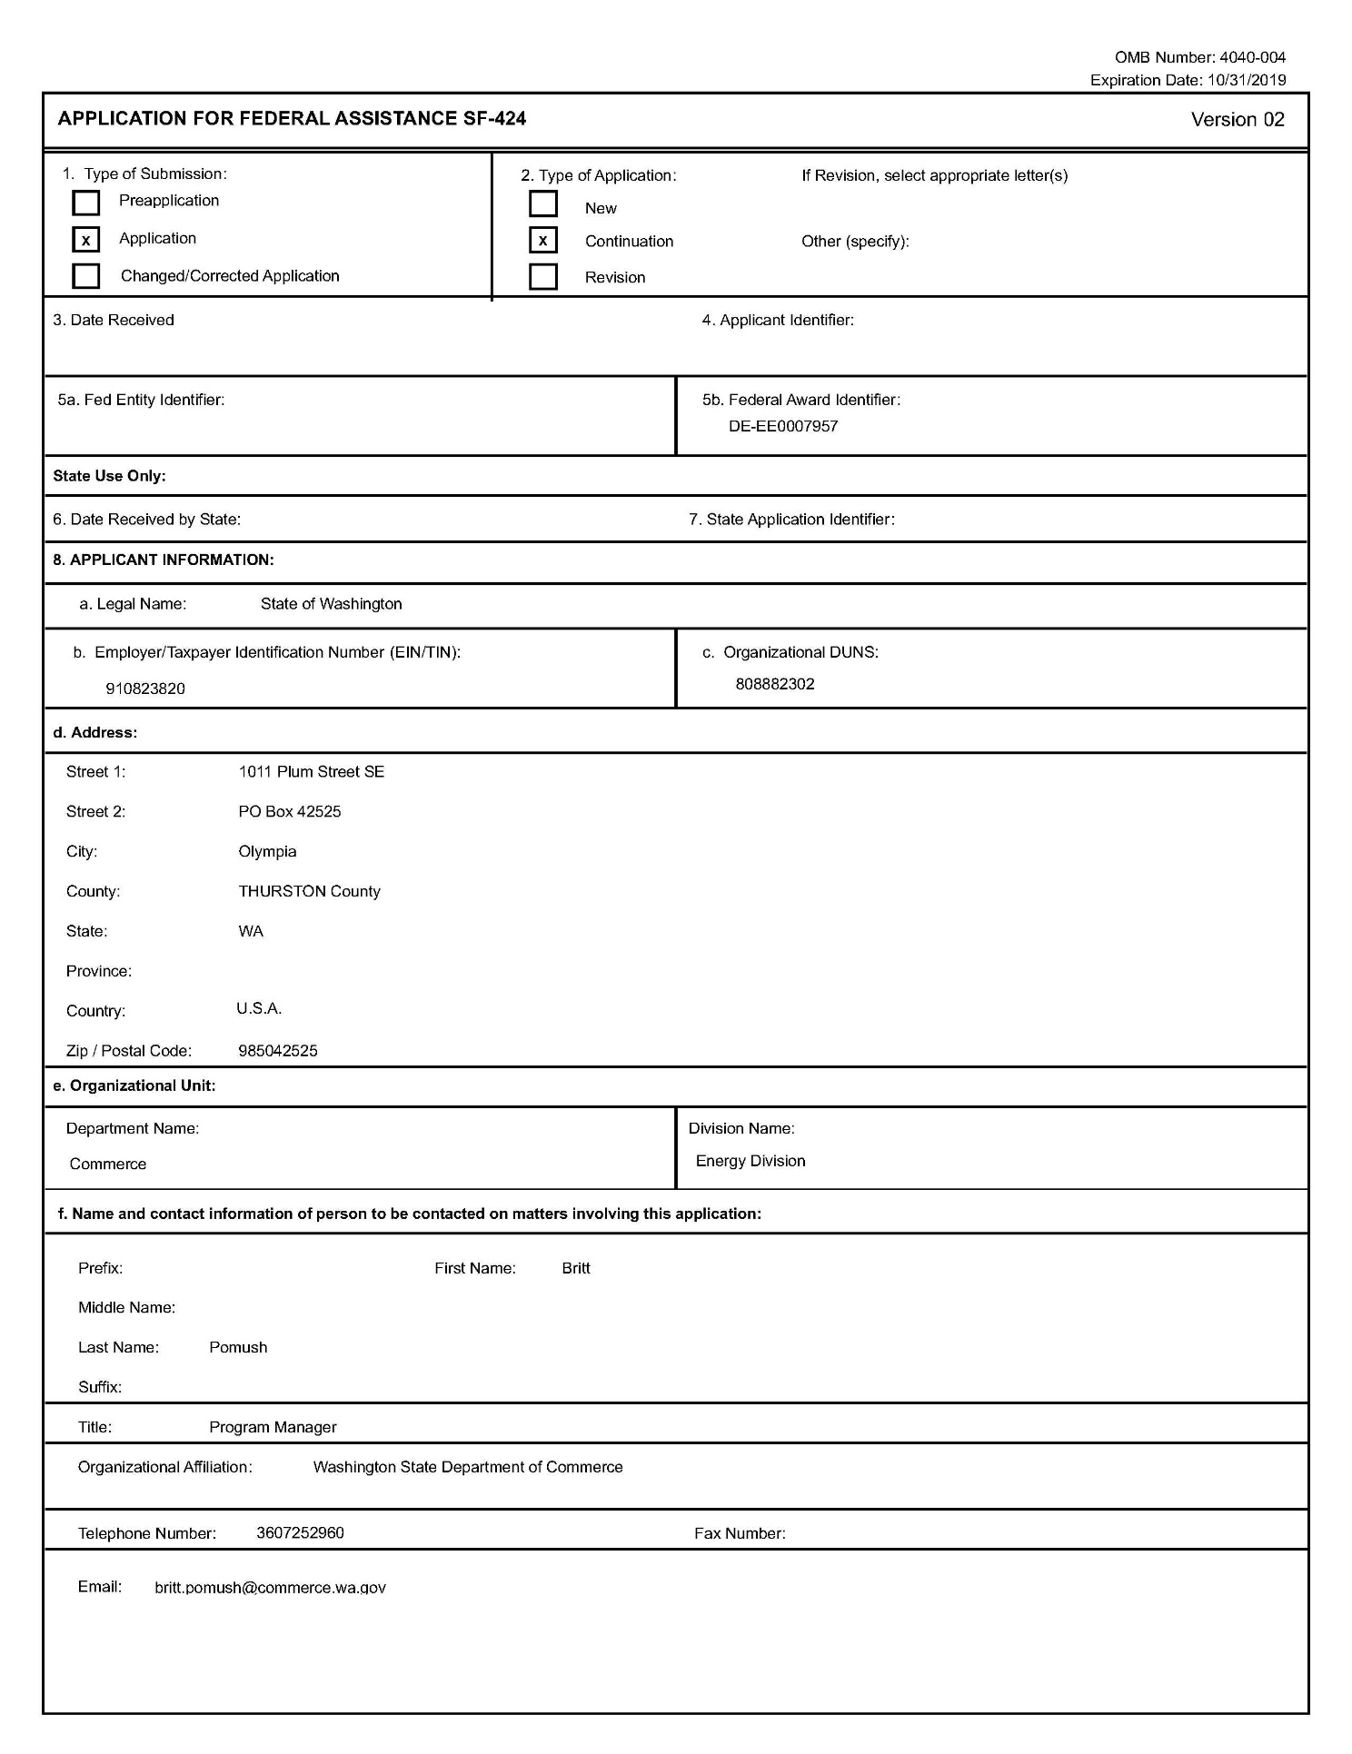

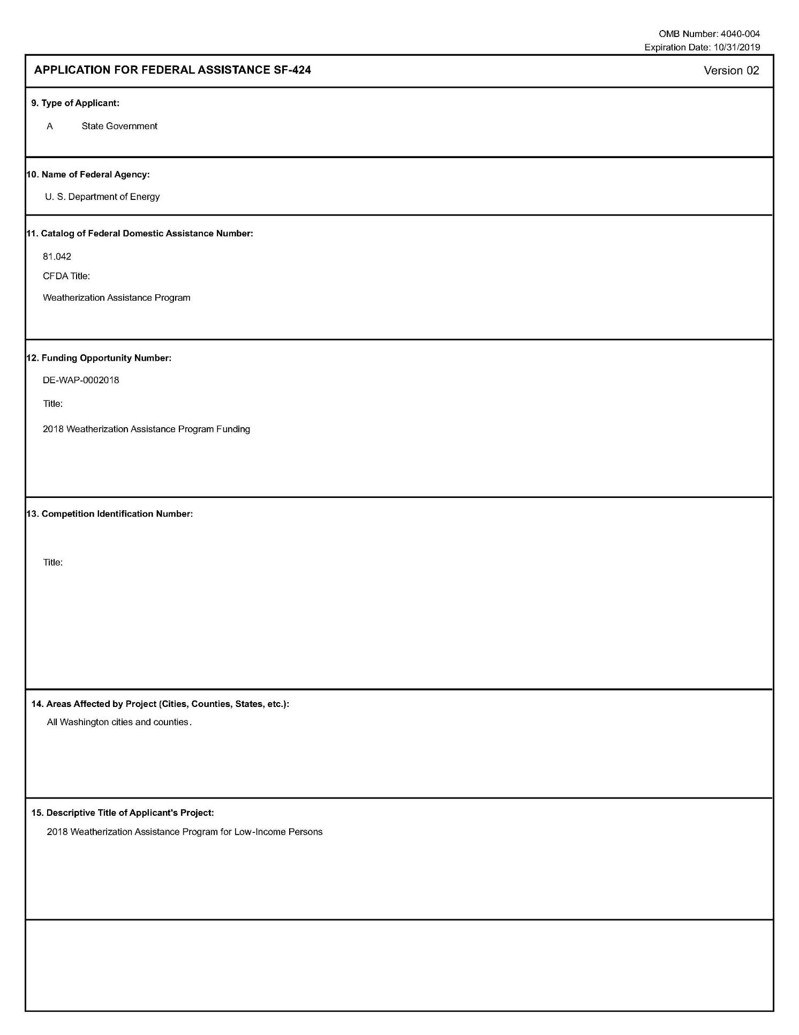
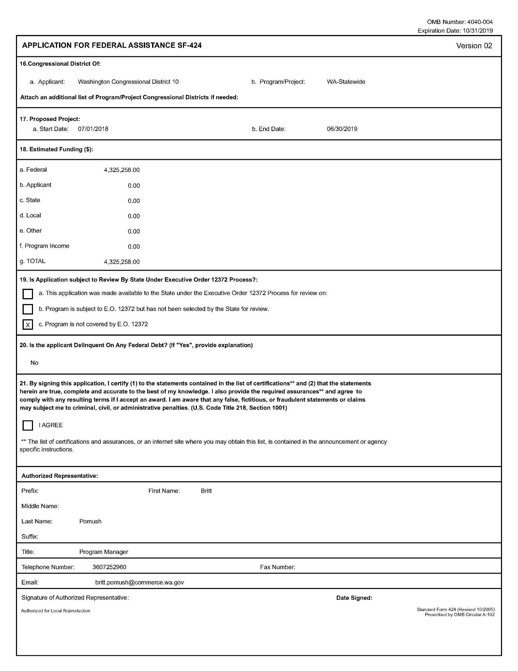

B. Program Budget
 | Grant Program, Function or Activity
Class Categories | Grantee Admin | Subgrantee Admin | Grantee T&TA | Subgrantee T&TA | Program Operations | Leveraging | Health & Safety | Total
a. Personnel | $47,564 |  | $162,875 |  |  |  |  | $210,439
b. Fringe Benefits | $17,598 |  | $60,264 |  |  |  |  | $77,862
c. Travel | $9,300 |  | $39,000 |  |  |  |  | $48,300
d. Equipment
e. Supplies | $1,660 |  | $9,297 |  |  |  |  | $10,957
f. Contractual | $1,450 | $431,725 | $150,630 | $150,000 | $2,553,034 | $70,945 | $439,972 | $3,797,756
g. Construction
h. Other | $18,921 |  | $24,263 |  |  |  |  | $43,184
i. Total Dir. Charges | $96,493 | $431,725 | $446,329 | $150,000 | $2,553,034 | $70,945 | $439,972 | $4,188,498
j. Indirect Charges | $33,265 |  | $103,495 |  |  |  |  | $136,760
k. TOTALS | $129,758 | $431,725 | $549,824 | $150,000 | $2,553,034 | $70,945 | $439,972 | $4,325,258

C. Subgrantees

1. Weatherization Providers, Service Area, and Congressional Districts
401 Benton Franklin Community Action Council  720 West Court Street  Pasco, Washington 99301-4178  509/545-4042 ext 215 - Fax 509/545-1449  (Benton & Franklin Counties) CD 4 | 410 Community Action Council of  Lewis, Mason, and Thurston Counties  3020 Willamette Dr. NE  Lacey, Washington 98512  360/438-1100 ext 1120 - Fax 360/491-7729  (Lewis, Mason, & Thurston Counties) CD 3, 6, 9, 10 | 420 Okanogan County Community Action Council  PO Box 1067  Okanogan, Washington 98840-1067  509/422-4041 - Fax 509/826-7339  (Okanogan County) CD 4
402 Blue Mountain Action Council  1520 Kelly Place #140  Walla Walla, Washington 99362  509/529-4980 ext 110 - Fax 509/529-4985  (Columbia, Garfield, & Walla Walla Counties) CD 5 | 412 Housing Authority of Skagit County  1650 Port Drive  Burlington, Washington 98233  360/757-6509 - Fax 360/757-7913  (Skagit County) CD 1, 2 | 421 Pierce County Community Connections  3602 Pacific Avenue, Suite 200  Tacoma, Washington 98418-7920  253/798-3835 - Fax 253/798-3999  (All Pierce County except City of Tacoma) CD 6, 8, 9
403 Chelan-Douglas Community Action Council  620 Lewis Street  Wenatchee, Washington 98801-3435  509/662-6156 ext 247 - Fax 509/662-1737  (Chelan & Douglas Counties) CD 4, 8 | 413 King County Housing Authority  700 Andover Park West  Tukwila, Washington 98188-2534  206/214-1240 - Fax 206/357-2446  (All King County except City of Seattle) CD 1, 7, 8, 9 | 422 Snohomish County Human Services Dept  3000 Rockefeller Avenue – MS 305  Everett, Washington 98201-3511  425/388-7202 – Fax 425/388-7311  (Snohomish County) CD 1, 2
404 City of Seattle  Office of Housing – HomeWise Program  PO Box 94725  Seattle, Washington 98124-4725  206/684-0354 - Fax 206/233-7117  (City of Seattle only) CD 1, 7 | 414 Kitsap Community Resources  1201 Park Avenue  Bremerton, Washington 98337-1760  360/473-2150- Fax 360/792-8708  (Kitsap County) CD 6 | 423 Spokane Neighborhood Action Partners  212 West Second Avenue  Spokane, Washington 99201-3606  509/744-3370 ext 208 - Fax 509/744-3374  (Spokane County) CD 5
405 Olympic Community Action Programs  228 West First Street, Suite J  Port Angeles, Washington 98362  360/452-4726 ext 6253 - Fax 360/457-4331  (Clallam & Jefferson Counties) CD 6 | 415 HopeSource  700 East Mountain View Ave., Suite 501  Ellensburg, Washington 98926  509/925-1448 ext 240 - Fax 509/925-1204  (Kittitas County) CD 8 | 424 Opportunity Council  1322 North State Street  Bellingham, Washington 98225  360/734-5121 ext 103 - Fax 360/671-2753  (Island, San Juan, & Whatcom Counties) CD 1, 2
406 Clark County Community Development  PO Box 9810  Vancouver, Washington 98666-9810  360/397-2375 ext 4540 - Fax 360/397-2011  (Clark County) CD 3  1300 Franklin, Vancouver WA 98661 | 416 Washington Gorge Action Programs  1250 East Steuben  Bingen, Washington 98605  509/493-2662 ext 203  (Klickitat & Skamania Counties) CD 3 | 425 Yakima Valley Farm Workers Clinic  (Northwest Community Action Center)  Post Office Box 831  Toppenish, Washington 98948-0831  509/865-7630 ext 2743 - Fax 509/865-5116  (Yakima County South of Union Gap) CD 4
407 Coastal Community Action Program  117 East Third  Aberdeen, Washington 98520-0304  360/533-5100 ext 112 - Fax 360/532-4623  (Grays Harbor & Pacific Counties) CD 3,6 | 417 Lower Columbia Community Action Council  1526 Commerce Avenue  Longview, Washington 98632-0173  360/425-3430 ext 226 - Fax 360/425-6657  (Cowlitz and Wahkiakum Counties) CD 3 | 426 Opportunities Industrialization  Center of Washington  815 Fruitvale Boulevard  Yakima, Washington 98902-1467  509/853-2275 ext 208 - Fax 509/452-2826  (Adams, Grant, Yakima County North of Union Gap) CD 4
408 Community Action Partnership  124 New 6th Street  Lewiston, Idaho 83501  208/798-4187 - Fax 208/746-5456  (Asotin County) CD 5 | 418 Metropolitan Development Council  721 Fawcett Avenue South, Suite # 201  Tacoma, Washington 98402-5503  253/284-7809 - Fax 253/597-6700  (City of Tacoma only) CD 6
409 Community Action Center  350 SE Fairmont Road  Pullman, Washington 99163-5500  509/338-4242 - Fax 509/334-9105  (Whitman County) CD 5 | 419 Rural Resources Community Action  956 South Main, Suite A  Colville, Washington 99114  509/684-8421ext 6055 - Fax 509/685-0108  (Ferry, Lincoln, Pend Oreille, & Stevens Counties) CD 5
Tribes and Tribal Organizations

Yakama Nation Housing Authority  PO Box 156  611 S Camas Ave  Wapato, WA 98951  509/877-6171 | South Puget Intertribal Planning Agency  3104 SE Old Olympia Hwy  Shelton, WA 98584  360/426.3990 | Spokane Indian Housing Authority  PO Box 100  6195 Ford-Wellpinit Road  Wellpinit, WA 99040  509/877-6171 ext 1101

2. Allocation and Production Schedule*

Agency | Estimated Units | Budget
401 - Benton-Franklin Community Action Committee | 18 | $128,429
402 - Blue Mountain Action Council | 7 | $51,248
403 - Chelan-Douglas Community Action Council | 8 | $58,819
404 - City of Seattle Office of Housing-HomeWise | 53 | $368,613
405 - Olympic Community Action Programs | 9 | $64,445
406 - Clark County Dept. of Community Services | 25 | $175,088
407 - Coastal Community Action Program | 9 | $66,879
408 - Community Action Partnership - Idaho | 2 | $15,455
409 - Community Action Center of Whitman County | 8 | $59,474
410 - Community Action Council of Lewis, Mason & Thurston Co’s. | 27 | $197,142
412 - Housing Authority of Skagit County | 9 | $65,173
413 - King County Housing Authority | 71 | $471,087
414 - Kitsap Community Resources | 14 | $102,667
415 - HopeSource | 6 | $43,114
416 - Washington Gorge Action Programs | 3 | $24,090
417 - Lower Columbia Community Action Council | 11 | $74,967
418 - Metropolitan Development Council | 20 | $137,903
419 - Rural Resources Community Action | 8 | $59,468
420 - Okanogan County Community Action Council | 5 | $38,863
421 - Pierce County Community Connections | 34 | $234,266
422 - Snohomish County Human Services Department | 35 | $246,411
423 – Spokane Neighborhood Action Partners - SNAP | 44 | $317,756
424 - Opportunity Council | 25 | $180,533
425 - Yakima Valley Farm Workers Clinic – NCCAC | 13 | $94,357
426 - OIC of Washington | 25 | $173,606
TRIBAL WEATHERIZATION ALLOCATION | 22 | $124,879
TOTALS | 511 | $3,574,731

*NOTE: Washington State’s approved 2018 Cost per Unit is $5,000. Estimated units are based on program operations allocation divided by $5,000. Budget column includes program operations, administration, and training and technical assistance allocations.

D. Energy Savings – 2018

DOE Program |  | Amount | Line
 |  | $4,325,258
Total DOE State Weatherization Allocation |  |  | (a)
Total Cost associated with Administration, T&TA, Financial and Energy Audits or 15% of allocation: Commerce Admin, Agency Admin, Leveraging, DOE determined T&TA, and Health and Safety |  | $1,774,194 | (b)
Subtract the amount entered in line (b) from line (a), for a total Federal (DOE) funds available to weatherize homes |  | $2,553,034 | (c)
State Average Cost per Home or National WAP Program Year Average Cost per Home (i.e. PY2015 $7,105) |  | $5,000 | (d)
Divide the amount entered on line (c) by the amount entered on line (d), for Total Estimated Homes to be Weatherized  Note - Rounded for consistency and accuracy with state application numbers |  | 511 | (e)
Multiply (e) by 29.3 MBTU* for Total Annual Estimated Energy Savings resulting from DOE appropriated funds |  | 14,929 | (f)
All Funding Sources
Total funds (e.g., DOE WAP, State, Leveraged, LIHEAP, and other non-Federal sources of funds) used by the State to weatherize homes |  | $ 15,372,361 | (g)
Total cost associated with the administration of Weatherization funds or 15% of total funds available to weatherize homes |  | $2,305,854 | (h)
Subtract the amount entered in line (h) from line (g), for total funds available to weatherize homes |  | $13,066,507 | (i)
State Average Cost per Home or National WAP Program Year Average Cost per Home (i.e., PY2015 $7,105) |  | $7,261 | (j)
Divide the amount entered on line (i) by the amount entered on line (j), for Total Estimated Homes to be Weatherized |  | 1,800 | (k)
Multiply (k) by 29.3 MBTU* for Total Annual Estimated Energy Savings resulting from all funding sources |  | 52,740 | (j)

III. MASTER FILE

A. Technical Assistance and Training
1. Allocation of Funding
The total 2018 T&TA budget ($699,825) will be allocated as follows:
- $549,825 will be retained by Commerce to support:
- Commerce for compliance monitoring and technical assistance to local agencies.
- The Building Performance Center for training and technical assistance to the weatherization network.
- Washington State University Energy Extension Office for program evaluation assistance.
- $150,000 will be allocated to local agencies. Of that amount $75,000 will be provided to each agency as a base amount of $1,200. The remaining $75,000 will be allocated to agencies based on the number of weatherization FTEs reported in the most recent General Weatherization Workplan.
2. Overview of Activities
Washington State’s weatherization training and technical assistance program incorporates:
- Energy and resource conservation
- Energy efficiency improvements
- Weatherization-related repairs
- Indoor air quality improvements
- Health and safety improvements
- Weatherization program management
- Consumer conservation education

All training and technical assistance supports the goal of sound fiscal and program management, efficient, cost-effective services with emphasis on quality. We continue targeting training and technical assistance to improve the quality of work performed by crews and contractors in the field. Training and technical assistance promotes energy efficiency, housing safety, building durability and maximum production of weatherized units within the federal guidelines.
3. Description of Activities
a) Training and Technical Assistance (T& TA) Needs Assessment
Commerce staff assesses and identifies training needs in the following ways:
- The Weatherization Advisory Committee (WxAC), composed of local agency and Commerce representatives, is the principal weatherization program planning body. The WxAC provides input to Commerce on policies and procedures as well as arranging for local agency representation on Disappearing Task Forces for specific weatherization program issues.
- The seven-member Technical Development Committee (TDC) includes selected weatherization technical experts from local agencies and Commerce, and meets three times a year. One regular agenda item for this committee is assess the network’s training needs.
- The Building Performance Center (BPC) conducts a survey of local agencies every year, and solicits further input on training needs at the at the mandatory weatherization managers and inspectors workshop to help prioritize and determine training needs. BPC then produces an annual training schedule. The BPC and Commerce work together to incorporate new DOE requirements each year.
- The General Weatherization Work Plan, completed by each agency annually, includes a section titled Weatherization Staff Training Needs Assessment and Planning where local agencies describe classes, conferences, or other trainings planned for staff assigned to the Weatherization Programs.
- The monitoring visits to local agencies include a follow up of the agency assessment and additional training recommendations.
- Survey Quality Control Inspectors to develop better understanding of areas of improvement and most common areas of deficiency during inspections.
b) Planned Delivery of Weatherization Training and Technical Assistance-The Building Performance Center
The primary training provider for the state of Washington’s weatherization network is the BPC, an IREC accredited training organization. In addition to their staff trainers, the BPC subcontracts with Washington State University (WSU) to provide training in the use of TREAT energy use modeling software, and IREC certified training providers for Tier 1 training for Multi-Family Quality Control Inspector.
Following Washington state procurement procedures, the BPC has been providing weatherization training to Washington’s weatherization network since 1999. The BPC website is http://www.buildingperformancecenter.org and provides course descriptions, on-line training registration, and a schedule of planned trainings.
Building Performance Institute (BPI) and the National Renewable Energy Lab have developed certification schemes for each of the four Home Energy Professional job classifications. The BPC is an approved BPI test center and is approved to proctor all four of these certifications. Currently the Building Analyst certification is required of all local agencies’ auditors and Quality Control Inspection certification is required for all inspectors. Washington State has implemented mandatory QCI inspections on all weatherized homes and requires complete auditor/inspector separation. Local Agencies that are unable to meet this requirement for any reason including, but not limited to, staff losses or changes, must contact Commerce within 10 business days. Local Agencies may apply for a waiver from the Auditor/Inspector separation requirement. This waiver requires prior written Commerce approval. (See Weatherization Manual Policy 7.1 Local Agency Inspectino of Weatherization Work)
In 2016 the cost of a training day ranged from $1000-$2000/day depending on the number of trainers required, travel, and materials necessary to deliver the training. Training costs will be in the same range for PY2018. The BPC is planning to deliver approximately 150 training days in PY2018 covering both Tier 1 and Tier 2 categories.
Training and technical assistance funds may be used to train contractors participating in the low-income weatherization program at the local agency level. The non-subsidized cost/person per training day is $350. Contractors associated with an agency providing weatherization services are charged ½ this cost or $175/person/day. Commerce and weatherization agency staff may attend BPC trainings at no cost.
Local agencies are advised to secure a retention agreement in exchange for the training that would stipulate that contractors will work in the Program, at a minimum, for a specific amount of time and should be in correlation to the cost of the training provided.

1. Tier 1 Weatherization Assistance Program Training
Tier 1 training as defined in WPN15-4 as comprehensive, occupation specific training which follows a curriculum aligned with the Job, Task Analysis (JTA) for that occupation and delivered by an Interstate Renewable Energy Council (IREC) accredited provider.
In December of 2013 the BPC achieved IREC accreditation as a weatherization training provider and provides Tier 1 training in support of the QCI and Crew Lead job designations and credentials.

a. Tier 1 Quality Control Inspector (QCI) Training
In January of 2014, the BPC began offering training in support of the QCI credential. Currently, the Building Performance Institute (BPI) website lists over 50 individuals in Washington that have successfully achieved the Home Energy Professional QCI credential. Due to this accomplishment it is anticipated there will be less need for QCI training and certification in PY2018. However, with normal attrition related to retirement or job change the QCI training will continue to be offered a minimum of once per quarter in PY2016.

b. Tier 1 Crew Lead Training and Technician Training
In PY2018 the BPC will continue to offer IREC accredited Crew Lead training to local agencies and contractors. While there is not a lot of uptake for this training since the majority of grantees hire contractors instead of having crews, if enough voluntary attendees are identified this year, the course will be provided. Recognizing the cost and burden on contractors and agencies have to send staff off for a week of training the BPC will offer a second option where the Crew Lead curriculum is divided into three two-day modules or two three-day modules offered quarterly.

c. Tier 1 Auditor Training
The BPC will prepare to begin offering IREC accredited auditor training in PY2018. We anticipate this training curriculum will be covered in 40 hours. Pre-requisites for this course include one year of experience in weatherization and BPI Building Analyst certification.

2. Tier 2 Weatherization Assistance Program Training
Tier 2 training is defined by DOE as single issue, short-term training to address acute deficiencies in the field. BPC Tier 2 trainings include:
- Blower Door/Pressure Diagnostics/House as a System
- Shell Measures/Air Sealing/Dense Pack/Insulation
- Combustion Safety Testing
- Combustion Safety Daily Test Out
- Indoor Air Quality/Ventilation
- Auditor Training/BPI Certification Preparation
- Single Family TREAT Computerized Audit
- Multifamily TREAT Computerized Audit
- Heating Systems
- Mobile Home Weatherization Techniques and Best Practices
- ASHRAE 62.2 2013
- OSHA 10
- RRP Lead Safe Work Practices/Lead Safe Weatherization
- IR Thermography and Weatherization
- Consumer Education
- Multifamily Auditor/Quality Control Inspector
- Healthy Home Essentials/Weatherization Plus Health
- Heating System Sizing/Manual J
- OSHA Confined Space

The PY2018 Tier 2 trainings listed above will be available and are scheduled based on local agency interest or needs as well as by Commerce recommendation.

3. Additional Weatherization Training for PY2018
Continued education and awareness of OSHA’s requirements for confined space entry including attics and crawl spaces will be provided in PY2018. This training will be included in the Tier 2 training calendar.

The Department of Commerce in coordination with the Building Performance Center (BPC) hold a three-day Weatherization Workshop every two years. The purpose of the workshop is to improve work quality and monitoring consistency throughout the network.

Commerce program management and compliance staff works closely with the BPC to develop the agenda. Topics include policy updates, technical demonstrations, and work specification interpretation and clarification. We choose technical topics based on monitoring trends and input from the contractors and crews.

The workshop emphasizes communication. We promote a clear understanding of weatherization program guidance, specifications and policy requirements needed to assure quality and program compliance. The Weatherization Workshop is an invaluable opportunity to learn from peers and share best practices.

In 2012, Commerce and the BPC worked with local agencies to develop a two-day Weatherization Managers Training for both new and existing program managers. This training will be offered again in PY2018. This training is ideal for program management staff or someone who wants to learn more about the weatherization program and the challenges facing program managers. The training covers:
- History of the weatherization program
- Overview of Policy and Procedure
- Determining priority of measures
- Managing client expectation
- Determining staffing levels
- Time allocation for field staff
- Budgeting
- Spending plans
- Direct cost allocation
- Managing subcontractors
- Quality assurance
- Audit/diagnostic testing requirements
- Lead/mold requirements

Additional training and training work includes the following:

- A two-day financial management workshop covering 2 CFR 200 and procurement policies and regulations detailed in the Financial Manager’s Toolkit will be developed and planned for 2019.
- Weatherization Plus Health is a state and national initiative designed to improve the indoor environment of houses receiving weatherization services. The BPC, in partnership with the National Center for Healthy Homes, has developed training in support of this initiative. The training will be available for intake and referral staff, in-home conservation education providers, program managers, auditors, and inspectors.
- The BPC offers ‘Mold and Moisture’ Train-the-Trainer training developed using the Montana State University Protocols. This training is mandatory for all agencies in our network so that local agencies have the capacity to train their new staff on mold and moisture issues. Mold training is required for new staff within nine months from the date of hire. The BPC will also offer the Mold and Moisture Training regularly for new hires and as a refresher course. Compliance with this requirement is monitored by Commerce.
- The BPC offers a one-day training in support of a state form known as “Combustion Safety Daily Test Out”. This form is required to be completed at the end of each work day on projects where a combustion appliance is present and the building envelope or systems have been altered. The crew or contractor lead completing this form is required to meet one of three criteria:
  - Possess BPI certification (i.e. Building Analyst that requires competency in combustion safety).
  - Have proof of attending a BPC two-day combustion safety training in the past.
  - Satisfactorily complete the one-day training on the “Combustion Safety Daily Test Out” form and procedure.
4. The Peer Circuit Rider (PCR) Program
The Peer Circuit Rider (PCR) Program administered by the BPC is an effective and proactive resource geared to meet the specific training needs of local agencies as identified by the local agencies or by Commerce. The BPC draws from the expertise throughout the field by subcontracting with weatherization providers specializing in the training topic requested. To most effectively demonstrate training principles and work within limited budgets of smaller agencies, the training is conducted at or near the location of the agency receiving the training. This ensures the broadest level of accessibility to necessitate trainings the BPC also organizes statewide training, particularly the core and advanced courses required for a skilled weatherization workforce.

5. Quality Control Inspector (QCI) Credentialing WPN 15-4 Section 3
Quality Control Inspectors (QCI) working for/or contracted by a local agency must possess the knowledge, skills and abilities identified by the National Renewable Energy Laboratory (NREL) Job Task Analysis for Quality Control Inspectors. Competency is demonstrated by certification as a Home Energy Professional Quality Control Inspector through the BPI. As the approved test center in Washington, the BPC will offer a minimum of one QCI credential exam dates per quarter. Arrangements can be made for additional exam dates depending on need.

B. Monitoring Activities

The overall goals of Weatherization monitoring are to verify that local agencies deliver high quality weatherization services, comply with applicable policies and regulations, and promote efficiency and effectiveness in program delivery. Monitoring is a continual, constructive process conducted in a professional manner comprised of desk monitoring, site inspections, and local agency visits. Commerce monitors provide technical assistance during all visits in addition to formal recommendations, training, and best practice discussions.

Commerce divides monitoring into three areas: program, fiscal, and technical. We schedule a minimum of two local agency visits each year. Monitors conduct one visit focused on technical inspections and performance and the other visit focused on programmatic and fiscal review.

Commerce inspects at least 5 percent and commonly 10 percent of each agency’s production. Monitors adjust the number of monitoring visits, up or down, based on agency risk and performance. Commerce uses video conferencing with local agencies to conduct some or all of the programmatic monitoring. This reduced travel costs and increased efficiency for both the local agency and the monitoring staff.

1. Monitoring Scheduling, Visits, and Reporting

Planning for monitoring visits and local agency communication processes are two major elements for Commerce monitoring staff. Commerce schedules inspections and monitoring visits up to 6 months in advance. We scheduling in collaboration with the local agencies and allow agencies time to prepare for each visit and enable all pertinent staff to be present for the annual monitoring, site visits, or both.

Prior to monitoring, local agencies are required to submit a weatherization work plan. Program Coordinators and Monitors review this plan and address any areas of concern with the local agency. Commerce uses the work plan to inform a level of risk and to develop the monitoring plan.

Commerce’s post-visit reporting process is an important aspect of the monitoring protocol. Commerce is committed to getting all inspection reports out to local agencies within 10 days, and monitoring reports out in 30 days or less. Local agency response, if required, is due within 30 days. Monitors review and track local agency responses to verify all action items are completed. Local agencies are required to submit a report detailing the corrections made and include photographic documentation if applicable. At the next monitoring visit, Commerce staff may choose to perform an onsite inspection of corrective work to verify compliance with Commerce weatherization specifications.

2. Multifamily Monitoring

A multifamily disappearing task force is working on defining multifamily specific requirements. The 2017 Weatherization Manual includes revised multifamily auditing procedures and blower door testing. In 2017, we submitted revised multifamily audit procedures. DOE approved these procedures. Commerce will incorporate the Standard Work Specification for Multifamily weatherization into the program according to DOE timelines.

3. Weatherization Monitoring Protocols

In continuing to improve consistency and comprehensive weatherization monitoring, Commerce developed the Weatherization Monitoring Guide. We also revised our weatherization monitoring and inspection protocols and put them into the Peabody style of systematic procedures.

The weatherization Monitors and Program Coordinators meet regularly to increase the effectiveness of desk monitoring, coordinate processes for comprehensive program review, and promote consistent follow-up of issues or concerns.

4. Fiscal Monitoring

Fiscal monitoring is part of every programmatic and administrative monitoring visit. Up until September of 2017, the Department of Commerce had a financial monitor position that served the entire agency. He provided support and assistance to the weatherization monitoring team part time. The weatherization lead monitors are currently responsible to conduct monitoring in fiscal areas including procurement, billing, and invoices. The monitors use Program Coordinators to assist. In 2018, the Housing Improvements and Preservation unit plans to hire a financial monitor who will be responsible for the fiscal monitoring. Field monitors will provide assistance and follow up on issues while onsite conducting programmatic monitoring.

5. Performance and Risk Assessment

Commerce developed a risk assessment instrument that assesses local agency’s risk. Based on risk, Commerce adjusts the frequency of monitoring and inspection visits and the number of units inspected for each agency. In addition, Commerce conducts quarterly check-in calls with all agencies assessing spending and productions issues while addressing any concerns or challenges local agencies are experiencing.

6. Washington State’s Weatherization Information Data System

Commerce implemented the Weatherization Information Data System (WIDS) in February 2011. This online database captures significant details on each home weatherized by a local agency. WIDS enables agencies to track the progress of all weatherization project progress, simultaneously keeping Commerce informed in real time. Alternatively, high volume agencies upload large quantities of data throughout the program year. WIDS also tracks inspection visits and corrections for each project monitored. This allows Commerce to identify trends through the reports generated from the database. We use this information to target training, identify potential issues, and conduct status checks. Commerce utilizes WIDS for reporting, monitoring, and as a part of a larger performance evaluation tool. Working with local weatherization agencies, Commerce will continue making upgrades to both the database and the user interface during the PY2018.

C. DOE Funded Leveraging Activities

Commerce will apply $70,945 of 2018 DOE Weatherization Assistance Program funds to co-sponsor The Energy Project with the Washington State Community Action Partnership.

The Energy Project serves the entire Washington weatherization network and has served as a model leveraging project for other states. The Opportunity Council in Bellingham serves as the administrative agent under an agreement with the Washington State Community Action Partnership (WSCAP). The Energy Project’s activities have resulted in approximately 7 million of additional low-income weatherization funding for low-income households during the most recent 12-month reporting period.

The Energy Project will continue to work with current and potential allies to advocate for energy program funding and program designs that help low-income households afford their home energy services. This will include providing technical assistance to local agencies, negotiating programs with local utilities in coordination with the affected agencies, educating decision makers, evaluating and reporting progress, researching new approaches and best practices for providing service, consulting with national experts, and managing project resources in an effort to expand the resources available and the effectiveness of program designs to improve the energy efficiency of low-income homes. The Energy Project director will maintain working relationships with key people in other states throughout the DOE network.

Technical assistance will be provided to all agencies regarding developments that will affect them universally. In addition, those agencies directly involved in a utility strategy will be consulted and kept informed regarding developments with the utilities in whose service territory they operate. These include all three electric Investor Owned Utilities (Avista – six agencies; PacifiCorp – three agencies; Puget Sound Energy - ten agencies), Cascade Natural Gas (eight agencies, though some have very little gas activity), Northwest Natural [Gas] (primarily one agency), and BPA (twenty-four agencies). In addition to our efforts at the Utilities and Transportation Commission and the Bonneville Power Administration, the Energy Project will work with interested local agencies to create a funding relationship with their smaller consumer-owned utilities.

In addition to protecting existing leveraged funds for energy efficiency work and expanding that funding, Energy Project staff will continue to seek companion funding to support the repair and/or health and safety work that is critical to installing energy measures in low-income homes. It will also continue its broad public educational efforts and direct technical assistance to local agency personnel. Particular areas of attention will be:
- the evaluation, measurement and verification of low-income and other utility-funded energy efficiency programs
- the application of cost tests to low-income energy efficiency programs
- implementing innovations such as decoupling or smart grid such that low-income households benefit, or at least are not harmed
- monitoring utility performance in response to the Washington’ renewable energy and energy efficiency portfolio standards
- monitoring and participating in energy conservation program tariff filings
- working to establish stable, multi-year utility funding arrangements
- effective intervention in any utility rate cases filed with the Washington Utilities and Transportation Commission. General rate cases will include Avista and Puget Sound Energy
- increasing the support of low-income energy efficiency by consumer-owned utility customers of the Bonneville Power Administration.

D. Policy Advisory Council
Organization Representative
AVISTA Renee Coelho
Cascade Natural Gas Allison Spector
Department of Commerce, Energy Office Chuck Murray
Community Action Council of Lewis, Mason, and Thurston Counties Brian Sanda
City of Seattle, Office of Housing, Locan Gov’t. Rep. Jen LaBrecque
Northwest Justice Project Meredith Bruch
Opportunities Industrialization Center of Washington, Rural Rep. Robert Ponti
Pacific Power Becky Eberle
Puget Sound Energy Sandra Sieg
The Building Performance Center Ross Quigley
Washington State Community Action Partnership Merritt Mount
Yakama Tribe David Olivas
The Energy Project Shawn Collins
NorthWest Energy Coalition Amy Wheeless
Washington State Independent Living Council Kimberly Conner
Washington State Department of Commerce Emily Salzberg
E. Hearings and Transcripts
A public hearing will be held regarding the 2018 US DOE Washington State Low-Income Weatherization Assistance Plan on Thursday, March 15, 2018. The Notice of Public Hearing will be published in the Legal Notices Section of the Seattle Times, Spokesman Review, and Yakima Herald, three major newspapers covering the state of Washington. The Notice of Public Hearing will also be posted on the Department of Commerce website.

WASHINGTON STATE DEPARTMENT OF COMMERCE
NOTICE OF PUBLIC HEARING

The Washington State Department of Commerce (COMMERCE) will conduct a public hearing to receive comments on the Draft 2018 United States Department of Energy/Washington State Low-Income Weatherization Assistance Plan. The hearing will be held Thursday, March 15, 2018, 8:30-10:00 am Pacific Standard Time (PST), at the Department of Commerce, 1011 Plum Street SE, PO Box 42525, Building 5, Floor 2, Conference Room 207, Olympia, Washington 98504-2525.
To obtain a copy of the draft plan please contact Britt Pomush.

COMMERCE requests that persons presenting oral testimony provide a hard copy of their comments at the conclusion of their testimony. Additional comments can be emailed to Britt Pomush by or before 5:00 pm PST on March 15, 2017.

Contact Information:
Phone (360) 725-2960
Email britt.pomush@commerce.wa.gov

F. Adjustments to On-File Information
Commerce Weatherization Program staff has reviewed the 2018 DOE Weatherization Program Guidance and will incorporate required changes in the July 2018 revision of Washington’s Weatherization Manual for Managing the Low-Income Weatherization Program. Commerce will include these changes into the on-file information after the changes are reviewed and approved by the Washington’s Weatherization Network.

G. Miscellaneous

1. Weatherization Advisory Committee
The Weatherization Advisory Committee (WxAC) serves as the principal steering committee to the Department of Commerce in partnership with the Washington State Community Action Partnership, (WSCAP). The WxAC advises and participates in strategic planning, policy development, and best practice adoption and implementation for weatherization and housing improvement programs. The WxAC collaborates with Commerce to set priorities, build agendas, facilitates research and establishes temporary work groups to resolve issues and develop recommendations to Commerce. Membership is comprised of the WSCAP Executive Director, a local weatherization agency fiscal director, an executive director, a Commerce representative, a local government weatherization program manager, and a rural weatherization program manager.

2. Service to Native Americans and Tribal Weatherization Project
Through the Tribal Liaison position, Commerce is committed to improving outreach and services to low-income Native Americans in Washington State. This position also seeks to motivate local agencies to increase the number of low-income Native American Homes weatherized, and encouraging local agencies to more accurately identify and report all Native American weatherization projects.

The goal is to increase the communication and interaction between the local agencies, tribes, and other service providers. The Tribal Liaison is responsible for developing state-to-tribal relationships, facilitating dialogue and projects between tribes and local weatherization agencies, and managing special project contracts with tribal nations or other entities.

According to the 2013 Census, the proportion of Native Americans in Washington statewide low-income population is 2%. Expectations are that local agencies will provide weatherization services to homes of eligible Native Americans in a proportion at least equal to the eligible low-income population in their service area and to submit accurate information on the number of Native American weatherized units in Weatherization Information Data System (WIDS).

Commerce will continue the following three approaches through the Tribal Weatherization Project in the 2018 program year.

a) Tribal Weatherization Set-Aside
In an effort to improve, the delivery of weatherization services to Native American families Commerce will reserve approximately four percent of the DOE budget to be awarded to tribal organizations and other entities that will increase weatherization service to reservation households. Over the past three years, Commerce has identified tribal nations whose nation size, capacity, and geographic location justify direct contracts for weatherization service. In addition, Commerce will consider solicited and non-solicited proposals, subject to available funds, from organizations identifying specific outreach goals and cooperative partnerships with local agencies, local area tribes, and tribal entities to maximize weatherization services to eligible low-income Native American families.

b) Training Opportunities for Tribes and Local Agencies
Tribes – As an incentive to increase technical and program knowledge of weatherization and conservation techniques, tribal housing authority staff or tribal members involved in weatherization activities may attend any BPC trainings at no cost.

Commerce coordinates with BPC to develop a core weatherization training curriculum for tribes. Commerce will work with tribal organizations to let them know about a variety of weatherization training opportunities. Commerce will also consider training scholarships when there is long-term benefit to the program and Native American households.

Local Agencies – To increase awareness of Native American culture, operation, and history as well as the Native American awareness of weatherization and conservation programs available to tribes and tribal entities, local agencies will be encouraged to attend Government-to-Government training provided by the Washington Governor’s Office of Indian Affairs. Training and technical assistance funding will be available to local agencies participating in this training. Other training for local agencies working with tribes will be offered at conferences.

c) Networking, Outreach and Coordination
Commerce will organize and help facilitate local or regional meetings between local agencies and tribal nations to increase the number of low-income Native American families receiving weatherization services through the weatherization programs available and to increase the weatherization technical and program capacity for tribes.

Commerce will continue to participate in groups such as Northwest Indian Housing Association (NWIHA), Tribal Housing Assistance Team (THAT) and other collaborations to provide information about the weatherization program, and to develop partnerships for collaborative outreach efforts to tribes. Commerce will support appropriate state and regional tribal meetings and conferences dealing with energy conservation, weatherization, and associated training.

Tribal grantees will also be encouraged to participate in the Weatherization and Health Enhanced Program, as funding becomes available. The Weatherization plus Health Enhanced Program is a pilot that is made available to eligible clients with chronic respiratory issues. One local tribal grantee submitted an application and received Washington State Capital MatchMaker funding to enact Weatherization Plus Health Enhanced and found success by serving families with a combination of standard weatherization measures and additional measures to ensure that the indoor air quality was greatly improved. It is hoped that this program will be able to expand to all grantees in the future.

Commerce welcomes tribal weatherization sub-grantees to take part in the regularly scheduled Network Meetings and the Technical Development Committee meetings to take part in the discussions and share the unique challenges that come with serving Native Americans on the reservations.

Commerce will also work to ensure coordination of the DOE Weatherization Assistance Program, the Bonneville Power Administration Weatherization Program, and the LIHEAP Weatherization Programs regarding tribal weatherization projects and activities.

Commerce requires that all sub-grantees create a tribal outreach plan to outline their individual efforts to reach the Native Americans in their service area. These plans are reviewed and approved. The plans are discussed during the annual monitoring and verified in the State’s Weatherization Information Database System (WIDS).

3. Weatherization Plus Health (Wx+H)
In 2015, the Washington State Legislature expanded the weatherization statute to include healthy home activities and charged the Washington State Department of Commerce with overseeing these activities. The Housing Improvement and Preservation (HIP) Unit within Commerce administers the Weatherization Program and developed a Wx+H pilot program for the 2015 -2017 Washington State Biennium. This pilot was designed to provide additional measures in weatherized homes for households with members experiencing asthma or other respiratory issues.

In January of 2018, the legislature approved the Washington State Capital budget for the 2017 – 2019 Biennium. State weatherization funding was approved at $10 million, down from $15 million, which is a 33% decrease from the 15-17 biennium. HIP is updating the Wx+H program to make Wx+H available to all WA weatherizing agencies for 2017 -2019 Washington State Biennium through their state weatherization allocation. This update incorporates lessons learned from the pilot, weatherizing agency feedback, and bears in mind that the capital budget has been reduced from the previous biennium.

Although DOE cannot provide funding for healthy home activities, these new activities can be combined with DOE supported activities to increase the health and safety of Washington’s homes.

4. Washington State Disaster Relief Plan
The purpose of the Washington State DOE Weatherization Assistance Program Disaster Relief Plan is to provide emergency services to qualified households affected by a disaster as determined by a Presidential or Gubernatorial order declaring either a Federal or State Emergency. The disaster generally involves three phases: the crisis itself, the cleanup, and the repair or rebuilding of the area. It is not uncommon for weatherization work to be suspended during the crisis and early clean-up period until community services such as electricity, water, and other infrastructure can be returned to normal. The plan may be in effect for a minimum of six months but could be extended depending upon the anticipated recovery period.
Disaster relief services are only available to qualified low-income households directly affected by the declared disaster. Local agencies may re-prioritize service requests from these households so that timely weatherization and reweatherization services can be provided. Dwellings may only be provided repairs or weatherization services that are not paid for by insurance or other forms of compensation. The burden of proof of what is and is not covered by insurance or other forms of compensation is put on the policyholder.
For qualified households, the unit allowance will be increased to the maximum reimbursement for a state of emergency as permitted in the DOE Weatherization Assistance Program contract. The maximum is calculated at approximately 15 percent higher than the most current average per weatherized dwelling unit as established by DOE.

Relief services shall be conducted in accordance with the WA State Weatherization Manual and Weatherization Program Notice (WPN) 12-07. Of interest may be, but are not exhaustive are:

- Debris removal at a dwelling unit so that the unit can be weatherized.
- Any home damaged by disaster such as flooding can be reweatherized without regard to date of weatherization if insurance or other forms of compensation do not cover the damage to materials.
- Commerce may take funds out of local agency grants to provide leveraging opportunities at the state and local levels. These funds can be used in innovative ways to increase the energy-related assistance that can be made available to people facing repair or rebuilding after a disaster.
Prior to initiating disaster relief services, local agencies will be required to submit a written plan to Commerce outlining the services to be provided and to report activities, expenditures, and demographics as required by the weatherization program.

5. Assurances and Certifications
The following certifications will be submitted with the final Washington State Low-Income Weatherization Assistance Plan:
- Nondiscrimination in Federally Assisted Programs, DOE F 1600.5 (06-94)
- Certifications Regarding Lobbying; Debarment, Suspension and Other Responsibility Matters; and Drug-Free Requirements

