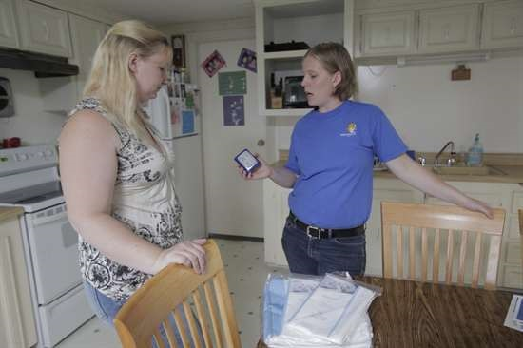
History
The Opportunity Council has been a pioneer in offering “wrap around” Wx +H for more than 10 years. It has targeted children under age six with asthma for comprehensive services. Opportunity Council is recognized as a national model for Wx+H work.
Weatherization Plus Health (Wx +H) Program
Wx + H combines energy efficiency and health improvements in low-income homes with home education. The goal is to reduce energy bills, increase home durability, and improve occupant health, safety, and well-being. Wx + H Enhanced Grants were competitively awarded for pilot efforts from February 2016 through June 2017. An evaluation of program impacts and model analysis will be completed in Summer 2017.
Pilot Program Budget
$556,060 – Weatherization Plus Health
Other funds leveraged:
- CDBG Home Repair
- HUD Lead Hazard Control
- City of Bellingham Mobile Home Repair
- Lummi Tribe
- Puget Sound Energy (PSE)
- Northwest Clean Air Agency Wood Smoke Reduction Program
Targets Served
Mostly households with children with asthma
Single-family and manufactured homes
Services Provided
Weatherization Improvements
* Air sealing of holes * Attic insulation
* Floor insulation * Water heater
* Ductless Heat Pump * Passive venting
Healthy Homes Improvements
*Green cleaning kits *Mechanical ventilation
* Walk-off Mat * CO Detector * Gutter repair
* Dust mite covers * HEPA Vacuum cleaner
* Gutter repair/replacement * Replace flooring
Health Education Services
* Healthy Homes Assessment
* Client screening and referral
* Three, six, nine month follow ups
Grant Spending
$17,027 Avg. Project Total
$3,687 for Wx+H measures
$ 13,340 for Wx energy measures
Pilot Projects Completed
Comprehensive Projects – 43
Education/Low-Cost Only – 10
Project Partners
Nooksack and Lummi Tribes
Three3, Inc. (Consultant)
Major Challenges
Balancing demonstration of results with efficient program design.
Finding high medical useage households while protecting privacy.
Serving renters/multi-family households.
Next Steps
Proposal to Accountable Communities of Health
Research grant with Washington State University
Contact Information
John Davies, Director, Home Improvement Dept.
360-734-5121, john_davies@oppco.org

