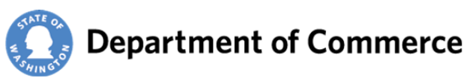 | Clean Energy Fund 4  Dairy Digester Grant Program  Certifications and Assurances

Organization
Project Title
Project Budget | $
ORGANIZATION OFFICIAL CERTIFICATION

I certify, on behalf of (Organization name) that (Organization name) will adhere to all Federal,
State and local laws and regulations that are applicable to the Clean Energy Fund 4
Dairy Digester Program, the operations of (Organization name), and the scope of the proposed project.

(Organization Name) has all necessary, current business licenses and regulatory approvals required in the state of Washington, including but not limited to current registration status with the Secretary of State and Department of Revenue.

The project proposed in this application could not go forward at the scale or on the schedule proposed without the requested funding. (Organization name) will use any funds received under this request, to supplement, not to supplant, other funds.

Documentation is on file for the required match amount as designated in the application and will be provided to Commerce within 30 days of any contingent award.

(Organization Name) certifies it is not using any other state grants as part of this project.

Signature Date

Print Name Title

