Background information for 8/22/19 discussion of social cost of greenhouse gas emissions

Sec. 14. RCW 19.280.030 and 2015 3rd sp.s. c 19 s 9 are each amended to read as follows:
[…]
(3)(a) An electric utility shall consider the social cost of greenhouse gas emissions, as determined by the commission for investor-owned utilities pursuant to section 15 of this act and the department for consumer-owned utilities, when developing integrated resource plans and clean energy action plans. An electric utility must incorporate the social cost of greenhouse gas emissions as a cost adder when:
(i) Evaluating and selecting conservation policies, programs, and targets;
(ii) Developing integrated resource plans and clean energy action plans; and
(iii) Evaluating and selecting intermediate term and long-term resource options.
[…]

NEW SECTION. Sec. 15. A new section is added to chapter 80.28
RCW to read as follows:
For the purposes of this act, the cost of greenhouse gas emissions resulting from the generation of electricity, including the effect of emissions, is equal to the cost per metric ton of carbon dioxide equivalent emissions, using the two and one-half percent discount rate, listed in table 2, technical support document: Technical update of the social cost of carbon for regulatory impact analysis under Executive Order No. 12866, published by the interagency working group on social cost of greenhouse gases of the United States government, August 2016. The commission must adjust the costs established in this section to reflect the effect of inflation.

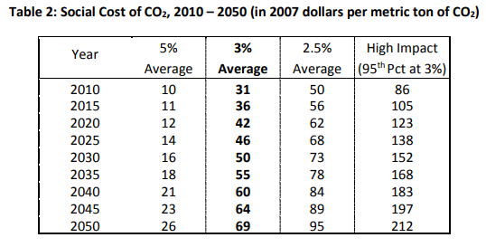
Discussion draft rule language
- The social cost of greenhouse gas emissions to be included by utilities in resource planning, evaluation, and selection, in compliance with RCW 19.280.030.(3), is equal to the cost per metric ton of carbon dioxide equivalent emissions, using the 2.5 percent discount rate, listed in table 2, technical support document: Technical update of the social cost of carbon for regulatory impact analysis under Executive Order No. 12866, published by the interagency working group on social cost of greenhouse gases of the United States government, August 2016, referred to in this rule as the ”technical support document.”
- As a convenience, the cost values established in subsection (1) are restated here:
Year in Which Emissions Occur or Are Avoided | Social Cost of Carbon Dioxide (in 2007 dollars per metric ton)
2010 | $50
2015 | $56
2020 | $62
2025 | $68
2030 | $73
2035 | $78
2040 | $84
2045 | $89
2050 | $95

- The social cost values established in subsection (1) are minimum values. A utility may apply a greater value if it has a reasonable basis to do so.
- The social cost values for intermediate years are calculated by linear interpolation and provided in Appendix A of the technical support document. Social cost values for years after 2050 must be determined by applying an escalation factor of 1.3 percent, consistent with Table 3 of the technical support document. Social cost values must be adjusted for inflation from 2007 dollars to the base year used for other cost and benefit values in the utility’s analysis.

