Washington State Low-Income Weatherization Program

Client Education Guide

July 1, 2019 Version



This Client Education Guide will provide general weatherization information to assist clients in saving energy, improving health and safety, and providing links to more resources

Local Weatherization Agency

Contact Information

Local Agency Name:

Contact Person:

Phone Number:

Email Address:

**Local Weatherization Agencies in Washington State (by County)**

|  |  |
| --- | --- |
| County | Local Weatherization Agency |
| Adams | [Opportunities Industrialization Center of Washington](https://www.yvoic.org/)   |  | | --- | | Opportunities Industrialization Center of Washington | |
| Asotin | [Community Action Partnership](https://www.cap4action.org/) |
| Benton | [Benton-Franklin Community Action Committee](http://www.bfcac.org/) |
| Chelan | [Chelan-Douglas Community Action Council](http://www.cdcac.org/) |
| Clallam | [Olympic Community Action Programs](https://www.olycap.org/) |
| Clark | [Clark County Department of Community Services](https://www.clark.wa.gov/community-development/weatherization-assistance-0) |
| Columbia | [Blue Mountain Action Council](https://www.bmacww.org/) |
| Cowlitz | [Lower Columbia Community Action Council](https://www.lowercolumbiacap.org/) |
| Douglas | [Chelan-Douglas Community Action Council](http://www.cdcac.org/) |
| Ferry | [Rural Resources Community Action](https://ruralresources.org/) |
| Franklin | [Benton-Franklin Community Action Committee](http://www.bfcac.org/) |
| Garfield | [Blue Mountain Action Council](https://www.bmacww.org/) |
| Grant | [Opportunities Industrialization Center of Washington](https://www.yvoic.org/) |
| Grays Harbor | [Coastal Community Action Program](http://coastalcap.org/) |
| Island | [Opportunity Council](https://www.oppco.org/basic-needs/home-energy/) |
| Jefferson | [Olympic Community Action Programs](https://www.olycap.org/) |
| King | [Seattle Office of Housing - HomeWise](http://www.seattle.gov/housing/homeowners/weatherization) |
| King, outside Seattle | [King County Housing Authority](https://www.kcha.org/wr) |
| Kitsap | [Kitsap Community Resources](https://www.kcr.org/) |
| Kittitas | [HopeSource](http://www.hopesource.us/weatherization.html) |
| Klickitat | [Community Action Council of Lewis, Mason, Thurston Counties](https://www.caclmt.org/) |
| Lewis | [Community Action Council of Lewis, Mason, Thurston Co](https://www.caclmt.org/)unties |
| Lincoln | [Rural Resources Community Action](https://ruralresources.org/) |
| Mason | [Community Action Council of Lewis, Mason, Thurston Counties](https://www.caclmt.org/) |
| Okanogan | [Okanogan County Community Action Council](http://occac.com/) |
| Pacific | [Coastal Community Action Program](http://coastalcap.org/) |
| Pend Oreille | [Rural Resources Community Action](https://ruralresources.org/) |
| Pierce | [Pierce County Human Services](https://www.piercecountywa.gov/1290/Home-Weatherization) |
| Pierce, inside Tacoma | [Metropolitan Development Council](https://mdc-hope.org/housing/weatherization) |
| San Juan | [Opportunity Council](https://www.oppco.org/basic-needs/home-energy/) |
| Skagit | [Housing Authority of Skagit County](http://www.skagitcountyha.org/default.htm) |
| Skamania | [Community Action Council of Lewis, Mason, Thurston Counties](https://www.caclmt.org/) |
| Snohomish | [Snohomish County Human Services Department](https://www.snohomishcountywa.gov/600/Weatherization) |
| Spokane | [Spokane Neighborhood Action Partners](https://www.snapwa.org/services-we-provide/i-need-help-with-my-energy-bill/weatherization/) |
| Stevens | [Rural Resources Community Action](https://ruralresources.org/) |
| Thurston | [Community Action Council of Lewis, Mason, Thurston Counties](https://www.caclmt.org/) |
| Wahkiakum | [Lower Columbia Community Action Council](https://www.lowercolumbiacap.org/) |
| Walla Walla | [Blue Mountain Action Council](https://www.bmacww.org/) |
| Whatcom | [Opportunity Council](https://www.oppco.org/basic-needs/home-energy/) |
| Whitman | [Community Action Center of Whitman County](https://www.cacwhitman.org/weatherization/) |
| Yakima, north of Union Gap | [Opportunities Industrialization Center of Washington](https://www.yvoic.org/) |
| Yakima, south of Union Gap | [Yakima Valley Farm Workers Clinic](http://www.ncactopp.org/weatherization/) |

Table of Contents

Local Weatherization Agencies in Washington State (by County) inner cover

View on Commerce website:  
 <http://www.commerce.wa.gov/wp-content/uploads/2019/03/HIP-Weatherization-County-Local-Agency-List-032619.pdf>

**What Is Weatherization?** 1

Also See: DOE Weatherize: <https://www.energy.gov/public-services/homes/home-weatherization>

Energy Efficiency 1

Also See: DOE Energy Saver: <https://www.energy.gov/energysaver/energy-saver>

Maintenance and Warranties 2

**Deferral** 2

**Combustion Safety** 3

Also See: Brochure, ***CO, The Invisible Killer:*** <https://www.cpsc.gov/s3fs-public/464.pdf>

Furnace Filter Maintenance 4

Dryer Vent Maintenance 5

**Mold and Moisture** 6

Also See: EPA Booklet, ***A Brief Guide of Mold, Moisture, and Your Home:***

<https://www.epa.gov/sites/production/files/2016-10/documents/moldguide12.pdf>

**Water Heater Temperature and Water Use** 7

**Ventilation and Indoor Air Quality** 8

**Efficient Lighting Information** 10

Cleaning up Broken CFLs and Fluorescents 11

**Pollutants Awareness** 12

Household Pollutants & Hazardous Waste Disposal 12

Handling Household Hazardous Waste 13

How to Use Household Hazardous Waste Facilities 14

**Hazardous Materials** 15

Mercury 15

Lead 16

Also see: EPA Booklet,*The Lead-Safe Certified Guide to* ***Renovate Right:***

<https://www.epa.gov/sites/production/files/documents/rr_english_color_book.pdf>

Radon 17

Also see: EPA Booklet, ***A Citizen’s Guide to Radon***:

<https://nepis.epa.gov/Exe/ZyPDF.cgi/P100F7ZO.PDF?Dockey=P100F7ZO.PDF>

Study, ***Weatherization and Indoor Air Quality:*** *Measured Impacts in Single-family Homes under the WAP*:

<https://weatherization.ornl.gov/wp-content/uploads/pdf/WAPRetroEvalFinalReports/ORNL_TM-2014_170.pdf>

Asbestos 18

Also see for **More Asbestos Information**: <https://www.epa.gov/asbestos> and

<https://www.epa.gov/asbestos/protect-your-family#identify>

# What Is Weatherization?

The Weatherization Program installs improvements to both save energy and improve your indoor air quality. All elements of these installations work together as a system designed to provide better living conditions for you and your family.

To best utilize these improvements, you should understand how they work together to improve the living conditions in your home. The ceilings, walls, and floors of your home separate your heated home from the unheated spaces outside; this is your envelope. When you improve the envelope of your home, you are weatherizing. Weatherizing may include adding insulation and sealing air leaks.

Having the envelope of your home properly weatherized reduces heat loss. Having to reheat a space due to the loss of heat can be costly and it is best to keep the heat you generate within the home. This results in increased comfort and energy savings. For more information, please see U.S. Department of Energy’s (DOE) [Weatherize](https://www.energy.gov/public-services/homes/home-weatherization) website.

# Energy Efficiency

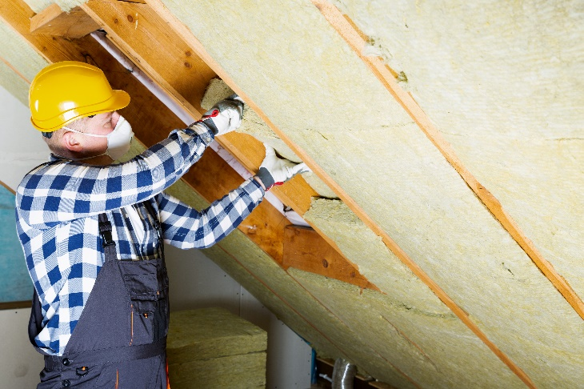Energy efficiency is using more efficient equipment in your home that uses less energy than the equipment that was there previously. Heating and ventilation systems that use less energy but provide increased ventilation through energy efficient fans and heating are examples of energy efficient equipment. There are many energy saving tips available either through your utility company or the [Energy Saver](https://www.energy.gov/energysaver/energy-saver) section of the U.S. Department of Energy website.

# Maintenance and Warranties

Clients will receive all manuals, operation and maintenance directions, warranties, and care instructions for all installed equipment.

If you have any questions, contact the Local Weatherization Agency providing Services.

* If you have energy efficient equipment installed in your home, please make sure to follow the maintenance schedule and read your manuals.
* Keeping your equipment in good working order will reduce issues and provide longevity of the equipment.
* For the warranty period on any equipment or appliances installed in your home, please reference the owner’s manuals you received.

**It is important to remember that our Weatherization Program is not a maintenance program and any issues with materials or workmanship will be the responsibility of the homeowner after the first year.**

**There is a one-year warranty on workmanship.** If you find defects or notice any issues with the workmanship within one (1) year from the date of completion of installation, report them. Please contact the contractor who performed the work or the Local Weatherization Agency. Any defects found and reported within the warranty period shall be remedied without charge and within a reasonable period-of-time.

Deferral

Unfortunately, Local Weatherization Agencies must defer some projects. If the condition of the home is beyond the scope of the Weatherization Program, funding is unavailable, or there are circumstances in the home that require repair, removal, or remedy before a project to weatherize can begin, then the project must be deferred until identified issues are resolved.

When deferral is necessary, you will receive a deferral form that clearly states the conditions requiring deferral, steps that must be taken to remedy it, and conditions that must be met in order for weatherization to begin. You will also be informed when, who, and how to contact the Local Weatherization Agency once all conditions have been met.

Combustion Safety

Appliances that use combustion gases for fuel require testing for safe operation. The Weatherization Auditor will test combustion equipment in the home to ensure it is installed properly and functioning within safety certification limits.

There are some combustion-fueled space heaters used with propane or gas. Typically, these can be unvented which means there is great risk for Carbon Monoxide poisoning and asphyxiation, as well as fire safety issues. As a rule, if we determine these are in your home we will not begin work until removed. We recommend you dispose of them.

## Smoke Detector

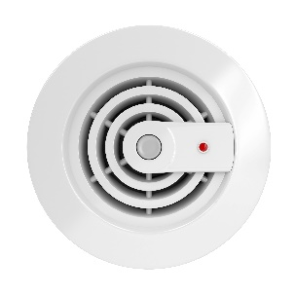A smoke detector is a safety device that can detect smoke, which may be an indicator of a fire.   
Some battery-operated models will "chirp" when batteries are low and need replacement. This helps to ensure the detector does not stop working. If it is determined that your smoke detector is inoperable, we may replace it. We cannot replace operable detectors. If we do replace your smoke detector, please refer to the owner’s manual for proper maintenance and operation.

## Carbon Monoxide (CO) Monitor

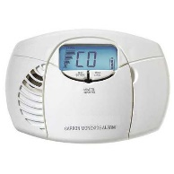A carbon monoxide detector is a safety device that detects the presence of carbon monoxide (CO) gas in order to prevent CO poisoning. CO is a colorless, odorless, and tasteless gas produced by incomplete combustion. Exposure is most commonly from car exhaust, faulty heaters, fires, and industrial accidents.

Symptoms of CO poisoning are nonspecific. Acute mild exposure to CO leads to headache, myalgia, dizziness, and neurologic disturbance. Heavier exposure may lead to retinal hemorrhage, myocardial infarction, loss of consciousness, coma, and death.

* **If you suspect poisoning, evacuate the home.**
* **In an emergency situation call 911 or call the Poison Help Hotline at 1-800-222-1222.**
* **Ventilate and air-out the home afterward.**

Furnace Filter Maintenance

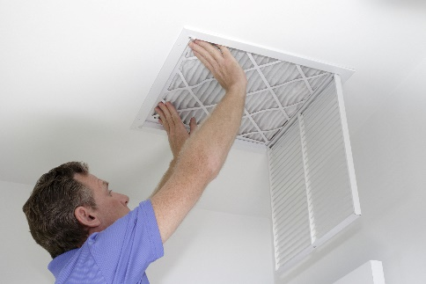Furnace filters must be the proper size and fill the hole in the furnace slot complete - otherwise they are a useless expense. Filters extend the life of your furnace by limiting the amount of dust and hair that will clog furnace mechanisms, making it work harder. To reduce cost, buy filters in bulk (a case or 12 at a time) or invest in a washable, reusable filter.

Your furnace will need service less often if you replace furnace filters every month in the heating months (winter) and every 3 months when only using the air handler in the warmer months (summer). Remember to have your furnace serviced on a regular basis.

Clogged, dirty furnace filters or filter fabric in the duct registers will reduce airflow by 50% and will not protect your health. Furnaces are designed to force a certain amount of air out into the home through the duct registers and to take the same amount of air in through the return register. If either of these airflow amounts are insufficient, the furnace will work harder, fail sooner, and will need to be replaced.

Dryer Vent Maintenance

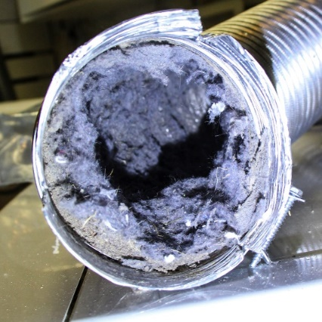Each year, thousands of house fires start because of dryer lint! The dryer lint trap captures only 70% of the lint in each load. The other 30% blows out through the dryer vent tube and some lint will attach to the moistened tube walls. Over time, the dryer vent tube will clog.

Once clogged, airflow is restricted in a now narrowed tube. Air will back up into the dryer body where it can deposit lint on or near the heating elements. This can cause a fire, which can then spread to the rest of the home.

## Recommendations

* **Clean your dryer lint trap after each load.**
* **Snake out your dryer** **vent tube** at least once a year. Use a long stiff brush on a wire wand, compressed air, or a plumbers snake to gently rid the tubing of dryer lint.
  + Do not use these methods on white plastic or shiny Mylar dryer vent tubes. They are not UL listed for this use and are not safe in this application.
  + If possible, they should be replaced with rigid dryer ducting taped at the seams with UL 181 foil tape (not screws as they capture and gather lint) or flexible aluminum vent tubes.
* **Remove Moisture.** Over a half gallon of water is extracted from each dryer load. It is important the dryer is properly vented to carry moist air to the outdoors, not to the crawlspace, attic, or definitely not into the home. There is no safe way to re-capture heat from the dryer vent without spreading lint, chemical fumes from detergents & fabric softeners, and moisture. Moisture can lead to mold and mildew which can give you asthma, a potentially fatal disease.

# Mold and Moisture

[](https://www.epa.gov/sites/production/files/2016-10/documents/moldguide12.pdf)There is always some mold everywhere. Mold can be a problem in any home where there is too much moisture or humidity present. An assessment of your home included a visual check for mold. This is not a mold inspection and the person making this assessment is not a certified mold inspector.

Exposure to damp and moldy environments may cause a variety of health effects: nasal stuffiness, throat irritation, coughing or wheezing, eye irritation, skin irritation, or infection. People with mold allergies, a compromised immune system, or chronic lung illnesses may have more severe reactions.

## Landscape

Proper landscape design impacts site drainage and moisture control.

* Ensure plants are at least 6" - 1' away from home.
* Ensure watering overspray neither hits the side of home nor drains into crawlspace.
* If possible, ensure ground slopes away from home to direct water away from home.

## Drainage Systems

Important to clean and maintain drainage systems.

## Plumbing Leaks

Repair any plumbing leaks especially on hot water lines, right away. Those drips can add up to an enormous amount of wasted energy. Just one drip per minute can waste 51 gallons per year. Moisture also creates damage and produces mold growth.

**For more information for your home**, please see *Client Health and Safety Observed Conditions* form.  
For general Mold information, see EPA booklet, [***A Brief Guide to Mold, Moisture, and Your Home***](https://www.epa.gov/sites/production/files/2016-10/documents/moldguide12.pdf)

Water Heater Temperature

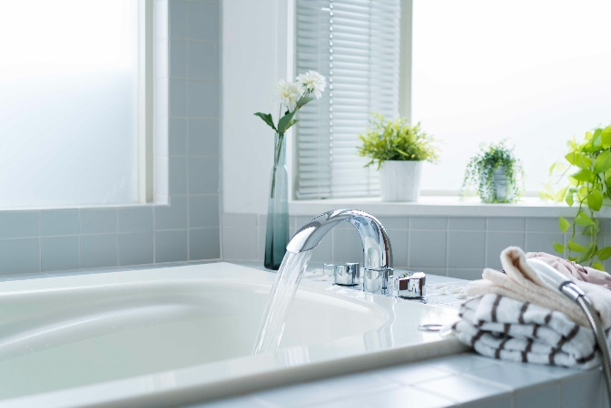The state recommends water heaters be set no higher than 120°F or the minimum setting if no specific temperature is available. While you are not required to adjust the temperature setting, be aware of the dangers, particularly to small children and elderly, of what water can do at 120°F and higher:

**Temperature:** **Scalding Time:**

150° 2 Seconds

140° 10 Seconds

130° 30 Seconds

120° 10 Minutes

Water Use

**Low Flow Showerheads and Faucet Aerators** can save you money. If you take a 20-minute shower each day and have a pre-1992 showerhead and an older electric water heater, you could be spending an extra $900 per year in energy bills to heat that hot water. Newer faucets and showerheads reduce the flow of water while they increase the water pressure, thereby reducing the amount of water that the water heater needs to heat.

Ventilation and Indoor Air Quality

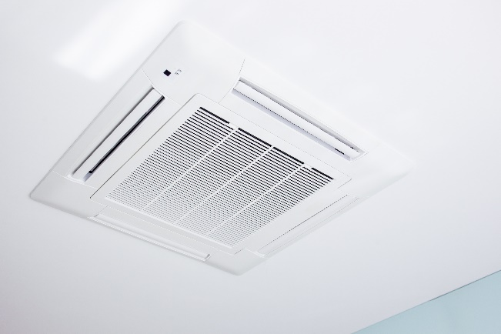Ventilation systems are designed to remove excess moisture from the indoor air, exhaust stale and stagnant air and increase airflow throughout the home. We will evaluate your home to see if there is the need for a new whole-house fan. These fans operate with very little power and increase the amount of fresh air in your home.

## Fans Installed (Whole-House, Bath, or Kitchen)

If the Weatherization Program installs a fan in your home, the Local Agency will provide you with information on function, use, and maintenance of ventilation system and components.

**Your new fan may have one of many possible controls**:

* Manual on-off switch
* Humidity sensor
  + When you take a shower, the fan will come on automatically to remove moisture and will continue to run for a specified period-of-time after you have finished.
* Automatic intermittent switch
  + The fan is on a preset timer and throughout the day, the fan will come on and turn off at set intervals.
* Occupancy sensor
  + When someone walks into the bathroom, the fan will come on automatically and will continue to run for a preset amount of time.

**Increased air circulation provides additional health benefits as well, such as**:

* Preventing mold and eliminating odors
* Reducing triggers associated with allergies and asthma
* Eliminating stagnant air
* Removing excess moisture from cooking and potential carbon monoxide from gas stoves

**It is important to not modify the settings of your fan**, as these settings have been determined based on Indoor Air Quality standards to provide you the most benefit. Changing these can potentially reduce the fresh air we have introduced into your home.

Please know the technician calculated the ventilation settings specifically for your home to meet fresh air standards, but these do not account for high polluting sources such as cigarette smoke or aerosol sprays or guarantee indoor air quality.

## Air Leakage

Air leakage in or out of a building has a considerable impact on the energy demand and cost to heat or cool your home. However, you still need fresh outdoor air. To balance these needs, the Weatherization Program works to eliminate uncontrolled air leaks and instead controls where fresh air can come into the home. For example, we prioritize sealing air leaks between the indoors and the crawlspace, garage, or the attic. Then, when the bath fan is on, the new air drawn-in to make-up for the air exhausted is fresh, because it is not drawn from these less desirable places.

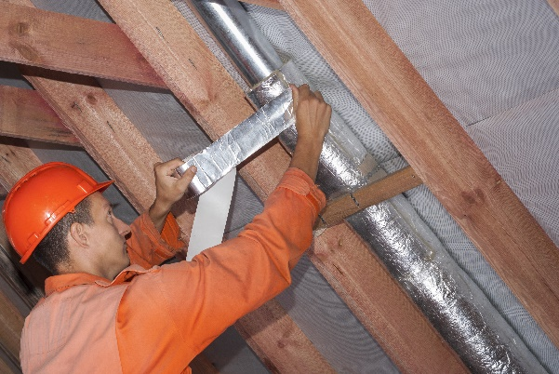**One of the best places to reduce air leaking out of the home is in the ductwork.**

According to U.S. Department of Energy research, an estimated 30% of the energy you paid to heat a home is actually escaping to the outdoors through leaky ductwork located outside the conditioned area of the home- the crawlspace, garage, or attic. Sealing ductwork with mastic is a very cost effective expense. Ductwork sealing is a one-time-fix in the life of the duct system.

Efficient Lighting Information

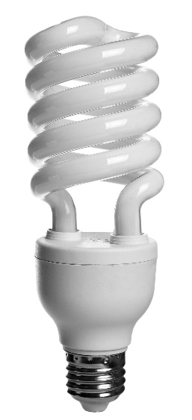An average household dedicates about 5% of its energy budget to lighting. Switching to energy-efficient lighting is one of the fastest ways to cut your energy bills. By replacing your home's five most frequently used light fixtures or bulbs with models that have earned the ENERGY STAR, you could save an average of $75 each year.

CFLs are Compact Florescent Light Bulbs

CFLs are simply compact version of the long tube fluorescent lights you may already have in a kitchen or garage. An ENERGY STAR-qualified CFL uses about 1/4 the energy and lasts 10 times longer than an incandescent bulb that puts out the same amount of light.

LEDs are Light-Emitting Diodes

LEDs use less energy and last up to 20 years (projected). Check with your local utility to inquire about where to purchase new LEDs at a discount. LEDs produce virtually no heat and nearly no wasted energy. Look for lumens, not watts; the higher the lumens the brighter the light. Color temperature (Kelvin) determines hue of your light. If you like bright white light or daylight, look for 3500 to 5000 Kelvin; if you prefer the soft glow of older incandescent bulbs, look for 2500 Kelvin. Since LEDs do not contain mercury, when (if) they burn out they can go directly in the garbage can.

Cleaning up Broken CFLs and Fluorescents

## Before Cleaning

* **Always Air-Out the Room.**
* **Open a window** and have everyone, including pets, leave the room for at least 15 minutes.
* **Turn off the air** conditioning or heating system, if it is on.

## Cleaning Hard Surfaces

* 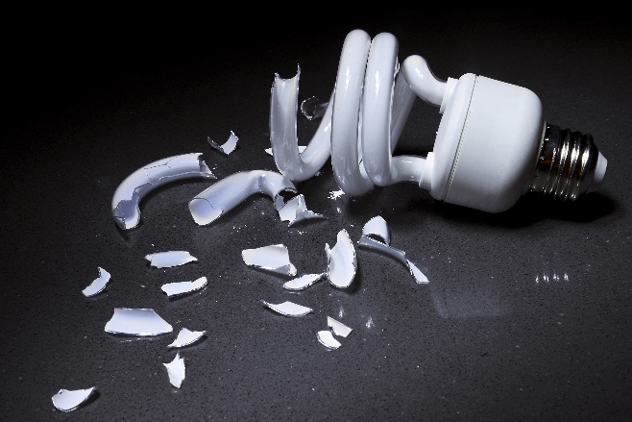Pick up glass fragments using either stiff paper or cardboard and place into a sealable plastic bag.
* Use tape to pick up all remaining small pieces and powder.
* Wipe area with wet paper towels and then place into plastic bag.
* Do NOT use vacuum or broom to clean up broken bulbs!

## Cleaning Carpet or Rug

* Pick up glass fragments and place in a sealable plastic bag.
* Use tape to pick up remaining small fragments and powder.
* After all visible pieces are cleaned, vacuum if needed.
* Remove vacuum bag and place in a sealable plastic bag, or,
* Dump out fragments from vacuum to sealable plastic bag and wipe canister that held debris with wet paper towels and then place into plastic bag as well.

## Cleaning Clothing, Sheets, Fabric, etc…

* Clothing or sheets that come in direct contact with broken bulbs or mercury-containing powder should be thrown away.
* If clothes do not come in direct contact with broken bulbs (such as the clothes worn while cleaning broken bulbs), it is okay to wash.
* If shoes come in contact with broken bulbs, wipe with wet paper towels and then place the paper towels in a sealable plastic bag to throw away.

## Throwing Away Clean Up Materials

* Seal plastic bag with clean up materials within, to throw away.
* Place all clean up materials in an outdoor trash container.
* Always wash hands with soap after cleaning up broken bulbs.
* Check with local or state laws to see if there are recycling centers specifically for CFL's.

Pollutants Awareness

The U.S. Environmental Protection Agency (EPA) considers some leftover household products that can catch fire, react, or explode under certain circumstances, or that are corrosive or toxic as household hazardous waste. Products such as paints, cleaners, oils, batteries, fluorescent lightbulbs, and pesticides can contain hazardous ingredients and require special care when you dispose of them.

## Household Pollutants & Hazardous Waste Disposal

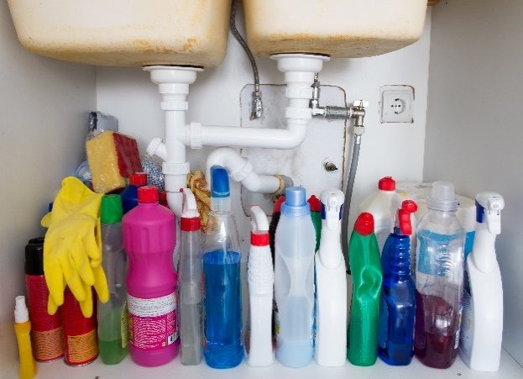Products labeled warning, flammable, combustible, danger, toxic, or poison need special handling and disposal. These may include: Aerosols; Automotive products; Batteries; Cleaning products; Contaminated motor oil; Flammable liquids, gasoline, & solvents; Oil-based paints & stains; Fluorescent tubes & light bulbs; Herbicides & pesticides; Mercury thermometers; Pool & spa supplies; Road flares; Small propane bottles; Syringes & sharps, and Latex paint cans with more than 2 inches of paint.

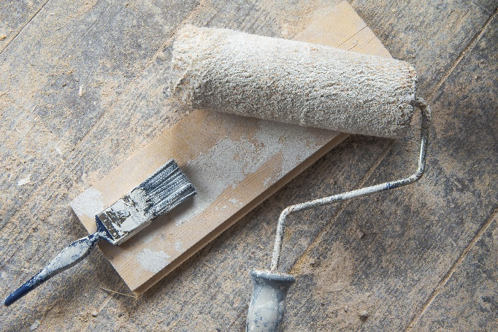Latex paint is not hazardous and can be disposed as garbage once dried. Please manage latex paint at home if you can. Dry smaller amounts of paint with kitty litter, concrete mix, or by painting a piece of cardboard. Larger amounts that you cannot dry at home can be taken to the Household Hazardous Waste Facility. Proper disposal prevents hazards from entering the environment; damaging soil, groundwater and streams and causing harm to people and animals.

## Not Accepted

**These products are not accepted at the Household Hazardous Waste Collection Facility**: leaking containers, empty containers (dispose in garbage with lid removed), explosives; ammunition, radioactive waste, household garbage, or e-waste: televisions, monitors, computers, laptops, tablets, e-readers, and portable DVD players.

## Handling Household Hazardous Waste

To avoid the potential risks associated with household hazardous waste (HHW), it is important that people always monitor the use, storage, and disposal of products with potentially hazardous substances in their homes. Improper disposal of HHW can include pouring them down the drain, on the ground, into storm sewers or in some cases putting them out with the regular trash.

The dangers of such disposal methods might not be immediately obvious, but improper disposal of these wastes can pollute the environment and pose a threat to human health. Certain types of HHW have the potential to cause physical injury to sanitation workers, contaminate septic tanks or wastewater treatment systems if poured down drains or toilets. They can also present hazards to children and pets if left around the house.

## Quick Tips for the Safe Handling of Household Hazardous Waste

* Follow any instructions for use and storage provided on product labels carefully to prevent any accidents at home.
* Be sure to read product labels for disposal directions to reduce the risk of products exploding, igniting, leaking, mixing with other chemicals, or posing other hazards on the way to a disposal facility.
* Never store hazardous products in food containers; keep them in their original containers and never remove labels. Corroding containers, however, require special handling. Call your local hazardous materials official or fire department for instructions.
* When leftovers remain, never mix HHW with other products. Incompatible products might react, ignite, or explode, and contaminated HHW might become unrecyclable.

## Safe Transport Tips

* **Use original containers.** Keep the product in its original container. If you have used a different container, label it.
* **Keep away from passenger cabin.** Keep the product out of the passenger compartment of your vehicle and away from children and pets.
* **Secure the load.** Place containers in a plastic bin or box with a lid, and keep them from tipping or leaking. If transporting waste in a truck, secure the load with ties to prevent the load from shifting.
* **Never mix.** Do not mix different types of products in the same containers.
* **Do not tape bulbs or let them get wet.** Do not tape fluorescent tubes or bulbs together, and when possible, transport them in the original box to prevent breakage.

## How to Use Household Hazardous Waste Facilities

Many HHW facilities are drive-up facilities. When it's your turn to be helped, you will be directed to drive under a covered area. Staff will sort your waste, with your assistance. They may ask you questions or provide education. Before you leave, you will sign an agreement verifying that your waste is from a home and not from a business.

* **Make an appointment if you have a large load**. Call a few days in advance for large loads (larger than 5 gallon containers, loads over 50 gallons total, or more than 50 containers). If you do not make an appointment, the facility may turn you away and then you will be required to make a follow-up appointment. Making an appointment helps you get in and get out faster.
* **Transport safely.** It is important that you safely transport your waste.
* **Do not bring empty containers**. Put empty containers in your household garbage. Remove the lid off so your garbage hauler can see they are empty.
* **Check with your local** environmental, health or solid waste agency for more information on HHW management options in your area.
* If your community doesn’t have a year-round collection system for HHW, **see if there are any designated days** in your area for collecting HHW at a central location to ensure safe management and disposal.
* **Check around**. If your community has neither a permanent collection site nor a special collection day, you might be able to drop off certain products at local businesses for recycling or proper disposal. Some local garages, for example, may accept used motor oil for recycling.
* Remember, **even empty containers of HHW can pose hazards** because of the residual chemicals that might remain so handle them with care.

Hazardous Materials

Hazardous Materials include

Refrigerant, Asbestos, Lead, and Mercury including CFLs/Fluorescents

Weatherization work can require the handling of hazardous waste materials. Any hazardous waste materials generated in the course of the weatherization work will be disposed of according to all local laws, regulation and federal guidelines, as applicable.

The following sections give more information on the more common hazards associated with hazardous waste materials generated or handled in the home.

**Hg** Mercury

## Where is Mercury Found?

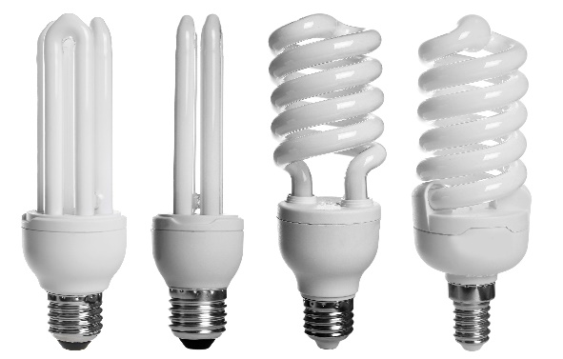Fluorescent lighting contains a trace amount of Mercury sealed in the glass tubing of the bulb. This includes tubes and Compact Fluorescent Lights (CFLs). The amount of mercury varies depending on bulb size and age. Newer bulbs contain less. When bulbs are broken, they must be handled with great care. In addition, they must be recycled or disposed of as Household Hazardous Waste at an approved site. Thermostats, especially older thermostats may also contain Mercury.

Mercury is a naturally occurring element, and poisoning can result from exposure to water-soluble forms of mercury (such as mercuric chloride or methylmercury), by inhalation of mercury vapor or by ingesting any form of mercury. Mercury can inhibit the development of the brain and nervous system in young children and women of childbearing age. When mercury enters our environment, it becomes part of the food chain for all living organisms. Mercury does not break down, so it builds up in fish, birds, and people.

**Pb** Lead

## Where is Lead Found?

Lead is a naturally occurring element and can be found in all parts of our environment – the air, the soil, the water, and even inside our homes. Lead and lead compounds have been used in a wide variety of products found in and around our homes, including paint, ceramics, pipes and plumbing materials, solders, leaded-gasoline, batteries, ammunition, and cosmetics.

Most homes built before 1978 contain some lead-based paint. Lead-based paint is more common and was used more extensively in homes built before 1950. Moisture problems, regular use, rubbing, or impact can cause paint failure. Lead-based paint chips and dust mixes with house dust. Lead can be absorbed into your body by breathing dust or eating particles. The most important step parents, doctors, and others can take is to **prevent lead exposure before it occurs**.

If the Local Agency identifies or presumes lead-paint and as part of the work plans to disturb those painted surfaces, this can create lead dust. Then, the weatherization workers will follow lead containment protocols to minimize risk.

**Children are especially vulnerable**. Lead in paint chips, dust, and soil can get on children's hands or toys, which they may put in their mouths. Lead poisoning can make children very sick and cause permanent brain and nerve damage and can result in learning difficulties and behavior problems. Adults are also at risk. Lead-based paint can cause damage to adult brains, nervous systems, and reproductive systems. This damage is irreversible. Lead poisoning is a tragedy we can prevent.

**For more information for your home**, please see *Client Health and Safety Observed Conditions* form.  
For general Lead information, see EPA booklet, [***The Lead Safe Certified Guide to Renovate Right***](https://www.epa.gov/sites/production/files/documents/rr_english_color_book.pdf).

[](https://nepis.epa.gov/Exe/ZyPDF.cgi/P100F7ZO.PDF?Dockey=P100F7ZO.PDF)**Rn** Radon

Radon is a naturally occurring, chemically inert, radioactive gas that is not detectable by human senses. It comes from the natural breakdown of uranium in soil, rock, and water and can get into the air you breathe. As a gas, it can move readily through particles of soil and rock, and can accumulate under the slabs and foundations of a home where it can easily enter into the living space through construction cracks and openings. Radon can be found all over the U.S. and homes may be tested for radon in areas where it is known to occur at a high level.

Radon gas exposure remains a significant U.S. health risk. The EPA estimates that indoor radon causes or contributes to 21,000 lung cancer deaths each year.

Weatherization benefits include energy savings, energy cost savings, improved home comfort, and increased safety. There is a small risk of increasing radon levels when building tightness is improved.

**For more information for your home**, please see *Client Health and Safety Observed Conditions* form.  
For general Radon information, see EPA booklet, [***A Citizen’s Guide to Radon***](https://nepis.epa.gov/Exe/ZyPDF.cgi/P100F7ZO.PDF?Dockey=P100F7ZO.PDF).

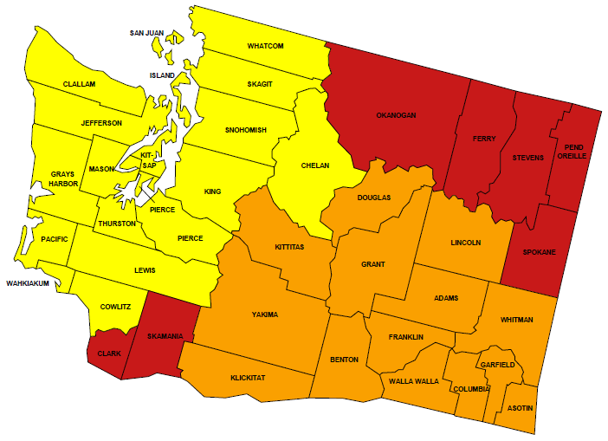Radon Zones

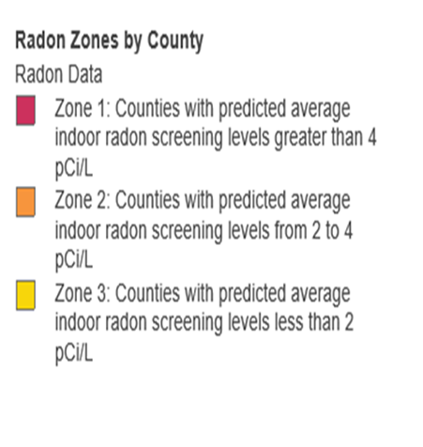

[](https://www.epa.gov/asbestos/protect-your-family#identify)Asbestos

United States Environmental  
Protection Agency (EPA)

## What is Asbestos?

Asbestos is a mineral fiber that occurs in rock and soil.

## Where Can I Find Asbestos?

Because of its fiber strength and heat resistance, asbestos has been used in a variety of building construction materials for insulation and as a fire retardant. Asbestos has also been used in a wide range of manufactured goods, mostly in building materials (roofing shingles, ceiling and floor tiles, paper products, and asbestos cement products), friction products (automobile clutch, brake, and transmission parts), heat-resistant fabrics, packaging, gaskets, and coatings.

## Where Asbestos might be found

* Attic and wall insulation produced containing vermiculite
* Vinyl floor tiles and the backing on vinyl sheet flooring and adhesives
* Roofing and siding shingles
* Textured paint and patching compounds used on wall and ceilings
* Walls and floors around wood-burning stoves protected with asbestos paper, millboard, or cement sheets
* Hot water and steam pipes coated with asbestos material or covered with an asbestos blanket or tape
* Oil and coal furnaces and door gaskets with asbestos insulation
* Heat-resistant fabrics
* Automobile clutches and brakes

## How Can People Be Exposed to Asbestos?

Asbestos fibers may be released into the air by disturbing asbestos containing material (ACM) during product use, demolition work, building or home maintenance, repair, or remodeling. In general, exposure may occur only when the ACM is disturbed or damaged in some way to release particles and fibers into the air.

Repeated exposure to asbestos increases your risk of developing lung cancer, mesothelioma, and asbestosis.

If you think there may be asbestos in your home, don’t panic! Generally, ACMs that aren’t damaged or disturbed are not likely to pose a health risk. Do not touch ACMs. Leave asbestos containing material alone if it is in good condition.

**If there are ACM’s in your home that does not mean we will not weatherize your home**; however, it may limit what we can do as we cannot remove the material.

**For more information for your home**, please see *Client Health and Safety Observed Conditions* form.  
For general Asbestos information, see EPA websites: <https://www.epa.gov/asbestos> and <https://www.epa.gov/asbestos/protect-your-family-exposures-asbestos>

