HMIS Annual Point in Time Count (PIT) Data Entry Instructions 2019
Contents
Introduction 3
HMIS Written Consent Policies 3
HMIS Consent – Consent Refused Households
Unsheltered PIT Count Entry 5
• Unsheltered and doubled-up (optional) surveys are entered into the lead PIT agency’s HMIS.
• Clients are entered into a temporary “PIT Count” program in HMIS.
Switching Agency Profiles 5
Client Search 5
Create New Client Profile 6
Link Household Members (Group Households Only)
Program Enrollment 9
Sheltered Count 12
Non-Year-Round Participating – PIT Shell Programs for TH or ES 12
• Surveys for agency Transitional Housing and Shelter programs that do NOT use HMIS year-round and only for PIT count are entered into temporary “shell” (PIT) programs in HMIS.
• There will be a shell PIT program for each housing type (TH and ES).
Year-Round HMIS Participating Programs – TH or ES 12
Whatcom County Agencies
• Contact your local HMIS admin, Katie Sly (Katie_sly@whatcomhsc.org), for special instructions.
• Whatcom County requires additional program record assessments.
Transitional Housing (TH)
• Automatically counted in the Point in Time Count. No additional data entry is required.
• Please check to make sure that all Transitional Housing clients enrolled on the night of the PIT count are active in HMIS with all of their Program Entry questions answered.
• If a client enrolls into TH on the night of the PIT count, enter them into HMIS as you normally do.
Emergency Shelter (ES)
• Automatically counted in the Point in Time Count. No additional data entry is required.
• Please check the data ensuring all ES clients enrolled on the night of the PIT count are active in HMIS with all of their Program Entry questions answered.
• Exit clients not staying the night of PIT count.
Night-by-Night or Minimal Entry ES:
• Complete the [2018] WA PIT Housed – Minimal or NBN program record level assessment. (The year in the name is based on when the assessment was created.)
Reports - Check Data Quality 15
Year-Round Agencies Data Quality 15
All Agencies Data Quality and Reports 16
Help & Resources 17

Introduction

This document is for agencies entering Point in Time (PIT) Count Data into HMIS using the Commerce Clarity system. General PIT Surveyor Instructions are available on the Commerce Annual Point in Time Count Webpage: http://www.commerce.wa.gov/serving-communities/homelessness/annual-point-time-count/

List of acronyms: PIT = Annual Point in Time Count
HMIS = Homeless Management Information System
Clarity = name of the HMIS software used in the WA Balance of State
TH = Transitional Housing
ES = Emergency Shelter
NBN or Night by Night = shelter using the Attendance feature in HMIS to track bed nights
Minimal Set Up = a project with limited entry questions in HMIS
Shell Program = a temporary program created in HMIS specifically for PIT entry
Year-Round Participating = Agencies/Programs regularly using HMIS for data entry
Non-Year-Round Participating = Agencies/Programs only using HMIS for PIT count entry

HMIS Written Consent Policies

- All agencies participating in HMIS data entry, including for PIT count purposes only, must follow the HMIS Consent Law.
- Consent Refused client profiles contain no Personal Identifiable Information. Follow our data entry instructions and standards available on our HMIS webpage.

All programs and projects must utilize the HMIS Consent form. For PIT shell programs and unsheltered count, the HMIS Consent form is imbedded in the consent section of the PIT Survey Forms. For year-round participating projects/programs – the HMIS Consent form should already be part of their standard intake process.

HMIS Consent – Consent Refused Households

Some households are entered into HMIS anonymously. The term for anonymous clients in HMIS is “Consent Refused.” All homeless households and individuals in those households (adults and minors) should be entered into HMIS; however, some will be entered as Consent Refused.

DO NOT enter name (first, last, or middle), social security number, birthday, or birth month if a household member is:
- In a DV agency.
- Currently fleeing or in danger from a domestic violence, dating violence, sexual assault or stalking situation.
- Being enrolled into a HOPWA program (as HOPWA is the only program which requires disclosure and HMIS tracking of HIV/AIDS status).
- Anyone you do not have written informed consent from (signature on first page of PIT survey form or previously signed HMIS consent form).

A signature is not needed to collect other, non-personally identifiable, information. A consenting person will sign the consent form as they are consenting to their personal identifiable information to be entered into HMIS.

If a one client in a household refuses to sign the PIT survey form or indicates they do not want to be personally identified in HMIS, all household information (adults and minors) will still be entered into HMIS without any personally identifying information such as name, full date of birth, and any other information or combination of information that can be used to identify the client.

For Consent Refused Data Entry guidance and instructions, refer to the HMIS Guidance for Domestic Violence and Consent Refused Providers (PDF) and Consent Refused HMIS Data Entry Guide - Step-by-Step (PDF) found on the HMIS Webpage: www.commerce.wa.gov/hmis

All Domestic Violence Housing Programs clients will be Consent Refused and follow our HMIS Guidance for Domestic Violence and Consent Refused Providers (PDF) and Consent Refused HMIS Data Entry Guide - Step-by-Step (PDF).

Unsheltered PIT Count Entry

- Unsheltered and doubled-up (optional) surveys are entered into the lead PIT agency’s HMIS.
- Clients are entered into a temporary “PIT Count” program in HMIS.

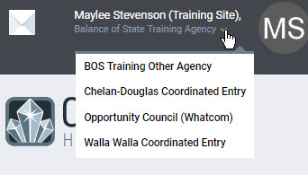
Switching Agency Profiles

If you do data entry for more than one Agency in HMIS, remember to switch your agency profile so you are in the correct agency BEFORE you start data entry. Failure to switch into the correct agency will result in client data being entered and counted incorrectly.

Client Search

If your household is “Consent Refused” – STOP. Please follow this guidance: HMIS Guidance for Domestic Violence and Consent Refused Providers (PDF) and Consent Refused HMIS Data Entry Guide - Step-by-Step (PDF) to create a client profile. Then skip to Link Household Members.

- From the Search tab search for all household members. A single person is their own household and head of household.

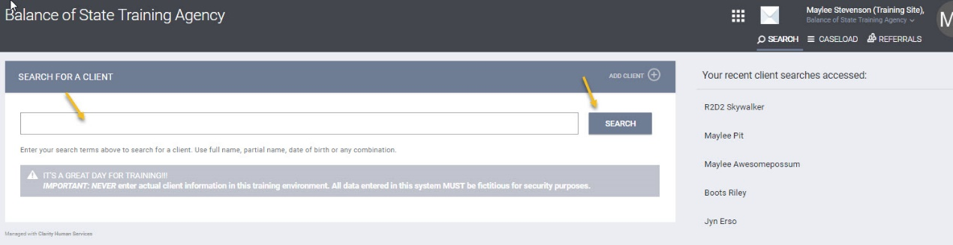

- To select a client, hover over the name and click the Edit icon that appears or click on the name if it auto pops up.

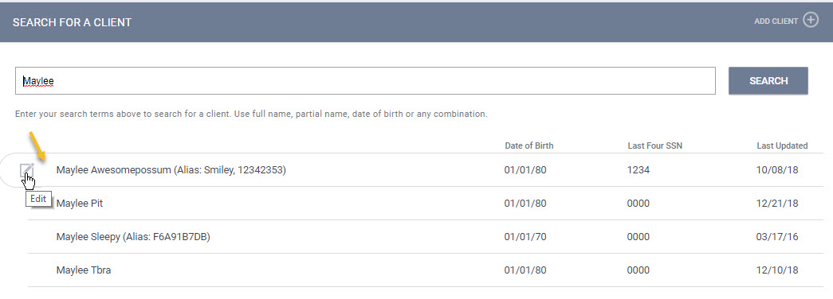

If the household is already in HMIS, check to see that their information is up to date and then move to Program Enrollment. If the household is not in HMIS, follow the instructions to Create New Client Profile.

Create New Client Profile

Create a Client Profile for each household member.

Remember: If anyone in the household is consent refused follow our HMIS Consent Refused Data Entry Guide.

- Click on the icon to create new client profile. 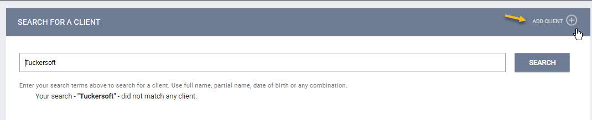

- Social Security Number: If you have a SS#, enter it. Otherwise, enter zeros (you cannot leave blanks), and pick the appropriate SS# quality choice.
- If no year of birth was provided, please estimate their age. Input 01/01 as the month and day and the estimated year (4 digits). In the DOB quality field, choose “Client Refused.”
- If Veteran Status is “yes”, a list of Theatre’s of Operation will appear as well as year entered and year separated from military service. Select “Data not collected” for all Theatre’s of Operation and enter 9999 for year entered and year separated from military service.

Screenhot of blank client profile screen for a consenting client.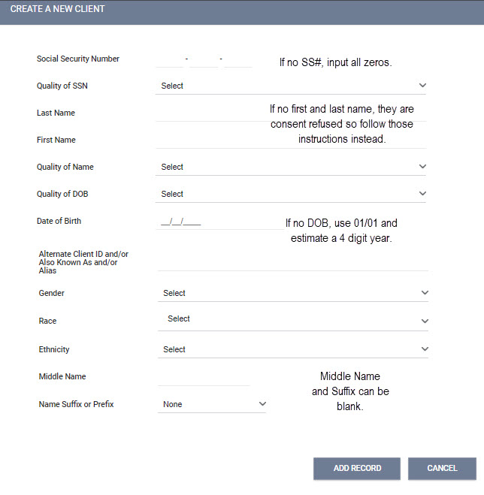
- After creation, write the HMIS generated Unique Identifier number on the PIT count form. All Consent Refused client PIT forms should have the HMIS unique identifier written somewhere on the form.
- A single person is their own household and head of household thus Skip to Program Enrollment.

Link Household Members (Group Households Only)

If you have a group household, you must link the household members before Program Enrollment.

- From the Head of Household Client Profile, click on the Manage button next to the header Household Members.
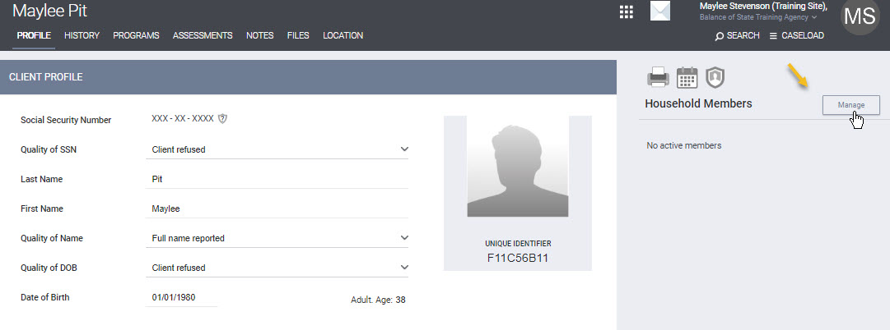

- From the bottom right side, hover over the client you want to add and click the Add link. If you do not see them listed, use the Household Members Search field to find them.

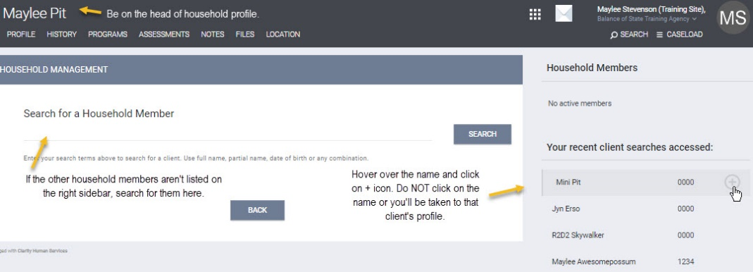

- In the Add to Household box, leave Member Type at NOT SET. Start Date is the date of the PIT Count. Be sure to add each household member.

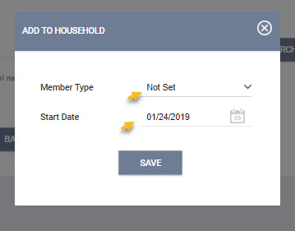

In the side bar, “No active members” will be replaced with the names of the household members you added and the head of household will have a star next to their name. If the star is NOT next to the head of household, contact the HMIS Trainer for instructions to fix it.

Program Enrollment

Enroll the household into the program.

- From the Head of Household Client Profile, click on the Program tab. Under Available Programs, pick the appropriate “PIT Count” program by click on the drop down arrow for it.

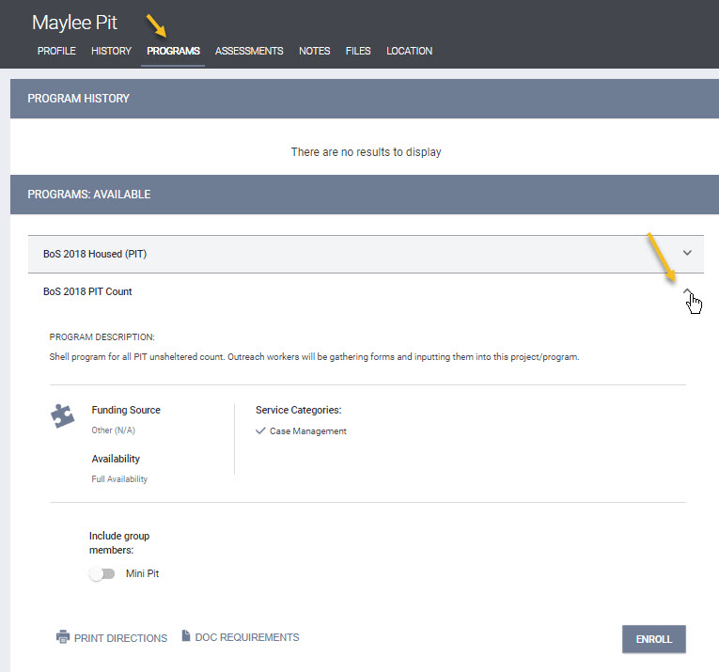

Group Households: you MUST toggle on the other group members. If you do not see the other members names, you forgot to Link Household Members and must complete that step before moving on. Contact the HMIS Trainer if you need help.
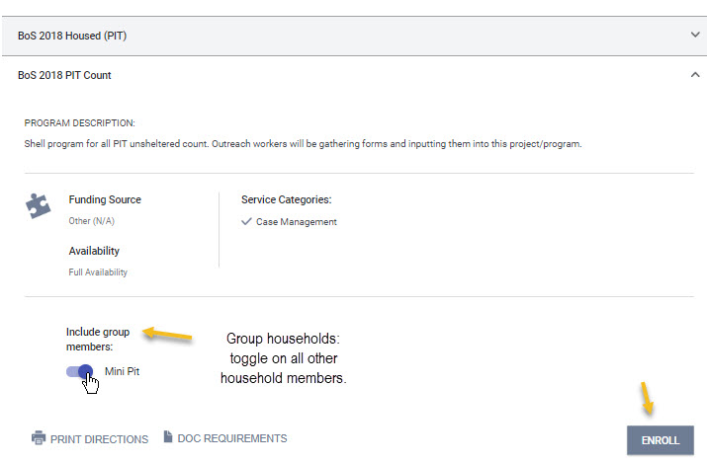

- Then choose the Enroll button.

- Fill in all the answers from the client’s completed PIT form. Start from the top and go down, as choices are sometimes auto filtered based on answers in the previous choices.

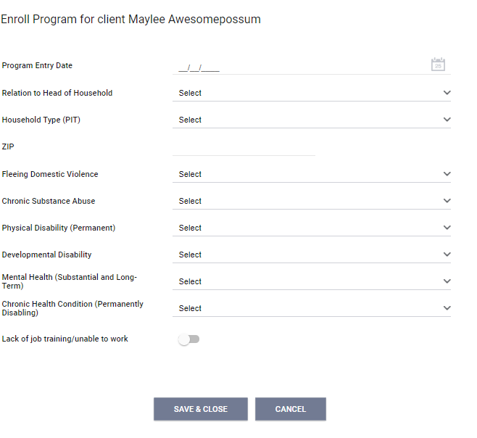

- Save when done. If you skip a required question, it will not let you save.
- If the household is an individual, Save and Close.
- Save and Next to move on to the next household member(s) questions.
- Once you have completed all household members and saved, you are done.

Sheltered Count

Non-Year-Round Participating – PIT Shell Programs for TH or ES

- Surveys for agency Transitional Housing and Shelter programs that do NOT use HMIS year-round and only for PIT count are entered into temporary “shell” (PIT) programs in HMIS.
- There will be a shell PIT program for each housing type (TH and ES).

Non-year-round TH and ES shell PIT program instructions are similar to the Unsheltered PIT Count instructions. The difference is noted below under Program Enrollment. Complete these steps as appropriate:
- Switching Agency Profiles (if appropriate)
- Client Search
  - Create New Client Profile (if not in HMIS already)
  - Link Household Members (for group household not already linked in HMIS)

Program Enrollment
Enroll the household into the shell (PIT) program as appropriate. Do not enter your TH or ES program into the Unsheltered “PIT Count” program. You should be able to tell from the program name what type of program it is (TH or ES) and if it is a PIT shell program (part of the program name is “PIT” in parentheses).

Year-Round HMIS Participating Programs – TH or ES

Whatcom County Agencies
- Contact your local HMIS admin, Katie Sly (Katie_sly@whatcomhsc.org), for special instructions.
- Whatcom County requires additional program record assessments.

Transitional Housing (TH)
For TH participants active in an HMIS program during PIT count:
- Automatically counted in the Point in Time Count. No additional data entry is required.
- Please check to make sure that all Transitional Housing clients enrolled on the night of the PIT count are active in HMIS with all of their Program Entry questions answered.
- If a client enrolls into TH on the night of the PIT count, enter them into HMIS as you normally do.

Emergency Shelter (ES)
For ES participants active in an HMIS program on the night of the PIT count:
- Automatically counted in the Point in Time Count. No additional data entry is required.
- Please check the data ensuring all ES clients enrolled on the night of the PIT count are active in HMIS with all of their Program Entry questions answered.
- Exit clients not staying the night of PIT count.

Night-by-Night or Minimal Entry ES:
- Complete the [2018] WA PIT Housed – Minimal or NBN Assessment* (program record level assessment_.

List of Night-by-Night (NBN) or Minima Entry programs that will need to complete the [2018] WA PIT Housed Assessment* by agency and county:

County | Agency Name | Programs Name | Type
Clallam | Serenity House of Clallam County | SHCNight-by-night Shelter | ES NBN - Minimal
Grant | HA Grant County | HAGRecording Fee Voucher Program | ES NBN - Minimal
Skagit | Friendship House | FSHWinter Shelter | ES NBN - Minimal
Skagit | Skagit Valley Family YMCA | OTSOasis Teen Shelter | ES NBN - Minimal
Thurston | Community Youth Services (Thurston) | CYSYoung Adult Shelter | ES NBN - Minimal
Thurston | Family Support Center | FSC2163-Cold Weather Shelter | ES NBN - Minimal
Thurston | Interfaith Works | IFWInterfaith Works Emergency Overnight Shelter | ES NBN - Minimal
Thurston | Interfaith Works | IFWOne Night Stay Shelter | ES NBN - Minimal
Thurston | Salvation Army (Thurston) | VATCold Weather Shelter | ES NBN - Minimal
Yakima | Salvation Army (Yakima) | SAYHotel Vouchers | ES NBN - Minimal
Yakima | St. Vincent DePaul (Yakima) | SVTHotel Vouchers | ES NBN - Minimal
List generated 1/10/2019

[2018] WA PIT Housed – Minimal or NBN Assessment*

Enter your household(s) into HMIS and mark their attendance as you normally do. In addition to your normal data entry, you will need to answer the additional questions in the “[2018] WA PIT Housed – Minimal or NBN assessment*” (the year reflects when the assessment was created - not the current year) located in the program record following these instructions:

- From the Head of Household (a single person is their own head of household), click on the Program tab. Hover over the program name and choose the Edit link to open the program record.

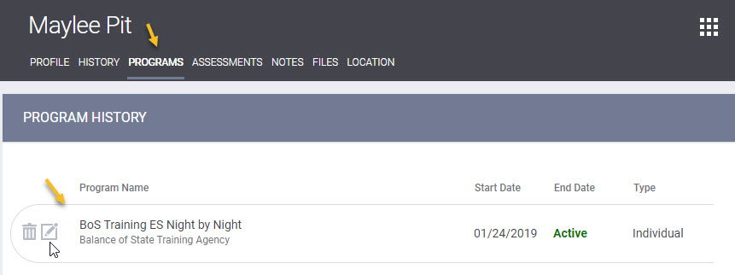

- Click on the Assessments sub tab located under the program record name. Click the Start button for the “[2018] WA PIT Housed – Minimal or NBN*.”

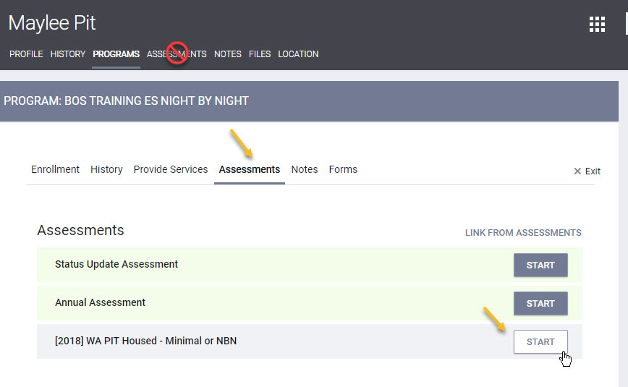

- Input the answers from your PIT form. Start from the top and work your way down as questions may change based on your previous answer.
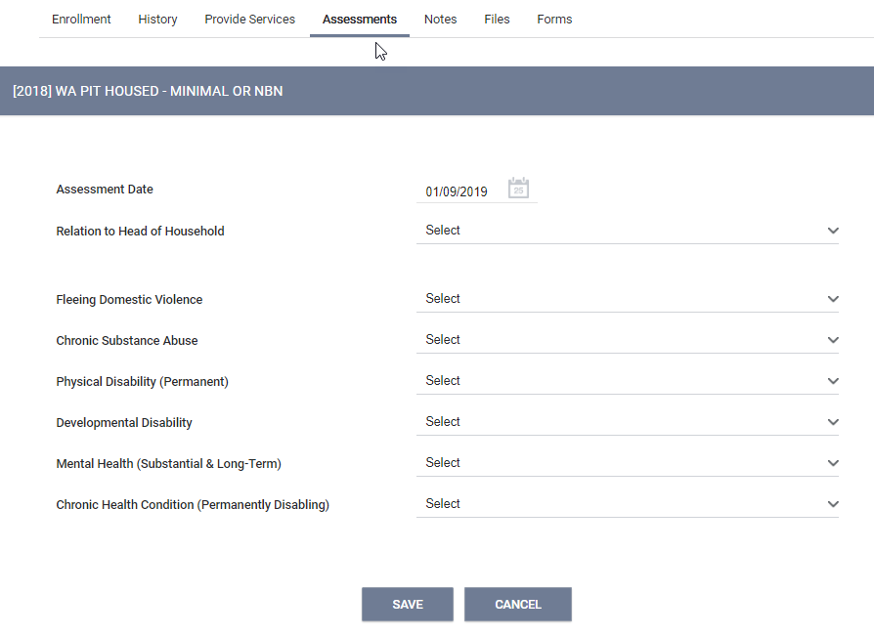

- Save. If you are missing any required answers, it will not let you save. Enter the missing data and try saving again.

Group Households: For additional household members in a group household, you will have to go to each client’s profile and complete a [2018] WA PIT Housed – Minimal or NBN assessment*. When you have completed the assessment for all household members, you are done.

*The year in the assessment name is based on when the assessment was created and not the year of the count.

Reports - Check Data Quality

Year-Round Agencies Data Quality

Year around agencies can check there data quality before PIT count day. Run reports to view clients that are currently enrolled in your TH and ES programs. Exit clients that are no longer in the program with the appropriate exit date. Do general data quality checks that household are correct and enrollment answers are done properly.

If your agency tracks Rapid Re-housing (RRH) or Permanent Housing (PH) programs in HMIS, check the housing move-in dates for those programs. Although these program types aren’t specifically tracked for PIT count purpose, they can impact TH and ES PIT totals. If a client has a RRH or PH housing move-in date, that is the same as or before PIT Count date, which overlaps with an TH or ES enrollment date, the TH or ES program – it will look like the TH or ES program has the wrong exit date and not be counted for PIT. It’s important that agencies are providing the correct data into HMIS as errors can impact future funding opportunities. For guidance on HMIS definition, such as the Housing Move-In Date, see the HUD HMIS Data Standards Manual.

All Agencies Data Quality and Reports

All agencies can run reports to check their HMIS data. Things to check for:
- Are consent refused client profiles are correct per our HMIS Consent Refused Data Entry instructions?
- Are the right clients in the correct household with the correct head of household?
- Is the program start date correct? (unsheltered and non-year-round TH/ES is always PIT count date)
- Are the answers correct?

NBN Only:
- NBN & Minimal Set Up Programs – was the [2018] WA Housed PIT Assessment* done and was there a bed night added for clients there PIT count night?

Year-round agencies only:
- Year-round agencies with RRH or PH programs – see the explanation in the Year-Round Agencies Data Quality section for details on checking your housing move-in dates.

Reports useful for all project/programs under the Programs Based Reports:

Limited Data for Basic Analysis
[GNRL-106] Program Roster: Clients Active/Exited by Program, Length of Stay, Program Enrollment Date, Households, (RRH & PH program Housing-Move-in Date)

All Data for Detailed Analysis
[GNRL-220] Program Details Report: Program Specific Data Elements (for extensive details), can see every question answer.

ES NBN Shelters
[GNRL-400] Program Linked Service Review: Clients by Services for service reporting of ES NBN

Help & Resources

PIT Count
PIT count forms, PIT guidelines, and PIT instructions can be found on our website: www.commerce.wa.gov/serving-communities/homelessness/annual-point-time-count.

If you have any PIT questions please contact Nick Mondau, nick.mondau@commerce.wa.gov.

HMIS Only
Non PIT HMIS forms, HMIS guides, HMIS Consent Refused data entry instructions, HMIS help contacts, and other HMIS information can be found at:
www.commerce.wa.gov/hmis

If you need HMIS Data Entry coaching, please contact Maylee Stevenson at maylee.stevenson@commerce.wa.gov.

