SNAP (Spokane Neighborhood Action Partners)
Glenda and her husband Jerome have lived in their north side home for 44 years. Their home, like so much of Spokane’s housing stock, is aging. Older housing stock, like the Glenda and Jerome’s 107-year-old home, can pose a unique set of challenges for both homeowners and the community. This can be further complicated when low-income families occupy these homes and struggle to afford maintenance and repairs.
Although the couple’s home may be cold and drafty, it is cared for meticulously. One of Glenda’s favorite things about her home is that it sits on a double lot. This leaves her plenty of room for one of her favorite pastimes, gardening.
When summer ends, Glenda utilizes the remainder of her harvest
to prepare canned goods for the winter. She cans everything from jams to sauces and salsas. The couple live on a fixed income. Gardening and canning are just one of the tools they utilize to make ends meet.
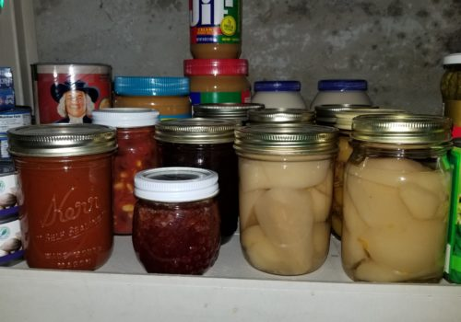
“It’s always tough to budget, especially in the winter months,” explained Glenda. “We do what we have to to make it through.”
Glenda and Jerome are not alone; in 2016, SNAP served 10,180 low-income residents 55 and older in various programs.
“To be eligible for weatherization, a household of two has to make less than $2,949 a month” Cynthia Brower, SNAP’s Administrative Assistant explains, “most of the households we serve make much less than that.
It doesn’t leave a lot of money for unexpected expenses.”
According to Oak Ridge National laboratory, families with limited income, on average, spend 16% of their income on energy costs. That is why when Glenda saw a flier for energy assistance at the Avista Utilities energy fair, she marked it on her calendar. Financial assistance to help cover high-energy costs in the winter can allow for more money to spend on food, medicine and other essential needs.
The Avista energy fair was the couple’s first introduction to SNAP. They learned they were eligible for a $400 senior grant toward their Avista bill. While speaking with a SNAP Energy Specialist, they also learned about the Weatherization Assistance Program (WAP).
The WAP program was launched in 1976 to save imported oil and reduce energy bills for vulnerable families. Recipients of the programs save an average of $283 per year in energy costs, according to the National Association for State Community Services Programs (NASCSP). The program installs measures in homes such as air sealing, wall and attic insulation, duct sealing and furnace repair/replacement to reduce the energy burden of low-income households.
After expressing interest in the program, the couple spent seven months on a waiting list before meeting with Aleks, their SNAP auditor, to perform an energy audit on their home. Depending on a variety of factors, this wait can vary anywhere from a couple months to a year or more. The high amount of interest in Weatherization signifies the need and importance for such programs in the community.
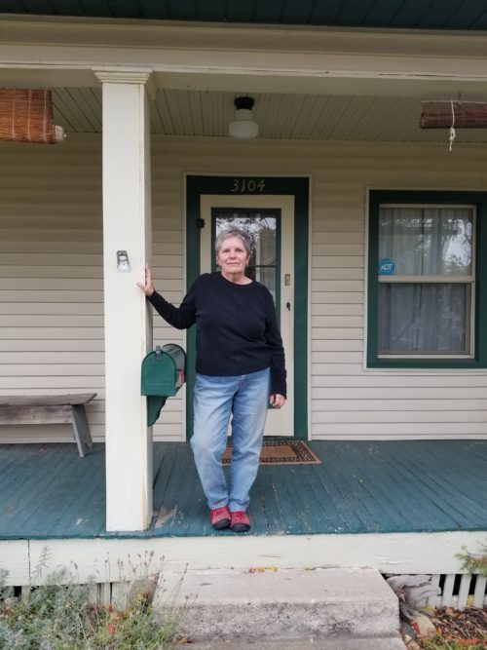
“We didn’t mind the wait,” said Glenda “We were just thrilled they are doing this for us and it’s not costing us anything.”
The audit revealed many opportunities to reduce the home’s energy use. It was determined that a 30-year-old faulty furnace needed to be replaced. The inefficient furnace required yearly maintenance and the couple was living in fear that it could stop working at any time.
“We are so happy to be going into the winter with a new furnace” Glenda exclaimed. “I know it’s going to be a lot warmer”.
The couple, whose weatherization work wrapped up in July, are already noticing significant improvements in the comfort of their home. The repairs kept their home much cooler in the summer months and they notice their furnace turning on less often as winter approaches.
In addition to weatherization, measures were installed to improve the health and safety of the home. For example, during an auditor’s evaluation, the risk of mold and moisture is evaluated.
“They installed a newer, safer, vent for my dryer as well as a new bathroom fan”, Glenda said. “The shower doesn’t steam up the mirror any more, I love it!” Glenda and Jerome can now monitor the moisture in their home on a hygrometer provided by SNAP.
The couple now keeps the majority of their appliances and electronics unplugged when they are not in use - just one of the helpful habits learned during the in-home conservation education portion of the WAP process.
“Aleks was so kind to show me how to change my furnace filter,” Glenda explains. “I do it regularly now”.
“It is our highest priority to ensure the safety and affordability of the homes of the clients we serve” said Kristi Sherlock, SNAP’s Housing Services Operation’s Coordinator, “SNAP has been providing weatherization services to the community for over 30 years and we plan to for many more”.
On average, SNAP weatherizes 18 homes a month.
November 17,

