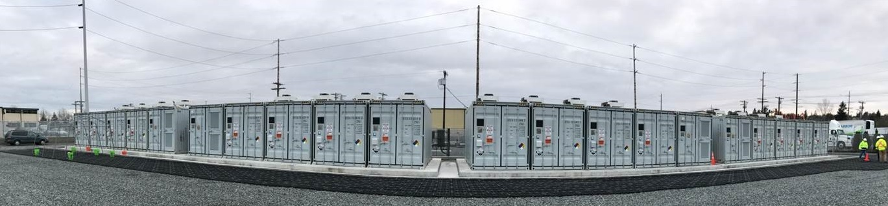

**Snohomish County PUD**

**MESA 2**

**Vanadium Flow Battery**

**Project Profile**

**Components:**

* 2.2 MW/8 MWh – Battery Energy Storage System
* Battery manufactured by UniEnergy Technologies
* MESA* compliant battery
* MESA software controls designed by Doosan GridTech

*MESA: Modular Energy Storage

Architecture, mesastandards.org

**Use Cases:**

* Peak Shifting
* Energy Arbitrage
* Managing Transmission Constraints
* Best Market Purchases
* Energy Imbalance Mitigation

*Pacific Northwest National Laboratory helped develop use cases and will provide analytical and technical support, including conducting benefits analysis.*

**Contact:**

Arturas Floria  
Engineer  
Snohomish County PUD  
425-783-5109  
afloria@snopud.com

**2320 California Street** Number of Employees: **1,002** Year Founded: **1936** Region Served:  **Everett, WA 98201** Website: **snopud.com Snohomish County & Camano Island**

**Project Address:**

3302 Paine Avenue

Everett, WA 98201

**Project Overview:**

In summer 2017, Snohomish County PUD deployed an energy storage system comprised of multiple advanced vanadium-flow batteries at its Everett Substation. By capacity, it is the world’s largest containerized vanadium-flow battery system. The system is housed in 20 shipping containers, each 20 feet in length, packed with tanks of liquid electrolyte solution.

**What will this project do?**

The vanadium flow battery system, along with other PUD storage projects, aims to transform the marketplace and how utilities manage grid operations. They are designed to improve reliability and the integration of renewable energy sources, which are rapidly growing in the Pacific Northwest. Energy storage changes the way that the PUD operates its SCADA system in that historically its distribution system has always operated one-way from generating resources.

**What will this grant demonstrate?**

The project demonstrates a variety of use cases, including peak shifting, energy arbitrage, managing transmission constraints, maximizing best market purchases and mitigating energy imbalance. Controls integration and optimization software is one of the keystones of the PUD storage program. Future energy storage systems could help resolve a broad range of other issues related to grid operations, such as frequency and voltage support.

The Modular Energy Storage Architecture (MESA) includes standard electrical and communications interfaces that connect batteries, power converters and software components. Its standardization will help barriers to growth in the energy storage industry.

**Milestones:**

2015: Project planning, design and contracting

2016: Battery manufacturing, civil construction and container delivery

2017: System integration, testing and acceptance by the PUD

**Challenges**

Safe containment of the vanadium electrolyte was critical to the design, ensuring that subsequent battery leakage issues did not impact the integrity of the project. It did require the manufacturer to replace parts under warranty. In addition, with a new technology and manufacturing complexities, the vendor delayed the battery strings’ delivery by 10 weeks.

**Lessons Learned**

A conservative approach regarding environmental safety benefitted the project, with multiple containment systems within the Doosan container design. This helped make the permitting process more efficient. As a new technology, the vanadium flow battery system has been a research and development project. As a result, more time was needed by the vendor to build, install, re-deign/repair the system as needed. Initial charging of batteries identified issues that required power conversion system firmware upgrades and additional coding, which ultimately was resolved.

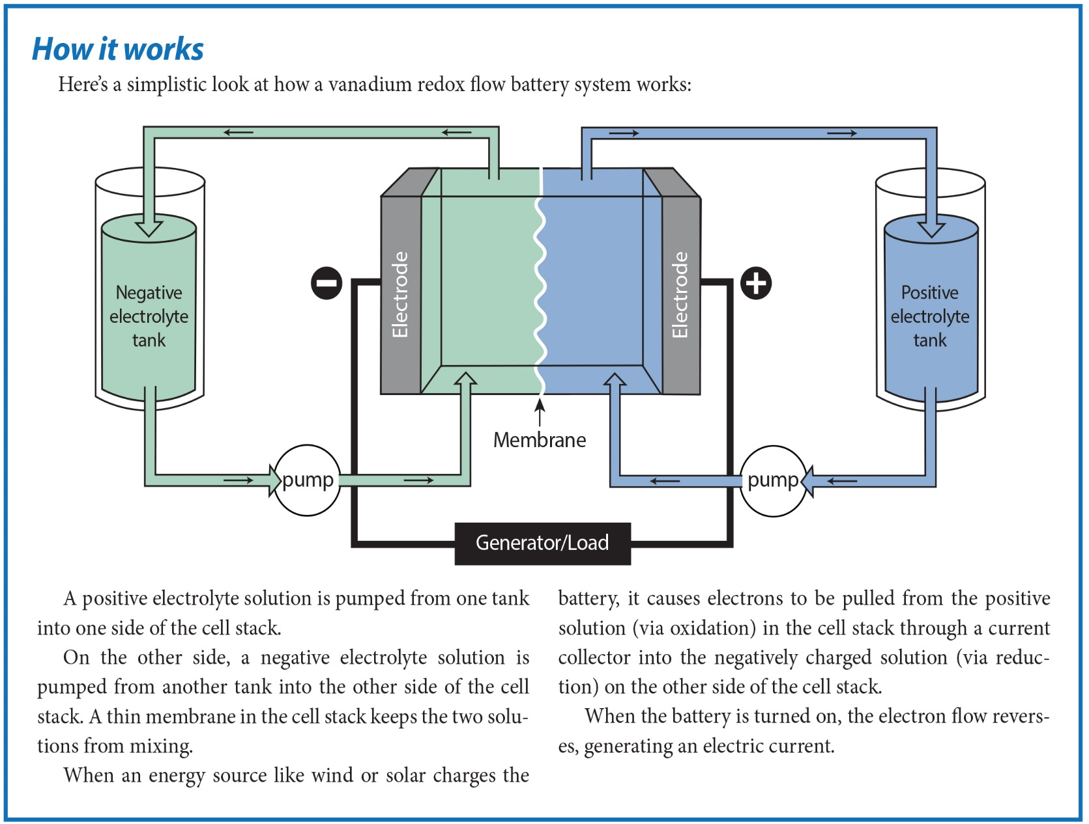

*The Modular Energy Storage Architecture utilizes standard interfaces between equipment components, such as the power conversion system, batteries and control system. These bring more choices for utilities, reduce projects’ complexity and ultimately lower costs.*

-- Craig Collar, former PUD CEO/General Manager

**About the PUD**

Snohomish County Public Utility District serves one of the fastest-growing counties in the Pacific Northwest, delivering electricity to more than 345,000 customers and water to 20,000 customers. It is currently the second largest public utility in the Pacific Northwest. The PUD has developed two energy storage systems in Everett, WA, with the third system planned for Arlington in 2020.