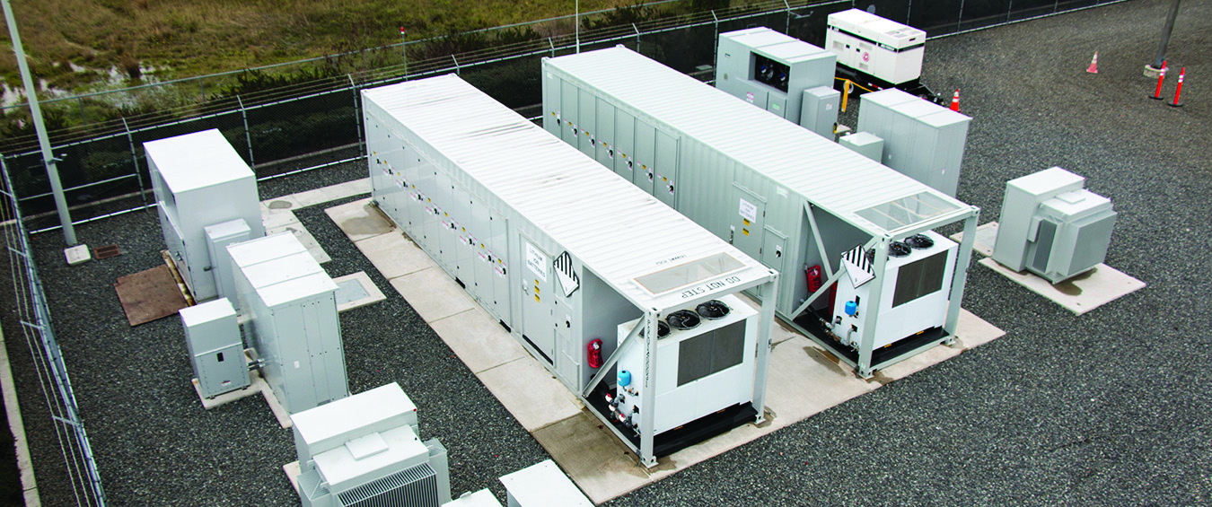

**Project Profile**

**Components:**

* 2 MW/1 MWh – Lithium-Ion Battery Energy Storage System
* Two-Battery system: One built by GS Yuasa (supplied by Mitsubishi) and second built by LG Chem
* Power Conversion System and containerization by Parker-Hannifin.
* MESA*-compliant batteries
* MESA software controls designed by Doosan GridTech

*\*MESA: Modular Energy Storage*

*Architecture, mesastandards.org*

**Use Cases:**

* Peak Shifting
* Energy Arbitrage
* Managing Transmission Constraints
* Best Market Purchases
* Energy Imbalance Mitigation
* System Capacity
* Volt/Var
* Load Shaping

**Contact:**

Jason Zyskowski  
Senior Manager, Planning, Engineering & Technical Services  
Snohomish County PUD  
425-783-4332  
jazyskowski@snopud.com

**Snohomish County PUD**

**MESA 1**

**Lithium-Ion Battery**

**2320 California Street** Number of Employees: **1,002** Year Founded: **1936** Region Served:  **Everett, WA 98201** Website: **snopud.com Snohomish County & Camano Island**

**Project Address:**

910 Shuksan Way

Everett, WA 98203

**Project Overview:**

In 2015, Snohomish County PUD deployed its first energy storage system comprised of two lithium-ion batteries, sited at a South Everett substation. The system was the first to be based on the innovative Modular Energy Storage Architecture (MESA). The project, along with a second vanadium flow battery system, is supported by a $7.3 million grant from the Washington Clean Energy Fund.

**What will this project do?**

The lithium ion system, along with other PUD storage projects, aims to transform the marketplace and how utilities manage grid operations. They are designed to improve reliability and the integration of renewable energy sources, which are rapidly growing in the Pacific Northwest. Energy storage changes the way that the PUD operates its SCADA system in that historically its distribution system has always operated one-way from generating resources.

**What will this grant demonstrate?**

UPDATE? The project demonstrates a variety of use cases, including peak shifting, energy arbitrage, managing transmission constraints, maximizing best market purchases and mitigating energy imbalance. Controls integration and optimization software is one of the keystones of the PUD storage program. Future energy storage systems could help resolve a broad range of other issues related to grid operations, such as frequency and voltage support.

The Modular Energy Storage Architecture (MESA) includes standard electrical and communications interfaces that connect batteries, power converters and software components. Its standardization will help reduce or eliminate barriers to growth in the energy storage industry.

**Milestones:**

2015: MESA 1a system completed and accepted by PUD

2016: MESA 1b system completed and accepted by PUD

2017: Pacific Northwest National Laboratory testing completed

**Challenges**

Engineering and deploying systems without standards – standards not only help drive down cost, they also provide a common platform for suppliers and utilities to understand design, manufacturing, environmental and operating requirements for equipment.

**Lessons Learned**

After project completion the battery underwent use case testing with the Pacific Northwest National Laboratory. The use case testing included energy shifting, system capacity, Volt/VAR control and load shaping. The testing provided insights into operation of the battery and round trip efficiency. The battery was also deployed in a demand response project in conjunction with Enernoc and the BPA. The BPA, UW, Doosan GridTech and the PUD did a joint Technology Innovation Fund project to study utilization of the battery for both transmission and distribution systems. The study demonstrated a communication and optimization framework for the coordinated use of energy storage systems. A case study was performed with the Pacific Northwest transmission system and the MESA 1 energy storage system. Results from the study demonstrated scheduling methodology to provide congestion relief, cost savings and improved renewable integration.

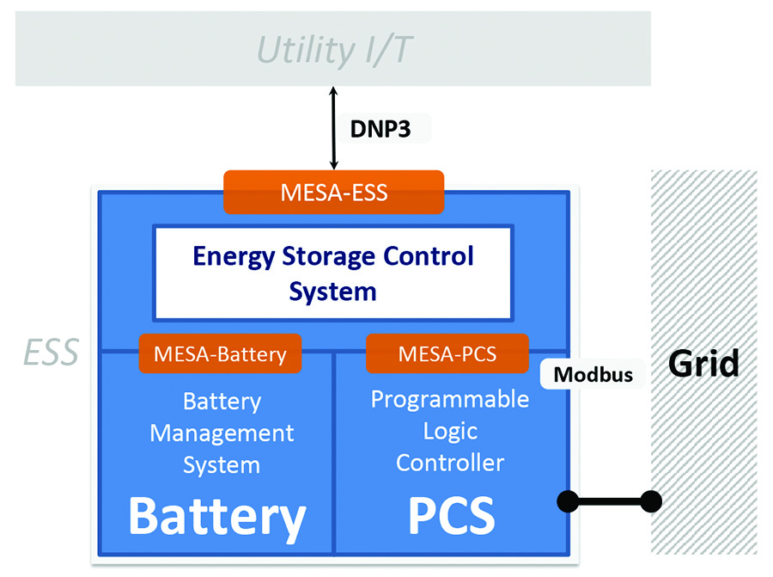**D**

Diagram of MESA Compliant System

*Past energy storage systems were each its own black box project, requiring a lot of non-recurring engineering costs in order for the battery system talk to the power conversion system and other utility systems such as SCADA. MESA software creates a common thread. It knits it all together to unlock the full potential of energy storage.*

-- Jason Zyskowski, PUD Senior Manager, Planning, Engineering & Technical Services

**About the PUD**

Snohomish County Public Utility District serves one of the fastest-growing counties in the Pacific Northwest, delivering electricity to more than 345,000 customers and water to 20,000 customers. It’s currently the second largest public utility in the Pacific Northwest. The PUD has developed two energy storage systems in Everett, WA, with the third system planned for Arlington in 2020.