# Emission Performance Standard Overview

In 2007 Washington established a greenhouse gas (GHG) emission performance standard (EPS) of 1,100 lb./MWh CO2 for baseload electricity generation. The details of the EPS are codified in the Revised Code of Washington (RCW) chapter 80.80. In 2012-13, through rulemaking, Commerce updated the EPS to 970 lb./MWh CO2.

RCW 80.80.060(1) prohibits utilities from acquiring through long-term contract (5 years or greater in length) electric power produced by a baseload[1] generating resource(s) that exceed the emissions performance standard. Short-term contracts of less than 5 years are allowed. Utilities are also prohibited from building or purchasing baseload generation resources that exceed the emission performance standard.

For Commerce, the relevant section of the statute is [RCW 80.80.050](http://apps.leg.wa.gov/rcw/default.aspx?cite=80.80.050) which specifies that the Energy Office of the Department of Commerce (Commerce) “shall provide interested parties the opportunity to comment on the development of a survey of new combined cycle natural gas thermal electric generation turbines commercially available and offered for sale by manufacturers and purchased in the United States to determine the average emissions of greenhouse gas for these turbines.” The turbines referred to in this language are called combined cycle combustion turbines (CCCTs) in the industry, a term used in this document as well.

The law requires Commerce to report the results of its survey to the Legislature every five years beginning June 30, 2013, and adopt by rule the “average available greenhouse gas emissions output” every five years beginning five years after July 22, 2007. If the average available greenhouse gas emissions output is lower than the current standard, it becomes the new standard for the state. For both brevity and clarity Commerce refers to the adopted or proposed rule as the emission performance standard (EPS).

A key word in the third paragraph above is “survey”. Commerce initially interpreted the word to mean the entire analytical process undertaken to establish the establish the EPS, but during the 2012-13 rulemaking (2012 rulemaking from here on) process realized that it was helpful in communicating with stakeholders to present the analytical process as being comprised of two separate parts. The first part is the actual survey, or accounting, of the CCCTs that utilities are purchasing and installing, the second part is the series of calculations required to determine the EPS value, and is referred to as the EPS calculator. Both the EPS survey and calculator are described in detail below.

**Methodology: Developing the EPS Survey**

The language in RCW 80.80.050 is very general, and during the 2012 rulemaking Commerce has had to interpret several keywords.

* The word “new” is interpreted as meaning CCCTs offered for sale by their vendors during five calendar years prior to the start of a rulemaking. These CCCTs represent the new machines that utilities and independent power producers are investing in.
* “Commercially available” is interpreted as meaning CCCTs available in the U.S. and designed to generate alternating current at 60 hertz, but does not include CCCTs made by other manufacturers under license from GE and Siemens, as these are copies of existing GE and Siemens products.
* “Purchased” is interpreted as meaning CCCTs that had been purchased by utilities or independent power producers in the U.S. and were installed or were in the process of being installed during the five calendar years prior to the start of rulemaking. These constraints limited the number of CCCTs that could be included in the survey, as several new machines were not commercially available or had not been purchased and installed[2]. The same applies for a large number of older and very small CCCTs that while technically still offered by manufacturers are not currently being purchased and installed by utilities.

Based on the above interpretations of the statute language, Commerce developed a survey of CCCTs purchased and installed in the United States during the five years preceding the start of the rulemaking. During the 2012 rulemaking Commerce used web searches and market reports found in the engineering journal Gas Turbine World (GTW) to establish the number and types of CCCTs utilities and independent power producers were purchasing and installing. The national survey categorized CCCTs by manufacturer, model, capacity when possible, and plant architecture. This categorization allowed Commerce to link heat rate and efficiency with the CCCTs in the survey. See Appendix A for definitions of terms used in establishing the ESP survey.

During the development of the 2012 rulemaking Commerce held several stakeholder meetings. A technical stakeholder subgroup was also created to assist in the development of the EPS survey and calculator methodology. Stakeholders were encouraged to comment on the survey methodology during the 2012 rulemaking. Commerce responded to the comments and, in some cases, incorporated changes into the rulemaking process.

**Methodology: Developing the EPS Calculator**

Manufacturers of CCCTs publish capacity, heat rate, efficiency and other parameters on their websites and in engineering journals. During the 2012 rulemaking Commerce used performance parameters published in GTW to guide its’ analysis, but quickly realized that emission performance parameters published by CCCT manufacturers are optimistic under the most ideal circumstances. Commerce concluded that efficiency and emission performance parameters published by GTW would have to be adjusted to reflect the challenging real world operation.

Determining real world operational efficiency and emission performance parameters for CCCTs meant examining a number of adjustment, or derating factors. A technical group comprised of state personnel, utility power engineers and representatives from environmental organizations developed the adjustment factors. The CCCT adjustment factors account for declining plant efficiency due to aging, partial and variable load operation, frequent stops and starts for load following, and several other operational or design factors that have an impact on CCCT performance and GHG emission rates. The survey and calculator methodologies outlined below are similar to the step-wise approach used by the Environmental Protection Agency, and New York State Department of Environmental Conservation, and others for calculating real world GHG emission factors from the new and clean gross efficiency values published by manufacturers. See Appendix A for definitions of terms used in establishing the ESP survey.

# The 2017-18 Emission Performance Standard Survey and Calculator

The 2017-18 (2017 from this point on) EPS survey follows the 2012-13 methodology with some evolutionary changes. For the current EPS cycle, we chose for presentation purposes to make a distinction between the survey of new, commercially available and purchased CCCTs and the EPS calculator where specific heat rates and adjustment factors are applied to arrive at the EPS value that the regulatory agencies will reference in their WAC. The 2017 survey and EPS calculator are discussed briefly below.

**2017 CCCT Survey**

* We surveyed new CCCTs purchased and installed in the U.S. from 2012 through mid-2017. This information was provided by the three primary CCCT suppliers at the request of Pacific Corp. The 2012 survey was derived from Gas Turbine World reports and website searching, and was likely not as thorough as the 2017 survey.
* There were 77 new CCCT installations reported during 2012-17 which is summarized in the Table 1 below. The CCCTs are broadly grouped in three categories: Aero-derivative, Mid-sized and mid-level technology, and Larger and advanced technology.
* The national survey represent the type of new CCCTs that electric utilities are likely to purchase and install. We created a smaller subset of 20 CCCTs to more conveniently represent the national survey sample. This group of 20 should be thought of as a representative sample and is the sub-group of CCCTs used in the EPS calculator: grouped by manufacturer and model.
* The national survey contained many large CCCT formats (variable number of gas turbines) of 900 to 1400 MW of capacity (possibly 1000 to 1600 MW if duct firing is added). The largest CCCT in the Northwest is about 600 MW, and is operated at a low capacity factor[3]. The Washington state average CCCT size is 300 MW. During the 2012 survey, stakeholders requested that Commerce remove or alter the formats of several large CCCT. For 2017 we elected to set a cap of roughly 600 MW of capacity for CCCTs in the EPS calculator.

**2017 EPS calculator**

* Following discussion at one of the technical group meetings the start/stop/partial load adjustment parameter was increased from 6 to 7 percent to account for additional up/down CCCT ramping that is expected as utilities join the Energy Imbalance Market and as more distributed variable resources enter service regionally.
* Heat rates for duct firing were lowered to 9200 and 9550 Btu/kwh for large and small CCCTs reflecting technological improvements and access to better information.
* The amount of duct firing time in the EPS calculator was reduced from 40 to 30 percent of run time.
* Following stakeholder discussion, the duct firing fuel input rate was increased from 80 to 100 percent. After receiving some last minute comments at the CR102 rulemaking stage, the fuel input rate was returned to 80 percent.

The 20 representative CCCTs derived from the national survey were entered into the EPS calculator, along with the altered adjustment factors noted above, resulting in the proposed EPS value of 930 lb./MWh shown in Table 2 below. This value was published in the CR 102 filing on March 21, 2018.

We allowed an extended comment period for the EPS value published in the CR 102 and received a number of comments, which we respond to in the Comments and Responses document. Refer to Appendix C for stakeholder comments and Commerce responses.

Table 1: National 2017 CCCT Survey



Table 2: Proposed 2018 Emission Performance Standard, March 2018

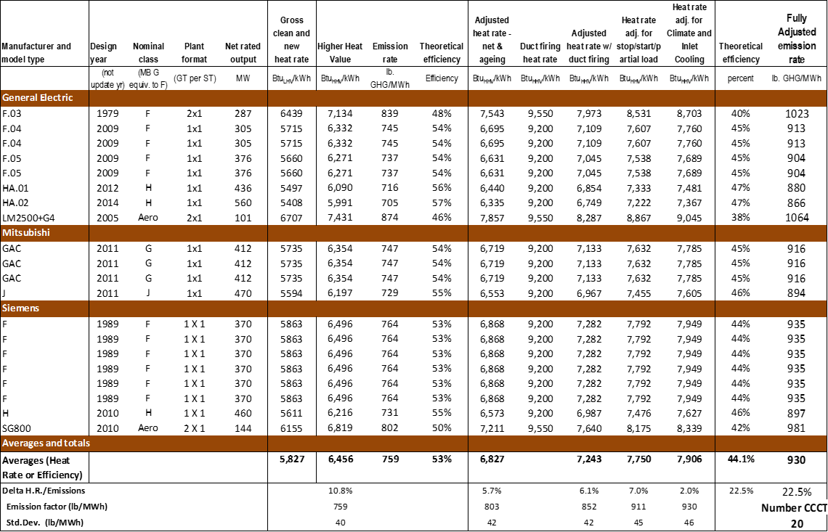

**Adjustments to the CR102 Emission Performance Standard Survey and Calculator**

After reviewing and responding to the stakeholder comments following the March 21 issuance of the CR102, we made the following adjustments to the CCCT survey and the EPS calculator.

1. Based on information in the national CCCT survey shown in Table 1, we adjusted the makeup of the CCCTs in the EPS calculator dated Feb. 26. To more precisely match the CCCT distribution of the 2017 national survey, we increased the number of GE F.03 CCCTs to two and reduced the number of F.04 CCCTs to one unit. The total number of CCCTs in the EPS calculator remains at 20. Manufacturer and category shares remain unchanged.
2. We changed the GE aero-derivative CCCT in the EPS calculator to a larger and more efficient model, the LM6000, which could replace smaller and older existing Northwest CCCTs and be permitted as a baseload power plant.
3. Earlier in the rulemaking, at the suggestion of a stakeholders, the duct firing fuel input rate was increased to 100%. After comment and review, we have returned the duct firing fuel input rate to the 80% value used in 2012.

The three modifications above were incorporated into the EPS calculator and the average GHG emission rate was accordingly recalculated. The results are shown in Table 3 below.

Table 3: Adjusted EPS Calculator, June 28th



The three adjustments lower the proposed EPS value slightly from the Feb. 26 calculator value of 930 lb./MWh to 925 lb./MWh.

To the test the reasonableness of using the sample set of 20 representative CCCT shown in Table 1 above we incorporated the entire 2017 national CCCT survey data set into the adjusted EPS calculator. The outcome of this procedure is shown in Table 4 below.

Table 4: Incorporation of the entire 2017 National Survey into the EPS calculator.



Table 4 (continued)



The final EPS value in Table 4 above is the same as shown in the previous table, which used the smaller representative set of 20 CCCTs. Several CCCT models in Table 2 are presented in the slightly more efficient 2X1 format and a slightly more efficient LM 6000 aero based CCCT is substituted into the calculator. Small alterations to the CCCT formats, sub-model variants, type of aero CCCT selected, etc. can be made that will drive the EPS calculator value of 925 lb./MWh in Table 4 by plus or minus 4 or 5 lb./MWh. We feel that this analysis, following the adjustments to the EPS calculator and using the full complement of the 2017 national CCCT survey data set confirms that the small downward adjustment of the EPS value to 925 lb./MWh is both justified and reasonable.

1. Baseload resources in Washington State are those permitted (not required) to operate 60 or more percent of the time.
2. Often CCCT power plant projects are announced, but never taken to completion. Commonly CCCTs are ordered and a spot in the production queue is reserved, but the machines are not fully purchased until the power plant project is well under way. On occasion projects where site development has begun are canceled.
3. It is owned by an independent power producer and is operated at a low capacity factor.