Utility Integrated Resource Plan
Cover Sheet Instructions
Due September 1, 2018
Dated June 25, 2018

Washington State Utility Resource Plans, 19.280 RCW (2006 House Bill 1010)

Utility Resource Plans including, at a minimum, the attached cover sheet must be submitted to the Washington State Department of Commerce (Commerce) by September 1, 2018. An excel spreadsheet template of this cover sheet is provided and is recommended for use in reporting as it ensures more accurate data compilation. For detailed requirements of plan development, see 19.280 RCW, at http://app.leg.wa.gov/RCW/default.aspx?cite=19.280

Selecting a Plan: Resource Plan or Integrated Resource Plan?

Before you continue, select the correct set of instructions for your utility. There are two plan types: 1) a Resource Plan and 2) an Integrated Resource Plan.

These instructions are for an Integrated Resource Plan which:
- must be completed by all utilities with more than 25,000 meters that are not full requirements customers of BPA (also referred to as 100% BPA utility customers, and
- may be used by utilities with less than 25,000 meters that follow their own loads.

A standard Resource Plan should be completed by full requirements customers (100% BPA or other) and utilities with fewer than 25,000 meters.

Integrated Resource Plan Cover Sheet screenshot
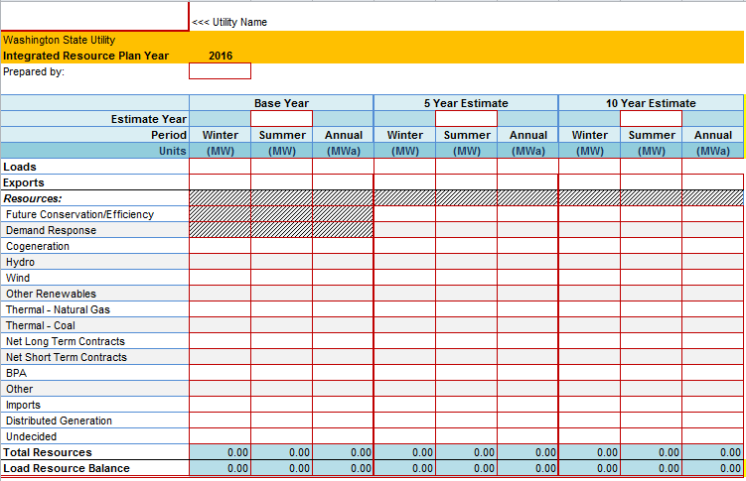
Reporting Details

Resource Plan Year
The IRP summarized in this cover sheet is to be completed this year: 2018.

Base Year
Twelve month period of actual, not projected electricity service. A Base Year of 2016 or 2017 is recommended.

Five and Ten Year Load and Resource Reporting:
On the cover sheet, five and ten year reporting is for calendar years or federal fiscal year, (October – September). Federal fiscal year has been added as an option to accommodate utilities that create plans consistent with federal power contract terms. If your Base Year is 2016, the five and ten year estimates should be 2021 and 2026. If your Base Year is 2017, they should be 2022 and 2027.

Reporting Units
Summer Peak One-Hour Demand, Megawatt (MW)
Winter Peak One-Hour Demand, Megawatt (MW)
Annual Energy, Average Megawatt (MWa)

Loads
19.280 RCW says that the IRP should include “a range of forecasts….of projected customer demand…..” For purposes of this cover sheet, utilities should report the data from their “preferred alternative” or equivalent scenario or their “mid-range” forecast or equivalent scenario.

All projected loads (non-base year) are before estimated reductions from conservation programs or demand reduction program estimates. Conservation and demand response are treated as a resource to meet load. The Base year does not include conservation or demand reduction as a load or resource.

Average Energy
Retail sales + line losses + utility needs
Adjusted for normal weather

Peak Energy
Highest estimated one-hour load for summer and winter, normalized for weather. In the IRP, detail the assumptions of the peak event. It is expected that utilities will use different assumptions. It is important the IRP provide enough detail to support aggregated reporting for all state utilities.

Base Year Load
On the cover sheet the utility may record the actual base year load, a weather adjusted load, or an alternative method. The method used to calculate the base year load should be documented in the IRP. COMMERCE recommends that utilities report a weather adjusted load for the base year. This will provide more consistent reporting between the base year, five year and ten year estimates. This will also provide more consistent reporting across the state.

Five and Ten Year Loads
On the cover sheet, record the weather adjusted loads for the five and ten year increments.

All loads are before estimated reductions from conservation programs or demand reduction program estimates. Conservation and demand response is treated as a resource to meet load.

The Base Year does not include conservation or demand reduction as a load or resource.

Exports
Exports have been included primarily to account for seasonal exchanges. Imports are listed as a resource below. Exports and imports should be detailed in the IRP.

Resources (General)
Power purchases that are linked to a specific resource or type of resource should be included in the row for that specific resource type. Unspecified resources should be included in Contracts (see below)

Five and ten year increments, expected energy or capacity to be applied to load as estimated in the IRP.

Future Conservation and Efficiency
Conservation and efficiency in the base year should be left at zero. Only power resources that have served load should be reported in the base year.

For the five and ten year estimates, summarize expected annual energy savings from planned added conservation and efficiency measures.

RCW 19.280.020 defines conservation and efficiency resources as “any reduction in electric power consumption that results from increases in the efficiency of energy use, production, transmission or distribution.”

Demand Response
Demand Response means temporary reductions in demand from customers who agree in advance to reduce their loads when called upon by the utility. It is directed not at average costs and loads, but at peak and near-peak costs and loads. Savings from current and forecast demand response programs should be listed in the peak load columns.

Base Year demand response should be blank.

Cogeneration
19.280.020 RCW defines Cogeneration as ’the sequential production of electricity and useful thermal energy from a common fuel source.” From the 5th Northwest Power plan Cogeneration is defined as “Cogeneration is the joint production of electricity and useful thermal or mechanical energy for industrial process, space conditioning or hot water loads.” For the purposes of this report co-generation can either result in a reduction in load at a specific customer’s site—e.g. a pulp mill—in which as it can be counted as conservation, or the utility can purchase the output from the industrial customer and use it meet other loads, in which case it can be reported as a resource.

Utilities reporting cogeneration as defined under the Energy Independence Act, (I-937) may categorize the resource differently. During the first year, if the energy is used by the generating facility, it may be categorized as conservation. If the cogeneration facility uses qualifying fuel types, it may be categorized as a renewable. For those utilities subject to the Energy Independence Act, if the IRP is to be consistent with the act, definitions in the act should be used.

Hydro (critical)
It is assumed that “critical water conditions” will be used. Utilities should specify if something else is used. The critical water year should also be specified in the IRP.

Wind
Base year wind data for capacity and energy may reflect actual experience, if available. Five and Ten year entries can be estimated on anticipated wind sites and/or best available generic studies such as the Northwest Wind Integration Plan or the Northwest Resource Adequacy Forum. As with all other resources, whatever is included in the IRP should be reported here.

Other Renewables
RCW 19-280 list renewable resources as follows. “ …(c) solar energy, (d) geothermal energy, (e) landfill gas, (f) biomass energy utilizing animal waste, solid organic fuels from wood, forest or field residues or dedicated energy crops that do not include wood pieces that have been treated with chemical preservatives such as creosote, pentachlorophenol, or copper-chrome-arsenic; (g) by-products of pulping or wood manufacturing processes, including but not limited to bark, wood chips, sawdust, and lignin in spent pulping liquors; (h) ocean thermal, wave or tidal power; and (i) gas from sewage treatment facilities.”

Note: This definition, from 19.280 RCW, varies in specific details from the definition of renewables in the Energy Independence Act (I-937).

Thermal: Natural Gas
Includes all gas generated resource including utility owned and long term contract purchases.

Thermal: Coal
Includes all coal generated resource including utility owned and long term contract purchases.
BPA
Combine all acquisitions from the Bonneville Power Administration. Exclude Tier 2 market purchases from 3rd Party, non BPA sources. Tier 2 non-BPA market purchases should be included with Net Long Term or Net Short Term contracts.

Contracts for Market Power, from unspecified sources

Net long term contracts (system purchases and sales) are the net energy or capacity that are resources that are obtained under agreements one year in length or longer and are not tied to specific resources. The energy or capacity for specific resources acquired under long-term contracts should be included under those resources in the rows above.

Net short-term contracts are net purchases of capacity or energy for less than a year that are planned in order to meet load.

Other
Other resources should be recorded here and detailed in the IRP.

Imports
Imports have been included primarily to account for seasonal exchanges. Imports should be detailed in the IRP.

Distributed Generation
This includes Distributed Generation sources as described in the Energy Independence Act: “an eligible renewable resource where the facility or any integrated cluster of generating units has a generating capacity of not more than five megawatts. Enter the total amount from such facilities or unit clusters. Identify the type of fuel sources in the Notes section.

Undecided
Use this category to identify power that will be acquired from undetermined source(s).

Additional Considerations
Utilities may include monthly load and resource in the IRP.

Total Resource and Load Resource Balance
Load Resource Balance is loads minus resources. These rows calculate automatically on the Cover Sheet Excel workbook template.

For more information, contact:
For basic questions:  Carolee Sharp  State Energy Office  360 725-3130  Carolee.Sharp@commerce.wa.gov | For more than basic questions:  Greg Nothstein  State Energy Office  360 725-3112  Greg.Nothstein@commerce.wa.gov

