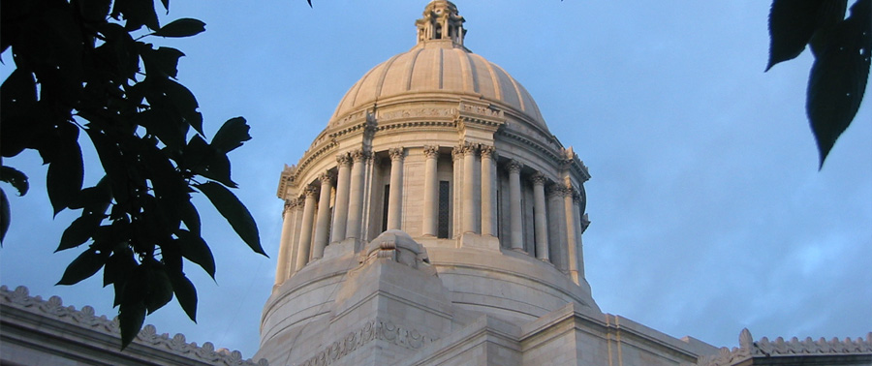

Washington Statewide Reentry Council

***Reentry Council***

***Priorities***

*For the 2018 Legislative Session*

**OUR MISSION**   
Grow and improve jobs in Washington state by championing thriving communities, a prosperous economy,   
and suitable infrastructure.

**Statewide Reentry Council Strategic Goal:**   
Improve public safety and outcomes for those reentering the community after incarceration by convening leaders in public safety, reentry and criminal justice reform.

**Reentry Council Contact**   
Christopher Poulos  
Executive Director  
Washington Statewide Reentry Council  
360.725.2852  
christopher.poulos@commerce.wa.gov

The Legislature tasked the Statewide Reentry Council with providing recommendations related to reentry. Action taken by the Legislature to make progress on these items will benefit Washington state citizens, including improving outcomes for individuals reentering the community, improving public safety, reducing recidivism, and saving taxpayer dollars. These views represent the majority of the Council.

**Enact Fair Chance Employment for Employment** – *HB 1298 | SB 6110*

People with criminal records face significant barriers to obtaining employment, and this increases the likelihood of them relapsing. In 2017, HB 1298 and SB 5312 aimed to create the Washington Fair Chances Act, which would have prohibited some employers from inquiring about criminal history until determining if a person is otherwise qualified for the position. Legislation or other efforts to Ban the Box will promote successful reentry by improving access to employment, which helps reduce recidivism.1

**Continue to Reform Legal Financial Obligations** – *HB 1733*

In Washington, people convicted of a crime are ordered to pay legal financial obligations (LFOs). In Superior Court, the average LFO is $2,540 per case. An LFO debt can grow quickly due to the statutorily required 12 percent interest rate and collection fees of $100 per year. In 2017 HB 1783 would have eliminated interest on non-restitution LFOs, made the DNA database fee non-mandatory, prohibited the imposition of LFOs on indigent individuals, and established payment options. LFO reform, coupled with other reentry reforms, assists in eliminating barriers and creates opportunities for a successful reentry.

**Issue Washington State identification Prior to Exiting Incarceration** – *HB 1679 | SB 6280 (Adults) and HB 2372 | SB 6114 (Juveniles)*

The Council supports efforts by the Department of Corrections, Department of Licensing, Juvenile Rehabilitation Administration and other agencies to continue to expand a successful statewide pilot and issue Washington state identification for individuals upon release. The issuance of state identification will help eliminate unnecessary barriers to reentry and improve access to housing and employment.

\

The Council supports Housing First models. Housing First is a state and national best practice that provides direct rent assistance for apartments rather than a pathway to housing support through shelter and transitional housing. Multiple studies have shown that Housing First reduces costly crisis and law enforcement services and helps improve health and public safety outcomes. The Council supports efforts that help rapidly house those reentering the community so that they can find employment and seek economic independence.

The Council also supports efforts to reduce source of income discrimination. Currently in most cities and counties in Washington, landlords can deny a tenant access to housing because of their source of income, including Social Security, Housing Choice (Section 8) vouchers, or Earned Release Date vouchers.

The Council supports Housing First models. Housing First is a state and national best practice that provides direct rent assistance for apartments rather than a pathway to housing support through shelter and transitional housing. Multiple studies have shown that Housing First reduces costly crisis and law enforcement services and helps improve health and public safety outcomes. The Council supports efforts that help rapidly house those reentering the community so that they can find employment and seek economic independence.

The Council also supports efforts to reduce source of income discrimination. Currently in most cities and counties in Washington, landlords can deny a tenant access to housing because of their source of income, including Social Security, Housing Choice (Section 8) vouchers, or Earned Release Date vouchers.

**AGENCY CONTACT**Xandre Chateaubriand  
Legislative Director

360.528.9703

Xandre.chateaubriand@commerce.wa.gov

http://www.commerce.wa.gov/reentry/





**AGENCY CONTACT**Xandre Chateaubriand  
Legislative Director

360.528.9703

Xandre.chateaubriand@commerce.wa.gov

http://www.commerce.wa.gov/reentry/



1011 Plum Street SE, Olympia, WA 98504  
<http://www.commerce.wa.gov/>

**Remove Barriers Based on Criminal Records** – *HB 2890*

People who have reentered successfully should have opportunities to remove record-related barriers to the hundreds of collateral consequences of a conviction, such as employment, housing and volunteer opportunities. The Council supports policy efforts to reform criminal records policies so that people do not face long-term barriers to contributing as productive members of a community.

**Expand Alternatives to Incarceration** *HB 2287 / SB 6060 (Diversion) and SB 5307 (Parent Confinement Alternatives)*

The Council supports expanding diversion programs, such as the Law Enforcement Assisted Diversion (LEAD) program, which diverts eligible individuals away from criminal justice system involvement and towards treatment and other resources. The Council supports expanding the Family and Offender Sentencing Alternative, commonly referred to as FOSA. FOSA allows judges to waive a sentence for eligible persons with current custody of minor children and impose 12 months of community supervision along with conditions for treatment and programming for people facing a prison sentence.

**Support Graduated Reentry** – *HB 2638 | SB 6277*

The Council also supports the principles of Graduated Reentry, which extend eligibility for work release and other community confinement options.

**Examine and Improve Conditions of Confinement to Promote Successful Reentry** – *HB 1889 | SB 5465*

The Council may support measures that help ensure the dignity, respect, and wellbeing of all incarcerated individuals. Fostering methods to decrease the likelihood of further trauma while incarcerated promotes successful reentry and reintegration. The healthier people are mentally and physically upon release, the more likely they will succeed in reintegration. The prospective measures include, but are not limited to, the creation of an independent ombuds that incarcerated people and their families can contact to oversee disputes with DOC.

**Expand Access to Housing for Returning Citizens**

Releasing people from prison to homelessness is a setup for failure. Providing housing vouchers and other housing supports, like rent assistance, to people reentering the community has demonstrated positive benefits in Washington and in other states. Housing vouchers are much less expensive than prolonged incarceration – and housing instability is a contributor to recidivism. The Legislature should increase access to housing for returning citizens, particularly Housing First models. Housing First is a state and national best practice that provides direct rent assistance for apartments rather than a pathway to housing support through shelter and transitional housing. Multiple studies have shown that Housing First reduces costly crisis and law enforcement services and helps improve health and public safety outcomes. The Council supports efforts that help rapidly house those reentering the community so that they can find employment and seek economic independence.