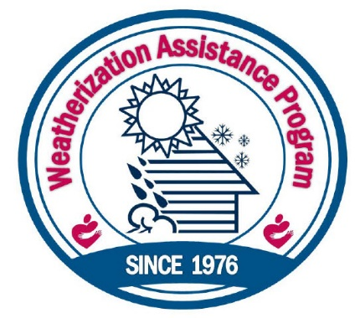
Benefits of Weatherization

Patching holes and insulating ceilings, attics, and floors can save an average of 20% on your energy bill.
Improving airflow, sealing ducts, tuning your furnace and removing asthma triggers can reduce visits to the Emergency Room and lost days of work for households with asthma and respiratory problems.
Repairing water heaters, plumbing leaks, and installing low-flow showerheads can reduce your water bills.

