Weatherization Works!

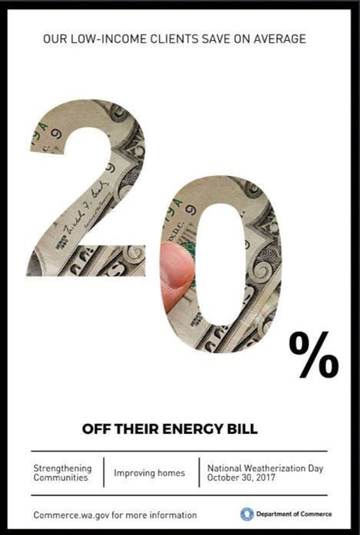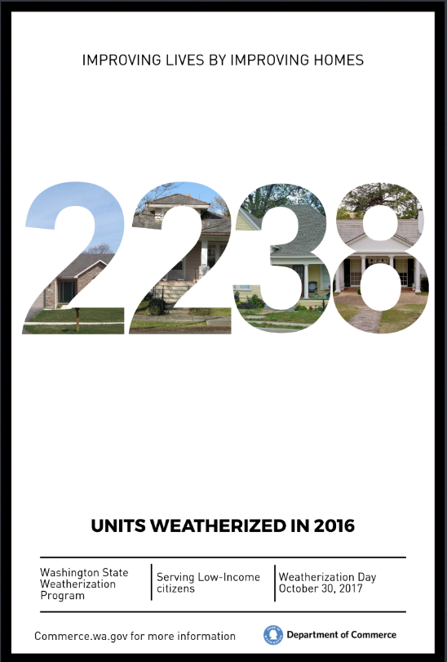
For more information on the Low-Income
Weatherization Assistance Program, call Hans Berg, (360) 725-2961

