## **Overview of Research to Improve the Washington State Fuel Mix Disclosure Net System Mix**

Part of the Fuel Mix Disclosure (FMD) process is to calculate the Net System Mix (NSM). The NSM is treated as the fuel mix for the market power, also referred to as unspecified power, that utilities often procure to supplement electric power from owned or contracted electric generating resources.

FMD is focused on electric power generation in the Northwest Power Pool (NWPP), which includes Washington, Oregon, Idaho, Utah, most of Montana, Wyoming, Nevada and a small part of northern California. See the map at end of document, which shows the boundary of the NWPP. The NSM calculation begins with total electric power generation in the NWPP from which total known, or specified, utility claims are subtracted, as shown in the simple formula below.

**Net System Mix = NWPP Power Generation – Specified Power Claims**

Currently, FMD only has access to specified power claims from the states of Washington and Oregon. This means that utility specified power claims, owned or contracted resources, in the rest of the NWPP are excluded, which increases the size and alters the composition of the NSM. Note that the final step of the current NSM calculation is to “zero out” wind, geothermal and solar. The reason behind this step is that these renewables are used to meet Renewable Portfolio Standards and are therefore claimed by utilities in the NWPP or California. The wind, geothermal and solar generation values are left in for illustrative purposed in this paper. The unadjusted[1] NSM for 2014, as currently calculated, is shown below:



To better understand the NSM, Commerce has undertaken research to account for the remaining specified power claims in the other non-Oregon and non-Washington parts of the NWPP using several data sources that are available. To be clear, this accounting attempts to incorporate specified utility claims on NWPP electric power generation resources from ID, MT, UT, NV, WY and CA utilities. The accounting takes place in two steps, referred to as the stage 1 adjustment and the stage 2 adjustment. Stage 3 will show the resulting mix when the current policy of zeroing our renewable energy is applied following the stage 1 and 2 adjustments. Stage 1 relies on solid utility reported power claim data, while stage 2 relies on data from less precise utility IRP reports and website information. Additional information on the two adjustments is below:

The stage 1 adjustment incorporates PacifiCorp and Avista specified claims on generating resources. It also incorporates claims associated with BPA supplied utilities in ID, MT, NV and the Canadian Entitlement power that BPA delivers to British Columbia. The NSM for 2014, after applying the Stage 1 adjustment, is shown below:



The stage 2 adjustment is an attempt to incorporate specified claims by Idaho Power, Northwestern Energy, Nevada Power (North) and several small utilities in ID, MT, NV, UT and WY. As noted above, these adjustments are less reliable than the stage 1 adjustment. The first table above is slightly different from the table shown in the Jan. 30 PowerPoint presentation, as formula for solar and geothermal were not complete.



This preliminary work on improving the NSM illustrates that, by accounting for specified utility power claims in other states in the NWPP, fuel shares in the NSM (market power) change significantly. The coal share of the NSM in particular declines markedly. There are likely other steps that could be taken to improve the FMD NSM accounting, including a more thorough tracking of NWPP contracted power imports and exports. Accounting for contracted power imports and exports would likely decrease hydropower and increase natural gas and solar sourced power in the table above.

The stage 3 NSM results, which reflects the current FMD policy of zeroing out renewables, are in the table below.



Note that category numbers in the above tables may differ slightly from the tables presented in the Jan. 30 slide deck, which relied on an older spreadsheet. Additional renewable claims associated with Pacific Corp and Nevada Power were deducted from the above tables.

Additional Charts and Tables

Northwest Power Pool Boundaries

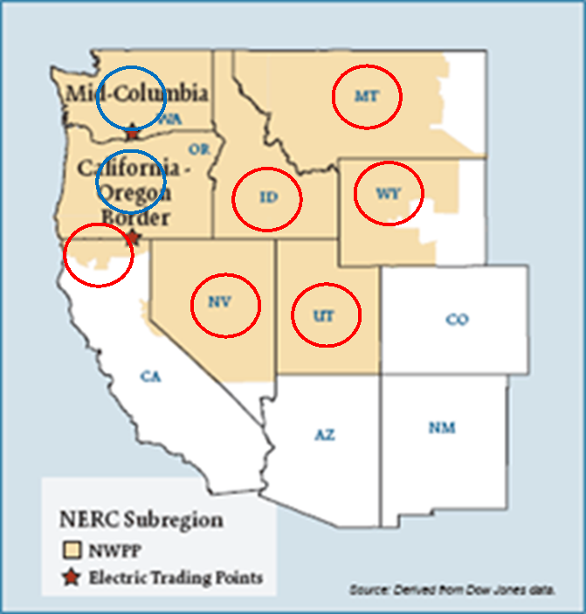

Blue circles represent states with specified claims on generating resources



1. Unadjusted NSM means that renewables are not zeroed out and that 3 non-NWPP Pacific Corp plants are included.