Signing up for SAW and InfoNet
- Receive Email
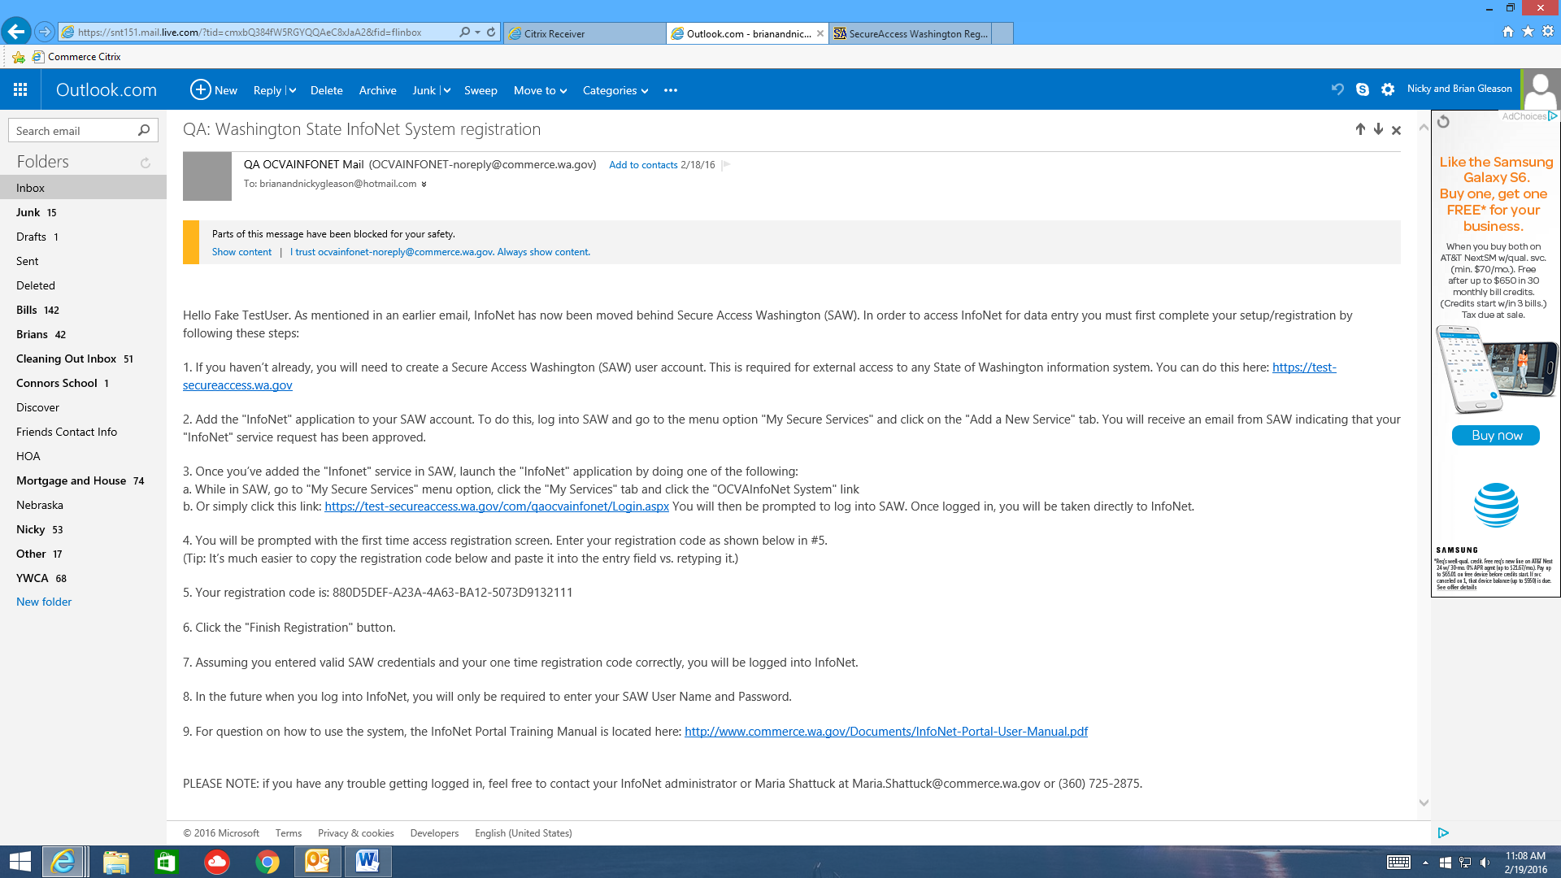

- To sign up for SAW account, click the link in the email to go to the SAW website
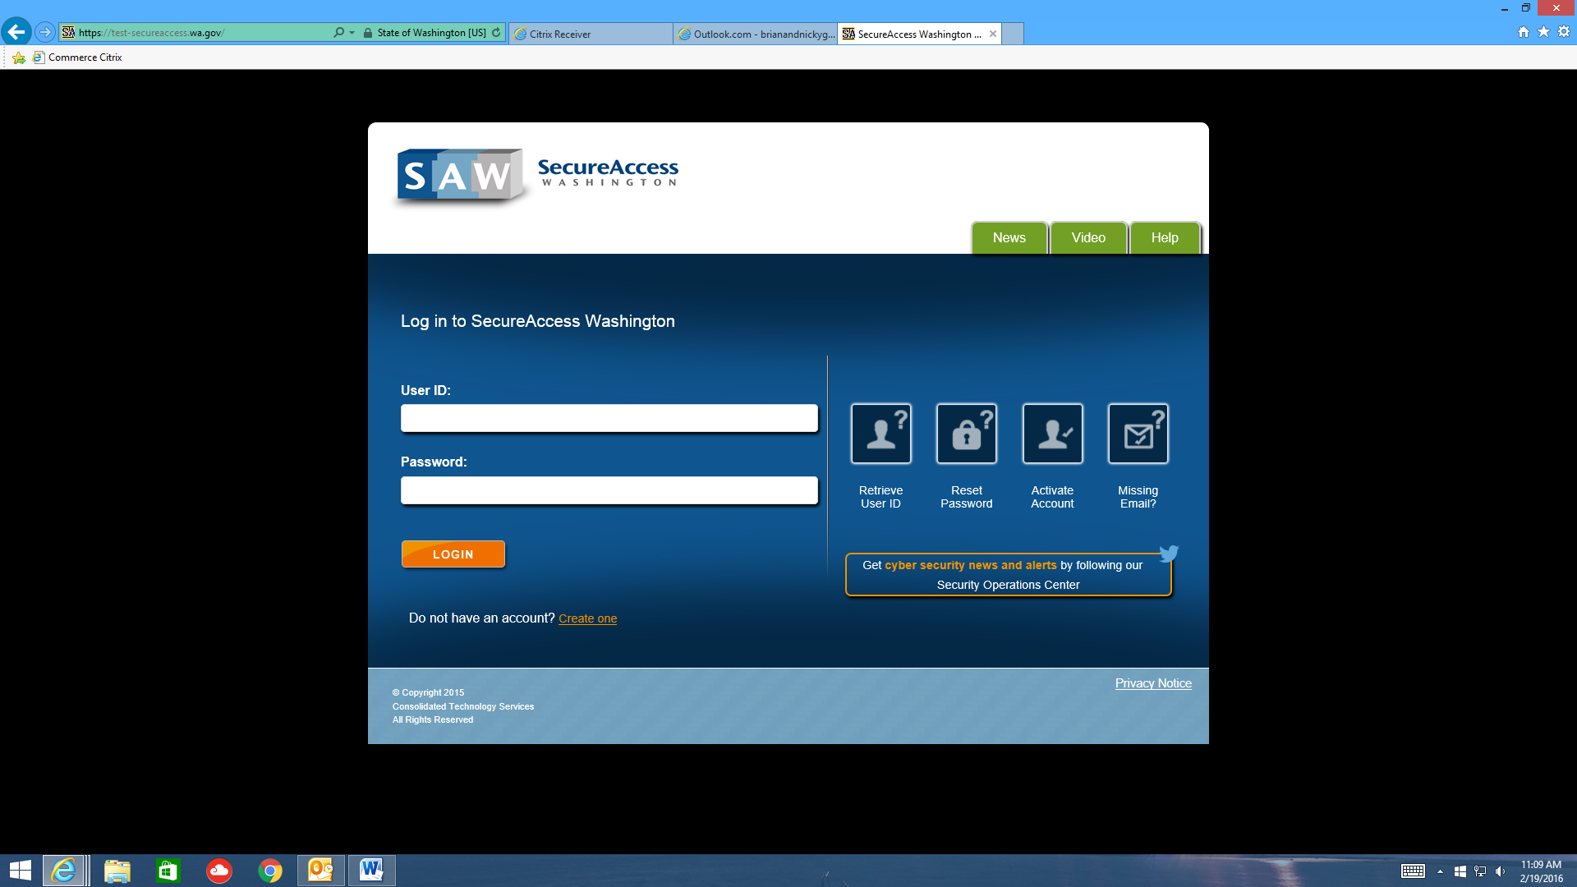
- Click the Create One link
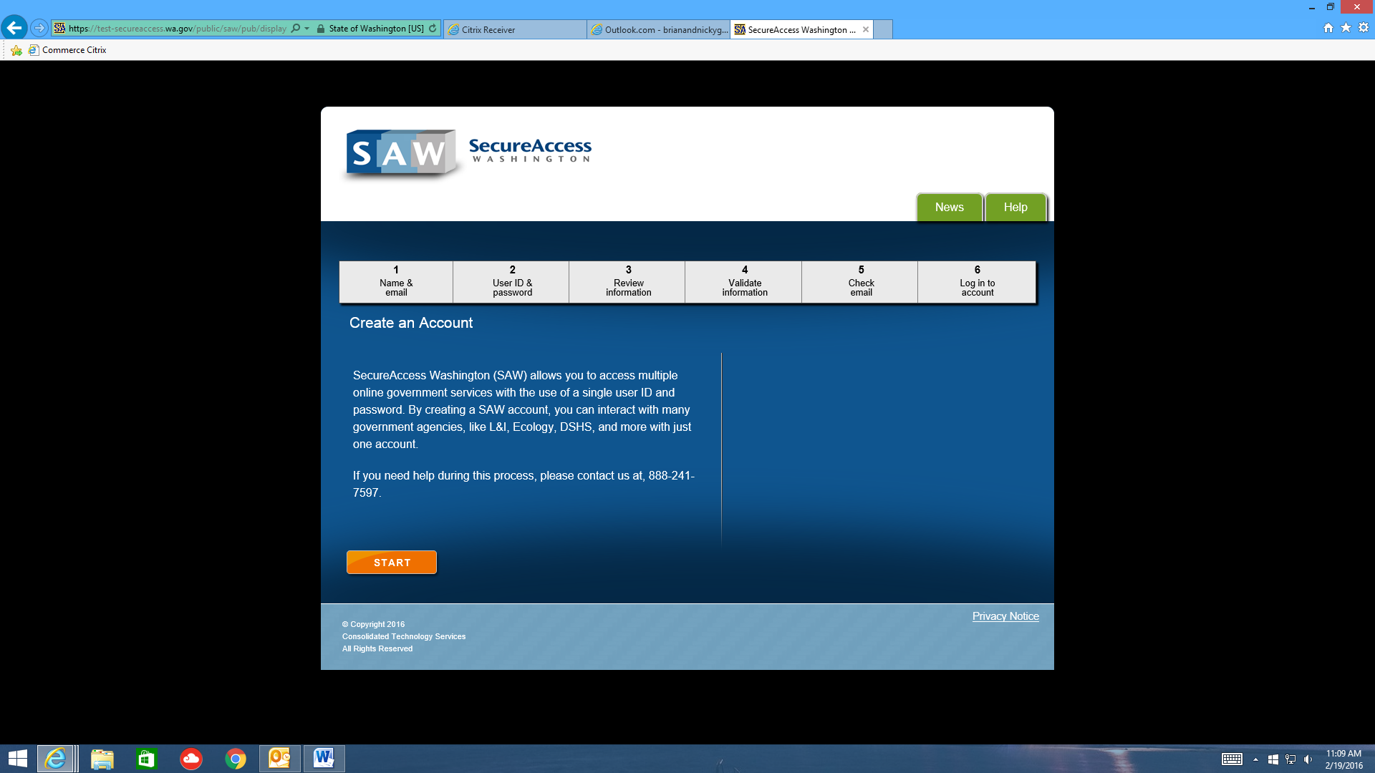
- Click START
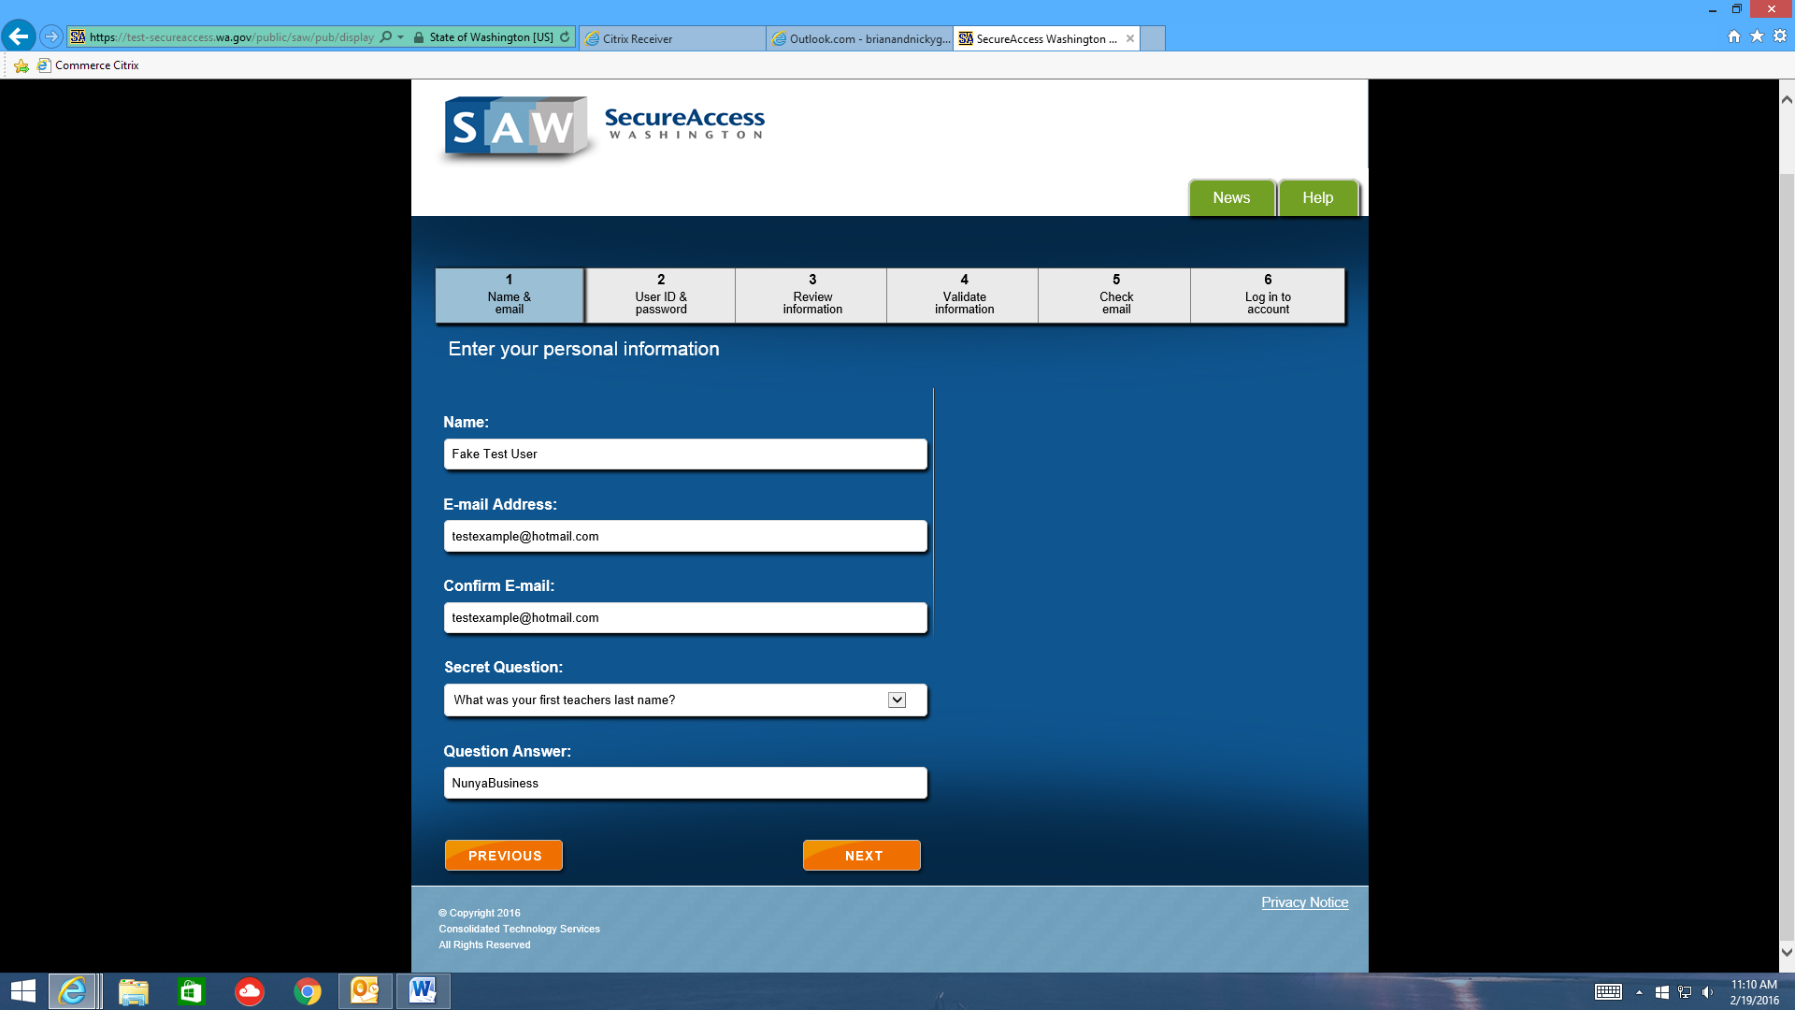
- Fill out the information and click NEXT
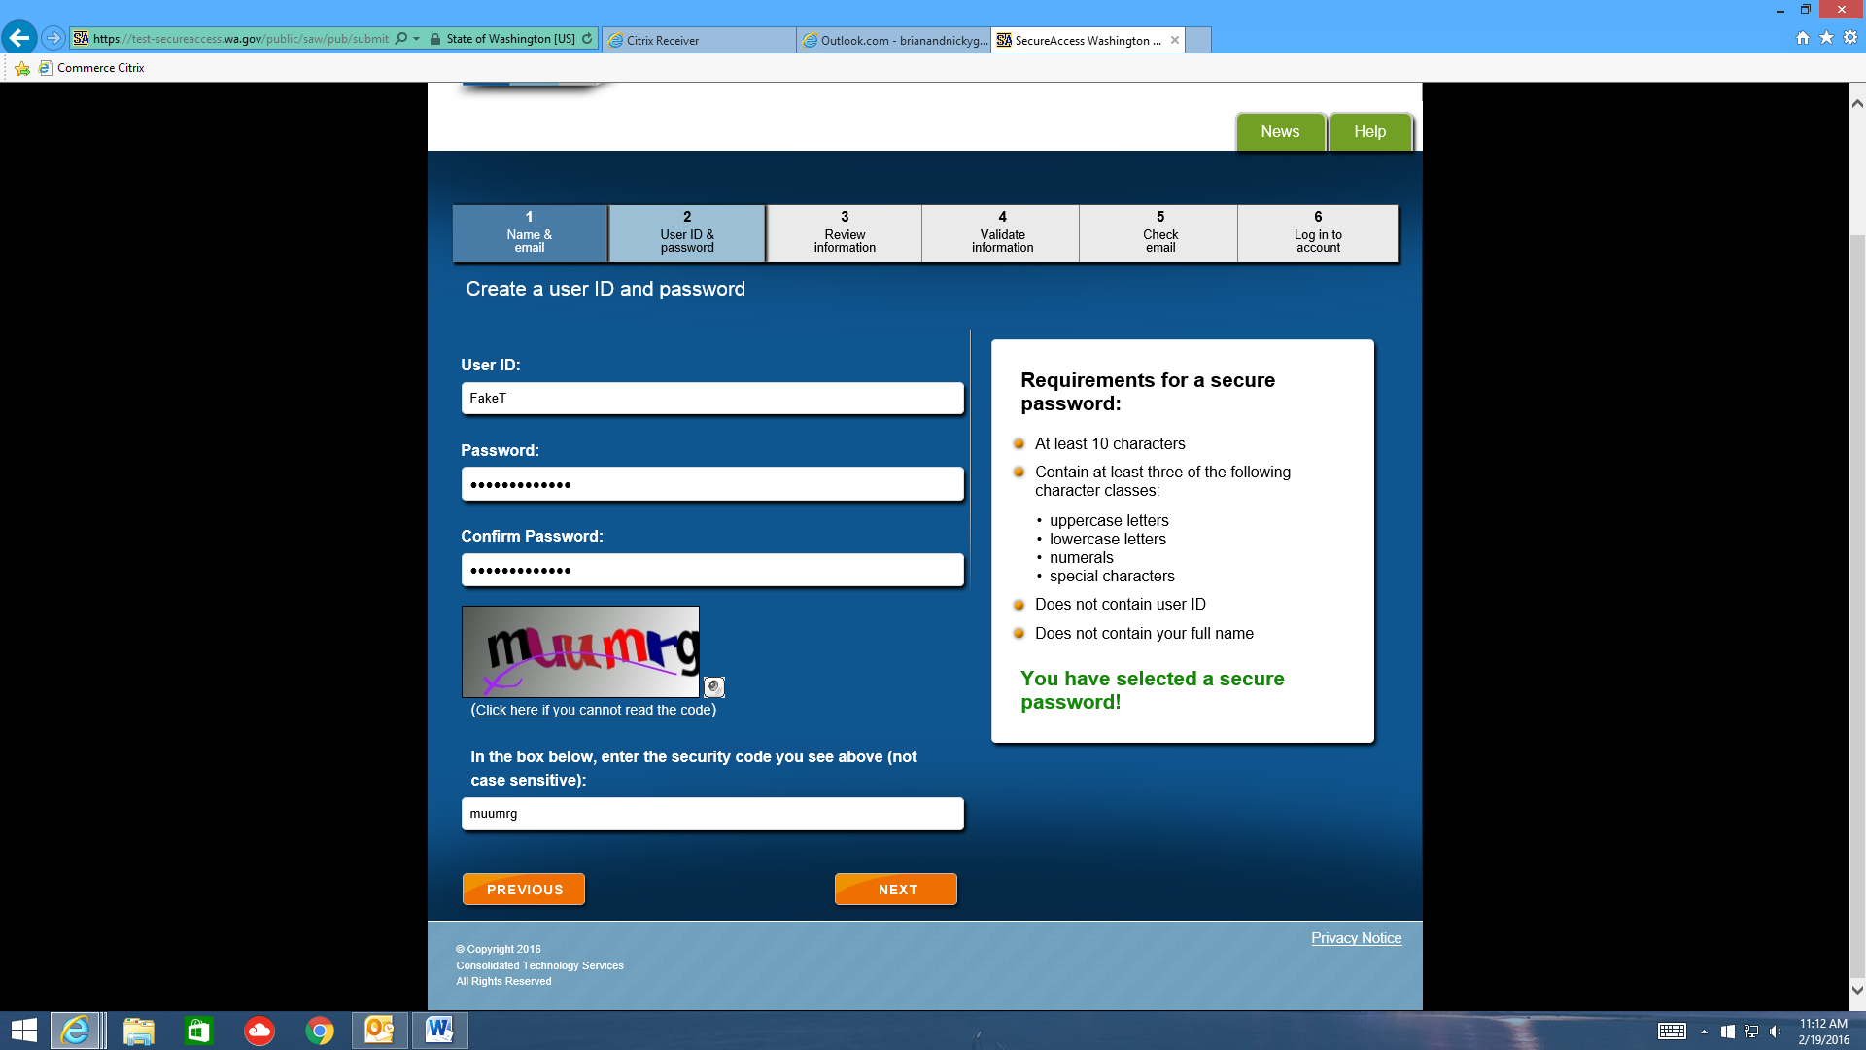
- Fill out the information and click NEXT
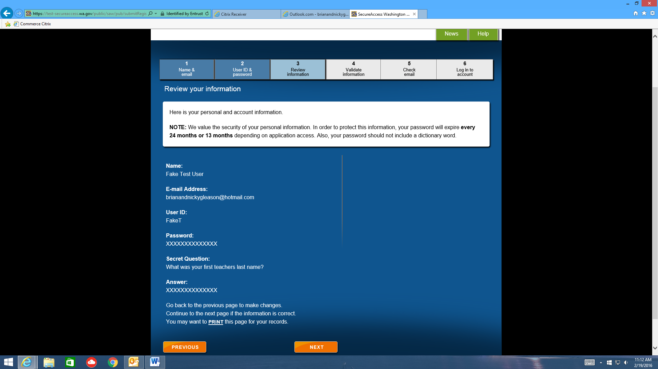
- Verify the information and click NEXT
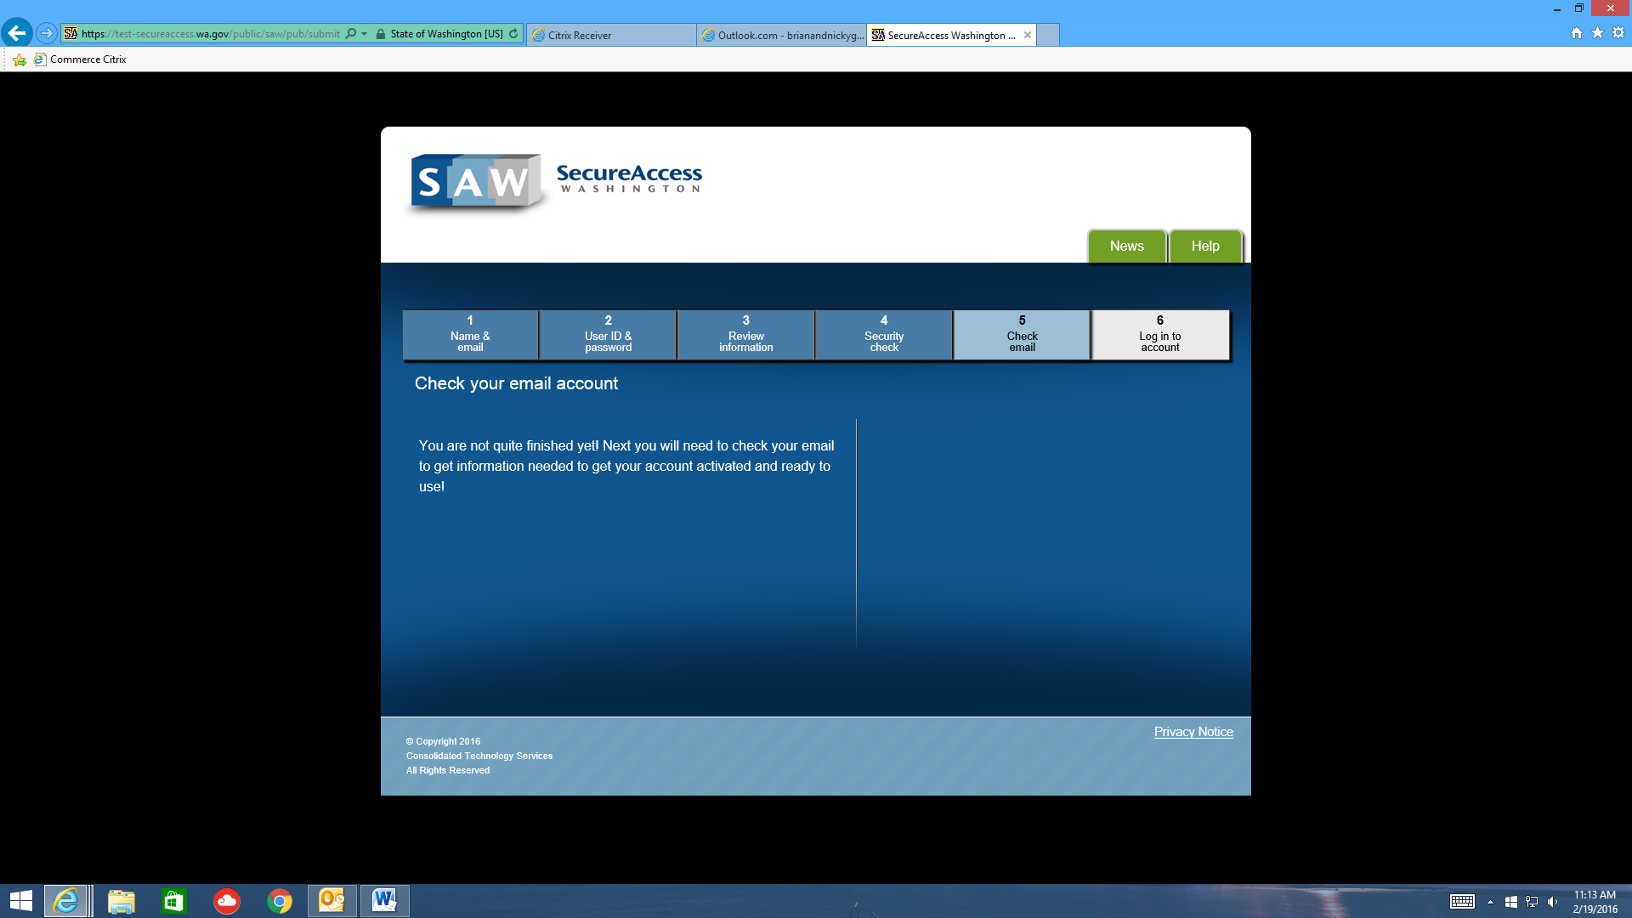
- You’ll see this screen. Wait to receive an email with a SAW Registration code.
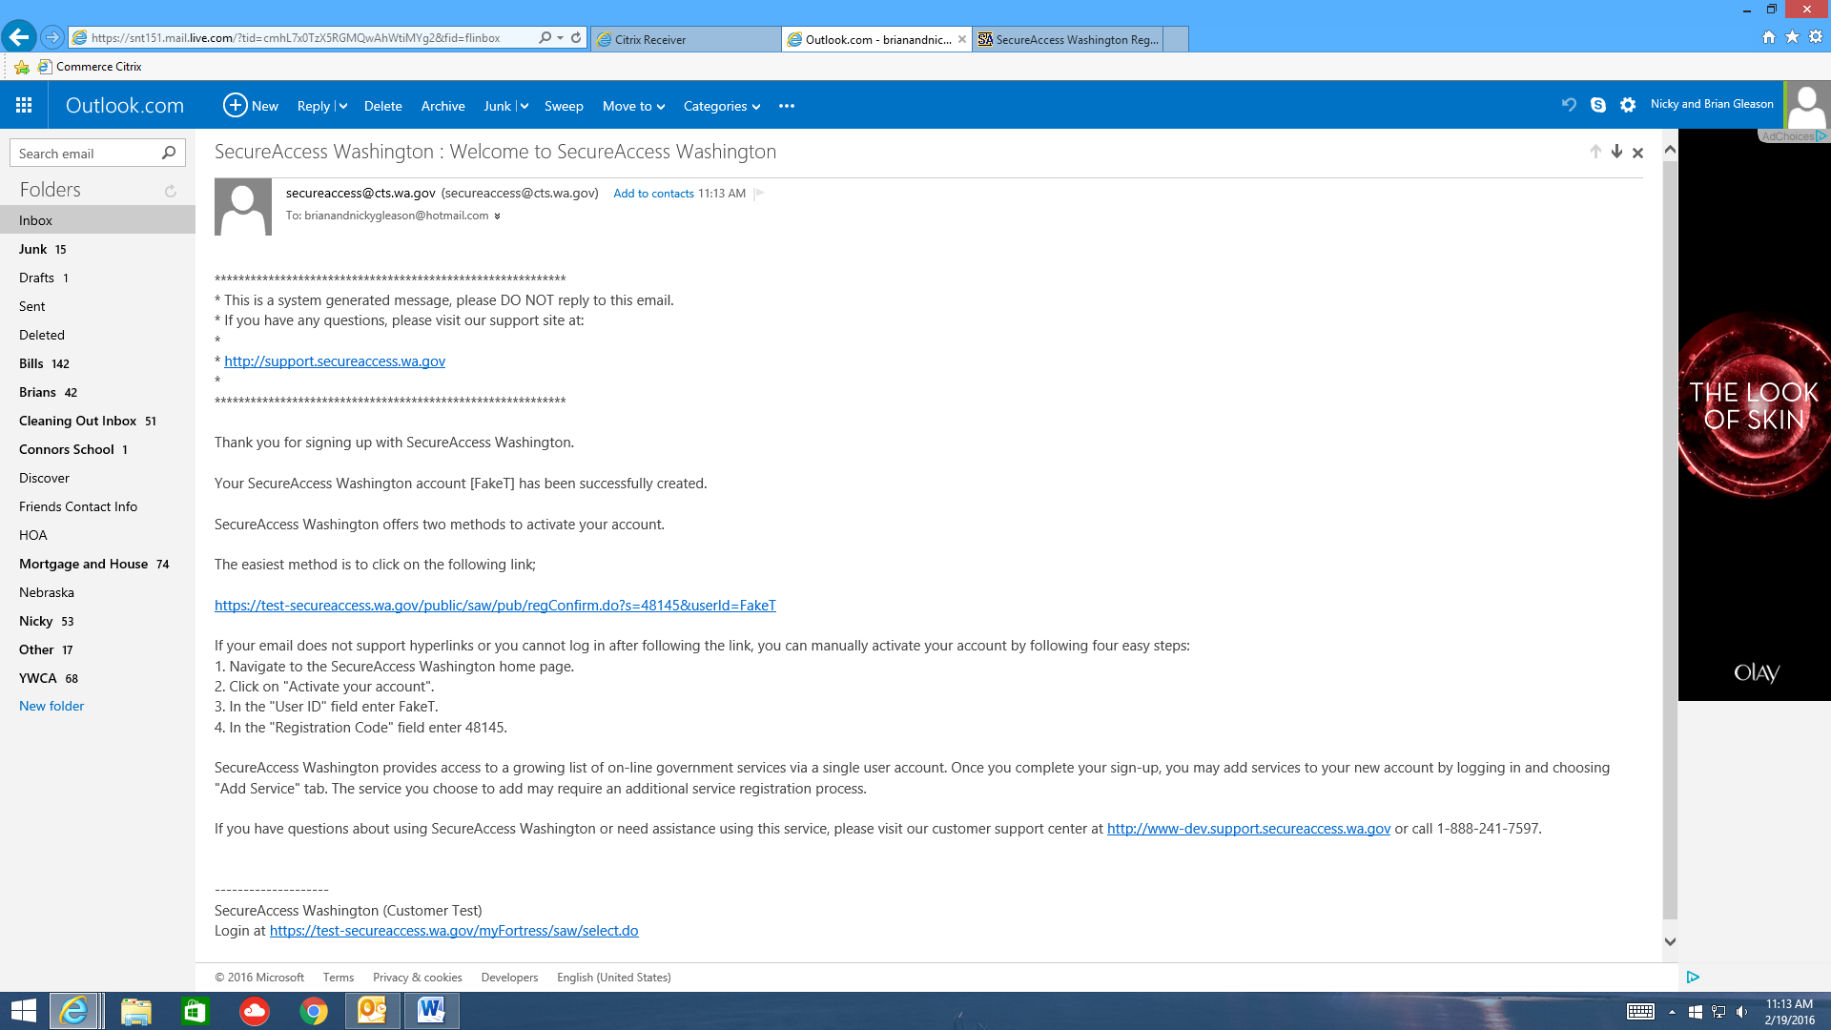
- Use the link in the email to go back to SAW
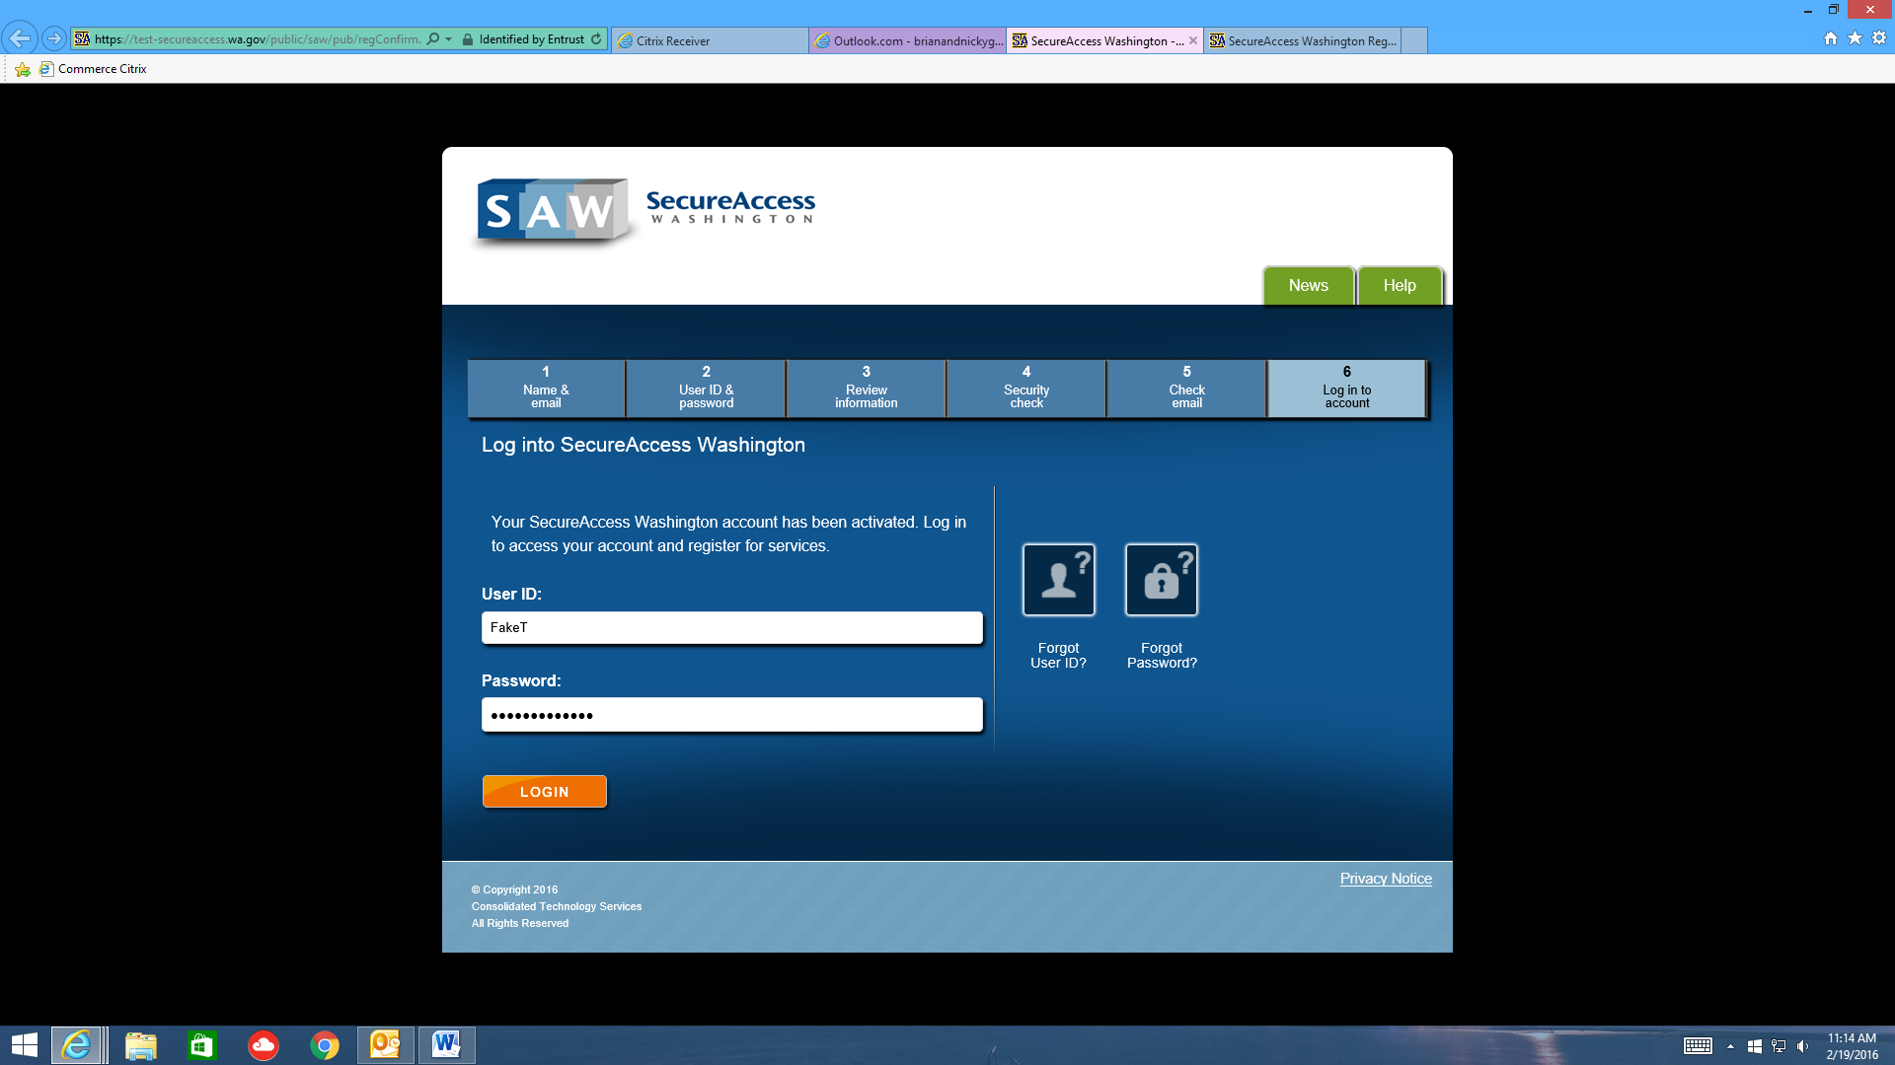
- Use the credentials you set up in STEP 5 above to log in
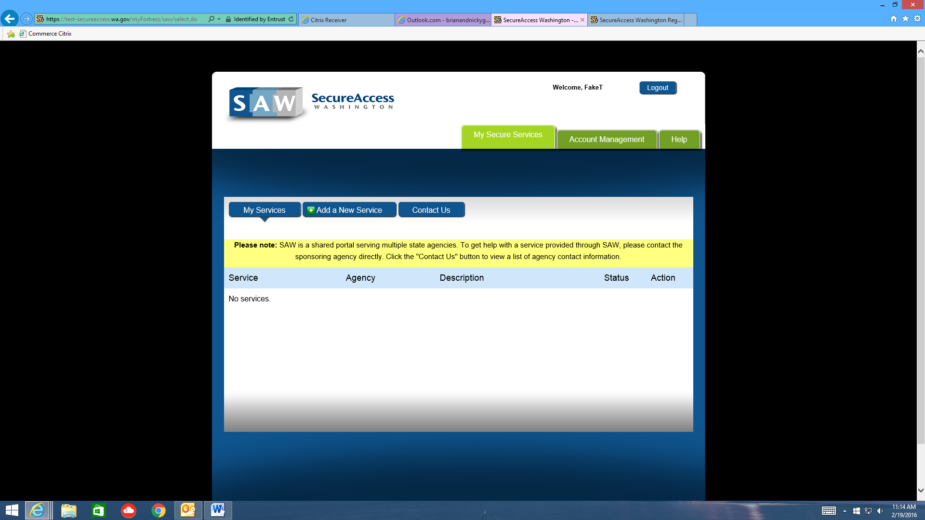
- Click ADD A NEW SERVICE
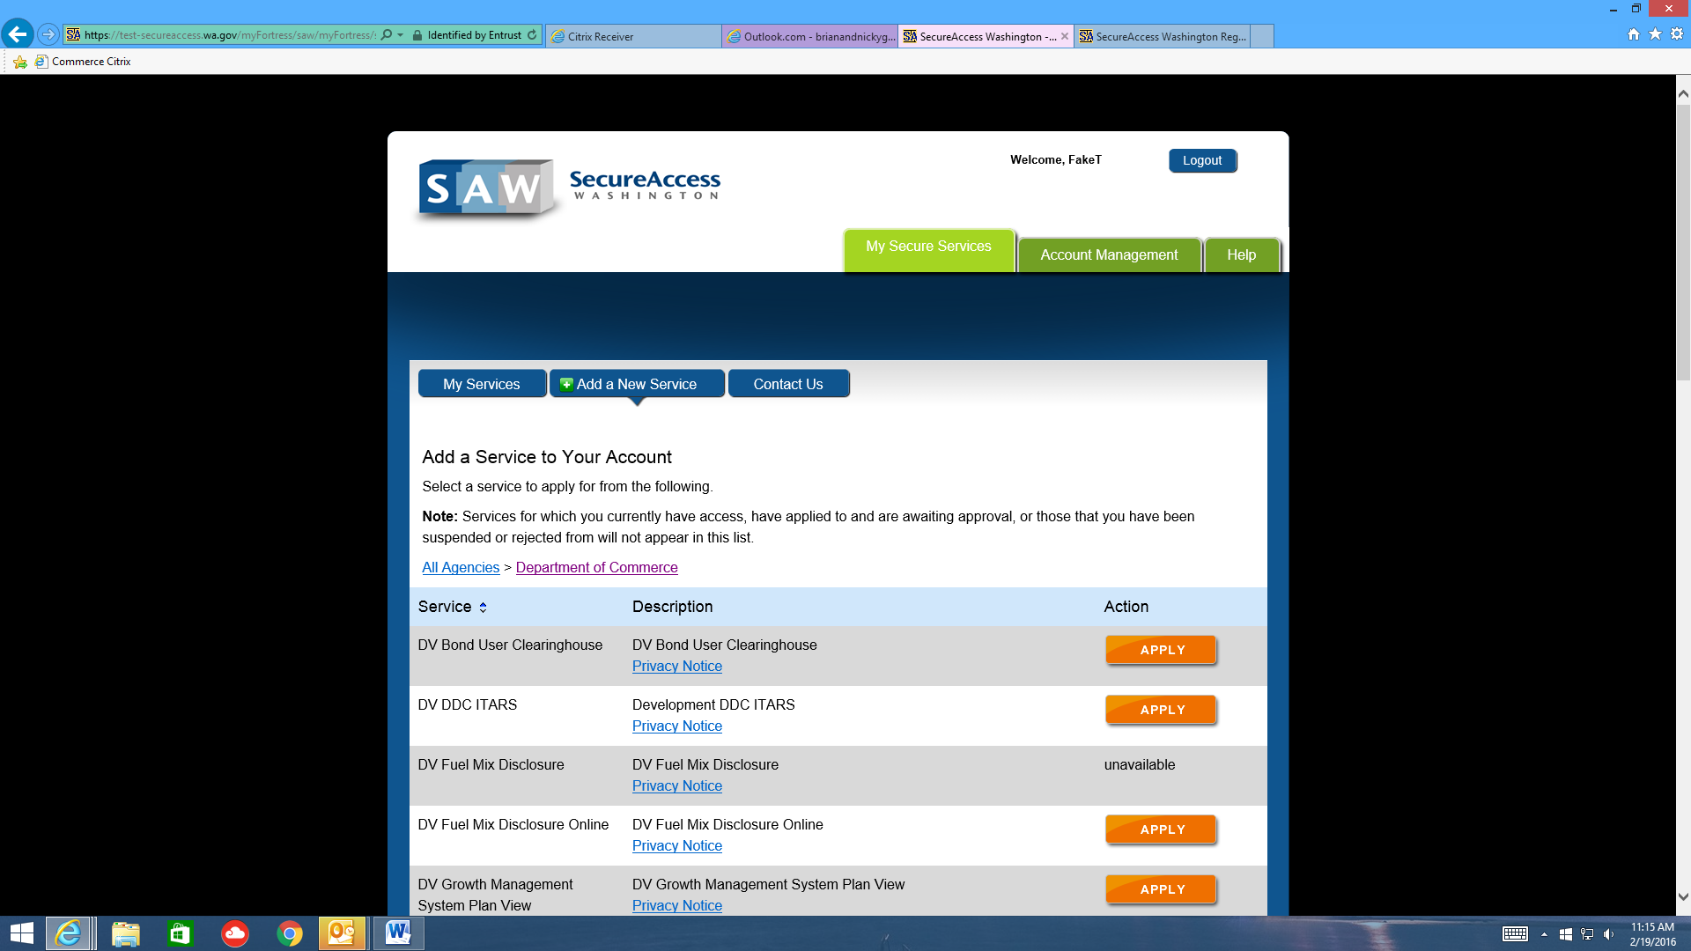
- Find the service named “OCVAInfoNet” and click APPLY
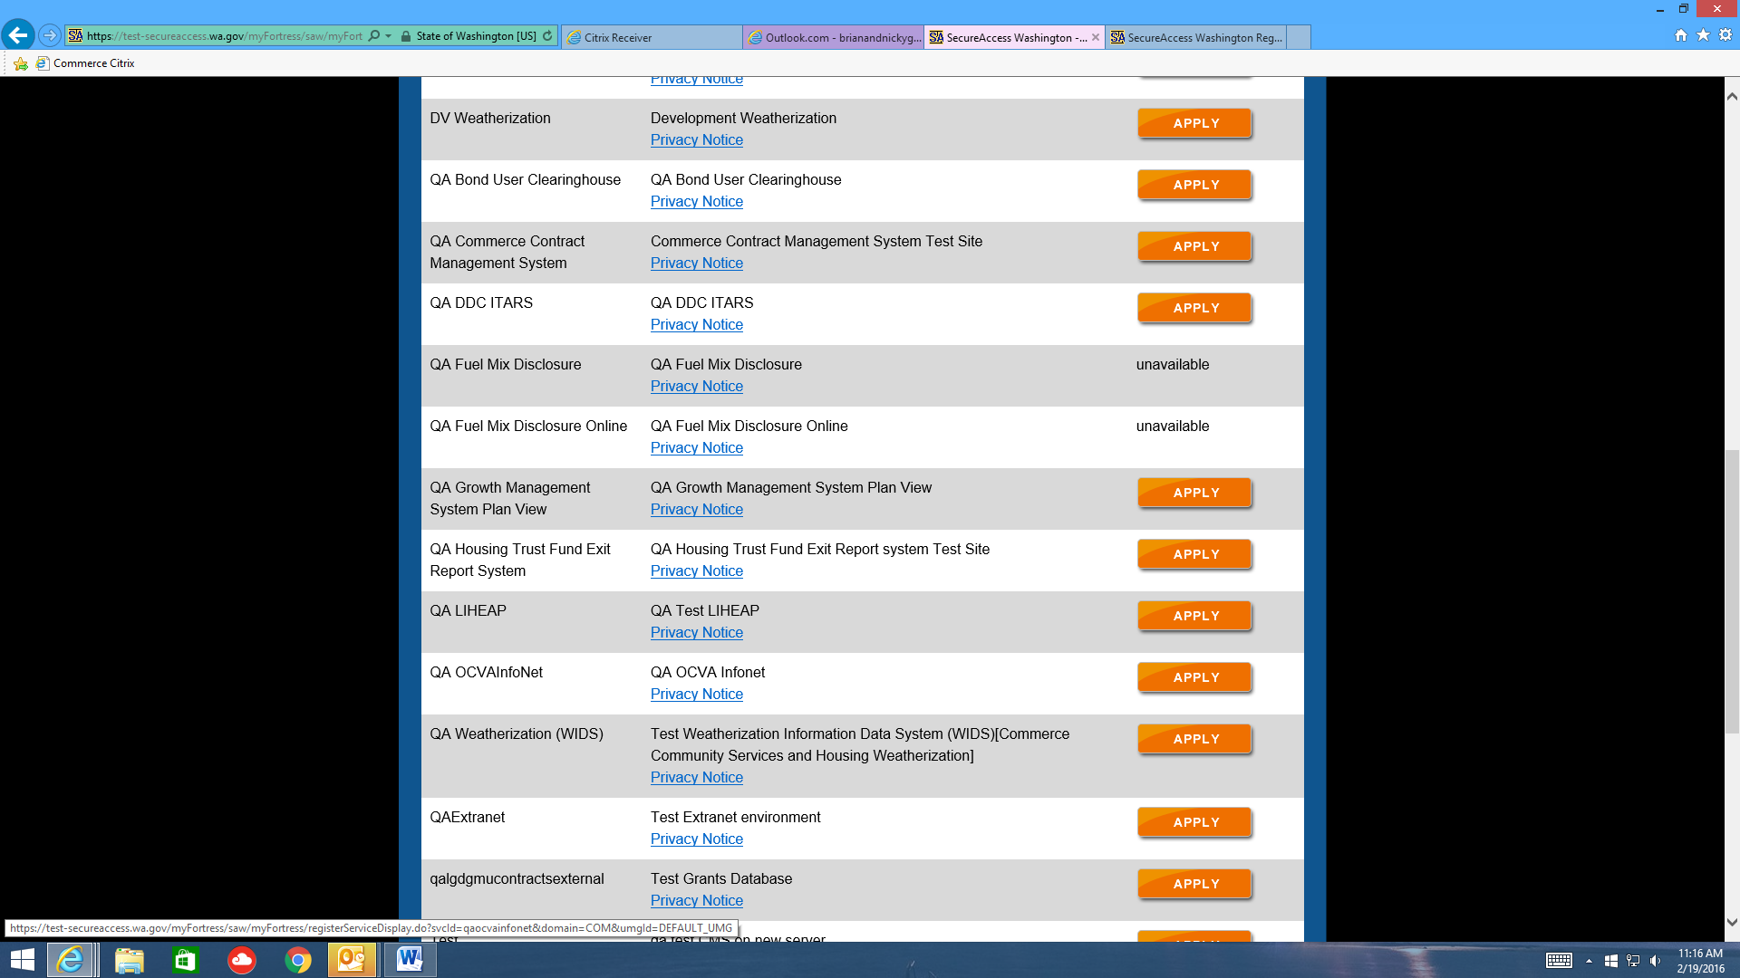
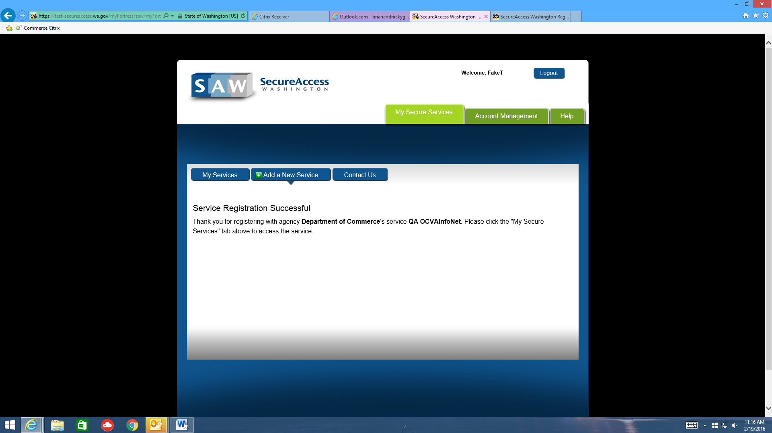
- Click MY SERVICES
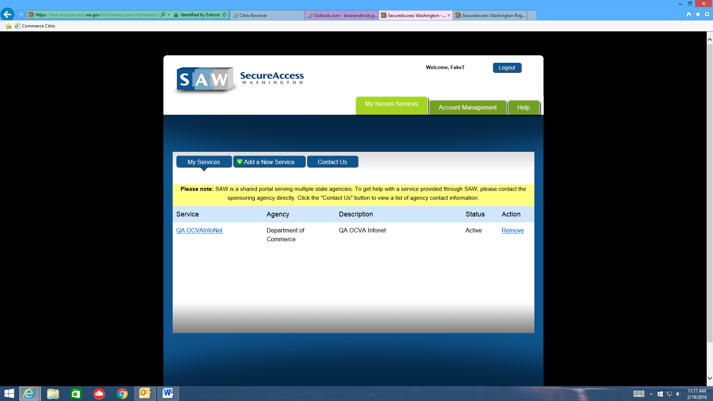
- Click the OCVAInfoNet link
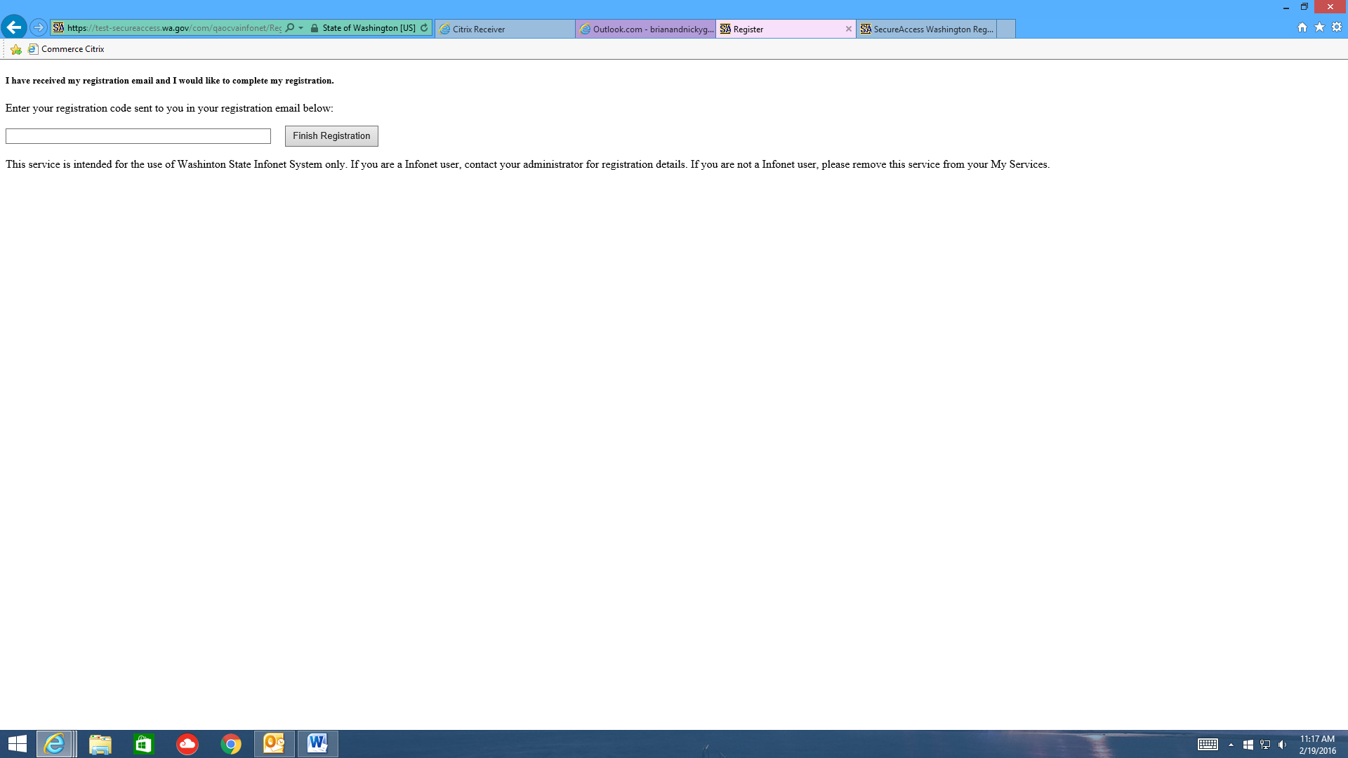
- COPY AND PASTE the registration code from your VERY FIRST EMAIL into this screen:

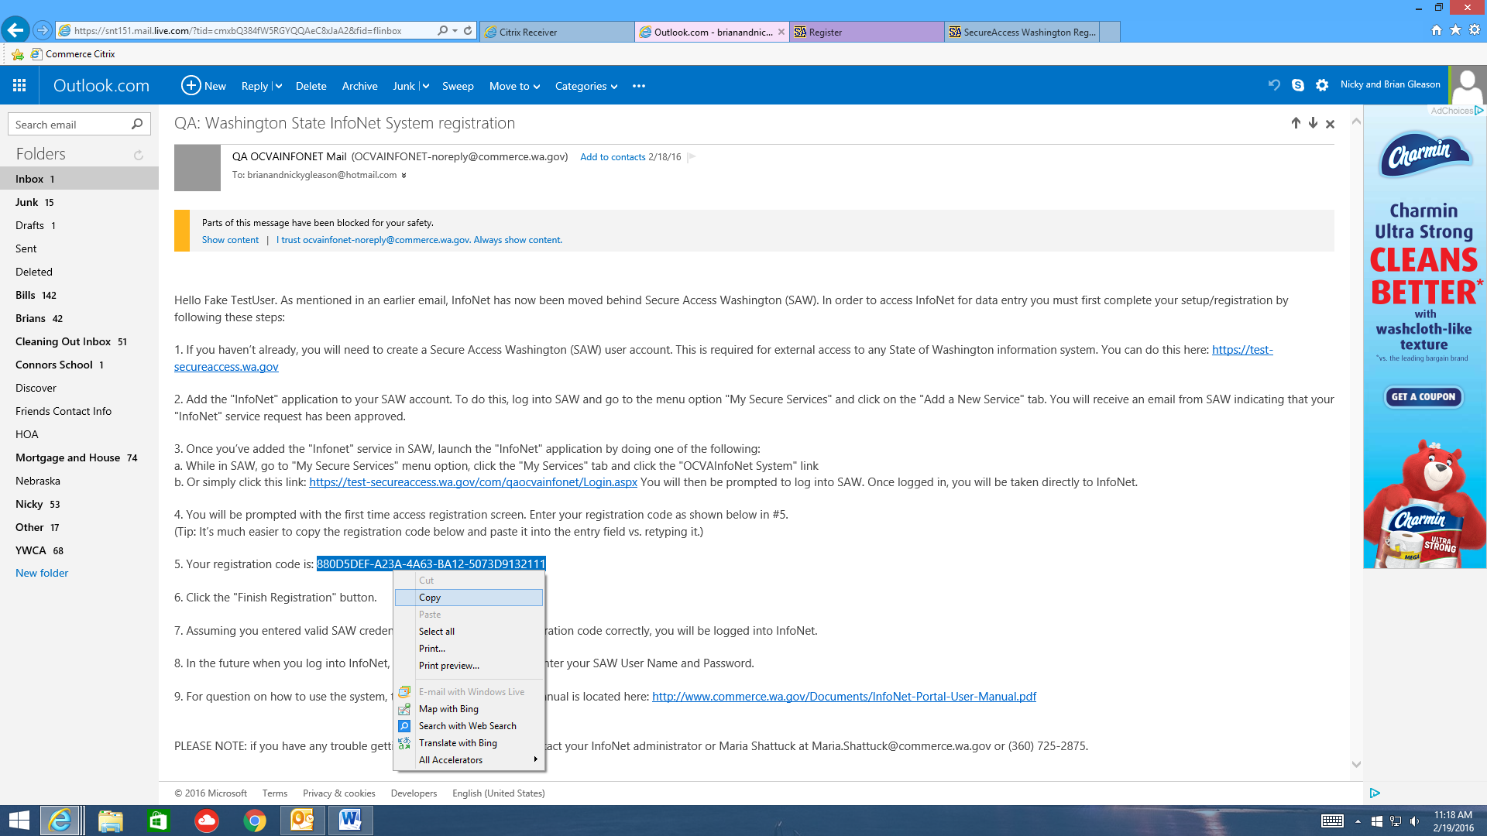

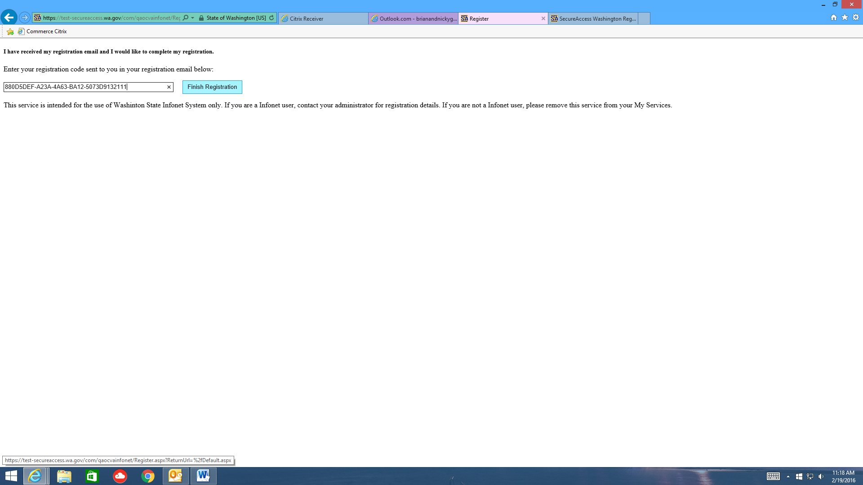
- Click FINISH REGISTRATION
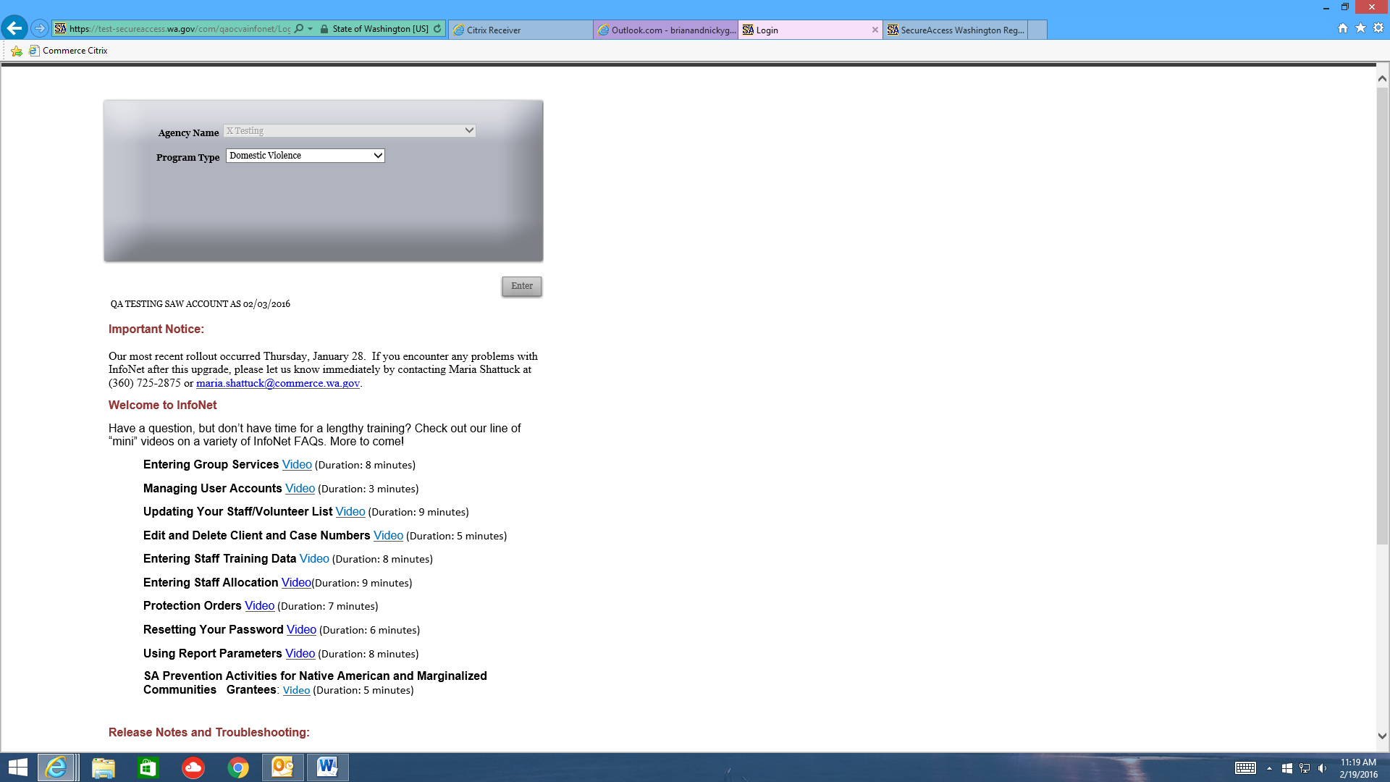
- You are now logged into InfoNet. Bookmark this page as your new InfoNet page.

The next time you log into InfoNet, you’ll come to this page:

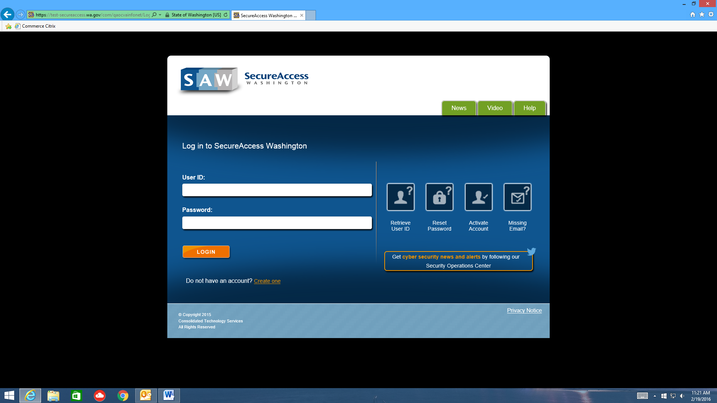

Use the credentials you set up in step 5 above to log in. This will take you directly to InfoNet, and you no longer need to log in on the InfoNet homepage.

