Foreclosure Fairness Program
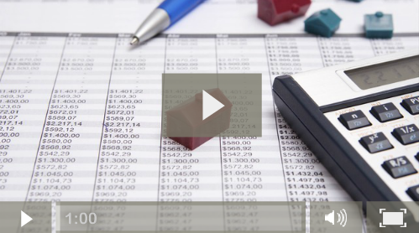 | Foreclosure Prevention Minute, King 5 (sponsored by the Department of Commerce and the Department of Financial Institutions)
The Foreclosure Fairness Program provides homeowner foreclosure assistance by offering free housing counseling, civil legal aid, and foreclosure mediation. The program, created by the 2011 Foreclosure Fairness Act , helps homeowners and lenders explore possible alternatives to foreclosure and reach a resolution whenever possible. The Act requires lenders to notify homeowners, prior to initiating foreclosure, of the availability of foreclosure counseling and the potential for mediation, and to participate in mediation with homeowners who have been referred to the Mediation Program. The program is funded by fees paid by the financial institutions issuing notices of default on owner-occupied residential real property in Washington State (some financial institutions are exempt from this fee).

What is the foreclosure process in Washington?
Washington is a “non-judicial foreclosure” state, meaning that a lender can foreclose on a property through a third party, the trustee, and not through the court system. The trustee has a duty of good faith towards both the lender and the homeowner. This non-judicial process is described the Foreclosure Fairness Program Brochure (translated in 10 languages, see below).
https://yohttps: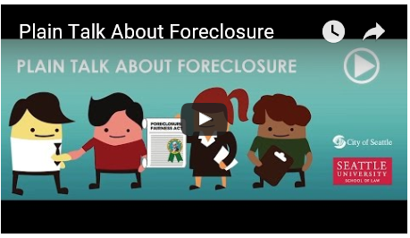//youtu.be/foDfpgFRuSkutu.be | The Seattle University School of Law, in collaboration with City of Seattle, produced an educational video that further explains the non-judicial foreclosure process and shows why it is important for homeowners to seek help as soon as possible.  Click here for the Spanish version.

How can homeowners obtain assistance?
Contact a FREE housing counselor ANYTIME at 1-877-894-HOME(4663).
Foreclosure prevention counseling is provided free of charge to Washington homeowners. Counselors are trained to help homeowners understand their options and determine the best course of action, including referring them into the Mediation Program, if the homeowner is eligible for mediation.

Low and moderate-income homeowners can also contact the statewide civil legal aid program at
1-800-606-4819 or visit www.nwjustice.org/get-legal-help.

What is foreclosure mediation?
Foreclosure mediation is a process where a neutral third party (the "mediator") helps the homeowner (the "borrower") and the lender (the "beneficiary") openly communicate and reach a fair, voluntary, and negotiated agreement whenever possible. The homeowner and the lender each pay half of the mediation fee to prepare, schedule, and conduct a mediation session. If more than one session is necessary, additional fees may apply.

Who is eligible to participate in the Mediation Program?
Homeowners may be eligible for mediation if they received a Notice of Default from their lender and lived in the home when the foreclosure process started. The referral to mediation must be submitted to Department of Commerce after a Notice of Default has been issued and no later than 20 days after the date the Notice of Trustee Sale has been recorded at the county where the property is located. Some lenders are exempt from mediation. Review the Eligibility Criteria for detailed information.

How is mediation requested?
Homeowners cannot self-refer into the Mediation Program. Homeowners can ONLY be referred to foreclosure mediation by a housing counselor or an attorney. The counselor or attorney will make an eligibility determination and may refer the homeowner to Department of Commerce for foreclosure mediation. Eligible homeowners will be assigned a mediator (by Department of Commerce) to conduct the foreclosure mediation process established in statute. Although not required, homeowners may benefit from a counselor or attorney assisting/representing them during the mediation process and session(s). The lender is typically represented by at least one attorney.
Contact a FREE housing counselor ANYTIME at 1-877-894-HOME(4663).

What happens if there is no agreement after mediation?
At the conclusion of the mediation, the mediator will send a written report (the "certification") to the homeowner, lender, trustee, and Department of Commerce. Once the mediator issues and sends her/his certification, the foreclosure mediation process is complete. If an agreement was not reached between the borrower and the lender, the mediator's certification authorizes the beneficiary to move forward with the foreclosure process, which may include selling the property at a trustee sale (see RCW 61.24.163 (13)). Borrowers may have a few options to consider. ​For more information, read "Borrower Options after Mediation."

Accordion Sections with links (sites and documents)

​​Homeowner Resources
- Learn about the foreclosure process in Washington State (video)
- Read the Foreclosure Fairness Program brochure (PDF)
- Find out if you are eligible for mediation (PDF)
- Find a housing counselor in your area (website)
- Find a HUD-approved housing counselor (website)
- File a complaint about a housing counselor (website)
- Get legal help (website)
- Review Northwest Justice Project's best practices for representing borrowers in foreclosure mediation (PDF)
- See if your lender is exempt from mediation​ (PDF)
- Learn about your options if your mediation ended in no agreement (PDF)
- Read the Foreclosure Fairness Act (Deed of Trust Act) (website)
- Learn about foreclosure assistance programs (website)
- Read a glossary of foreclosure terms (PDF)
- Attend a foreclosure assistance event (website)
- Find out what to do if you are late or can't make payments (website)
- Get foreclosure and mortgage assistance, and fraud information (website)
- Avoid scams and mortgage fraud (website)
- Learn about mortgage lending fraud prosecution (website)
- Read the Department of Financial Institutions' Guide to Home Loans (PDF)
- File a consumer complaint with the Office of Attorney General (website)
- Read the Washington Foreclosure Prevention Resource Guide (PDF)

Program Performance & Updates
- New - SHB 2876 Summary and Q&A
- Submit a Foreclosure Fairness Program Success Story
- Foreclosure Fairness Program Quarterly Report
- Program Success Stories (2014-2015)
- Borrower Home-Retention Survey (2014)
- Program Success Stories (2014)
- Program Success Stories (2012-2013)

Program Guidelines & Processes
- Program Guidelines
- Foreclosure Mediation Timeline
- Borrower Options After Mediation
- Mediator Complaint Form
- Housing Counselor Complaint Form (link to WSHFC)

Mediators
- Mediation Report/Certification Form
- How to Fill-out the Certification Form
- Mediation Scheduling Form
- RCW 61.24.163 - Foreclosure Mediation Program
- Interested in Becoming an FFA Mediator?

Referrers
- Referral to Mediation Form and Instructions
- Eligibility Criteria and Referral Guidance
- Financial Institutions Currently Exempt from Mediation (2016)
- Northwest Justice Project's Best Practices for Representing Borrowers in Foreclosure Mediation

Financial Institutions
- Financial Institutions Currently Exempt from Mediation (2016)
- Beneficiary Reporting Form & Instructions
- Electronic Funds Transfer Instructions
- Exemption Guidance
- July 2016 Exemption from Fees Only Template
- Notice of Pre-Foreclosure Options Template
- Financial Institutions Exempt from FEES (2016)

Foreclosure Training and Events
- November 2015 All-Mediator Event
- 2015 Summit Presentation
- FFA Stakeholder Summit Minutes

In the Media
- Foreclosure Prevention Minute, King 5
- “Few Washington Homeowners Using Landmark Law to Halt Foreclosure,” Chris Ingalls, King 5 News
- "Program Helps Tri-City Families Avoid Losing Home," Kristi Pihl, Tri-City Herald
- "Foreclosure Fairness Makes a Difference," State Rep. Tina Orwall, Kent Reporter
- "Struggling Homeowners Can Get Mediation Aid," Kristi O' Harran, The Herald Business Journal

Contact Us
foreclosuremediation@commerce.wa.gov
360-725-3040

​

