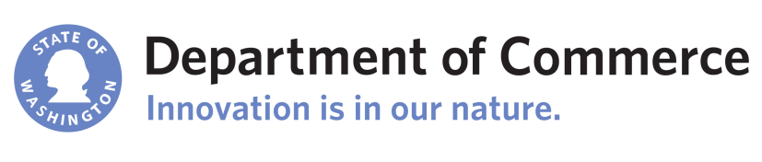  commerce.wa.gov/eia | Washington State  Energy Independence Act  Application for Advisory Opinion – Conservation Resource
All information provided in this application, including supplemental materials, is subject to public disclosure.
Section 1: Applicant Information
Applicant Contact: |  |  | Title:
Applicant Phone:
Applicant E-mail:
Applicant Company Name:
Company Address:
City: |  | State/Province:
Zip Code: |  | Country:
Section 2: Proposed Conservation Resource
Describe the proposed conservation resource.

Explain how the proposed conservation resource will result in a reduction in electric power consumption resulting from increases in the efficiency of energy use, production, or distribution.

Explain how the proposed conservation resource will be cost-effective, which means that the project or resource is forecast: (a) To be reliable and available within the time it is needed; and (b) To meet or reduce the electric power demand of the intended consumers at an estimated incremental system cost no greater than that of the least-cost similarly reliable and available alternative project or resource, or any combination thereof.

Section 3: Reservation
The Washington Department of Commerce makes a determination of resource eligibility under the Washington Energy Independence Act based on the information provided by the applicant and does not independently verify that information. Commerce reserves the right to modify or withdraw a designation if it determines that the information supplied by the applicant was incomplete or inaccurate.
Section 4: Attestation
I declare that the information provided in this application and any supplemental forms and attachments are true and correct to the best of my knowledge, that no information materially affecting the eligibility of the proposed resource has been withheld, and that I am authorized to file this submission.

Signature:
Date Signed:
Authorized Officer/Agent:
Officer Title and Company:

Application Checklist for Submission
Applicants should ensure that the following documents are provided:
- Electronic copy of this application, including a signed attestation page.
- Optional project background documentation. Background documentation can be submitted or published in regulatory settings or informal forums (websites, articles or factsheets).
- Payment of advisory opinion fee of $1,250.
To submit your facility for certification, e-mail the application and any supplemental materials to (eia@commerce.wa.gov). Submit payment of the advisory opinion fee to:

Department of Commerce
Attn: State Energy Office
P.O. Box 42525
Olympia, WA 98504-2525

Commerce will post each application on its website. Applications are subject to a public comment period of at least 10 days.

