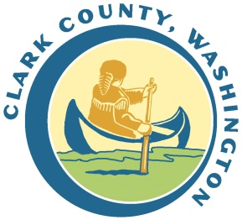
You Have Rights as a Tenant!
Fair Housing Laws
The Fair Housing Act protects people from discrimination when they are renting, buying, or securing financing for any housing. The prohibitions specifically cover discrimination because of race, color, national origin, religion, gender, disability and the presence of children.
To learn more about Fair Housing in Southwest Washington, ask questions or report a complaint about Fair Housing contact:
Fair Housing Council of Oregon

Can I refuse to pay rent if my landlord does not make needed repairs?
No! If you do not pay rent, no matter the reason, your landlord can start the eviction process against you

www.fhco.org
503-223-8197 x.2

Washington State Residential Landlord-Tenant Act (RLTA)
The WA State Residential Landlord Tenant Act specifies the rights and responsibilities of tenants and landlords. Generally the State law requires landlords and tenants to act in good faith toward one another.

- To learn more about Your Rights as a Tenant in Washington State:
http://www.washingtonlawhelp.org/resource/your-rights-as-a-tenant-in-washington?ref=ce2h5
Includes information about Landlord and Tenant Responsibilities, requirements around repairs, moving out and when a unit can be considered abandoned.

- To learn more about Eviction and your Defense:
http://www.washingtonlawhelp.org/resource/eviction-and-your-defense?ref=4mm2N

- Landlord Tenant Issues for Survivors of Domestic Violence, Sexual Assault and/or Stalking
http://www.washingtonlawhelp.org//resource/landlordtenant-issues-for-survivors-of-domest

- Additional information about the RLTA
http://www.washingtonlawhelp.org/issues/housing

What must the landlord do after getting notice of needed repairs?
S/he must start assessing repairs as soon as possible after getting your written notice and no later than:
- 24 hours to start to restore heat, hot or cold water, electricity, or fix a very hazardous condition.
- 72 hours to begin to fix a refrigerator, range and oven, or major plumbing fixture supplied by the landlord.
- 10 days to start making repairs in all other cases.
If the landlord cannot meet these timelines due to circumstances beyond his/her control, s/he must still have the repairs finished as soon as possible.

What is a Rental "Condition Check-In List?"
You should always get a "Condition Check-In List" before you move in. It describes the condition and cleanliness of the unit or its furnishings. It is very important. The landlord may try to blame you for damages that were there when you moved in. With the list, you can prove they were already there.

How fast does my landlord have to return my security or damage deposit?
After you move out, your landlord has fourteen days to send you all of your deposit OR a letter telling you why s/he is not giving some or all of it back.

City of Vancouver Tenants
Protections against Being Turned Down for a Rental Unit only for tenants renting within the City of Vancouver, WA
http://www.washingtonlawhelp.org/resource/city-of-vancouver-tenants-new-protection-against-being-turned-down-for-a-rental-unit?ref=ohv9h

- More notice to vacate: Landlords who own five or more units must now give a 60 days’ notice to vacate for month-to-month tenancies. A landlord’s failure to follow this ordinance is an affirmative defense to eviction.
- More notice of rent increase: Landlords who increase rent by ten percent or more must give 45 days’ written notice of the change. The landlord must give this notice 45 days before the next rental due date.
- Source of Income Discrimination: Landlords may not refuse to rent to applicants based on source of income, which includes state and federal public benefits and subsidized housing assistance. For income screening, landlords must use only the unsubsidized portion of rent as a rent multiplier (most landlords require income of twice the monthly rent). This ordinance does not apply to homeowners who rent a space in their home.

Mobile Home Landlord-Tenant Act
Covers Renters of a space in a mobile home park.
http://www.washingtonlawhelp.org/resource/tenants-rights-under-the-manufacturedmobile-h?ref=tb4ps

CLEAR Legal Assistance Hotline
Call the CLEAR Hotline for Legal Assistance related to landlord-tenant issues. Generally, callers are screened for income eligibility and type of legal problem. CLEAR gets many calls. It may take a while to speak to someone. Please be patient.

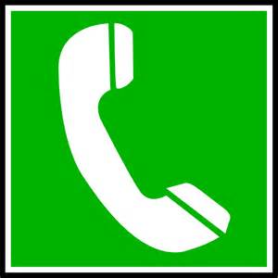

CLEAR* Senior Hotline  Age 60 and Better  1-888-387-7111  (M-F 9:15 am to 12:15 pm) | Call NJP's CLEAR Hotline  at 1-888-201-1014  (M-F 9:15 am to 12:15 pm) | Share your situation on-line and get legal advice.  https://nwjustice.org/get-legal-help

Ask your housing case manager for hard copies of any documents that may be helpful.

